Retinex-Based LLIE:
A Comparative Evaluation of Five Models on LOL-v1 and LSRW
Ammar Elsonbaty, 22646204
Advanced Machine Learning, Assignment 2

Introduction
In Assignment 1, I took a deep dive into 15 papers focused on Retinex-centered and structure-aware low-light image enhancement (LLIE). The Retinex theory breaks down an image into two components: I = R × L. Here, R represents the reflectance, which captures the scene's colors and textures, while L indicates the illumination, or how much light hits each pixel. In darker images, L tends to be low, prompting most of the methods I reviewed to estimate L, or both R and L, before brightening the image. However, this brightening process often amplifies the noise present in dark photos. The key differences among these methods lie in how they estimate the light and manage this noise. For this assignment, I opted for setting 1, which is Dataset-Based Evaluation. I evaluated five Retinex-based models: SCI [1], PairLIE [2], URetinex-Net [3], Retinexformer [4], and RUAS [5], using two paired datasets, LOL-v1 [6] and LSRW [7]. I utilized the official code and weights provided by the authors for each model. I implemented two protocols for my testing. In Protocol A, I assessed the official pretrained weights. I quickly realized that comparing the official results was quite challenging. Each model had been trained on different datasets, one evaluation script reads the ground truth during testing, and another training setup selects its checkpoint based on the test images. To address this, I retrained four models myself in Protocol B, using the same LOL-v1 training split, along with a fixed validation split and seed, and tested them in a consistent manner. URetinex-Net was only included in Protocol A since its authors didn’t release the training code.

Model Selection
I selected models which apply Retinex theory through various approaches to demonstrate how different design choices affect the models which I analyzed in my first assignment. The five peer-reviewed articles span from 2021 through 2023 and they provide official code for their research findings.
The SCI model learns only illumination through a compact network which divides the input by its learned illumination output. It needs no ground truth. The training process connects multiple stages through a self-calibrated module which uses the same weight system for each stage. The system maintains only one operational stage during testing which results in SCI becoming an extremely fast system.
PairLIE [2] uses two low-light photographs from the same scene to train its system. Both photos should have the same reflectance, so the network can learn R and L without any normal-light image. The system operates without supervision to perform the explicit separation between R and L components.
URetinex-Net [3] develops the Retinex split through optimization techniques which transform three solver steps into network-based stages. The system replaces human-designed priors with small learned modules. The deep unfolding method trains through paired data which serves as its training foundation.
The Retinex model receives noise term additions from the Retinexformer [4] system. The system performs image enhancement through a single step before it uses illumination-based transformer guidance to remove noise and artefacts. The system operates under supervision and it produced the best published LOL-v1 result from my candidate pool.
The RUAS system [5] breaks down illumination processing and noise elimination into separate steps while its small network cells develop through architectural exploration. It is unsupervised and tiny. I added it when I found that URetinex-Net could not be retrained. The SCI system derives from RUAS which serves as its foundation to form an effective combination between these two systems.
Table 1. Selected models. Parameters are counted on the network used at test time.
Model | Venue | DOI | Use of Retinex | Supervision | Params
SCI [1] | CVPR 2022 | 10.1109/CVPR52688.2022.00555 | illumination only, I / L | unsupervised | 258
PairLIE [2] | CVPR 2023 | 10.1109/CVPR52729.2023.02131 | explicit R and L | unsupervised (pairs) | 341,767
URetinex-Net [3] | CVPR 2022 | 10.1109/CVPR52688.2022.00581 | unfolded R, L optimisation | supervised | 340,105
Retinexformer [4] | ICCV 2023 | 10.1109/ICCV51070.2023.01149 | one-stage light-up + restorer | supervised | 1,605,701
RUAS [5] | CVPR 2021 | 10.1109/CVPR46437.2021.01042 | unrolled illumination + denoise | unsupervised | 3,438

Datasets
LOL-v1 [6] consists of 500 image pairs which photographers captured through varied exposure settings. The dataset includes 485 images for training purposes and 15 images for testing which forms the eval15 set. I test on eval15. The 485 training pairs under Protocol B received a random split which created two sets of 450 training pairs and 35 validation pairs through seed 42 random selection. The configuration directory contains separate files which store these two sets. The LSRW [7] dataset contains real-world low-light and normal-light image pairs which were captured using Huawei and Nikon camera devices. The official evaluation split of 50 pairs from Huawei and Nikon serves as my only testing resource because I do not train on it. The LSRW evaluation dataset allows me to measure how different models perform when they encounter new camera devices and different photographic situations. I obtained LSRW through a Kaggle mirror which duplicates the official dataset distribution. Its folders and pair counts match the official split (2450 + 30 Huawei and 3150 + 20 Nikon pairs).
I verified the data through two steps before starting my analysis of low-light images. I verified that every low-light image contains a ground-truth image which shares its name and dimensions. I verified that each low image contains less brightness than its corresponding ground truth image. I conducted pixel decoding followed by hash generation for all training and validation and test images which resulted in separate sets without any matching elements.
Table 2. Datasets used in this work.
Dataset | Source | Use | Pairs | Image size
LOL-v1 [6] | daooshee.github.io/BMVC2018website (archive via Retinexformer README) | test (eval15) | 15 | 600 × 400
LOL-v1 train | same archive | Protocol B train / validation | 450 / 35 | 600 × 400
LSRW [7] | github.com/JianghaiSCU/R2RNet (Kaggle mirror bjzh123/lsrw123) | test (official Eval) | 50 (30 + 20) | 960 × 720 / 960 × 640

Implementation

Code sources and what I changed
I used the official repositories of all five models at fixed commits (Section 10) and their official weights. SCI, PairLIE, URetinex-Net and RUAS ship their weights in the repositories, and the Retinexformer weights come from the authors' Google Drive. I did not change any file in these repositories. Instead I wrote wrapper scripts that import the official network code and run every model with the same image loader, the same saving function and the same metric script. To check the wrappers, I ran each official test script once on LOL-v1 and compared the images. They agree within 1/255 per pixel (some official scripts truncate when saving, while I round), and for Retinexformer they are identical.
Some official code does not run on PyTorch 2.7 or on Windows. The URetinex-Net checkpoints need torch.load(weights_only=False). The official RUAS training step crashes at the first update of its noise removal module, because of an in-place gradient error in newer PyTorch. I give that module a detached copy of its input, which leaves the gradients of its own weights unchanged. I also found a bug in the official RUAS training script: it rebuilds the data iterator at every step without shuffling, so it only ever trains on the first image. I pick a random training image at every step instead. All fixes are listed in docs/code_changes.md, together with the place in my scripts where they are made.

Problems I had to solve
My PC runs Windows with an RTX 3060 (12 GB) but only 8 GB of RAM, and this caused most of my problems. The conda version of Pillow clashed with the image libraries inside torchvision, so I installed Pillow with pip. numpy crashed on every matrix multiplication with its MKL library, which also broke matplotlib, so I switched numpy to OpenBLAS. OpenBLAS then reserved about 1.9 GB of memory per Python process, and with the Retinexformer data-loader workers the memory commit reached 96% of the limit. Setting OPENBLAS_NUM_THREADS=1 and cutting the workers from 8 to 2 fixed this without slowing training down. Windows also restarted the data-loader workers at the start of every short epoch, which made Retinexformer run at 0.50 s per iteration instead of 0.14 s. The BasicSR option dataset_enlarge_ratio solved this without changing the training itself.
Two problems came from the models. URetinex-Net has no training code. I checked the authors' later URetinex-Net-PLUS repository: the networks are the same, but its illumination adjustment training adds a fusion network and uses a different loss, so it cannot reproduce URetinex-Net. I therefore kept URetinex-Net in Protocol A and added RUAS to Protocol B. PairLIE needs two low-light shots of the same scene, which normal LOL-v1 pairs do not have. I downloaded the authors' training set and found, by pixel hashing, that 145 of its 324 sequences use only LOL-v1 training images (the rest come from SICE [8]). After removing my validation images I kept 128 sequences with 318 images, so Protocol B stays LOL-only. Finally, SCI's official 1000 epochs would take about 34 hours on my GPU, so I trained it for 200 epochs.

The models in detail
SCI. A three-channel network (a convolution, one residual block with batch normalisation, and a convolution with sigmoid) predicts a residual, and the illumination is x = clamp(y + residual). The output is y / x. Training runs three stages that share their weights, with a 16-channel self-calibration module between them. The loss for each stage is 1.5 times the mean squared error between the illumination and the stage input, plus a smoothness term that is weighted by the image edges. The official code uses Adam, learning rate 3e-4, weight decay 3e-4, batch 1, full-size images and 1000 epochs (the paper states batch 8 and learning rate 1e-4). Input and output are RGB images in [0, 1] of any size, and only 258 parameters are used at test time.
PairLIE. Three small CNNs (five 3 × 3 convolutions with 64 channels each) estimate a cleaned image X, the illumination L (one channel) and the reflectance R (three channels). The loss has three parts: reflectance consistency between the two images of a pair (weight 1), a Retinex term in which L·R should rebuild X while L follows the brightest RGB channel and stays smooth (weight 1), and a projection term that keeps X close to the input (weight 500). Training uses Adam with learning rate 1e-4, halved every 100 epochs, for 400 epochs, with batch 1 and random 128 × 128 crops. At test time the output is L^0.2 · R. I keep the default exponent 0.2 on both datasets, even though the paper uses 0.14 for LOL.
URetinex-Net. A decomposition network gives a first R and L. Three unfolded stages then alternate closed-form least-squares updates with two learned networks: a residual denoiser with a squeeze-and-excitation layer for R, and a small network for L. An adjustment network finally brightens L by a ratio that the user chooses. Each module is trained separately with Adam, learning rate 1e-4, batch 4 and 48 × 48 patches. The official evaluation script computes the ratio from the ground-truth image, so I use the fixed ratio 5 from the official test script instead.
Retinexformer. An illumination estimator takes the image and its channel mean and outputs a light-up map and light-up features. The brightened image then goes through a U-shaped transformer whose attention is guided by these features. My configuration has 40 base channels and blocks [1, 2, 2], 1.61 M parameters in total. Training uses an L1 loss, Adam with learning rate 2e-4 and cosine annealing, batch 8, 128 × 128 crops with flips, rotations and mixup, and 150,000 iterations. Any image size works, because the input is padded to a multiple of 4.
RUAS. Three illumination stages estimate the illumination t and compute u = y / t, and a noise removal module subtracts estimated noise from u. Both use searched cells with 3 and 6 channels, 3,438 parameters in total. Training needs only low-light images. The illumination module minimises a fidelity term plus a weighted smoothness term (SGD, learning rate 0.015). The noise module minimises a small fidelity term plus total variation (SGD, learning rate 0.001) and is updated only every 50th step. The batch size is 1, the crops are 320 × 320, and training lasts 800 iterations. The noise module starts from the authors' pretrained file denoise.pt, whose training data is not reported.

Experimental Setup
I test all models in the same way: RGB input scaled to [0, 1] at full resolution, batch 1, output clipped and saved as 8-bit PNG, and one metric script. No model sees the ground truth at test time, I do not use the GT-mean correction that some papers use, and I did not tune anything on the test sets. All runs use an RTX 3060 (12 GB), 8 GB RAM, Windows 11, Python 3.10.21 and PyTorch 2.7.1 with CUDA 11.8. Table 3 lists the other settings. For Protocol A these are the authors' training settings, and for Protocol B they are what I actually ran.
Table 3. Experimental setup. (a) Protocol A, official weights and the authors' training settings.
Field | SCI | PairLIE | URetinex-Net | Retinexformer | RUAS
Pretrained weights | medium.pt | PairLIE.pth | init_low, unfolding, L_adjust | LOL_v1.pth | lol.pt
Trained on | mainly LOL + LSRW | SICE + LOL, 324 seq. | LOL train | LOL-v1 train (485) | LOL, 689 pairs
Train input size | full image | 128 × 128 | 48 × 48 | 128 × 128 | 320 × 320
Batch size | 8 (code: 1) | 1 | 4 | 8 | 1
Epochs / iterations | 1000 ep. | 400 ep. | not reported | 150k it. | 800 it.
Optimizer | Adam | Adam | Adam | Adam | SGD, mom. 0.9
Learning rate | 1e-4 (code 3e-4) | 1e-4, ×0.5 / 100 ep. | 1e-4, ÷10 at 30k | 2e-4, cosine | 0.015 / 0.001
Loss | fidelity + smooth | consist. + Retinex + proj. | per module | L1 | fidelity + smooth / TV
Augmentation | none | crop | not reported | crop, flip, rot., mixup | crop

Table 3. (b) Protocol B, retrained by me on LOL-v1 (450 train / 35 validation pairs, seed 42).
Field | SCI | PairLIE | Retinexformer | RUAS
Training data | 450 low images | 128 LOL sequences (318 images) | 450 pairs | 450 low images
Initialisation | random | random | random | random; denoiser from denoise.pt
Train input size | 600 × 400 | 128 × 128 | 128 × 128 | 320 × 320
Batch size | 1 | 1 | 8 | 1
Epochs / iterations | 200 ep. (90,000 it.) | 400 ep. (51,200 it.) | 150,000 it. | 800 it.
Optimizer / LR | Adam, 3e-4 | Adam, 1e-4, ×0.5 / 100 ep. | Adam, 2e-4, cosine | SGD, 0.015 / 0.001
Loss / augmentation | official / none | official / crop | official / flip, rot., mixup | official / crop
Checkpoint tested | final | final | best validation (103k) | final
Training time | 6 h 39 min | 18 min 43 s | 6 h 31 min | 60 s

Evaluation Metrics
Enhancement produces an image, and each test image has a normal-light reference. So I use three full-reference image quality metrics, all computed by one script on RGB images in [0, 1] at full resolution. PSNR measures pixel-wise fidelity in dB and reacts strongly to the overall brightness. SSIM [9] compares local luminance, contrast and structure (scikit-image, 7 × 7 window). LPIPS [10] is a learned perceptual distance based on AlexNet features. It reacts to lost texture and colour, and lower is better. For efficiency I report the number of parameters, the FLOPs for a 256 × 256 input counted with fvcore (one multiply-add counts as one FLOP), and the mean GPU time per image after 10 warm-up passes, all on the same RTX 3060.
Classification metrics such as accuracy, precision, recall, F1-score and AUC need class labels. Segmentation metrics such as Dice and IoU need region masks. Enhancement has neither, because the output is a whole image that should match a reference image. Regression metrics such as MAE or RMSE are closer, and PSNR is in fact a log-scaled MSE, but they ignore structure and perception, which SSIM and LPIPS cover. As a sanity check, the unprocessed low-light inputs score 7.773 dB on LOL-v1 and 9.159 dB on LSRW, and a ground-truth image compared with itself gives infinite PSNR, SSIM 1 and LPIPS 0.

Results
Table 4 gives the results with the official weights, Table 5 the results after my retraining, and Table 6 the efficiency numbers. The best value in each column is in bold. Figures 1 and 2 show example outputs, Figure 3 compares PSNR and SSIM, Figure 4 relates quality to speed, and Figure 5 shows the training curves of Protocol B.
Table 4. Protocol A (official weights). PSNR in dB. Drop = PSNR(LOL-v1) minus PSNR(LSRW).
Model | LOL PSNR ↑ | LOL SSIM ↑ | LOL LPIPS ↓ | LSRW PSNR ↑ | LSRW SSIM ↑ | LSRW LPIPS ↓ | Drop (dB)
SCI | 14.85 | 0.5274 | 0.3389 | 15.28 | 0.4219 | 0.3221 | ‑0.42
PairLIE | 18.50 | 0.7430 | 0.2434 | 17.61 | 0.5077 | 0.3310 | +0.89
URetinex-Net | 19.86 | 0.8239 | 0.1282 | 18.25 | 0.5188 | 0.2994 | +1.61
Retinexformer | 25.15 | 0.8434 | 0.1314 | 17.78 | 0.5085 | 0.3196 | +7.37
RUAS | 16.45 | 0.5053 | 0.2698 | 14.29 | 0.4633 | 0.4648 | +2.15

Table 5. Protocol B (retrained by me). The last two columns give the PSNR change from Protocol A.
Model | LOL PSNR ↑ | LOL SSIM ↑ | LOL LPIPS ↓ | LSRW PSNR ↑ | LSRW SSIM ↑ | LSRW LPIPS ↓ | Δ LOL | Δ LSRW
SCI | 12.97 | 0.4964 | 0.3493 | 14.31 | 0.3986 | 0.3297 | ‑1.88 | ‑0.96
PairLIE | 18.22 | 0.7217 | 0.3955 | 17.52 | 0.5175 | 0.4793 | ‑0.28 | ‑0.09
Retinexformer | 22.11 | 0.8237 | 0.1508 | 17.61 | 0.5095 | 0.3310 | ‑3.04 | ‑0.17
RUAS | 16.17 | 0.5001 | 0.2651 | 14.05 | 0.4603 | 0.4606 | ‑0.27 | ‑0.24

Table 6. Efficiency (same architecture in both protocols). FLOPs with fvcore for 1 × 3 × 256 × 256; runtime on the RTX 3060, batch 1, mean over the test images after warm-up.
Model | Parameters ↓ | FLOPs @256 (G) ↓ | ms / image LOL-v1 ↓ | ms / image LSRW ↓
SCI | 258 | 0.016 | 5.9 | 15.7
PairLIE | 341,767 | 22.347 | 35.4 | 96.2
URetinex-Net | 340,105 | 56.934 | 81.7 | 222.5
Retinexformer | 1,605,701 | 16.716 | 103.6 | 286.1
RUAS | 3,438 | 0.214 | 37.1 | 101.0

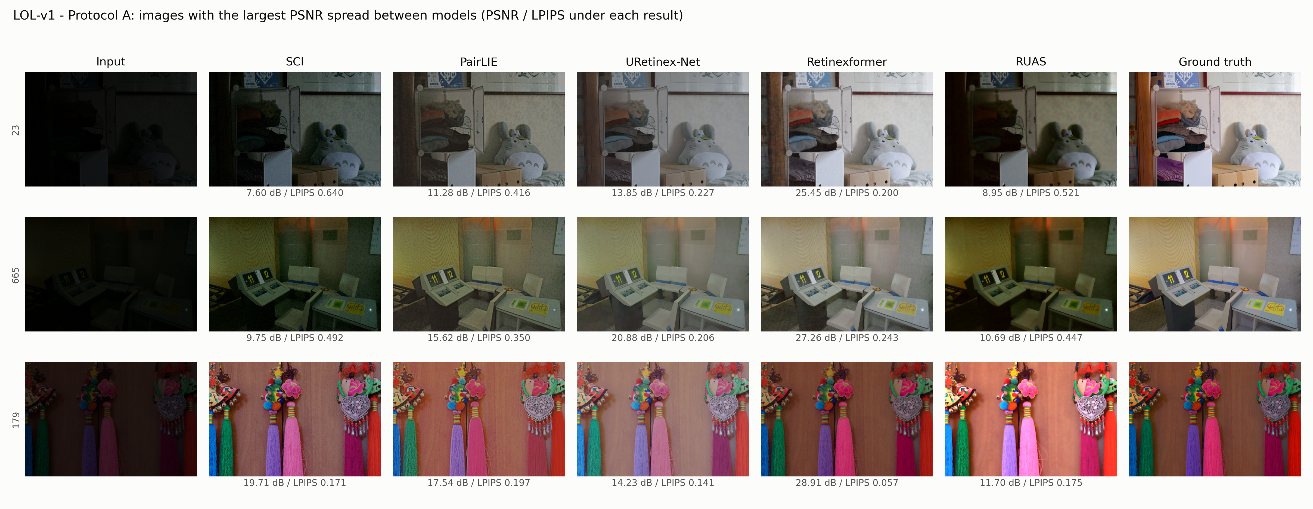
Figure 1. Protocol A outputs on LOL-v1 for the three test images where the models differ most in PSNR. PSNR and LPIPS are printed under each result.
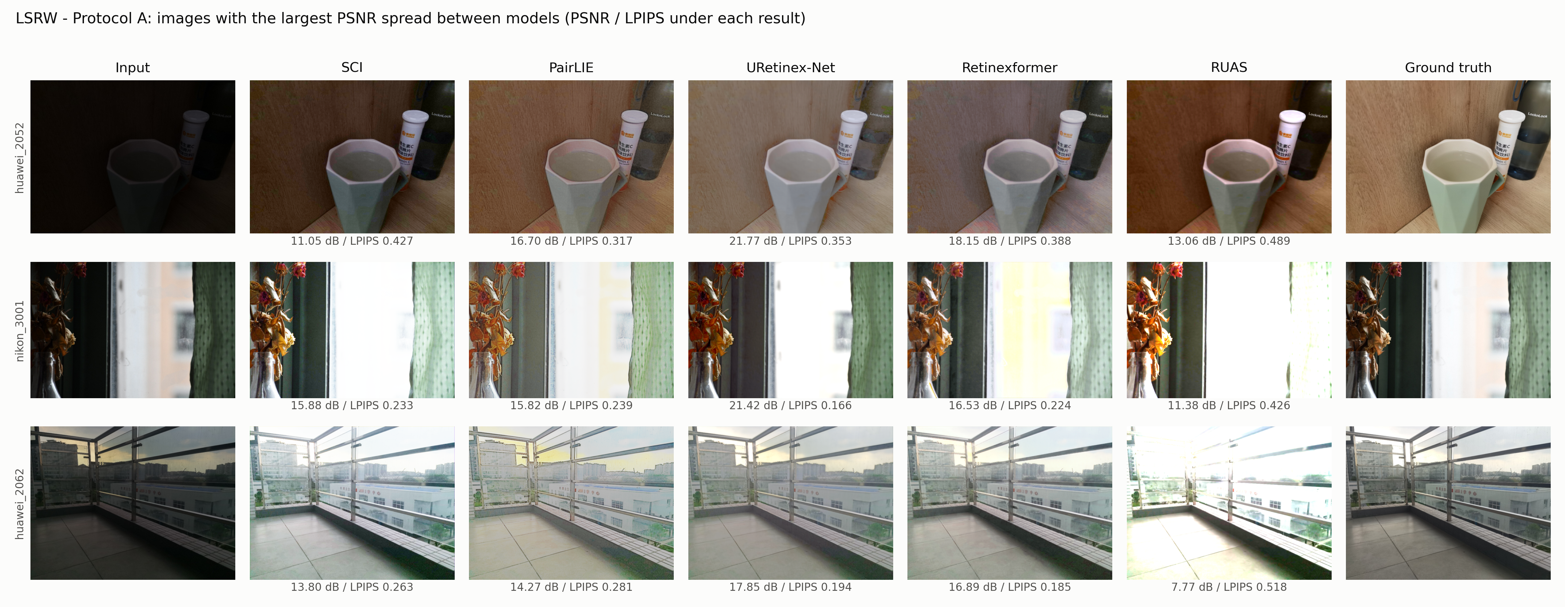
Figure 2. Protocol A outputs on LSRW (two Huawei images and one Nikon image).
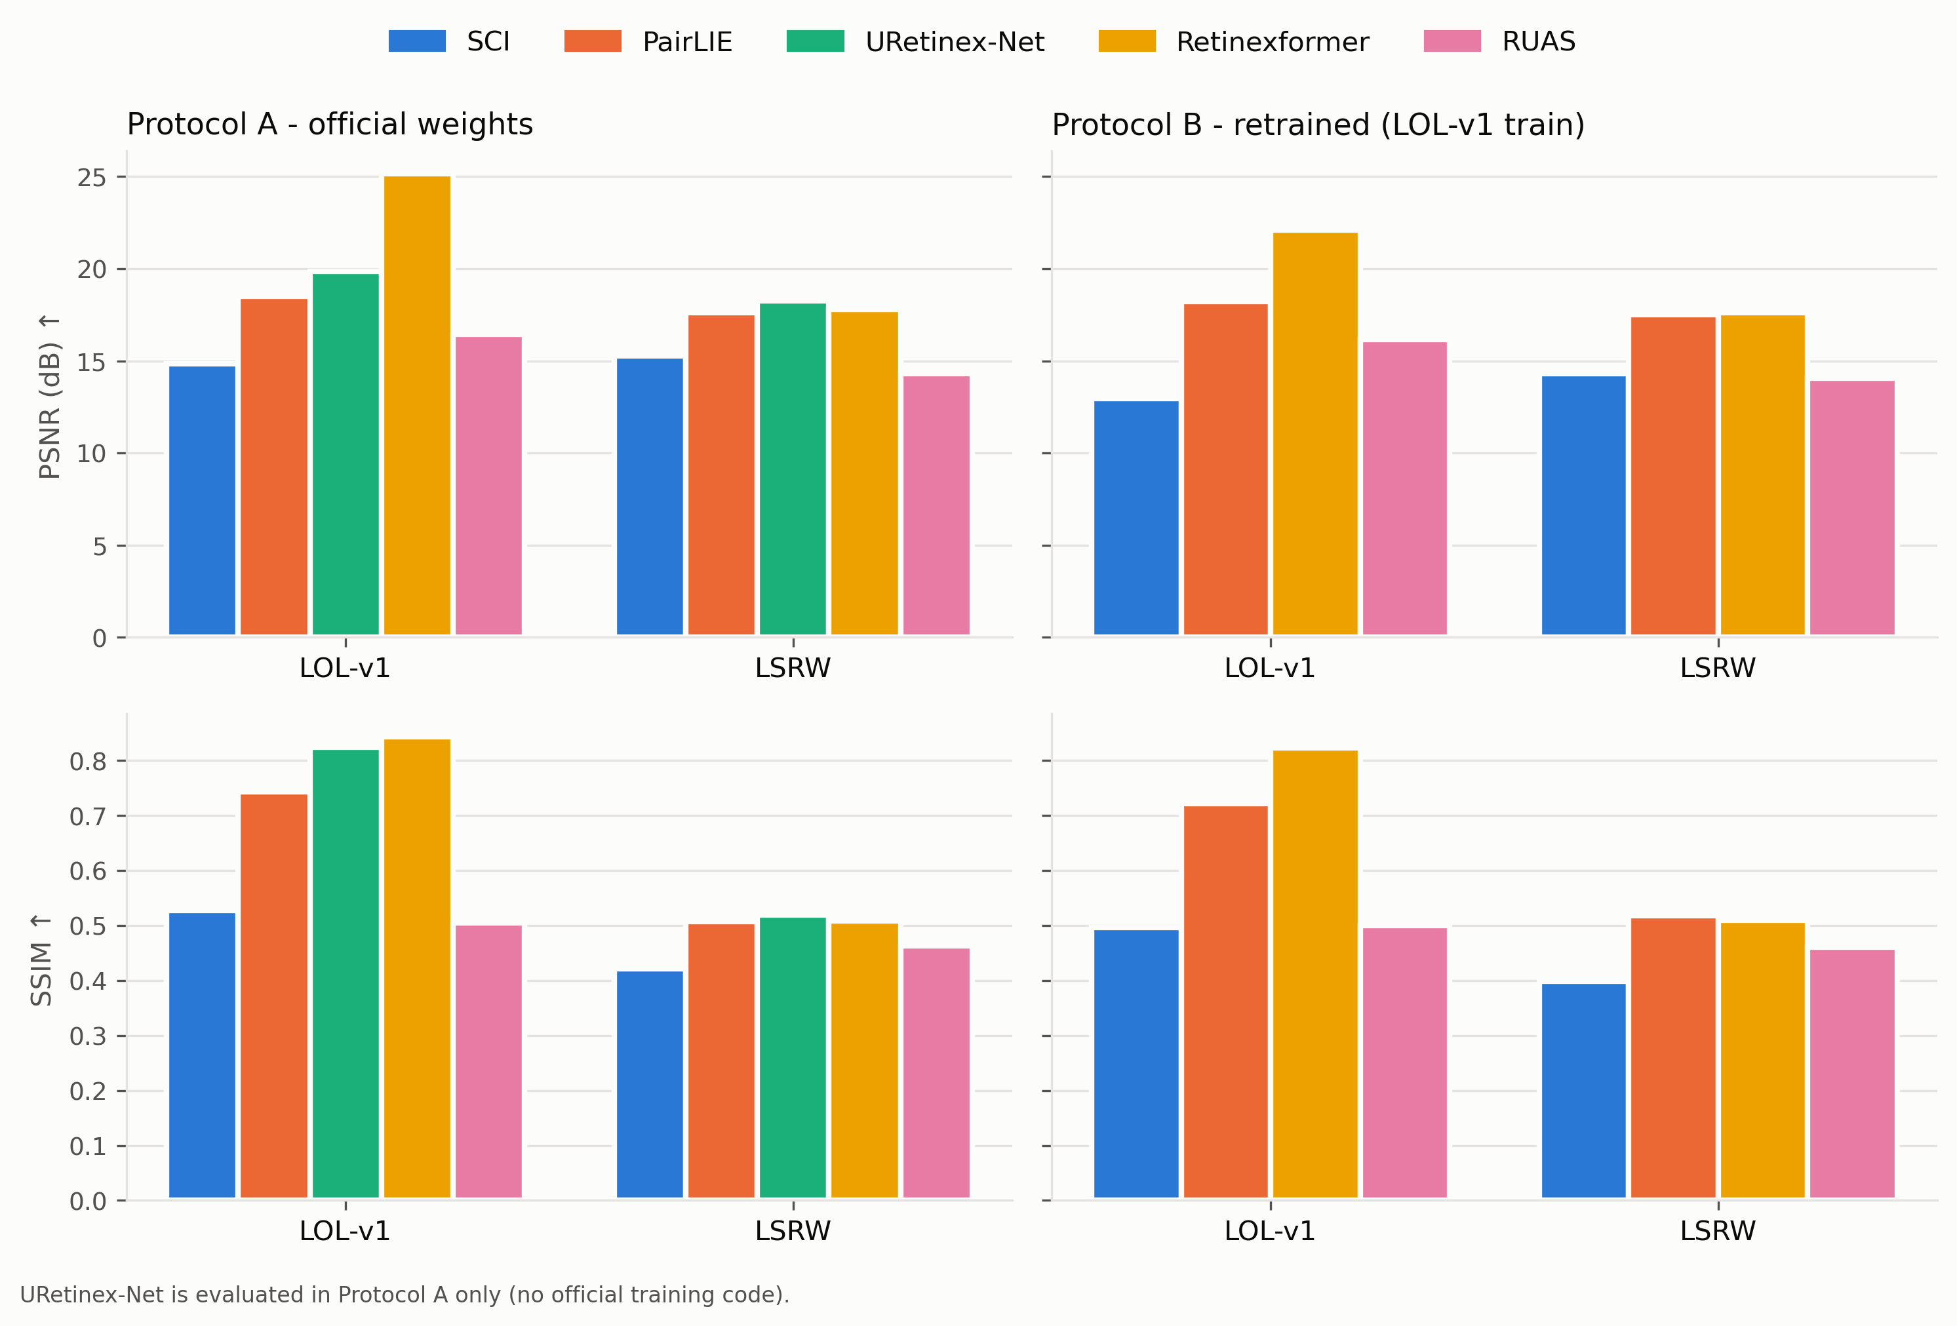
Figure 3. PSNR and SSIM of all models on both datasets, Protocol A (left) and Protocol B (right).
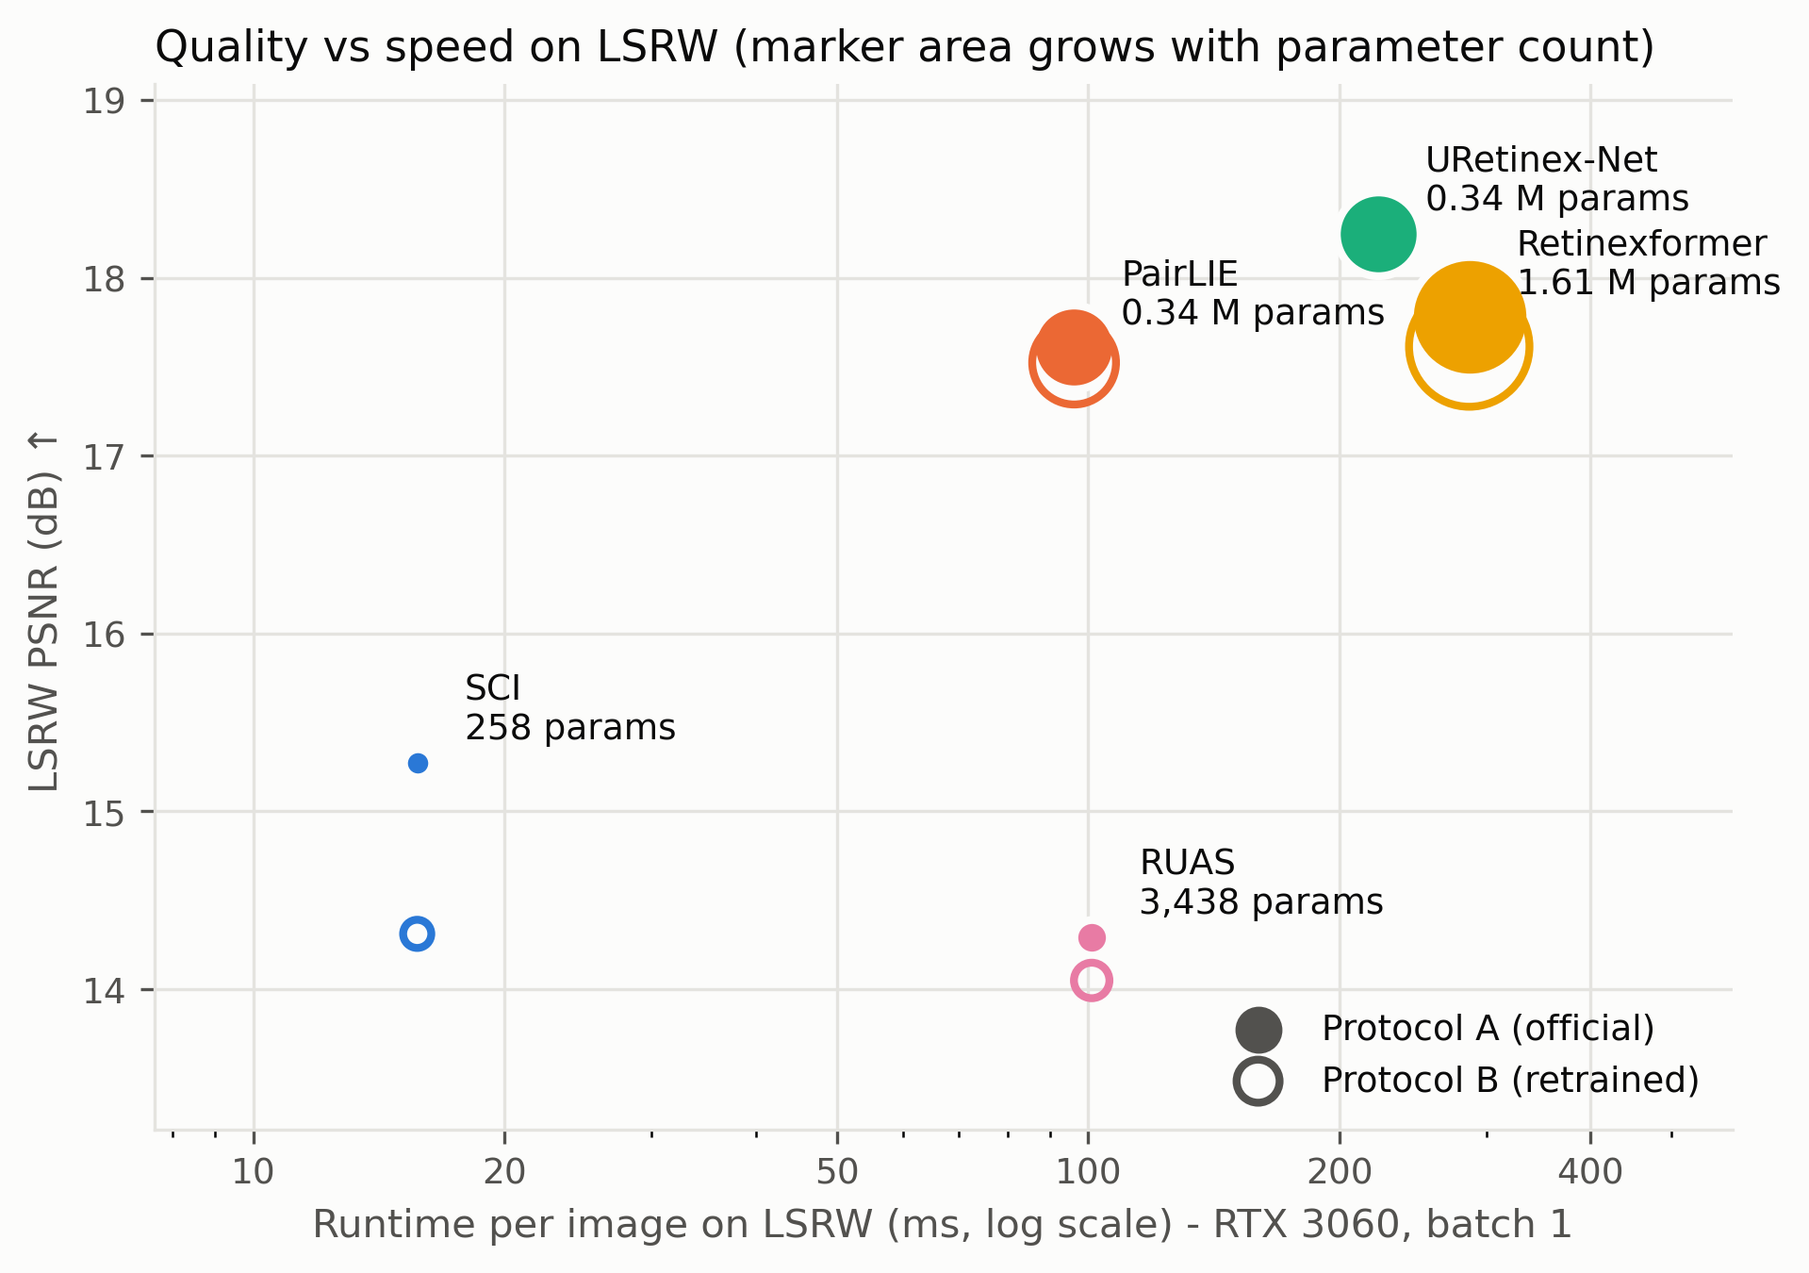
Figure 4. LSRW PSNR against runtime per image. Filled markers: official weights; rings: my retrained models. Marker area grows with the number of parameters.
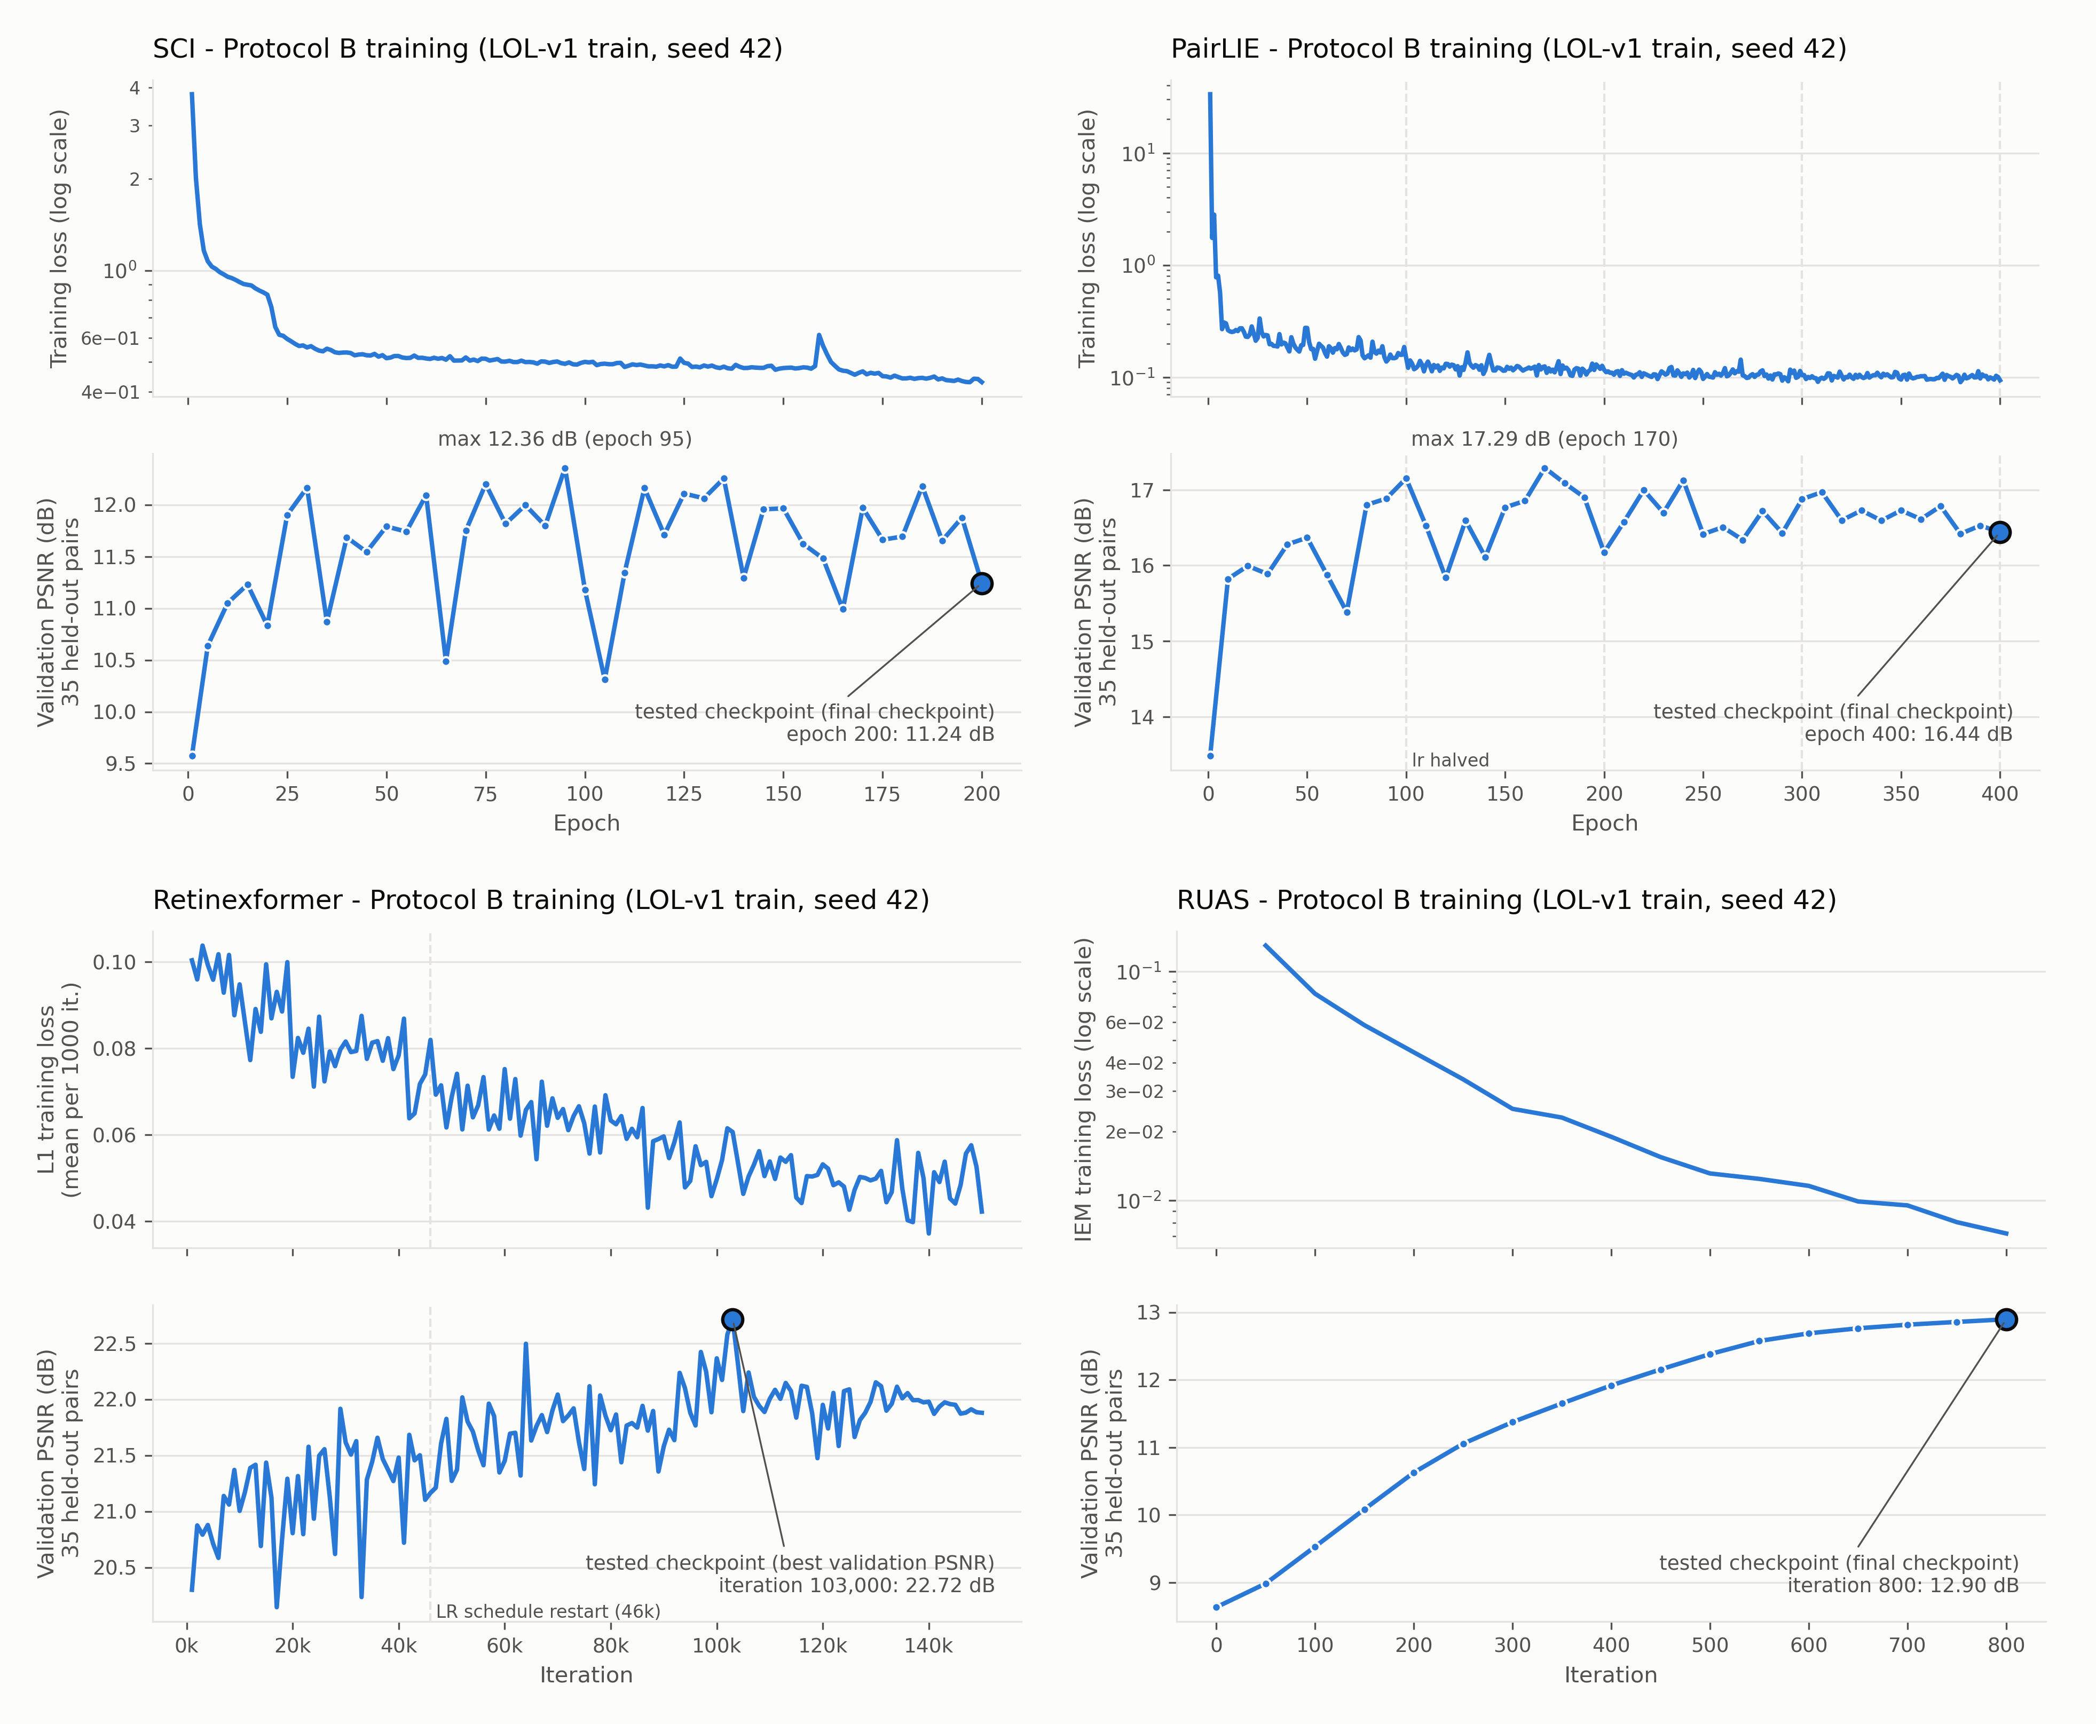
Figure 5. Protocol B training curves: training loss (top of each panel) and validation PSNR on the 35 held-out LOL-v1 pairs (bottom). The marked point is the tested checkpoint.

Result Analysis
With the official weights, Retinexformer is clearly best on LOL-v1 (25.15 dB, SSIM 0.8434), and URetinex-Net has the best LPIPS there (0.1282). On LSRW the order changes. URetinex-Net is best on all three metrics (18.25 dB, 0.5188, 0.2994), and Retinexformer, PairLIE and URetinex-Net are within 0.64 dB of each other. Figures 1 and 2 show that much of the PSNR gap comes from brightness. On LOL-v1 the ground truth has a mean brightness of 0.451. URetinex-Net (0.446) and Retinexformer (0.433) come close, while SCI (0.273) and RUAS (0.371) stay too dark, and these two also have the lowest PSNR on LOL-v1. On LSRW, RUAS is instead a bit brighter than the ground truth (0.441 against 0.426) and washes out bright outdoor areas, as in the Nikon image of Figure 2. Retinexformer gives the cleanest images with the most natural colours, while URetinex-Net is bright but slightly washed out.
How well the models carry over from LOL-v1 to LSRW differs a lot. Retinexformer loses 7.37 dB, URetinex-Net 1.61 dB, RUAS 2.15 dB and PairLIE 0.89 dB, while SCI even gains 0.42 dB. The SCI gain does not mean that SCI generalises best. It mainly reflects its weak LOL-v1 score. The large Retinexformer drop fits a high-capacity supervised model that was fitted to LOL. SSIM is lower for every model on LSRW, because its real images contain more noise and harder lighting. When I split LSRW by camera, every model scores a lower PSNR on the Nikon images than on the Huawei images, except my retrained SCI (14.79 dB against 14.00 dB).
Retraining under one protocol changes Retinexformer the most. Its LOL-v1 PSNR falls from 25.15 to 22.11 dB (‑3.04 dB), but on LSRW it only moves from 17.78 to 17.61 dB. I expected this drop on LOL-v1. The official configuration validates on the LOL-v1 test images during training and keeps the checkpoint with the best score on them. Protocol B picks the checkpoint on 35 held-out training pairs and never looks at the test images. To measure the effect directly, I scored all 150 checkpoints of my run on LOL-v1 eval15 (Table 7). Across the checkpoints the test PSNR varies with a standard deviation of 0.82 dB, and the correlation between validation and test PSNR is only 0.70. Picking the best checkpoint on the test images would have given 23.63 dB instead of 22.11 dB. That is +1.52 dB from the selection alone, about half of the gap. The rest can come from the smaller training set (450 instead of 485 pairs), the different seed and normal run-to-run variation. Because LSRW was never used for any choice, I see LSRW as the fairer comparison between the models.
Table 7. Checkpoint selection for my Retinexformer run (150 checkpoints, one per 1000 iterations), scored on LOL-v1 eval15. Only the first row is a reported result; the second row shows what test-set selection would give.
Checkpoint choice | Iteration | LOL-v1 PSNR | LOL-v1 SSIM
Best validation PSNR on 35 held-out pairs (mine) | 103,000 | 22.110 | 0.8237
Best PSNR on the test images (official practice) | 93,000 | 23.628 | 0.8255

For PairLIE, PSNR and SSIM barely change after retraining (‑0.28 dB on LOL-v1), but LPIPS gets clearly worse (0.2434 to 0.3955). When I looked at the images, my retrained PairLIE gives paler and smoother results. The noise is gone, but so are fine texture and colour. I think the reason is the training data. I only used the 318 LOL images, which are very dark and noisy, while the authors also used SICE sequences with more varied exposures. This case shows why a perceptual metric is needed next to PSNR.
My retrained SCI is weaker than the official weights (12.97 against 14.85 dB on LOL-v1). It brightens less: its mean output brightness on LOL-v1 is 0.216 against 0.273 for the official model. SCI never sees a normal-light image, so how bright it ends up depends only on its training images, and the official weights were trained mainly on LOL and LSRW. The shorter training is probably not the main reason, because the validation PSNR stopped improving after about 25 epochs and stayed between 10.31 and 12.36 dB (Figure 5).
My retrained RUAS with the official 800 iterations is close to the official weights (16.17 against 16.45 dB on LOL-v1, with slightly better LPIPS). Its validation PSNR was still rising at iteration 800, so I wanted to know whether the short official schedule holds RUAS back. Before looking at any result, I fixed one extra run with 50,000 iterations and the same rule of testing the final checkpoint (Table 8). It became much worse, with 10.14 dB on LOL-v1 and 8.80 dB on LSRW. The images show why. The long model over-brightens: its mean brightness on LOL-v1 is 0.755 against 0.451 for the ground truth, and 44.0% of its output pixels are close to white (at least 0.98). Its validation PSNR did not warn me. It peaked at 12.99 dB around iteration 1,000 and then stayed between 12.17 and 12.53 dB. On the validation pairs the 800-iteration model is too dark (mean brightness 0.302 against 0.458) and the 50,000-iteration model is too bright (0.654). These opposite errors give a similar PSNR (12.90 and 12.31 dB). So the official 800 iterations are the better choice for RUAS, and PSNR alone cannot tell an image that is too dark from one that is too bright.
Table 8. RUAS with the official weights, my 800-iteration run (Protocol B) and the extra 50,000-iteration run. Brightness is the mean output value on LOL-v1 (ground truth 0.451).
RUAS run | LOL PSNR ↑ | LOL SSIM ↑ | LOL LPIPS ↓ | LSRW PSNR ↑ | LSRW SSIM ↑ | LSRW LPIPS ↓ | Brightness
Official weights (Protocol A) | 16.45 | 0.5053 | 0.2698 | 14.29 | 0.4633 | 0.4648 | 0.371
800 iterations (Protocol B) | 16.17 | 0.5001 | 0.2651 | 14.05 | 0.4603 | 0.4606 | 0.397
50,000 iterations (extra run) | 10.14 | 0.4246 | 0.4712 | 8.80 | 0.3946 | 0.6047 | 0.755

Speed and quality do not go together in a simple way (Figure 4). SCI is by far the fastest model (5.9 ms per LOL-v1 image, 258 parameters), but it has the lowest quality. Retinexformer is the slowest (286.1 ms per LSRW image) and has the most parameters, yet it needs fewer FLOPs (16.72 G) than PairLIE (22.35 G) and URetinex-Net (56.93 G). RUAS has only 3,438 parameters but still needs 37.1 ms, because most of its work is many small element-wise steps that FLOP counting ignores. My Retinexformer FLOP count is slightly higher than the 15.57 G in its paper [4], probably because counting tools include different operations. On LSRW, URetinex-Net gives the best quality in less time than Retinexformer.
Three fairness decisions shape these numbers. First, no model uses the ground truth at test time. The official URetinex-Net evaluation computes its brightening ratio from the ground truth, and its paper reports 21.33 dB on LOL [3]. With the fixed ratio 5 I get 19.86 dB. For the same reason I kept PairLIE's default exponent and did not use the GT-mean correction. Second, Retinexformer's official training picks its checkpoint on the test set, which I avoided in Protocol B (Table 7). Third, URetinex-Net could not be retrained, so its numbers come only from the official weights and are not fully comparable with Protocol B.

Conclusion
I compared five Retinex-based low-light enhancement models on LOL-v1 and LSRW, first with the official weights and then after retraining four of them under one protocol. Retinexformer is the strongest model on LOL-v1, but most of its lead disappears on LSRW, and about half of the gap between its official and retrained LOL-v1 score comes from picking the checkpoint on the test images. URetinex-Net gives the best LSRW results The two very small unsupervised models, SCI and RUAS, give the lowest quality. SCI is by far the fastest at test time (5.9 ms per LOL-v1 image). RUAS trains the fastest (60 s for its 800 iterations), but at test time it is only about as fast as PairLIE (37.1 against 35.4 ms), even though it has about 100 times fewer parameters. PairLIE sits in the middle but loses perceptual quality when it is trained on LOL alone. LSRW, which no model or decision used, was more useful for a fair comparison than LOL-v1. My extra RUAS run also taught me that a single PSNR value can hide whether an image is too dark or too bright, so I would always look at the images and at their brightness as well.
Limitations: Protocol B fixes the data split and seed, but each model retains its own official training schedule. SCI was reduced to 200 epochs so that the results compare the published methods rather than those under equal computing power. An additional RUAS run demonstrated the sensitivity of an unsupervised model to this choice and revealed that validation PSNR is an unreliable stopping rule when brightness drifts. As I only trained on LOL-v1, my generalization results only cover the direction from LOL-v1 to LSRW. The weights for Protocol A also come from different training sets, meaning that the ranking mixes model quality with training data. Finally, PSNR and SSIM react strongly to global brightness and runtimes were measured on one consumer GPU.10.

References
[1] L. Ma, T. Ma, R. Liu, X. Fan, and Z. Luo, “Toward Fast, Flexible, and Robust Low-Light Image Enhancement,” in 2022 IEEE/CVF Conference on Computer Vision and Pattern Recognition (CVPR), New Orleans, LA, USA: IEEE, Jun. 2022, pp. 5627–5636. doi: 10.1109/CVPR52688.2022.00555.
[2] Z. Fu, Y. Yang, X. Tu, Y. Huang, X. Ding, and K.-K. Ma, “Learning a Simple Low-Light Image Enhancer from Paired Low-Light Instances,” in 2023 IEEE/CVF Conference on Computer Vision and Pattern Recognition (CVPR), Vancouver, BC, Canada: IEEE, Jun. 2023, pp. 22252–22261. doi: 10.1109/CVPR52729.2023.02131.
[3] W. Wu, J. Weng, P. Zhang, X. Wang, W. Yang, and J. Jiang, “URetinex-Net: Retinex-based Deep Unfolding Network for Low-light Image Enhancement,” in 2022 IEEE/CVF Conference on Computer Vision and Pattern Recognition (CVPR), New Orleans, LA, USA: IEEE, Jun. 2022, pp. 5891–5900. doi: 10.1109/CVPR52688.2022.00581.
[4] Y. Cai, H. Bian, J. Lin, H. Wang, R. Timofte, and Y. Zhang, “Retinexformer: One-stage Retinex-based Transformer for Low-light Image Enhancement,” in 2023 IEEE/CVF International Conference on Computer Vision (ICCV), Paris, France: IEEE, Oct. 2023, pp. 12470–12479. doi: 10.1109/ICCV51070.2023.01149.
[5] R. Liu, L. Ma, J. Zhang, X. Fan, and Z. Luo, “Retinex-inspired Unrolling with Cooperative Prior Architecture Search for Low-light Image Enhancement,” in 2021 IEEE/CVF Conference on Computer Vision and Pattern Recognition (CVPR), Nashville, TN, USA: IEEE, Jun. 2021, pp. 10556–10565. doi: 10.1109/CVPR46437.2021.01042.
[6] C. Wei, W. Wang, W. Yang, and J. Liu, “Deep Retinex Decomposition for Low-Light Enhancement,” Aug. 14, 2018, arXiv: arXiv:1808.04560. doi: 10.48550/arXiv.1808.04560.
[7] J. Hai et al., “R2RNet: Low-light image enhancement via Real-low to Real-normal Network,” J. Vis. Commun. Image Represent., vol. 90, p. 103712, Feb. 2023, doi: 10.1016/j.jvcir.2022.103712.
[8] J. Cai, S. Gu, and L. Zhang, “Learning a Deep Single Image Contrast Enhancer from Multi-Exposure Images,” IEEE Trans. Image Process., vol. 27, no. 4, pp. 2049–2062, Apr. 2018, doi: 10.1109/TIP.2018.2794218.
[9] Zhou Wang, A. C. Bovik, H. R. Sheikh, and E. P. Simoncelli, “Image quality assessment: from error visibility to structural similarity,” IEEE Trans. Image Process., vol. 13, no. 4, pp. 600–612, Apr. 2004, doi: 10.1109/TIP.2003.819861.
[10] R. Zhang, P. Isola, A. A. Efros, E. Shechtman, and O. Wang, “The Unreasonable Effectiveness of Deep Features as a Perceptual Metric,” in 2018 IEEE/CVF Conference on Computer Vision and Pattern Recognition, Salt Lake City, UT: IEEE, Jun. 2018, pp. 586–595. doi: 10.1109/CVPR.2018.00068.

Code repositories (official, used at these commits) and data:
SCI: github.com/vis-opt-group/SCI, commit f6f88fd
PairLIE: github.com/zhenqifu/PairLIE, commit 3fd5c15
URetinex-Net: github.com/AndersonYong/URetinex-Net, commit 7ee2196
Retinexformer (with BasicSR training code): github.com/caiyuanhao1998/Retinexformer, commit 1e9a0ef
RUAS: github.com/KarelZhang/RUAS, commit f621bb1
LSRW data: github.com/JianghaiSCU/R2RNet (used via Kaggle mirror kaggle.com/datasets/bjzh123/lsrw123); LOL-v1 archive via the Retinexformer README; PairLIE training sequences via the PairLIE README
My code, configurations, logs and full reproduction steps: README.md of the submission

