

**CGND 314**

**MILESTONE 2**

**EduConsult-Advisory System**

**DC98784**

**Mikhail Hussain Bin Sharifaizal**

Project Supervisor: Ts. Eddren Law Yi Feng

**COLLEGE OF COMPUTING AND INFORMATICS**

**UNIVERSITI TENAGA NASIONAL**

## 

## REQUIREMENT GATHERING TEHNIQUE

In order to efficiently collect requirements for the proposed "EduConsult System," I conducted an online poll using Google Forms as my primary tool. Google Forms was chosen due to its robust features that support efficient data collection and management, as well as its intuitive interface and compatibility across devices. With this platform, I was able to design a structured questionnaire that included various question formats, such as multiple-choice, checkboxes, and open-ended questions. The questions were crafted to gather insights about users' educational backgrounds, professional expertise, preferences for consulting features, and expectations for the functionality and design of the system.

Google Forms enabled me to easily reach a broad audience by sharing the form link through email and social media channels, which helped attract a diverse and substantial pool of responses. This approach saved both time and costs, as it eliminated the need for in-person interviews while still allowing for comprehensive feedback collection. Additionally, Google Forms provided built-in data analysis tools like summaries and charts, enabling me to quickly identify trends and extract critical insights, such as the importance of personalized consultation tools and user-friendly scheduling features.

By leveraging Google Forms, I streamlined the requirement-gathering process and ensured that the collected data accurately reflected the needs and expectations of potential users for the EduConsult System. These insights will play a pivotal role in guiding the development process and customizing the system to deliver value to its users.

**Link to google form result/responses**  
<https://docs.google.com/forms/d/e/1FAIpQLScFy4WsjgHo4NM41nCyEIPgOE7U1QDRqxfD9okcB829VqBkkA/viewform?usp=sf_link>

## Result and Analysis

Students are expected to table out survey/interview/observation result and analysis for each result. Justification of the question also need to be written.

Question 1: **Education Level**

*Justification:*

The education-level data gathered from the question will inform both the functional design of the EduConsult System and its strategic objectives. By categorizing user needs based on education levels, the system can provide tailored solutions that resonate with its users, thereby enhancing engagement and satisfaction.

*Result:*

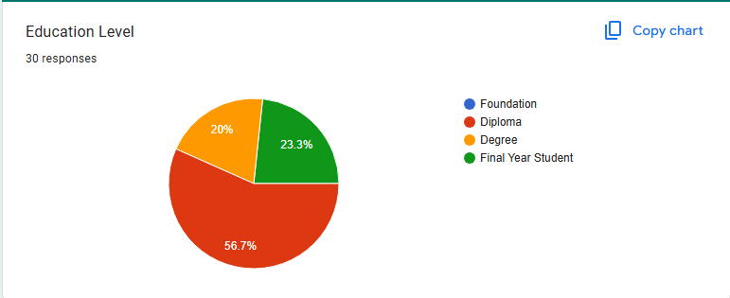

*Analysis:*

The analysis of 30 responses reveals that the majority (56.7%) of users are at the diploma level, highlighting a strong demand for resources like transfer guidance and career planning. Final-year students (23.3%) and degree-level users (20%) also represent significant groups, indicating the need for job placement support, postgraduate guidance, and advanced learning tools. The absence of responses from the foundation level suggests a gap in outreach or alignment with their needs, which may require targeted strategies. Overall, the EduConsult System should prioritize diploma-level services while ensuring robust features for final-year and degree users to address their academic and career transitions effectively.

Question 2: Do you stay on UNITEN campus?

Justification: The question **"Do you stay on UNITEN campus?"** is essential to identify users' living arrangements, which can influence their needs for the EduConsult System. On-campus students may prioritize services like academic consultation scheduling and campus-specific resources, while off-campus users might require flexible, remote access to support and guidance. This distinction ensures that the system provides tailored features to meet the varying requirements of both groups effectively.

Result: 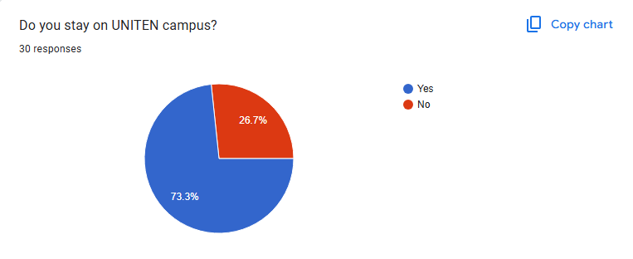

Analysis: The responses show that a majority (73.3%) of users stay on the UNITEN campus, indicating that most users likely have easy access to on-campus resources and events. This group may prioritize services such as in-person consultations, campus-specific information, and academic support. On the other hand, the 26.7% who live off-campus may need more flexible, remote-access options to ensure they can benefit from the EduConsult System despite their physical distance from campus. These insights suggest that the system should balance both on-campus and remote features to cater to the diverse needs of its user base.

Question 3: Are you a full-time or part-time student?

Justification: Understanding whether users are full-time or part-time students is important for tailoring the EduConsult System to meet their specific needs. Full-time students are likely to have more time for in-depth consultations and academic support, while part-time students may require more flexible and efficient resources that accommodate their limited schedules. By identifying the proportion of full-time versus part-time students, the system can be optimized to provide targeted support that aligns with their availability and study commitments.

Result: 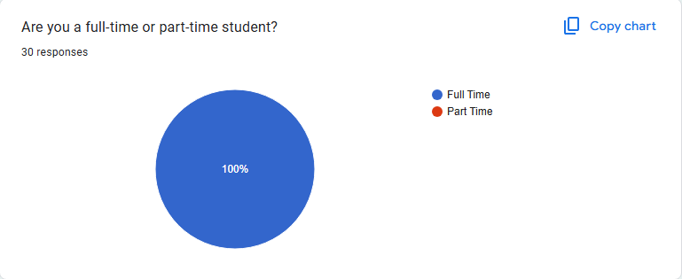

Analysis: The responses show that 100% of users are full-time students, with no part-time students in the sample. This suggests that the EduConsult System should focus on providing resources and services that cater to full-time students' needs, such as extensive academic support, career guidance, and extracurricular opportunities. Given the absence of part-time students, the system may not need to prioritize flexible or time-efficient features, but should instead focus on offering comprehensive, in-depth services that align with the schedules and commitments of full-time students.

Question 4: How often do you have a meeting with your advisor?

Justification: The question **"How often do you have a meeting with your advisor?"** is crucial for understanding the frequency of student-advisor interactions, which can impact the level of support students expect from the EduConsult System. Students who meet with their advisors regularly may require more advanced or ongoing academic guidance, while those who meet less frequently may benefit from more self-service resources and tools. By identifying the meeting frequency, the system can be tailored to offer the appropriate level of support, ensuring it complements and enhances existing advisor-student interactions.

Result: 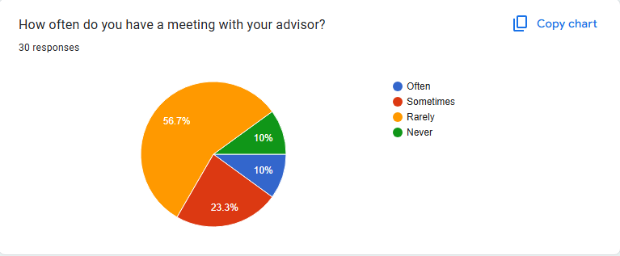

Analysis: The responses show that the majority of students (56.7%) meet with their advisor rarely, followed by 23.3% who meet sometimes, and 10% who meet often or never. This indicates that most students may not have frequent, consistent advisor interactions and could benefit from additional support through the EduConsult System, such as self-guided resources or tools for academic planning. For the smaller group that meets more often, the system can offer advanced features to complement regular advisor meetings. Tailoring the system to provide both independent and advisor-supported options will address the diverse needs of students based on their meeting frequency.

Question 5: How often do you experience difficulties in scheduling appointments with your advisor?

Justification: The question **"How often do you experience difficulties in scheduling appointments with your advisor?"** is important for understanding potential barriers students face in accessing academic support. If students frequently experience difficulties, it suggests a need for a more streamlined scheduling system within the EduConsult platform. By identifying how often students face this issue, the system can be designed to provide efficient scheduling tools or alternative ways to facilitate timely advisor access, ensuring that students can receive the support they need without unnecessary delays.

Result: 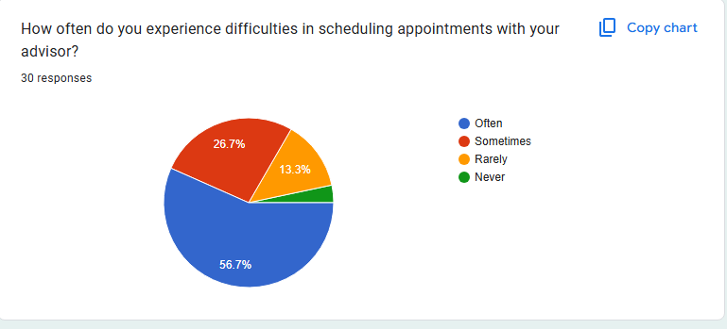

Analysis: The responses indicate that a significant portion of students (56.7%) often experience difficulties in scheduling appointments with their advisor, while 26.7% face this issue sometimes. Only a small percentage (13.3%) rarely encounter problems, and just 3.3% never face any scheduling challenges. This suggests that a majority of students struggle with accessing their advisors in a timely manner, highlighting the need for the

Question 6: I find it convenient with the current advisor/advisee management system in UNITEN?

Justification: The question **"I find it convenient with the current advisor/advisee management system in UNITEN?"** helps assess the effectiveness and user satisfaction with the existing system. If students find the current system inconvenient, it highlights areas for improvement, such as issues with accessibility, ease of use, or communication. Understanding their perspective will provide valuable insights into whether the EduConsult System should offer a more streamlined or user-friendly alternative, addressing pain points and enhancing the overall advisor-advisee experience for students.

Result: 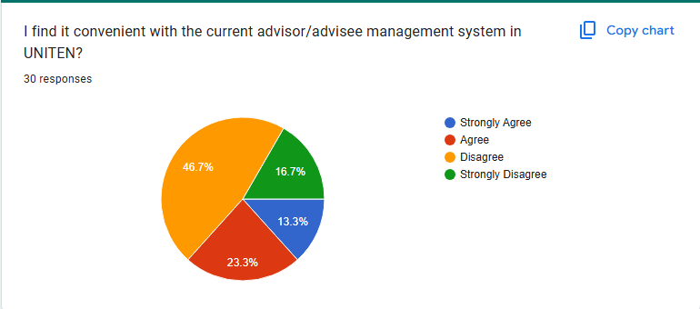

Analysis: The responses show that a significant portion of students (46.7%) disagree with the convenience of the current advisor/advisee management system, while 16.7% strongly disagree. Only 23.3% agree and 13.3% strongly agree, indicating a general dissatisfaction with the existing system. This suggests that many students find the current system inefficient or challenging to use, pointing to a clear opportunity for the EduConsult System to offer improvements, such as a more intuitive interface, better accessibility, and enhanced communication features to better meet students' needs.

Question 7: I find it hard to keep track of the status of my advising appointments for the current advisor-advisee process

Justification: The question **"I find it hard to keep track of the status of my advising appointments for the current advisor-advisee process"** helps identify challenges students face in managing their appointments. If students find it difficult to track their appointments, it suggests that the current system may lack transparency, reminders, or real-time updates, leading to confusion or missed appointments. This feedback is valuable for the EduConsult System, indicating the need for features like appointment tracking, automated reminders, or status updates to ensure students can easily manage and stay informed about their advising sessions.

Result: 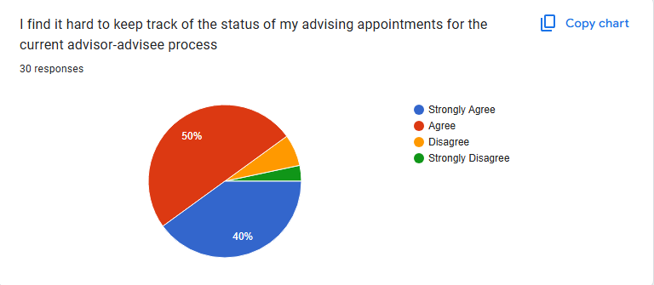

Analysis: The responses show that a large majority of students (90%) agree (50%) or strongly agree (40%) that it is hard to keep track of the status of their advising appointments. This indicates that the current system lacks effective tools for appointment management, leading to significant challenges in tracking and staying updated. With only a small portion (10%) disagreeing or strongly disagreeing, it is clear that there is a strong need for the EduConsult System to incorporate features like real-time status tracking, automated reminders, and a centralized view of appointment details to improve the user experience and streamline the advising process.

Question 8: I hardly receive reminder for my advising session.

Justification: The question **"I hardly receive reminder for my advising session"** is important for understanding whether students are receiving adequate notifications about their appointments. If students report receiving few or no reminders, it suggests that the current system lacks effective communication tools, such as automated reminders or notifications. This feedback indicates a need for the EduConsult System to include reminder features that ensure students are alerted in advance about their advising sessions, helping them stay organized and reducing the likelihood of missed appointments.

Result: 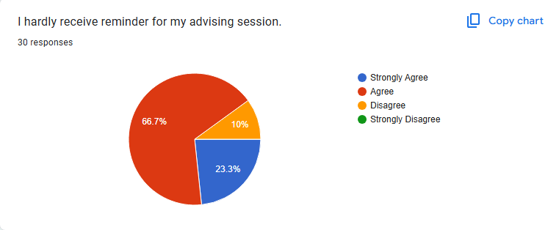

Analysis: The responses show that a majority of students (66.7%) agree and 23.3% strongly agree that they hardly receive reminders for their advising sessions. This highlights a significant gap in the current system's ability to notify students about their appointments. With only 10% disagreeing and no respondents strongly disagreeing, it is clear that reminders are a critical need. This feedback suggests that the EduConsult System should prioritize incorporating automated reminder features to help students stay informed and ensure they do not miss important advising sessions.

Question 9: I hardly make appointments for my advising session with my advisor.

Justification: The question **"I hardly make appointments for my advising session with my advisor"** helps identify potential barriers preventing students from scheduling advising sessions. If students find it difficult to make appointments, it could be due to a lack of available time slots, an inefficient scheduling system, or a lack of motivation or awareness about the importance of regular advising. This feedback is valuable for the EduConsult System, suggesting that features such as an easy-to-use scheduling tool, more flexible time options, or automated reminders might encourage students to book their sessions more regularly and improve their overall academic support experience.

Result: 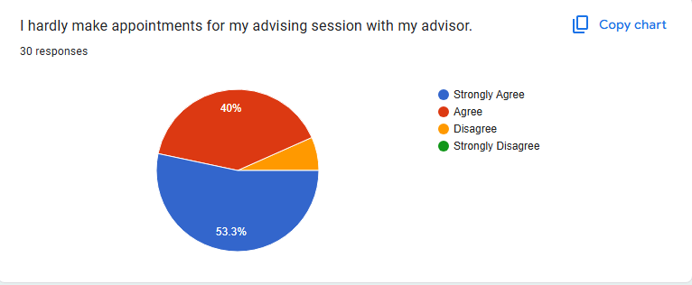

Analysis: The responses show that a significant majority of students (53.3%) strongly agree and 40% agree that they hardly make appointments for their advising sessions, indicating a clear challenge in scheduling or a lack of engagement with the advising process. With only 6.7% disagreeing and no students strongly disagreeing, it suggests that many students find it difficult or inconvenient to book appointments. This feedback highlights the need for the EduConsult System to implement an easier, more accessible appointment scheduling process, perhaps with flexible options and reminders, to encourage more regular advising sessions and enhance student engagement.

Question 10: I hardly follow up my appointments for my advising session with my advisor.

Justification: The question **"I hardly follow up my appointments for my advising session with my advisor"** is important for understanding whether students are actively engaging with the advising process after their appointments. If students rarely follow up, it could indicate a lack of clarity or perceived value in the advising sessions, or it may suggest that students forget or lack the motivation to take further action. This feedback is valuable for the EduConsult System, as it suggests the need for features such as post-session reminders, follow-up tools, or action items that could encourage students to follow through on advice, ensuring the advising process is more effective and impactful.

Result: 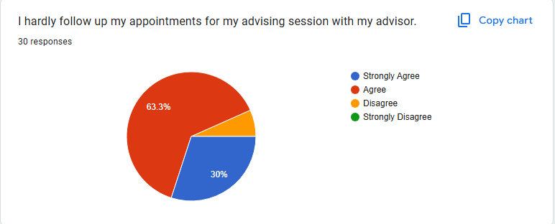

Analysis: The responses show that a large majority of students (63.3%) agree and 30% strongly agree that they hardly follow up on their advising appointments, suggesting that many students do not actively engage with their advisors after sessions. With only 6.7% disagreeing and no respondents strongly disagreeing, it indicates a significant gap in post-session follow-up. This highlights the need for the EduConsult System to include features such as automated follow-up reminders, action items, or a tracking system for students to monitor their progress, encouraging them to take necessary steps after their advising sessions and enhancing the overall effectiveness of the advising process.

Question 11: I expect an online advisory system where I may easily make an appointment with my advisor

Justification: The question **"I expect an online advisory system where I may easily make an appointment with my advisor"** is important as it reflects students’ desire for convenience and accessibility in managing their academic support. If students expect an easy-to-use online system for scheduling appointments, it indicates a demand for a streamlined, digital solution that eliminates the challenges of traditional appointment booking methods. This feedback highlights the need for the EduConsult System to incorporate a user-friendly, efficient online scheduling feature that allows students to quickly and easily book appointments, improving their overall experience and ensuring they receive the guidance they need in a timely manner.

Result: 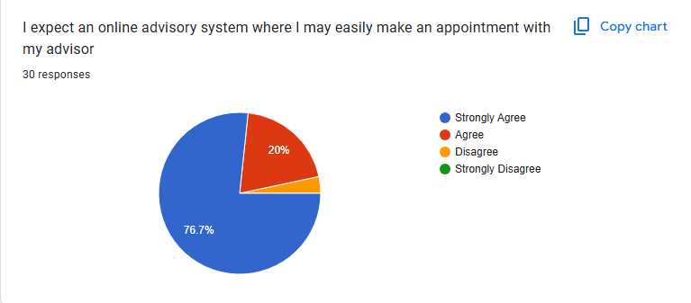

Analysis: The responses show that a significant majority of students (76.7%) strongly agree and 20% agree that they expect an easy-to-use online advisory system for scheduling appointments. This indicates a strong preference for digital solutions that offer convenience and accessibility. With only 3.3% disagreeing and no respondents strongly disagreeing, it is clear that the majority of students want a simplified, online appointment booking process. This feedback emphasizes the need for the EduConsult System to prioritize the development of a user-friendly, online scheduling feature to meet students' expectations and improve their overall academic advising experience.

Question 12: I expect to complete my advisory scheduling in a smooth and fast manner without any interruptions or confusion throughout the entire session.

Justification: The question **"I expect to complete my advisory scheduling in a smooth and fast manner without any interruptions or confusion throughout the entire session"** highlights students’ expectations for an efficient, hassle-free scheduling experience. If students expect a smooth and uninterrupted process, it suggests that they value convenience and time-saving features when booking appointments with their advisors. This feedback points to the need for the EduConsult System to provide a seamless, intuitive scheduling interface that minimizes technical issues, reduces complexity, and ensures a fast, straightforward appointment process, enhancing user satisfaction and encouraging greater engagement with the advising system.

Result: 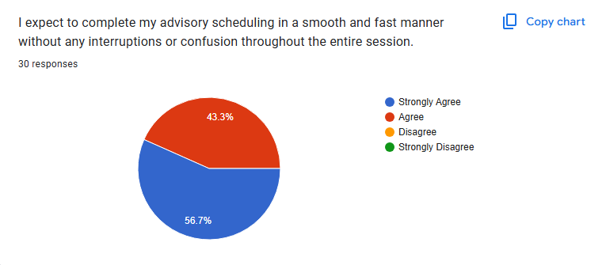

Analysis: The responses show that a significant majority of students (56.7%) strongly agree and 43.3% agree that they expect to complete their advisory scheduling smoothly and quickly without any interruptions or confusion. This indicates a strong preference for a seamless and efficient scheduling process. With no respondents disagreeing or strongly disagreeing, it is clear that students prioritize convenience and reliability in the system. This feedback underscores the importance of developing an intuitive, error-free scheduling interface in the EduConsult System to meet these expectations and enhance the overall user experience.

Question 13: I expect to receive any notifications and updates related to the advising session in a timely manner via the system.

Justification: The question **"I expect to receive any notifications and updates related to the advising session in a timely manner via the system"** is crucial for understanding students' need for real-time communication regarding their advising appointments. If students expect timely notifications, it highlights their desire for reminders, updates, and alerts about their sessions, ensuring they stay informed and prepared. This feedback emphasizes the need for the EduConsult System to include automated, timely notifications such as appointment reminders, rescheduling alerts, or updates on advisor availability, helping students manage their academic support more effectively and reducing the likelihood of missed or forgotten sessions.

Result: 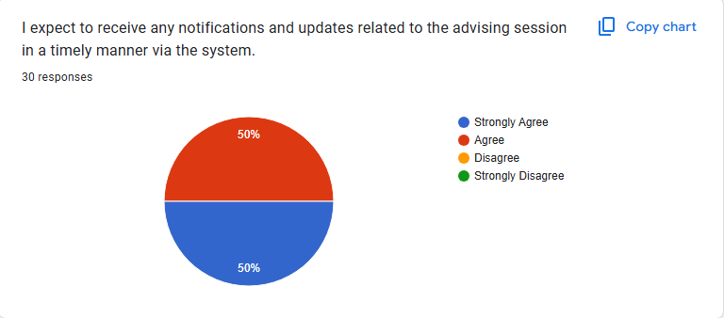

Analysis: The responses show that half of the students (50%) strongly agree and 50% agree that they expect to receive timely notifications and updates about their advising sessions. This indicates a strong consensus among students for the need to stay informed about their appointments and any related changes. With no students disagreeing or strongly disagreeing, it is clear that real-time communication is a key expectation. This feedback highlights the importance of incorporating automated, timely notifications in the EduConsult System to ensure students are always updated and can manage their advising sessions efficiently.

Question 14: I expect an attractive and modern interface for advisory system

Justification: The question **"I expect an attractive and modern interface for the advisory system"** is important for understanding students' expectations regarding the user experience. If students desire an attractive and modern interface, it suggests that they value ease of use, visual appeal, and intuitive design when interacting with the system. A well-designed interface can enhance user satisfaction, encourage engagement, and make the overall advising process more enjoyable and efficient. This feedback highlights the need for the EduConsult System to prioritize a clean, modern design that is visually appealing and user-friendly, ensuring students can easily navigate the system and access its features.

Result: 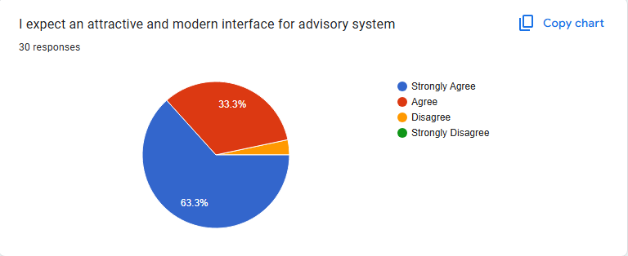

Analysis: The responses show that a majority of students (63.3%) strongly agree and 33.3% agree that they expect an attractive and modern interface for the advisory system. This indicates a strong preference for a visually appealing and user-friendly design. With only 3.3% disagreeing and no students strongly disagreeing, it is clear that students value a modern and intuitive interface. This feedback emphasizes the importance of prioritizing design in the EduConsult System, ensuring that it is both visually appealing and easy to navigate, thereby enhancing user engagement and satisfaction.

Question 15: I expect to retrieve the history log of my advisory schedules via the system.

Justfication: The question **"I expect to retrieve the history log of my advisory schedules via the system"** is important because it reflects students' desire for easy access to past appointment details and a record of their academic advising history. If students expect this feature, it suggests they want a transparent and organized way to review past interactions, track their progress, and plan future meetings. This feedback highlights the need for the EduConsult System to include a history log feature, allowing students to easily retrieve past appointments, view any advice or recommendations given, and stay organized in their academic journey.

Result: 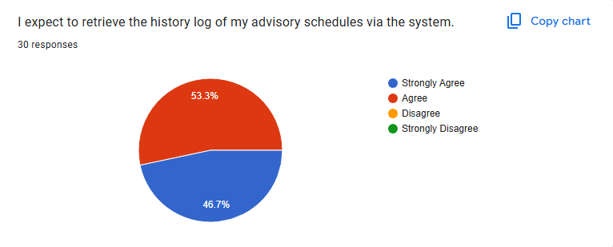

Analysis: The responses show that a significant majority of students (53.3%) agree and 46.7% strongly agree that they expect to retrieve the history log of their advisory schedules via the system. This indicates that almost all students value the ability to access a record of their past appointments, which would help them track their academic progress and review prior advice. With no students disagreeing or strongly disagreeing, it is clear that the history log feature is highly desired. This feedback highlights the importance of incorporating this functionality into the EduConsult System to meet students' needs for easy access to their advisory history and enhance their overall experience.

## SYSTEM DESIGN

## Flowchart OR Navigational Structure

**Flowchart for Student**  
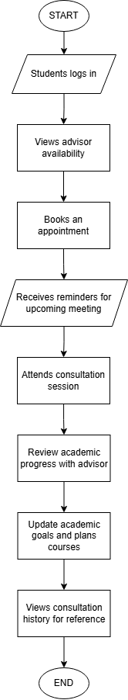

**Flowchart for Advisor**

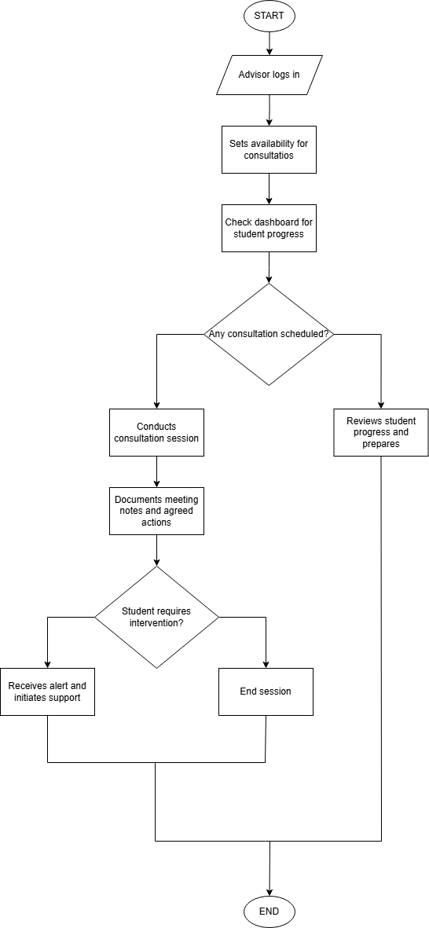

## Entity Relationship Diagram OR Storyboard OR Schematic Diagram

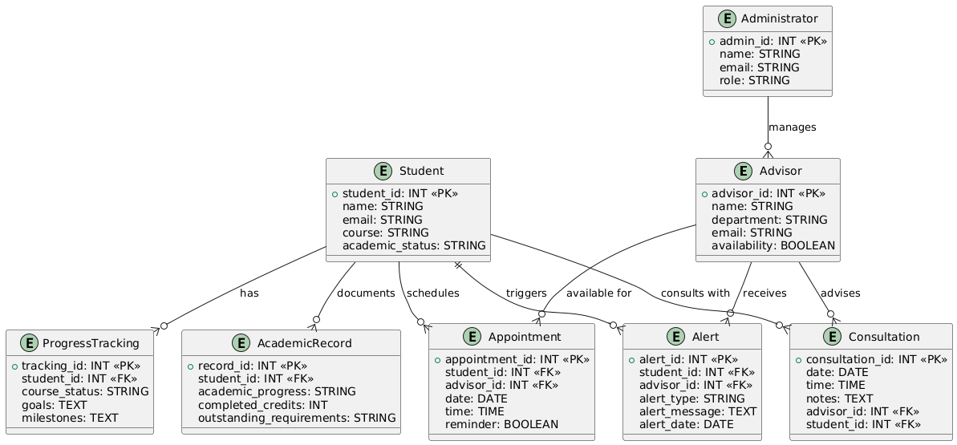

## Interface Design OR Pictorial Circuit Diagram

Depends on your project type, students should provide the Interface OR Pictorial Circuit Diagram design if necessary.

**2.3.1** Main Page

**2.3.2** Login Page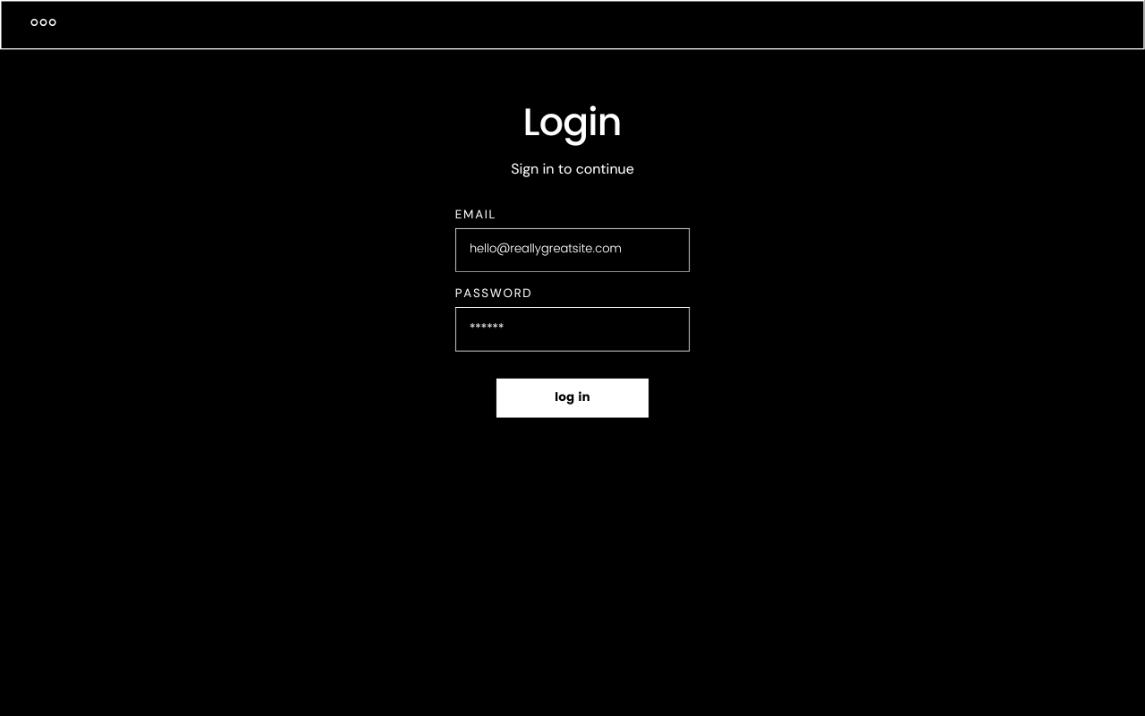

**2.3.3** Register Page