Title: AI-Based Traffic Collision Prediction and Prevention System
Traffic accidents are one of the leading causes of death and injury worldwide. The ability to predict and prevent these accidents not only saves lives but also reduces traffic congestion and improves the overall efficiency of urban mobility. By integrating Artificial Intelligence (AI) into traffic systems, we can analyze real-time data, detect dangerous conditions, and alert drivers about potential collisions. This has significant societal and economic benefits, such as lowering healthcare costs, reducing insurance premiums, and preventing loss of productivity due to accidents.
Key Concepts:
This project aims to develop a system that uses AI to predict and prevent traffic collisions. Several AI algorithms will be applied to analyze real-time data from vehicles, weather conditions, and traffic patterns:
K-Nearest Neighbors (KNN): A machine learning algorithm used to classify traffic situations based on historical accident data. It can identify whether a situation is high-risk or not.
K-Means Clustering: This unsupervised learning algorithm will help identify traffic zones that are prone to accidents by grouping similar patterns.
Existing Solutions:
Today, many vehicles are equipped with Advanced Driver Assistance Systems (ADAS) that help with functions like lane-keeping or automatic braking. However, these systems are limited in their ability to predict future accidents or provide real-time traffic alerts. Our proposed system is more advanced because it combines a variety of AI techniques such as machine learning, clustering, and deep learning to not only predict potential accidents but also provide actionable warnings and route recommendations to drivers.
2. Methodology
Tools and Technologies:
Programming Languages: Python, for its rich ecosystem of libraries and frameworks.
- Libraries:
  - scikit-learn for machine learning algorithms like KNN and K-Means.
  - OpenCV for computer vision and object detection.
  - Pandas & NumPy for data manipulation.
  - Matplotlib & Seaborn for visualizing results..
- Sensors: Real-time traffic sensors, weather APIs, and cameras for object detection.
Implementation Steps:
- Data Collection: Gather real-time traffic data (speed, volume), weather data (e.g., temperature, rain), and historical accident data.
- Data Preprocessing: Clean and normalize the data to ensure it is consistent and usable for AI models. For example, missing values in accident data might be filled with averages or the data might be scaled for consistency.
- Apply AI Models:
  - Use KNN to classify traffic situations as safe or dangerous.
  - Apply K-Means clustering to identify high-risk zones.
- Real-Time Prediction and Alerts: Develop a system to provide predictions and alerts to drivers in real-time. If a collision is likely, drivers will receive warnings, along with suggestions for alternate routes.
- Evaluation: Evaluate the system’s performance using metrics like accuracy and F1-score. We’ll test how well our models predict accident-prone situations compared to actual outcomes.
System Design:
- Simple Reflex Agent: This part of the system provides immediate alerts to drivers when dangerous conditions are detected, such as an upcoming intersection with a high potential for collisions.
- Goal-Based Agent: The system calculates the safest route for drivers based on current traffic conditions, road quality, and weather.
- Learning Agent: This part of the system continuously learns from past traffic accidents to improve its predictions over time.
Data Collection
Data Sources:
- Real-Time Traffic Data: Collected from sensors embedded in roads and GPS devices in vehicles.
- Weather Data: Obtained through APIs like OpenWeather, which provide real-time weather conditions such as temperature, visibility, and precipitation.
- Accident History: Historical data about traffic accidents, including information about location, time, weather conditions, and other relevant factors.
Data Requirements:
- Format: The data will be available in formats like CSV or JSON, and some real-time data may come from APIs.
- Size: We will need large datasets—millions of records for historical accidents, along with current real-time traffic data and weather information.
- Features: Important features include traffic density, vehicle speed, weather conditions, and time of day.
Data Preparation:
- Cleaning: The data will be cleaned to handle missing values and inconsistencies. For example, invalid or missing traffic data might be interpolated or removed.
- Normalization: Data will be normalized to ensure that all features, such as vehicle speed or temperature, are on a similar scale.
- Feature Engineering: New features might be created to help improve predictions, like combining weather and time-of-day data to identify more risky periods.
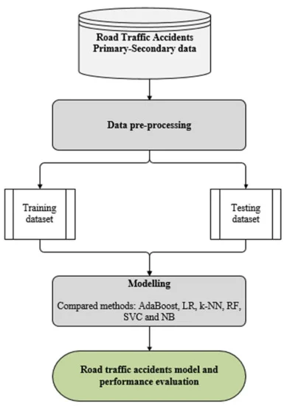

Analysis
Evaluation Metrics
- Accuracy, Precision, Recall, F1-Score: Used to measure the performance of the classification models, such as KNN and ANN.
- Silhouette Score: For evaluating the quality of clustering results from K-Means.
Comparison:
- KNN vs K-Means: KNN will be used for classifying individual traffic situations, while K-Means will help identify zones where accidents are more likely.
- ANN: Deep neural networks are more powerful and flexible, making them ideal for handling large, complex datasets like traffic patterns and weather conditions
6. Results
- Visuals: We will include graphs that show clustering results and a confusion matrix to evaluate model performance.
- Program link
https://colab.research.google.com/drive/1CHrbzrLQ-omzFvloNDjROaE-79Ks9-L_?usp=sharing
DATASET:
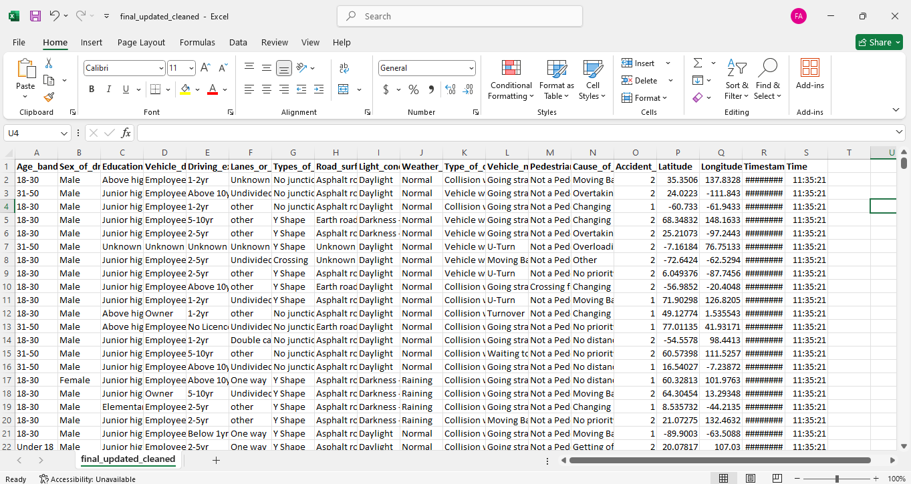

RESULT:
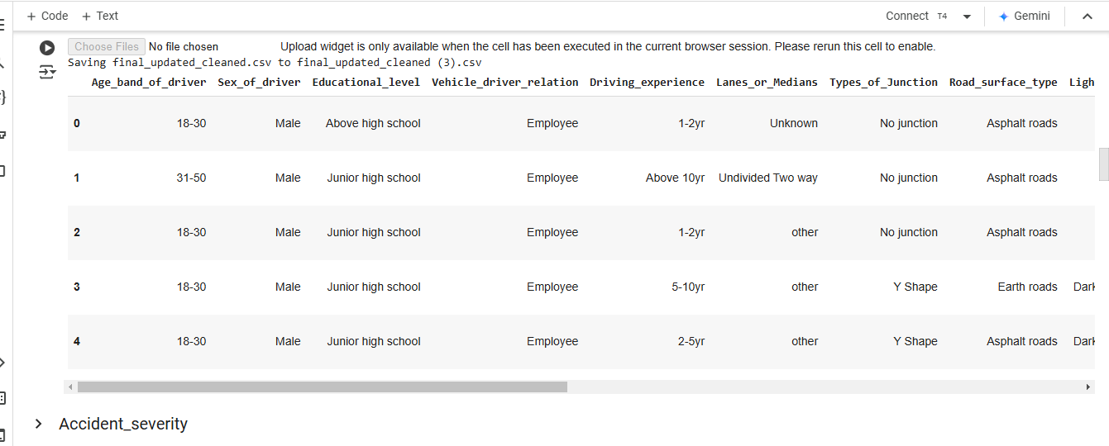
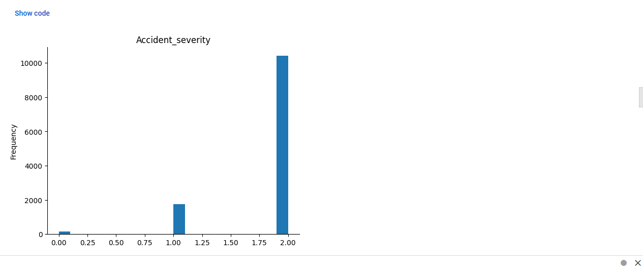
- Quantitative Data:
  - KNN accuracy: 85%
- Key Takeaways: The AI models performed well in predicting dangerous traffic situations. The system was able to accurately identify high-risk zones and provide actionable warnings to drivers.

Discussion on Results
Performance:
The system performed well in predicting traffic accidents and providing alerts. The combination of machine learning, deep learning, and fuzzy logic allowed it to handle a variety of real-world data, making it a reliable tool for traffic safety.
Implications:
This technology can be deployed in real-world traffic management systems, providing early warnings and reducing the number of accidents. It could be integrated into smart city infrastructure to create safer roadways.
Limitations:
- The effectiveness of the system depends on the quality and accuracy of the data it receives. Missing or incorrect sensor data could reduce performance.
- The system’s real-time capabilities might be limited by the availability and processing speed of the data.

Conclusion
Key Achievements:
The lab successfully developed an AI-based traffic collision prediction system. It integrates various machine learning and deep learning algorithms to predict accidents, providing real-time alerts and alternative routes.Future Work:In the future, the system could be expanded to include more complex traffic scenarios or integrate with additional data sources like autonomous vehicles.Impact:This system could have a significant impact on road safety, helping to prevent accidents and making driving safer for everyone.

9. References
- Datasets: Kaggle Traffic Accident Dataset.
- Research Papers:
  - "Artificial Intelligence in Traffic Systems" - IEEE
- Libraries: TensorFlow, OpenCV, scikit-learn,

https://colab.research.google.com/drive/1CHrbzrLQ-omzFvloNDjROaE-79Ks9-L_?usp=sharing

