A project report on

**DIGITAL VOTING SYSTEM**

Submitted in fulfilment of the requirement for the

**“BACHLEOR OF”**

**IN**

**“COMPUTER SYSTEM ENGINEERING”**

**By**

**Farhan Ali 24CS061**

**Tofeeque Shaikh 24CS059**

**Muhammad Ammar 24CS021**

**Mir Hamza 24CS055**

*Submitted to*

**DR. FAWAD ALI MANGI**

**(LECTURER CSE)**



**DEPARTMENT OF COMPUTER SYSTEM ENGINEERING**

**MEHRAN UNIVERSITY OF ENGINEERING AND TECHNOLOGY JAMSHORO**

**22, November,2024**

**INTRODUCTION**

**Digital Voting System**

A digital voting system is an electronic method of conducting elections where votes are cast, recorded, and counted using digital technology. It replaces traditional paper ballots with systems like computers, machines, online voting platforms, or mobile apps, aiming to improve accuracy, efficiency, and accessibility in the election process.

The digital voting system has become more important in today’s world because it makes the voting process easier, faster, and more reliable. It helps avoid mistakes, keeps the process more transparent as compared to traditional ballot voting system, and gives the real time results too.

It also makes voting more accessible, so more people can use it, even with low literacy level because it is way easier to cast a vote digitally rather than traditional voting system, also ensuring that everyone’s vote is casted accurately.

Our Project Digital Voting System aims to improve the functionality of this digitalized system. Our Project will save the user’s time as well as make sure that the Voting is as accurate as possible.

**PROBLEM STATEMENT**

Traditional voting systems face challenges such as inefficiency, high costs, voter fraud, and limited accessibility for remote usage. Traditional voting system used paper ballots as votes which can be costly as well as harmful for our environment. It also lacks to offer pure and transparent voting as it is done manually by humans so, chances of interruption of intruders are high. It is also limited to just one place and maintaining the overall voting system sometimes gets hectic. A secure, transparent, cost-friendly and user-friendly digital voting system is needed to ensure accurate vote counting, prevent manipulation, and improve accessibility while maintaining voter privacy and trust in the electoral process.

**TECHNOLOGIES/RESOUCES WE HAD USED FOR OUR PROJECT**

**RESEARCH OBJECTIVES**

Our Project offers a secure and easy to use voting platform which is easier to maintain, less costly, and user-friendly. With this project we aim to solve all those problems discussed in the Problem Statement. Our Project Digital Voting System aims to improve the functionality of this digitalized system.

Our Project will save the user’s time as well as make sure that the Voting is as accurate as possible.

**Our Voting System offers various features like:**

1. **Timer:**

30 seconds timer will be given to the user to save the time.

1. **Real Time Results:**

As the voter casts it’s vote. A real time result will be shown of the voted candidate along with other candidates to avoid any inconvenience in vote counting.

1. **Separate Admin and User Panel:**

Two Separate Panels will be given in our program. 1 for admin and 1 for User. Admin Panel will only be accessed and edited by the admin. The user panel will be based on the info given by the admin in admin panel and will be accessed by the user at the time of voting.

1. **Graphical User Interface:**

Graphical user interface will be offered in the program to make it more interactive, user friendly, and easy to use.

1. **Facial Verification:** We have use Facial Verification for our project to make it more transparent for voters. In **Digital Voting System** Facial Verification ensures that only the authorized voters can cast their vote. It uses Facial Recognition Technology to match the voter’s live image with their pre-registered photo in database. This Process enhances security by preventing voter impersonating and ensuring authenticity.

**WORKING PROCESS**

**Main Menu**

In this we have three things:

1.Admin Panel

2.User Panel

3.About Us

**Admin Panel**

Before changing anything, Admin has to verify his/her identification by Logging-in. This panel has the authority to add candidates, new voters, and can also delete or remove any voter or candidate.



Now admin have to choose whether he/she have to add candidate or add voters. The Admin have to select Candidate option “**Setting up Candidates to be voted**” and for voters “**Setting up Voters that can Vote**”

**Setting up Candidates to be voted:** Admin have to enter the Name and ID of participating candidates. Multiple candidates can be entered. Only the admin has the right to set the candidates. No other individual is allowed to set up admin procedures.

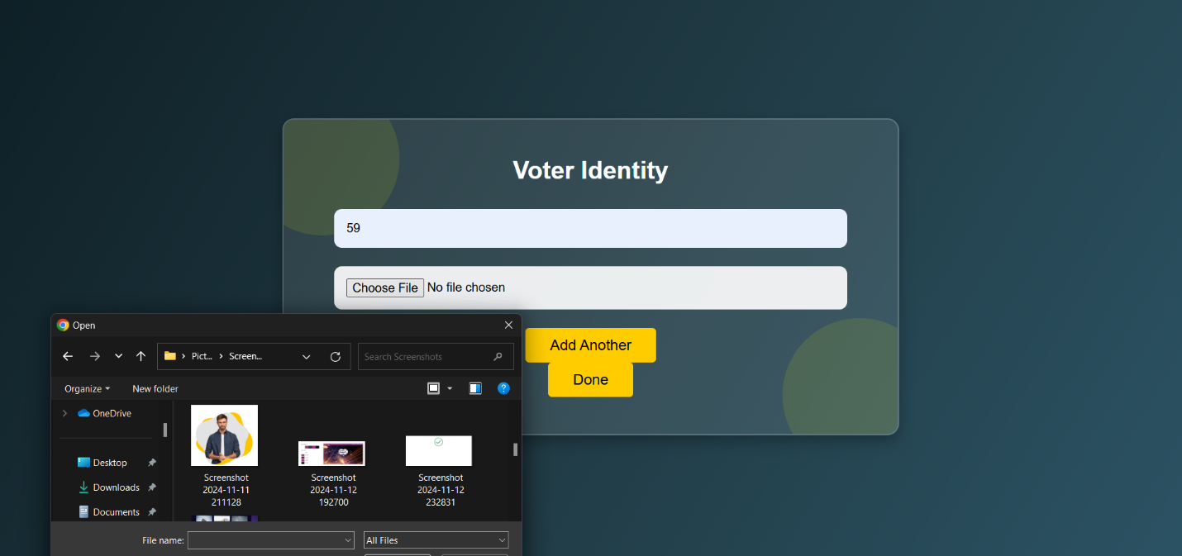**Setting up Voters that can Vote:** Admin have to enter the Roll: no, and Picture of voter that want to vote, the picture will be used foe face verification.

**USER PANEL:**

The user panel provides a simple and clear interface for voters to select candidates and cast their votes. It ensures that the voting process is user-friendly while maintaining the integrity of the voting system through validation and feedback.

The user panel allows voters to view candidates and cast their votes. It displays each candidate’s wish to vote, and the system checks if the ID is valid.

If valid, the corresponding candidate’s vote will be increased, and the system confirms the vote while displaying current results. If the wrong ID is entered, or trying to enter the roll: no again, there will an “error” message prompt them to try again but within the limit of 30 seconds.

**Polling procedure:**

* Participants have to enter their roll: no. An error will be displayed if the wrong roll: no, or a roll: no is entered again.

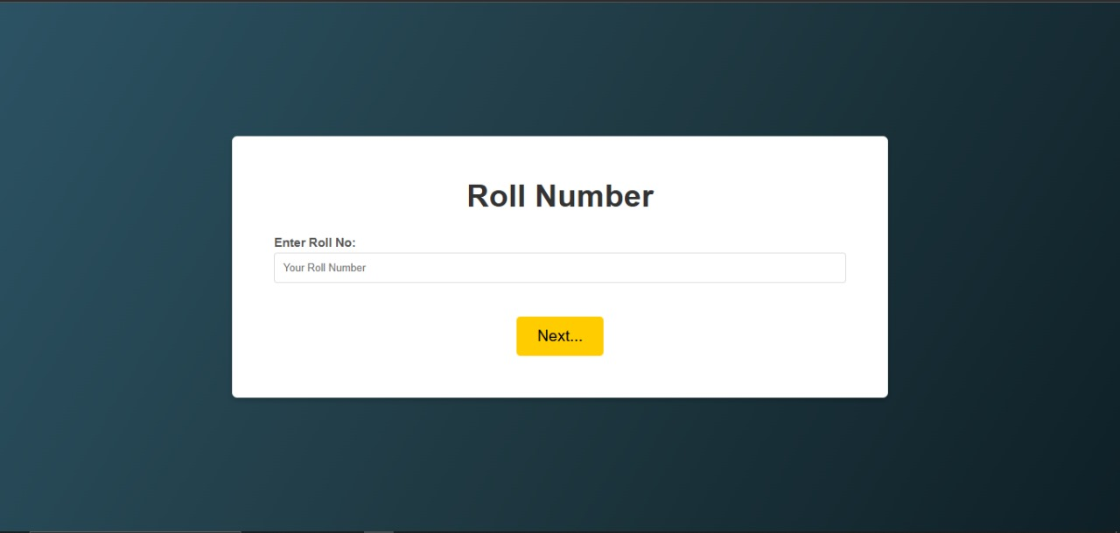

* For Face Verification procedure a window will pop. Then click on the verify button to verify your face for voting. In case of wrong face detection, an error will be prompted.

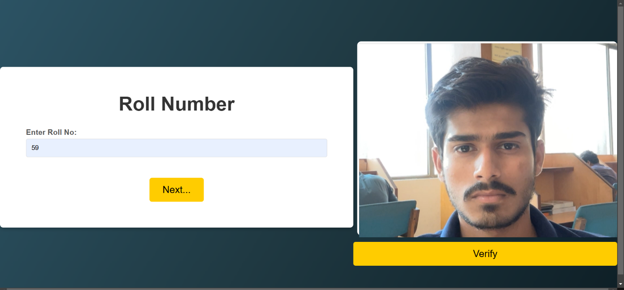

* If verification failed there will be showed as Facial Verification Failed

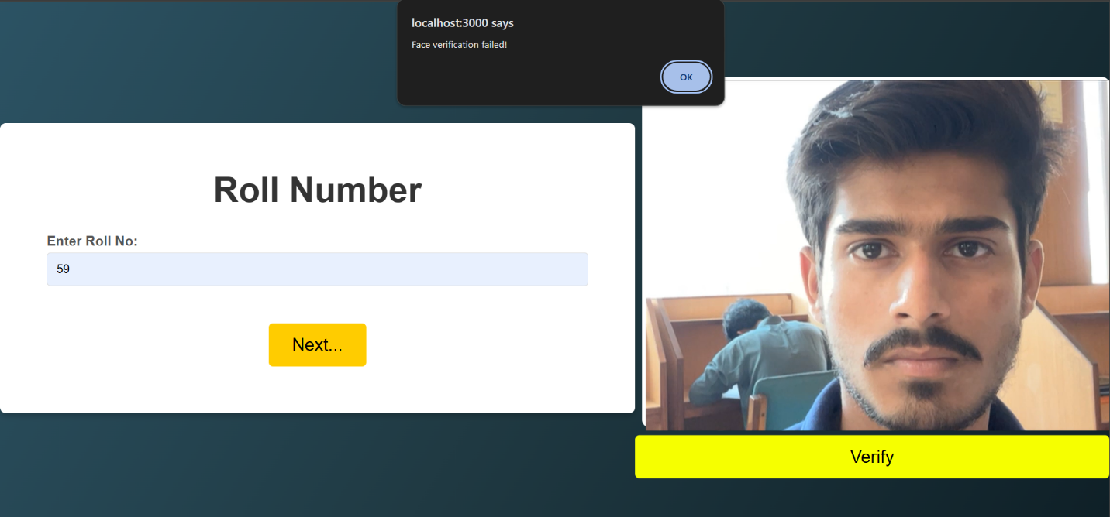

* If verification is Successful there will be a message shown Verification Successful

* A list of registered candidates will be shown.
* Voters have to choose their desired candidate within the 30 second time frame.

* If a voter does not cast, it vote within a Time limit it will be shown as “Time Over You Can Not Vote Now”.

* A list of all candidates and their current vote count will be displayed after a voter casted it’s vote successfully.
* **Real Time Results:**

The results display shows the current vote counts for all candidates after the vote has been cast. Once a voter successfully votes, the system will update and display the total votes cast to a candidate, allowing voters to see how many votes each candidate has secured.

In the last “A Thank You” message will be displayed.

**About Us**

**Advantages Of Digital Voting System:**

* **Efficiency:** Digital Voting Machines enhance voting process and reduce the time taken for counting and recording votes.
* **Accuracy:** Digital voting system minimizes errors caused by manual counting/human errors, ensure more accurate election results.
* **Speed:** Digital Voting System enables quick results, allowing for fast sharing of election outcomes.
* **Reduce the use of Paper:** It eliminates the need for paper ballots, reducing waste
* **Real-time Results:** The Digital Voting System provides real time (on time or live) results, making the process more transparent.
* **User-friendly:** DVS is designed to be easily operated by users.

**Conclusion:**

The Digital Voting System project addresses the limitations of traditional voting methods by providing a secure, efficient, and user-friendly platform. Key features such as facial verification, real-time results, and separate admin and user panels ensure transparency, accuracy, and accessibility. The system reduces human error, minimizes fraud, and eliminates paper ballots, making it environmentally friendly and cost-effective.

Looking ahead, In future, we are aiming to maximize our project scope at national level. We aim to implement this project in organizations, Educational Institutions and much more. Lastly Thank You so much for your support. We really hope that you found our work commendable. If you any suggestion/Feedbacks do let us know.