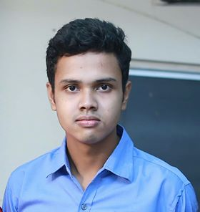

**CURRICULUM VITAE**

**Name of the Post: Cabin Crew (MALE/FEMALE)**

|  |  |  |  |  |  |
| --- | --- | --- | --- | --- | --- |
| 1. | Name (in English): | Arafat Mahamud Bhuiyan | | | |
| 2. | Mother’s Name: | Momena Akter | | | |
| 3. | Father’s Name: | Abul kalam Azad Bhuiyan | | | |
| 4. | Spouse Name (if applicable): | NO | | | |
| 5. | National ID No. (if any): | NO | | | |
| 6. | Passport No. (if any): | NO | | | |
| 7. | Marital Status: | Unmarried | | | |
| 8. | Present Address: | Vill:Jahanpur,p.o:Fatehpur,u.p:Feni Sadar,Dis:Feni. | | | |
| 9. | Permanent Address: | Do | | | |
| 10. | Date of Birth: | Age: 21 | Years: | Months: | Days: |
| 1997 | jan | 20 |

11. Educational Qualifications:

|  |  |  |  |
| --- | --- | --- | --- |
| **Name of Certificate** | **Name of Board / Institute** | **Year of Passing** | **Class/ Division/ Grade** |
| SSC/O Level | Feni Govt. Pilot High School | 2012 | A+ |
| HSC/A Level | Feni Govt college | 2014 | A- |
|  |  |  |  |

12. Working Experience as Cabin Crew: NO

|  |  |  |  |  |  |  |  |  |  |  |
| --- | --- | --- | --- | --- | --- | --- | --- | --- | --- | --- |
| 13. | Height:182.88 cm | | | Weight: 72 Kg | | 14. BMI: 21.53 kg/m2 | | | | |
| 15. | Eye Sight: | 6/6 | 6/5 | | 16. Contact No: | 01831917246 | | | | |
| 17. | Email: | arafatmahamud16@gmail.com | | | | | 18. Date: | 27 | 02 | 2018 |

Please attach 1 copy recent Passport size, 1 copy Half Length 4R size and1 copy Full Length 4R size color picture to the following email address- Or send hard copy of the Form to the following address-