Project
  - Deadline: Sunday 29/11/2026 @ 23:59
[Total marks for this project are 14]

Operating Systems
DS351

Instructions:
- You must submit two separate copies (one Word file and one PDF file) using the Assignment Template on Blackboard via the allocated folder. These files must not be in compressed format.
- It is your responsibility to check and make sure that you have uploaded both the correct files.
- Zero mark will be given if you try to bypass the SafeAssign (e.g. misspell words, remove spaces between words, hide characters, use different character sets or languages other than English or any kind of manipulation).
- Email submission will not be accepted.
- You are advised to make your work clear and well-presented. This includes filling your information on the cover page.
- You must use this template, failing which will result in zero mark.
- You MUST show all your work, and text must not be converted into an image, unless specified otherwise by the question.
- Late submission will result in ZERO mark.
- The work should be your own, copying from students or other resources will result in ZERO mark.
- Use Times New Roman font for all your answers.
Student Details:
Name: ###  CRN: ### |  | ID: ###

Description and Instructions
- This project is a research group activity. Each group has up to 3-5 students.
- Each group should choose a topic from the provided topics list.
- The chosen topic and students’ names in each group must be sent to the course instructor by October 7, 2026.
- Students must use reputable sources and at least 2 scientific papers in their research.
- Use the following fonts.
  - Times New Roman font with font size of 12 for paragraphs
  - Times New Roman font with font size of 14 bold for headings
- The line spacing should be single.
- Paper should not have more than 15% plagiarism.
- Avoid grammatical mistakes.
- Each group will select a group Leader who will submit the paper via Blackboard.
- The group leader will submit the presentation slides and paper in both MS Word and PDF format. These files must not be in a compressed format. It is your responsibility to check and make sure that you have uploaded both the correct files.
- Total Marks = 14

The deliverables of the project should include A report with the following sections:
- Abstract: Provide a concise summary of the selected problem or research topic. The abstract should briefly explain the purpose of the study, the main areas discussed, and the key findings. (2 Marks)
- Introduction: Introduce the selected topic and explain its importance and relevance to operating systems. Support the introduction with appropriate text, figures, diagrams, or illustrations where applicable. (2.5 Marks)
- Background: Provide the necessary background information needed to understand the topic. This section should explain important terminology, concepts, principles, and theories related to the selected subject. (3 Marks)
- Discussion: Discuss the selected topic in detail. This should be the main section of the paper and should include relevant research, comparisons, technical explanations, examples, diagrams, and findings from reliable sources. (3 Marks)
- Conclusion: Summarize the discussion findings, and the conclusion should clearly reflect what you learned from the research. (2 Marks)
- References: The citations should follow APA style. (1.5 Marks)
Your paper must be 6-8 pages, including references.
Topics: can be selected from the below major topics:
Learning Outcome(s):
Describe the OS mechanism for process management, threads, memory, storage management, I/O, file and concurrency management.
- Comparative Study of Android and iOS Operating Systems
Compare their architecture, memory management, security, application management, file systems, and power management.
- Comprehensive study of Mobile operating systems based on Microsoft Windows and Linux.
- Deadlock Detection and Prevention in Operating Systems
Review deadlock conditions, prevention, avoidance, detection, and recovery techniques, including the Banker's Algorithm.
- CPU Scheduling Algorithms: A Comparative Study: Compare FCFS, SJF, Round Robin, Priority Scheduling, and Multilevel Queue Scheduling using criteria such as waiting time, turnaround time, and response time.
- An In-Depth Study of Process Synchronization, Inter-Process Communication, Networking, Protection, and Security in Operating Systems

Your answer here
A Comparative Study of Android and iOS Operating Systems

Abstract
A smartphone has to share a small amount of memory, storage, and battery among many competing apps, and the operating system decides how. This paper examines how the two leading mobile systems, Android and iOS, handle that job. It compares six areas, namely architecture, application management, memory management, file systems, security, and power management, using vendor documentation and peer-reviewed research. Both systems share the same foundation of layered kernels, isolated apps, and limits on background activity, but they apply it with opposite philosophies. Android is open and adaptable, which gives choice but adds variation. iOS is closed and tightly integrated, which gives consistency and, in the studies reviewed, stronger security and lower idle power use, but fewer options. The paper concludes that the two systems are better understood as different trade-offs than as a ranking.

1. Introduction
Every smartphone must answer the same questions: which app gets the processor now, how much memory each app may use, where its files are kept, what it is allowed to touch, and how to do all of this without draining the battery. A mobile operating system answers them on behalf of every installed app. Android and iOS answer them differently, and together they account for more than 99% of the mobile device market (Khan et al., 2022).
These differences matter in practice. They explain why Android devices vary so much between manufacturers, why iOS apps are reviewed before release, and why two phones with similar batteries can last for different lengths of time. They also give a concrete view of classic course topics, from memory management and file systems to protection and scheduling, in a setting where resources are scarce. Figure 1 shows where the six areas covered here sit between the apps and the hardware.
Figure 1. The six areas of a mobile operating system compared in this paper
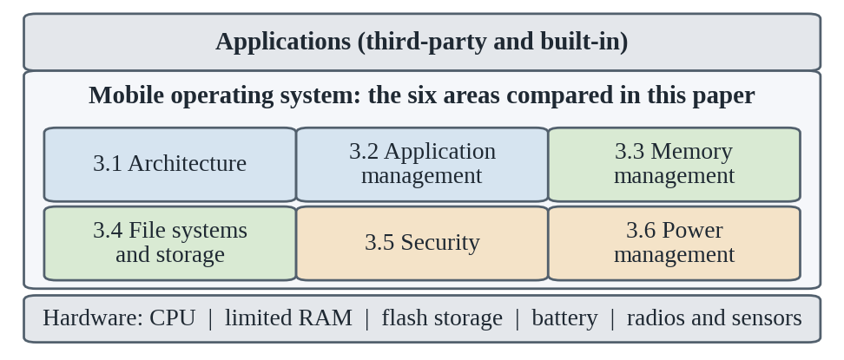
The rest of the paper is organized as follows. Section 2 introduces the main terms, Section 3 compares the two platforms area by area, and Section 4 summarizes the lessons learned.

2. Background

2.1 What a Mobile OS Has to Do
Like any operating system, a mobile OS manages processes, memory, storage, input and output, and protection. Three conditions set it apart from a desktop system. RAM is small, storage is flash memory that wears out, and the battery is a hard limit that the OS must actively protect. In addition, apps are untrusted by default, because users install them from many sources. Most of the design differences discussed later follow from how each platform responds to these conditions.

2.2 Key Terms
Kernel. The core of the OS, which schedules processes, manages memory, and controls hardware through drivers.
Runtime. The software that executes app code, such as the Android Runtime (ART) on Android.
Sandbox. A restricted environment that stops an app from reading another app’s data or using system resources without permission.
Garbage collection. Automatic freeing of objects that a program can no longer reach (Android Developers, n.d.-a).
Reference counting. A method in which each object tracks how many references point to it and is freed when the count reaches zero (Swift.org, n.d.).
Flash storage. The non-volatile memory used in phones, which must erase blocks before rewriting them and wears out over time, so it needs specially designed file systems (Lee et al., 2015).
Code signing. A digital signature that identifies who created an app and shows that it has not been changed.
Background execution. Work that an app performs while it is not on screen, which is the main target of power-saving rules (Shankari et al., 2016).

2.3 How the Comparison Is Organized
Each area in Section 3 follows the same pattern: the design goal, what Android does, what iOS does, and a short takeaway. The evidence comes from official documentation, which shows how each system is built, and from peer-reviewed studies, which show how the systems behave when measured or analyzed.

3. Discussion

3.1 Architecture: How Each System Is Built
Goal. Keep apps independent of hardware details by stacking the system in layers.
Android. The platform sits on a modified Linux kernel. A hardware abstraction layer (HAL) lets device makers plug in their own drivers behind standard interfaces, and apps run in ART with access to native libraries and a framework API (Android Developers, n.d.-c). This is what allows one Android release to run on devices from many manufacturers.
iOS. The system is built on the XNU kernel, which combines the Mach microkernel with BSD components. Apps are written against Apple frameworks such as UIKit. Because Apple controls the hardware, drivers, and OS together, it does not need a vendor-facing abstraction layer.
Takeaway. Android’s layering favors hardware diversity, while iOS’s layering favors tight integration.

3.2 Application Management: How Apps Arrive and Run
Goal. Decide how software reaches the device and what the OS does with it afterwards.
Android. Apps are packaged as APK files and published through Android App Bundles, from which device-specific APKs are generated (Android Developers, n.d.-d). Google Play is the main store, but apps can also be installed from other sources with the user’s consent. In the study by Han et al. (2013), Android apps were signed by their developers, and Google scanned its store automatically instead of requiring a prior approval step.
iOS. Apps are signed by Apple and delivered mainly through the App Store after review (Han et al., 2013; Apple, 2026). Regulation in some regions, such as the European Union, has opened additional distribution options.
Takeaway. Android trades gatekeeping for choice, while iOS trades choice for a single control point that can screen apps before release.

3.3 Memory Management: Coping with Little RAM
Goal. Keep many apps responsive when there is not much memory to share.
Android. Each app normally runs in its own ART process, created from a shared Zygote process so that common framework code is held once in memory. A garbage collector frees objects that are no longer reachable. Recently used apps stay in memory as cached processes so that they restart quickly, and when memory runs low the system ends the least important ones first (Android Developers, n.d.-a). Apps must therefore save their state before moving to the background.
iOS. Swift uses automatic reference counting (ARC): the compiler adds the code that updates reference counts, and an object is freed as soon as its count reaches zero. This avoids collection pauses, but developers must avoid strong reference cycles, which ARC cannot free (Swift.org, n.d.). When memory is scarce, iOS asks apps to release memory and may suspend or end background apps, always favoring the app on screen. Figure 2 compares the two responses.
Figure 2. Simplified response to low memory on Android and iOS
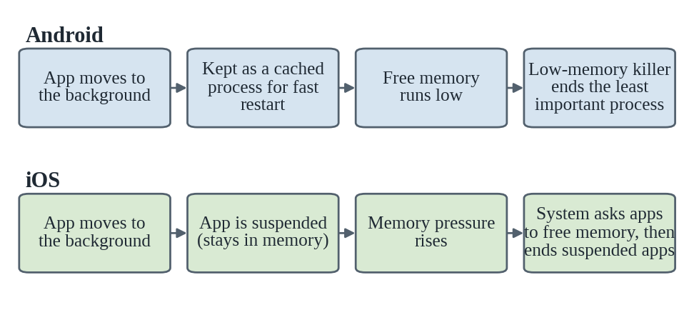
Takeaway. Garbage collection is convenient for developers but can add background work and pauses, whereas reference counting is predictable but leaves the bookkeeping to the developer. On both platforms, background apps are the first to be sacrificed under memory pressure.

3.4 File Systems: Storing Data on Flash
Goal. Store data safely on flash memory while keeping each app’s files separate.
Android. Devices commonly use ext4 or F2FS. F2FS was designed by Samsung researchers for NAND flash and, in their tests on a mobile system, outperformed ext4 by up to 3.1 times in the iozone benchmark and 2 times in SQLite workloads (Lee et al., 2015). Each app has private storage by default, and shared files are reached through permissions.
iOS. The Apple File System (APFS) is used, and each app works inside its own container with separate directories for documents, caches, and temporary files (Apple, n.d.-b). APFS is designed for flash storage and supports efficient cloning, snapshots, and built-in encryption (Apple, 2026).
Takeaway. Both platforms use flash-aware file systems with encryption and per-app isolation; Badami (2024) identifies APFS and F2FS as the file systems of the two platforms in a study of how such protections complicate forensic investigation. The difference lies in control: Apple chooses one file system for all devices, while Android manufacturers can choose.

3.5 Security: Treating Apps as Untrusted
Goal. Protect user data and the system from apps that may be careless or malicious.
Android. Apps are isolated through Linux user IDs, as described by Han et al. (2013), and the platform adds SELinux, app signing, permissions, and Verified Boot (Android Open Source Project, n.d.).
iOS. The platform combines sandboxing, mandatory code signing, App Review, a secure boot chain, and hardware-backed encryption through the Secure Enclave (Apple, 2026).
What the research shows. Khan et al. (2022) compared the two systems and concluded that iOS is more secure, although at the cost of user freedom. Han et al. (2013) analyzed 1,300 pairs of popular apps that exist on both platforms and found that 73% of the iOS versions used additional security-sensitive APIs, averaging 5.9 types per app against 3.5 on Android. They linked this to the fact that Android showed users a permission list at installation, while iOS at the time asked users about only a few privileges, such as location, and they cautioned that the result does not prove Android protects privacy better. Since then, both platforms have added permissions that can be changed at run time (Galuppo et al., 2018), and both rely on hardware-backed protection such as the Secure Enclave and Android’s Trusted Execution Environment (Badami, 2024).
Takeaway. Neither design is simply safer: iOS limits risk through control, Android through transparency and flexibility, and findings depend on the period studied and on how users behave.

3.6 Power Management: Making the Battery Last
Goal. Keep standby time long even though phones stay connected all day.
Android. Doze and App Standby, introduced with Android 6.0, defer background network activity and jobs when the device is idle or when an app has not been used recently (Android Developers, n.d.-b). Developers are expected to use system-managed scheduling so that work from many apps can be batched.
iOS. Background execution has long been limited to a small set of permitted modes, and tasks scheduled through the BackgroundTasks framework run when the system decides (Apple, n.d.-a; Shankari et al., 2016).
What was measured. Shankari et al. (2016) found that a stock iPhone 6 lost essentially no charge overnight, while a stock Nexus 6 running Android 6.0 lost 6%, and they observed that both platforms have moved toward allowing background work under limits set by the OS.
Takeaway. Standby battery life depends mostly on how strictly the OS limits background work, and Doze brought Android much closer to iOS.

3.7 Summary
Table 1. Android and iOS at a glance
Area | Android | iOS
Philosophy | Open and adaptable | Closed and integrated
Kernel | Modified Linux kernel | XNU (Mach and BSD)
App delivery | Google Play and other sources | App Store with review
Memory | ART garbage collection; low-memory killing of cached processes | ARC reference counting; suspension and ending of background apps
Storage | ext4 or F2FS | APFS
Security | User-ID sandbox, SELinux, permissions, Verified Boot | Sandbox, code signing, Secure Enclave
Power | Doze and App Standby | Strict background modes

4. Conclusion
This study set out to compare how Android and iOS manage the limited resources of a smartphone, and three lessons stand out. First, both systems use the same building blocks, namely layered kernels, isolated app processes, flash-aware file systems, and limits on background work, so the real difference is how much control the vendor keeps. Second, every design choice has a cost: Android’s openness brings diversity and more variation in security exposure, while iOS’s control brings consistency and, in the studies reviewed, stronger security and lower idle power use, but less freedom for users and developers. Third, evidence ages quickly, because platform features change with each release; the privacy gap reported by Han et al. (2013), for example, came before the run-time permission prompts that both systems now use (Galuppo et al., 2018). Android and iOS are therefore best seen as two answers to the same set of constraints rather than as a ranking, and the better choice depends on whether flexibility or predictability matters more.

References
Android Developers. (n.d.-a). Memory management. https://developer.android.com/topic/performance/memory-management
Android Developers. (n.d.-b). Optimize for Doze and App Standby. https://developer.android.com/training/monitoring-device-state/doze-standby
Android Developers. (n.d.-c). Platform architecture. https://developer.android.com/guide/platform
Android Developers. (n.d.-d). Publish your app. https://developer.android.com/studio/publish
Android Open Source Project. (n.d.). Android security features. https://source.android.com/docs/security/features
Apple. (n.d.-a). Background tasks. Apple Developer Documentation. https://developer.apple.com/documentation/BackgroundTasks
Apple. (n.d.-b). Files and directories. Apple Developer Documentation. https://developer.apple.com/documentation/technologyoverviews/files-and-directories
Apple. (2026). Apple platform security. Apple Support. https://support.apple.com/guide/security/welcome/web
Badami, P. (2024). Forensic analysis of encrypted Android and iOS applications: A multi-layer investigation framework with statistical validation. NFSU Journal of Cyber Security and Digital Forensics, 3(2), 24–33. https://jcsdf.nfsu.ac.in/
Galuppo, R. I., Luna, C., & Betarte, G. (2018). Security in iOS and Android: A comparative analysis. In 2018 37th International Conference of the Chilean Computer Science Society (SCCC). IEEE. https://doi.org/10.1109/SCCC.2018.8705237
Han, J., Yan, Q., Gao, D., Zhou, J., & Deng, R. (2013). Comparing mobile privacy protection through cross-platform applications. In Proceedings of the Network and Distributed System Security Symposium (NDSS). Internet Society. https://www.ndss-symposium.org/wp-content/uploads/2017/09/06_2_0.pdf
Khan, S., Yusuf, A., Haider, M., Thirunavukkarasu, K., Nand, P., & Imam Rahmani, M. K. (2022). A review of Android and iOS operating system security. In 2022 ASU International Conference in Emerging Technologies for Sustainability and Intelligent Systems (ICETSIS) (pp. 67–72). IEEE. https://doi.org/10.1109/ICETSIS55481.2022.9888847
Lee, C., Sim, D., Hwang, J., & Cho, S. (2015). F2FS: A new file system for flash storage. In Proceedings of the 13th USENIX Conference on File and Storage Technologies (FAST ’15) (pp. 273–286). USENIX Association. https://www.usenix.org/conference/fast15/technical-sessions/presentation/lee
Shankari, K., Culler, D. E., & Katz, R. H. (2016). “Doing nothing well”: OS-application coordination for energy saving (Technical Report No. UCB/EECS-2016-119). University of California, Berkeley. http://www.eecs.berkeley.edu/Pubs/TechRpts/2016/EECS-2016-119.html
Swift.org. (n.d.). Automatic reference counting. In The Swift programming language. https://docs.swift.org/swift-book/documentation/the-swift-programming-language/automaticreferencecounting/

