*CC3220 Server Certificate installation and Service Pack Upgrade Guide*

Upgrade CC3220 files using CC320SF Dev Kit before testing Wi-Fi HTTP/s client application.

Connect CC320SF Dev Kit with cc3220sf using following Pins

**PIN Connection Table**

|  |  |
| --- | --- |
| **CC3220SF DEV KIT** | **WIFI BATTERY BOARD** |
| TX | TP09(BOOTLOAD_RX) |
| RX | TP11(BOOTLOAD_TX) |
| RESET | TP17(RESET) |
| GND | GND |

To update service pack and load iNet certificate follow these steps

Download Uniflash version 4.2.2 from <http://www.ti.com/tool/UNIFLASH>

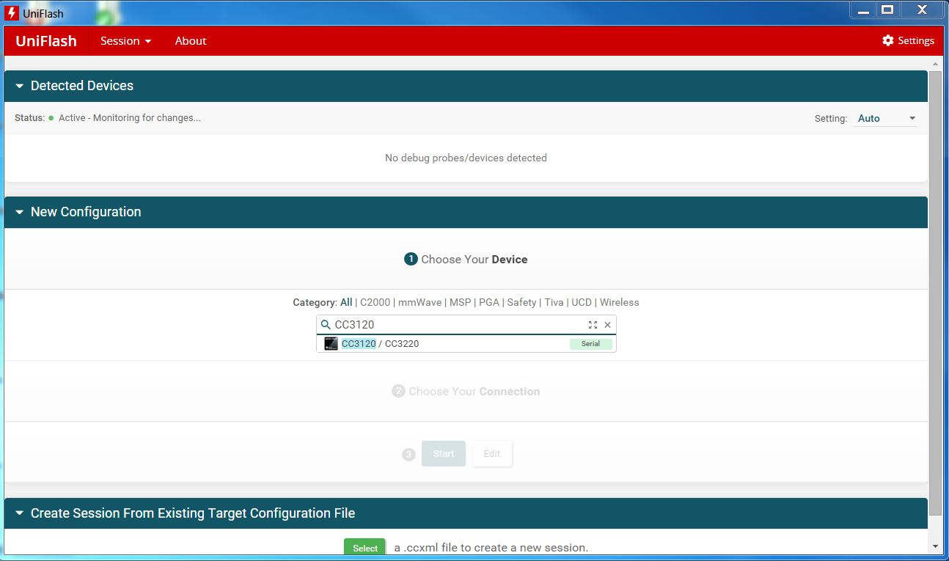

Install Uniflash v4.2 and launch application. Select CC3120/CC3200 in Category and then click start image creator

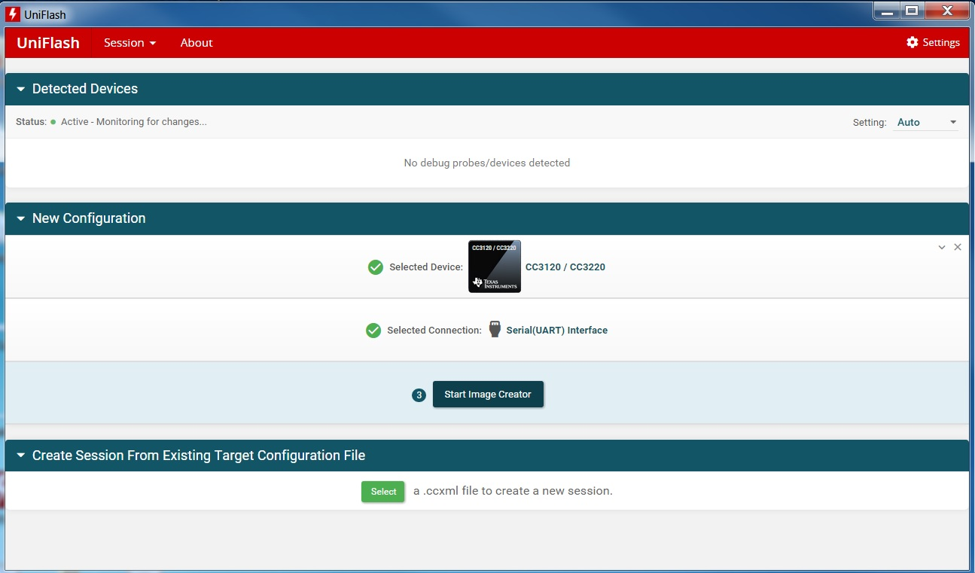

Select Program Image

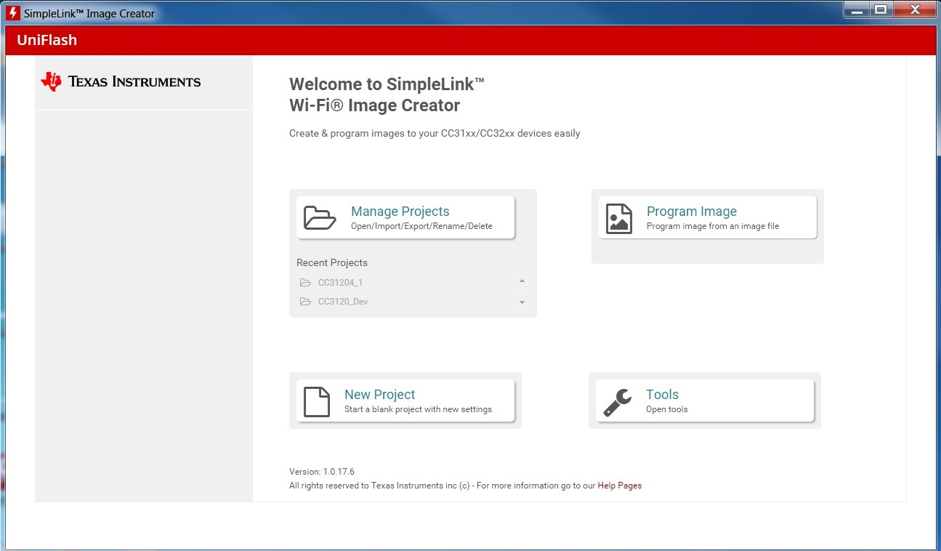

To Program certificate, service pack and webserver html files, click on Browse and select CC3120.sli file in \Doc\CC3220.sli

