Auto Zone Web Site

Abstract

Auto Zone Is a project is to have a trusted website that you can buy car parts from the website will have a new parts imported from outside of the country the parts are new to Jordan market where it’s a new feature in Jordan maybe never done before. I identified the challenges and the solutions, Then we collected the requirements for building the site and were collected by a questionnaire and then we identified the functional and nonfunctional requirements. Then we use all requirements to build use case and sequence diagram, and took Data and we have created data then founded databases and tables of data and designed Screen to the site and we started implementing the project and used the language of JavaScript to build the site with the help of The MERN stack which is MongoDB for the database with Exepress And ReactJS and nodeJS .

# Chapter 1: Introduction

## Introduction

Tech News is a site specialized in technology news, it is directed to all people interested in technology and the latest developments and the most important new updates.

## System Goals

The goal of building the site is to:

1. To Be the first one selling parts and accessories new to the market only available at the website
2. A trusted website selling these types of products which is maybe the only one

## Feasibility Study

### Challenges

1. A new method to buy car parts from the internet not every one is familiar with .

### Proposed Methods

1. Make people more interested to customize there cars.

## The Method Adopted in The Design of The System

1. System Design: In this stage, the complete architecture of the desired system is designed. The system is conceived as a set of interacting subsystems that in turn is composed of a hierarchy of interacting objects, grouped into classes.
2. System design is done according to both the system analysis model and the proposed system architecture.

### Analyze & Requirement

In the first week I analyze and gather information to gather requirements.

Chapter 2: Requirement

Analysis

Requirements analysis, also called requirements engineering, is the process of breaking a complex topics or substance into smaller parts in order to gain a better understanding of it. These features, called requirements, must be quantifiable, relevant and detailed. In software engineering, such requirements are often called functional specifications. Requirements analysis is an important aspect of project management.

Requirements analysis involves frequent communication with system users to determine specific feature expectations, resolution of conflict or ambiguity in requirements as demanded by the various users or groups of users, avoidance of feature creep and documentation of all aspects of the project development process from start to finish. Energy should be directed towards ensuring that the final system or product conforms to client needs rather than attempting to mold user expectations to fit the requirements.

#### User Requirement

This field of indoor and outdoor maintenance and all services with just one click with entering the problem (The main features:)

**A-Front Web Site**:

1. Login and register page for new user or author
2. Category to filter products were user can find it in the navbar

**B-Back Web site:**

1. Admin dashboard to add / delete / edit the products

#### Functional requirement

1. log in / register page
2. Dashboard page to control the products
3. Home page to show all category and products
4. List of categories to show specific products

#### Non-Functional Requirement

1. External Requirement

* The web site has Admins to create / edit / delete products.

##### 2. Organizational Requirement

1. Require any OS (such as Windows (XP, 7, 8.1, 10) Linux and Mac). Etc.
2. Web browser (chrome, Firefox, Opera, Explorer).
3. Connected to the Internet.
4. To Program Web pages I used the MERN stack React and connect it with mongoDB, Web pages CSS, Html.

#### System requirement

1. The web site must be compatible with pc’s and mobiles devises.
   1. To achieve all these functions a computer or mobile devise must be available and connected to the internet.
   2. The version or model of the device does not matter, but defiantly needs at least a web browser.

1. Programming languages used

* HTML (Hyper Text Markup Language) is the most basic building block of the Web.
* CSS is a language that describes the style of an HTML document.
* JavaScript (JS) is a lightweight, interpreted, or just-in-time compiled programming language with first-class functions.

#### Use Case Description

1. Actors:

a. Human actors: Admin, Customer.

|  |  |
| --- | --- |
| **Use case** **Number** | **1** |
| **Use case name** | Browsing |
| **Participation actor** | 1. User 2. Admin |
| **Pre-condition** | Internet connection |
| **Flow of events** | 1. Open web site 2. Browse the web site |
| **Post-condition** | Retrieving, presenting and traversing information resources |
| **Quality**  **Requirements** | Speed site browsing |

|  |  |
| --- | --- |
| **Use case** **Number** | **2** |
| **Use case name** | sign up for Users |
| **Participation actor** | 1. Customer |
| **Pre-condition** | Internet connection |
| **Flow of events** | 1. open website 2. click on Register 3. insert information 4. check information 5. send to server |
| **Post-condition** | user confirmation |
| **Quality**  **Requirements** | 1. User Name must be unique name. 2. Must enter all the information. |

|  |  |
| --- | --- |
| **Use case** **Number** | **3** |
| **Use case name** | Add Product |
| **Participation actor** | 1. Admin |
| **Pre-condition** | Admin Role |
| **Flow of events** | 1. Go to dashboard 2. Click Add Product 3. Insert all data |
| **Post-condition** | Admin publish the Product |
| **Quality**  **Requirements** | 1. Just the admin can add a product |

##### *Use Case Diagram*

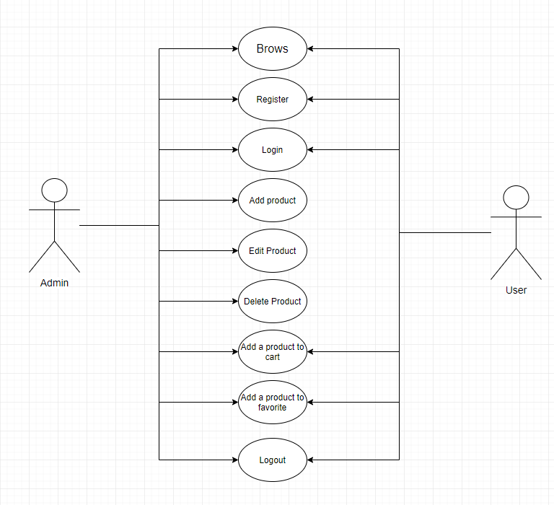

Chapter 3: Design

Class diagram

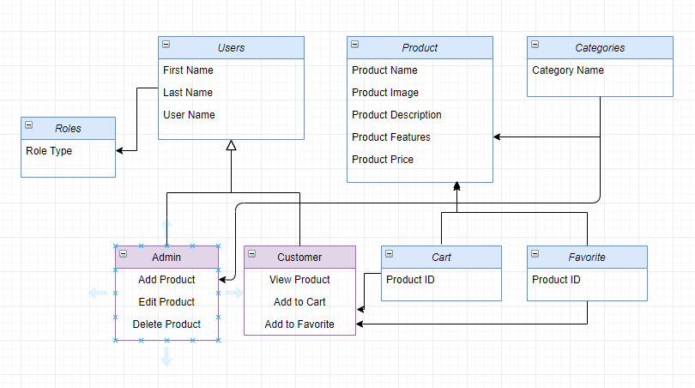

Data Base Tables

Data Base: Table Users

|  |  |
| --- | --- |
| **Data Name** | **Type** |
| **Id** | big Increments |
| **First name** | String |
| **Last name** | String |
| **User name** | String |
| **Created at** | timestamp |
| **password** | hash |

|  |  |
| --- | --- |
| **Role** | string |

Data Base: Table categories

|  |  |
| --- | --- |
| **Data Name** | **Type** |
| **Id** | big Increments |
| **Name** | String |

Data Base: Table Products

|  |  |  |  |
| --- | --- | --- | --- |
| **Data Name** | | **Type** | |
| **Id** | | big Increments | |
| **Product Image-Name** | | String | |
| **Product Name** | | String | |
| **Product Description** | | String | |
| **Product Featuer 1** | | String | |
| **Product Featuer 2** | | String | |
| **Product Price** | | String | |

Data Base Tables

Data Base: Table Cart

|  |  |
| --- | --- |
| **Data Name** | **Type** |
| **Id** | big Increments |
| **Product ID** | String |

Data Base Tables

Data Base: Table Favorites

|  |  |
| --- | --- |
| **Data Name** | **Type** |
| **Id** | big Increments |
| **Product ID** | String |

Mock-ups

Website Mock-ups

*Home Page*

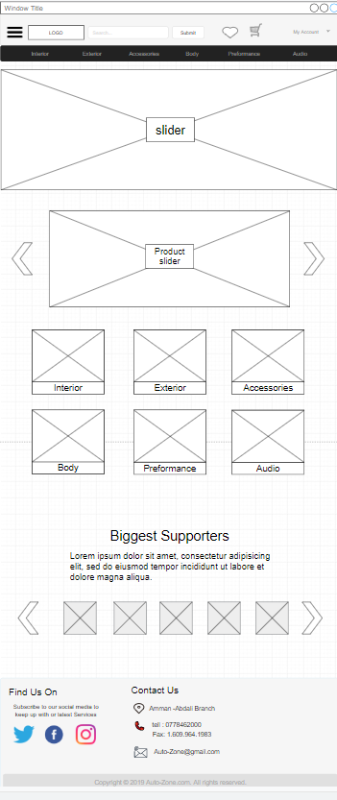

*Products Page*

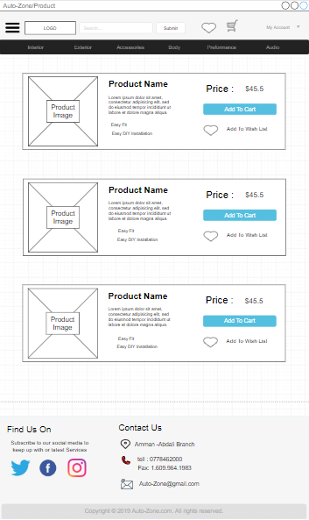

*Favorites Page*

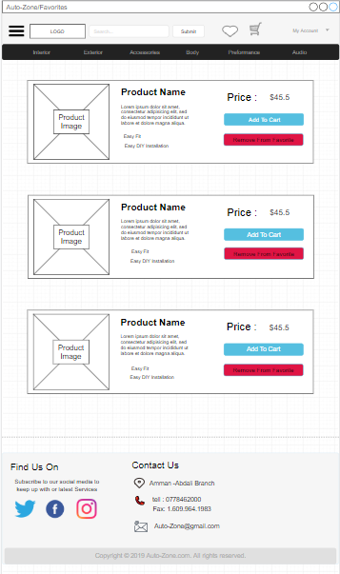

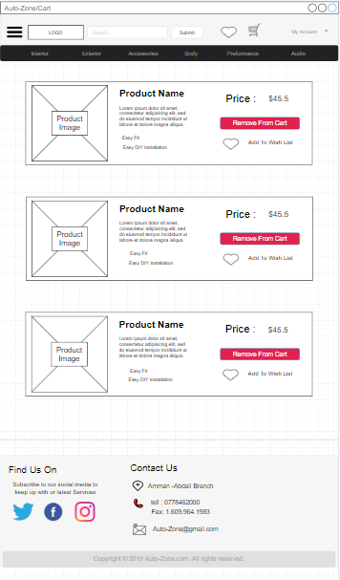

Cart Page

Profile page

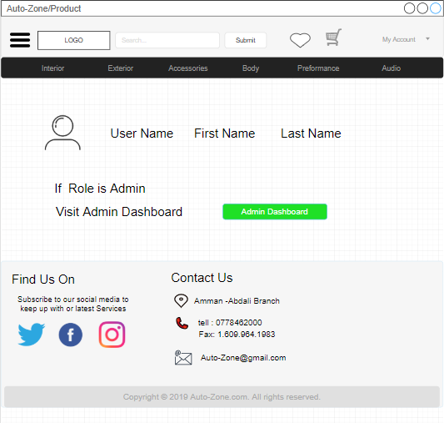

Admin Dash Board

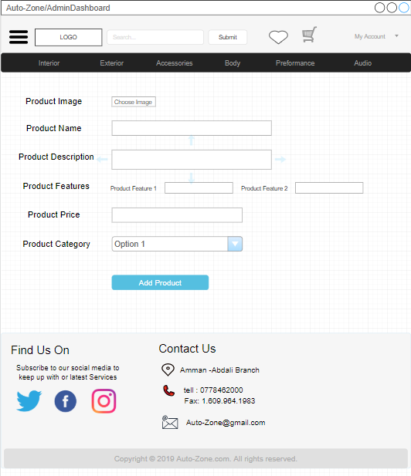

Register page

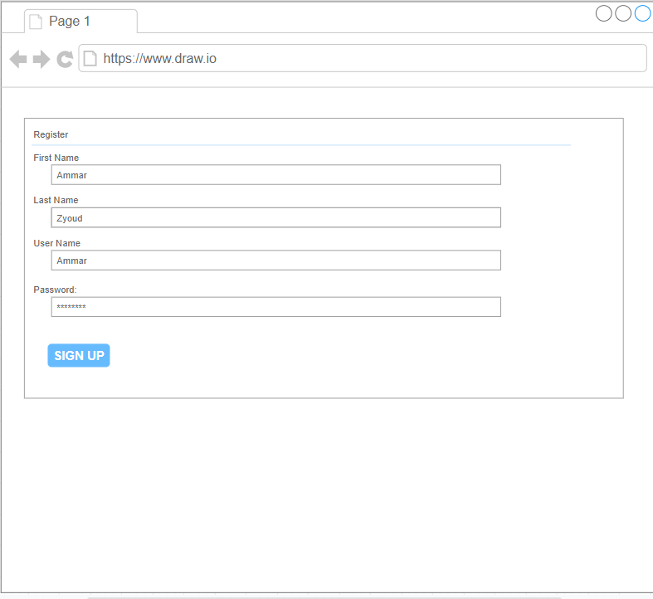

Login page

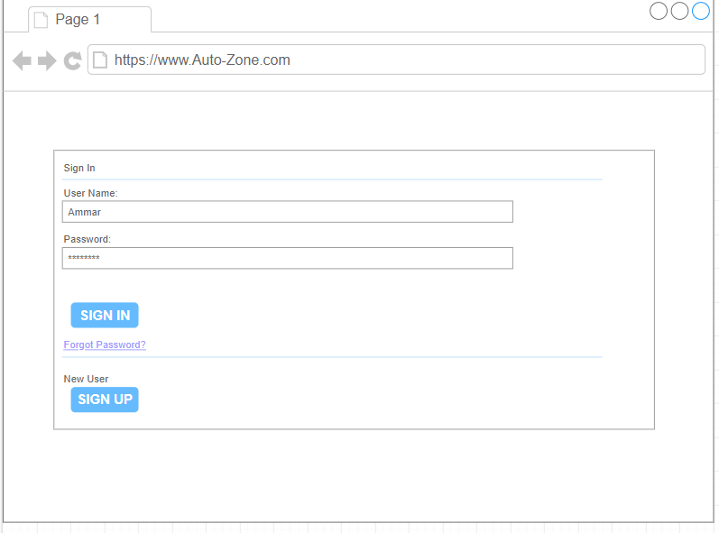

*Technologies Used To build the project*

*The MERN Stack:*

1- MongoDB for the database

2- Exepress

3- NodeJS for the server

4- ReactJS