WES7E SOP

1. Open Image Configuration Editor (ICE)

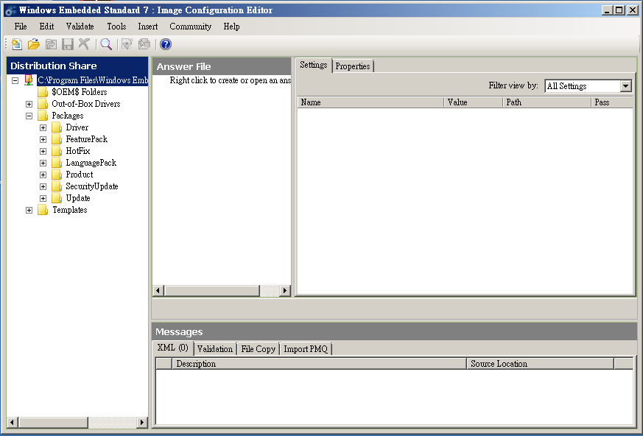

2. Select Database for System x64 or x86

(File → Select Distribution Share → Windows Embedded Standard 7 → DS64SP1)

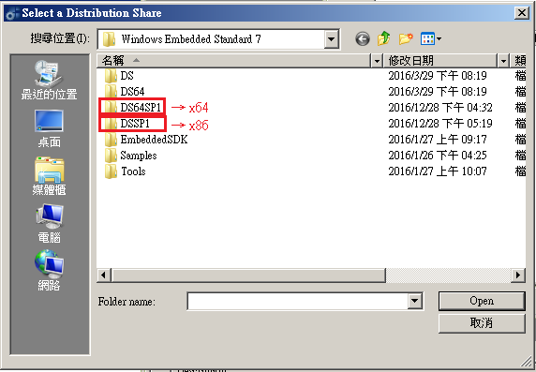

3. Select XML : Open Answer File → template.xml(0000-WES7E-x64-SP1-Eng.xml)

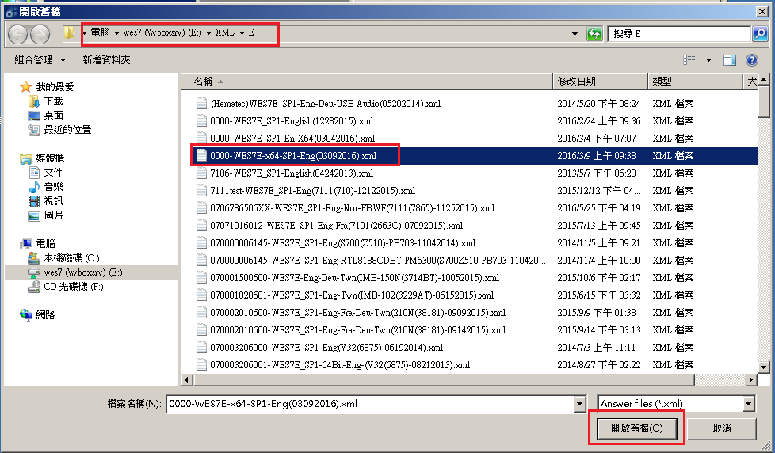

4. Save Answer File : File → Save Answer File As…→ 071681500603-WES7E-x64-Eng-Twn(SBC-7111(815)01252017.xml)

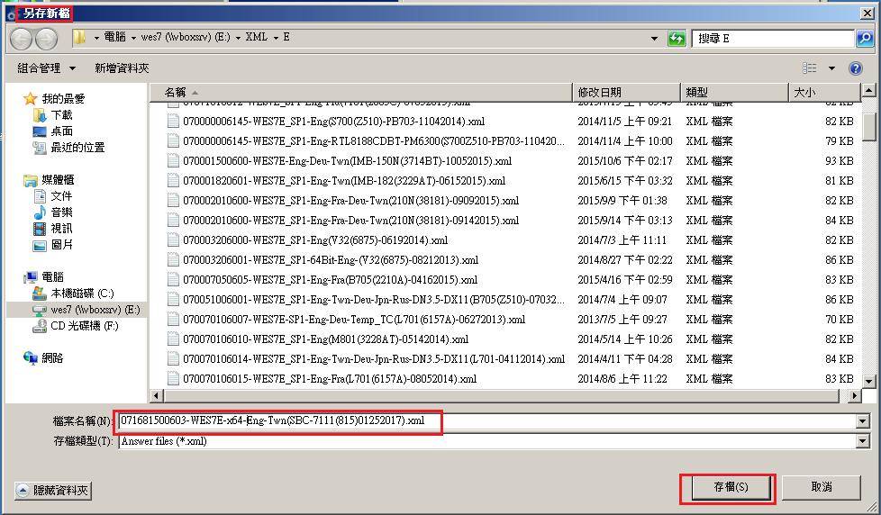

5. Import PMQ : File → Import → Import PMQ → 7111 R2.1.pmq

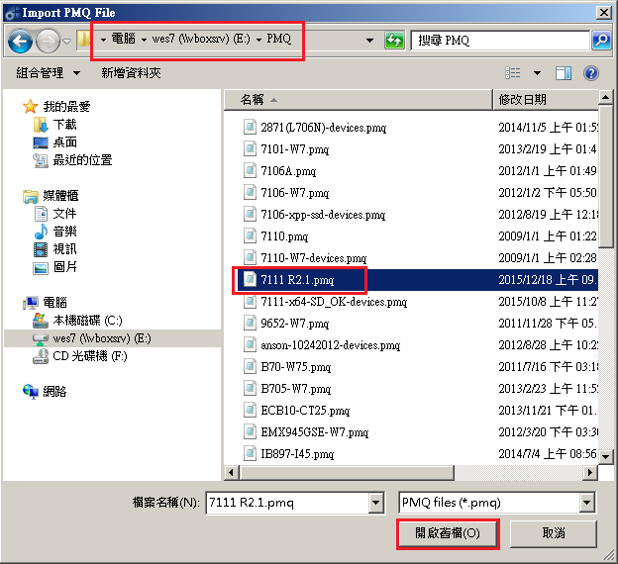

6. Set Product

6.1 Product Key

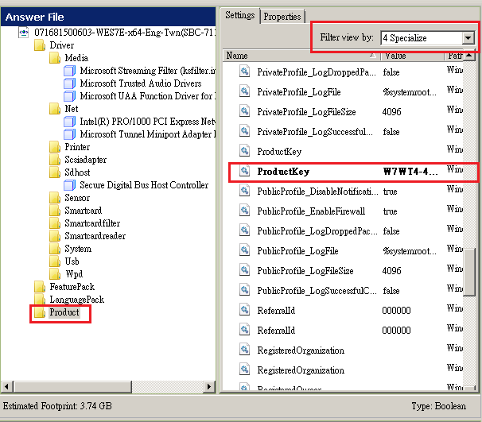

6.2 Set DoNotCleanUpNonPresentDevices & PersistAllDeviceInstalls Value to “true”

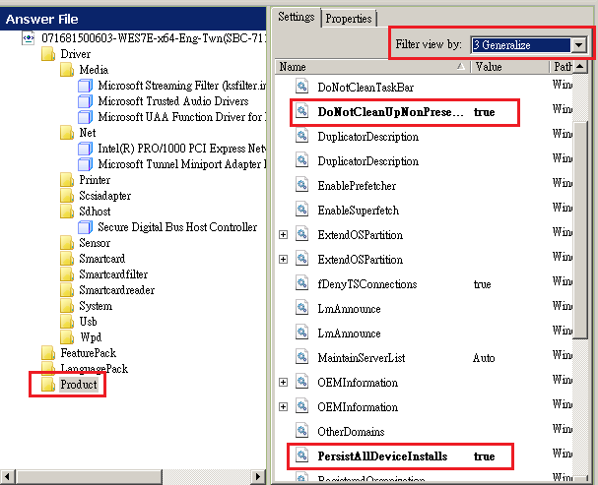

7. Check Compatibility : Validate → Add Required and Optional Packages

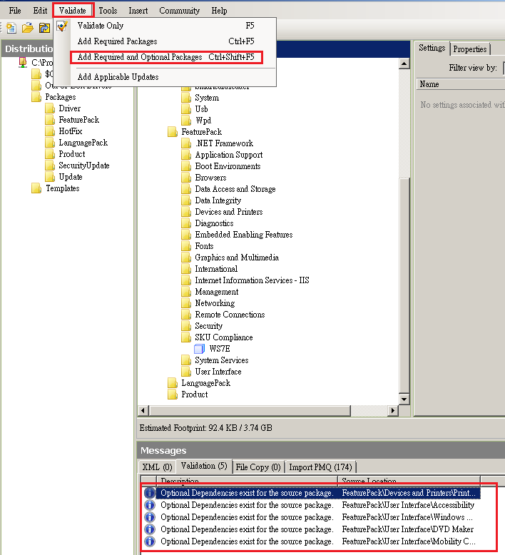

**※SKU Compliance Check**

◆ Make WS7E, must delete “Photo Viewer”、”Tablet PC Support”、”AntiMalware” file

◆ Make WS7P, don’t delete “Photo Viewer”、”Tablet PC Support”、”AntiMalware” file

8. Add Language – Twn language(add in with click twice )

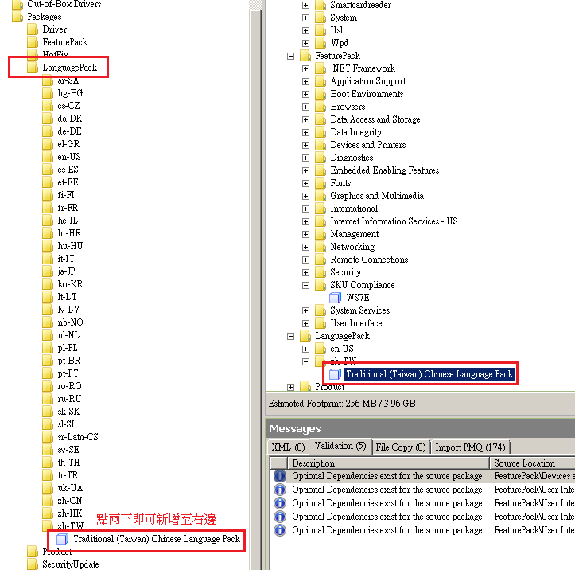

**Note:**

Make WS7E : add in two or more languages, and delete ”SKU Compliance”, but don’t click ”Add Required and Optional Packages”.

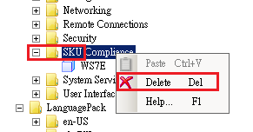

9. Add EWF

9.1 add:

1. Boot Environments →Enhanced Write Filter Boot EEnvironment

2. Embedded Enabling Features→Enhanced Write Filter Management Tool

3. Embedded Enabling Features→Enhanced Write Filter Provider

4. Embedded Enabling Features→Enhanced Write Filter with HORM

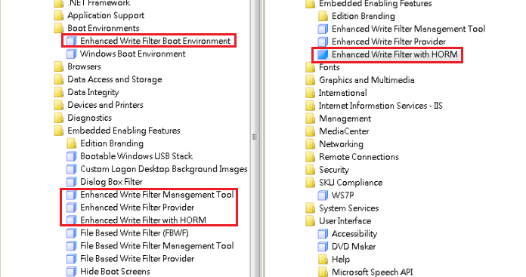

9.2 EWF check & change

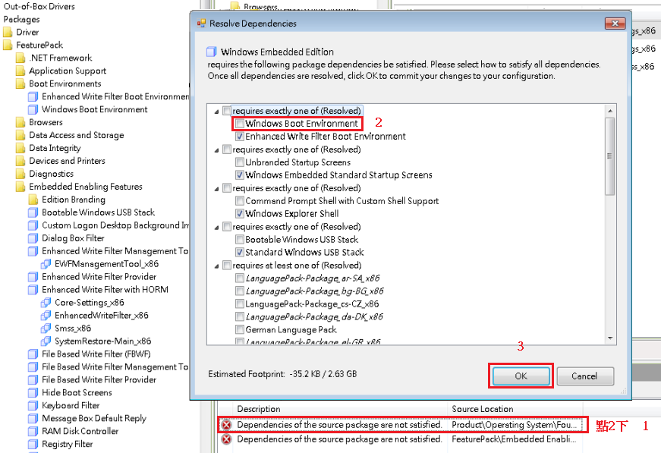

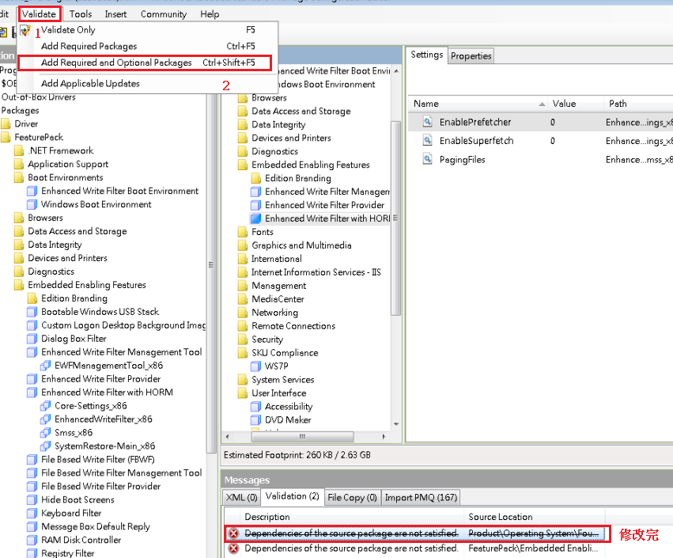

10. Create IBW : Tool → Create Media → Create IBW Image From Answer File → select to save the folder location (C:\test)→OK。(note: Folder must Create under C:\ in advance)

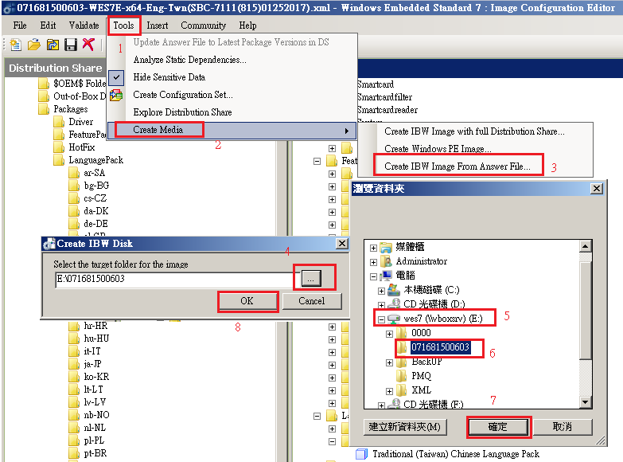

11. Create success. Copy the files to your hard drive, and Install with a portable hard drive.

