**EWF SOP**

1. ”run_EWF.reg” and“EWF_enable.reg”put into ”C:\Windows\System32”under

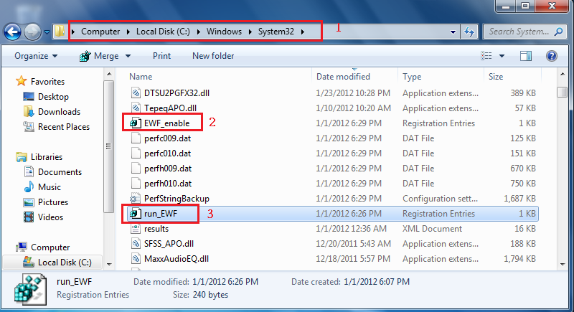

2. view EWF now state, and EWF must disable.

2.1 start🡪 all programs🡪 Accessories🡪click Command Prompt🡪right click choose run as administrator.

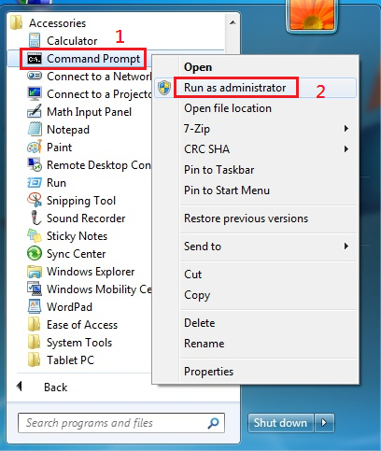

2.2 key in: ewfmgr c:

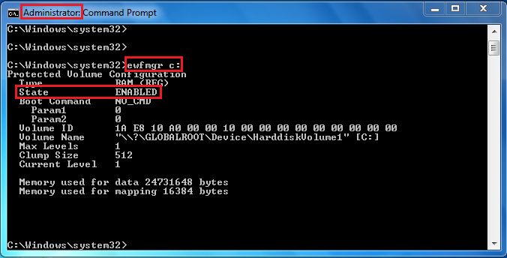

2.3 key in: ewfmgr c: /commitanddisable –live

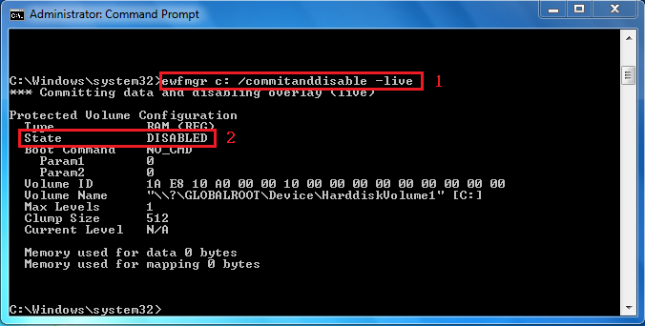

2.4 key in: regedit.exe /s run_EWF.reg 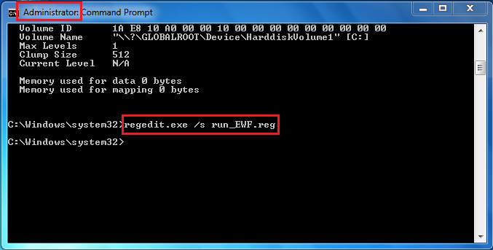

3.shutdown & ghost

4. auto reboot twice

6. view EWF enable successful

6.1 start🡪 all programs🡪 Accessories🡪click Command Prompt🡪right click choose run as administrator.



6.2 Key in :ewfmgr c:

