Software Development Methodology (SDLC model)
For the development of the FixIt Jo application, the Agile Scrum SDLC model will be followed.
This model is well-suited for the project because it supports iterative development, continuous
feedback, and flexibility in handling changing requirements.
The use of this model provides several advantages:
- Step-by-step development of system features, ensuring better control over the project.
- Flexibility to modify requirements based on user feedback during development.
- Continuous testing after each sprint to ensure system reliability and performance.
- Improved collaboration among team members through regular updates and reviews.

Each sprint follows a structured process that includes planning, design, development, testing, and
review. During the planning phase, the required features are identified and prioritized. In the
design phase, system structure and user interface are prepared. The development phase involves
coding the features, followed by testing to ensure correctness. Finally, feedback is collected and
improvements are applied in the next sprint.

This iterative approach reduces project risks, improves system quality, and ensures that the final
application meets user needs effectively. It also supports future scalability and enhancements,
making the system more maintainable and adaptable.

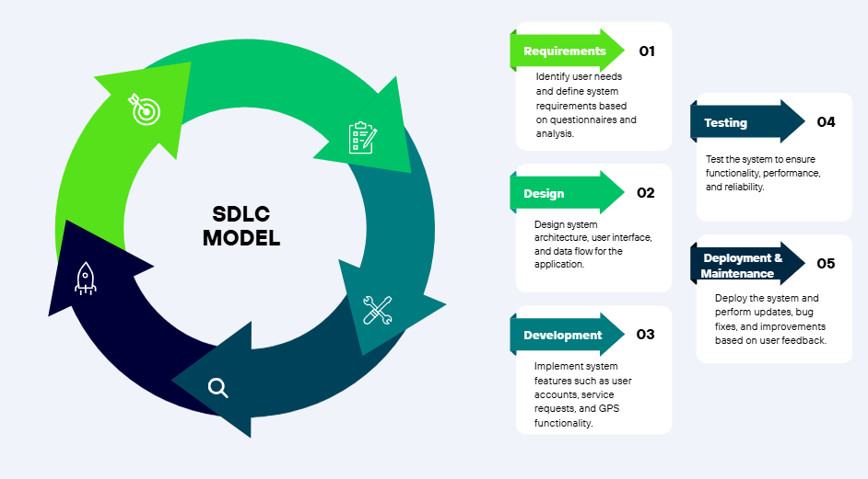
Figure 1: SDLC Model

