User Interface Mockups
The following figures present the User Interface (UI) mockups designed for the FixIt Jo
mobile application. The UI follows a clean and modern design with light blue and white
color scheme, ensuring a simple and user-friendly experience for all users.
Figure 1 illustrates the Login Screen of the FixIt Jo application it allows users to log in using their
Jordanian mobile number (+962) to access the system.
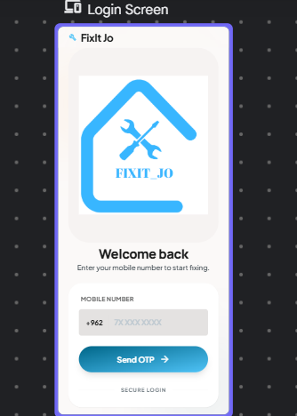
Figure 1: Login Screen

Figure 2 displays the Registration Screen of the FixIt Jo application. It allows new users to create
an account by first selecting their role as either a customer or a technician using interactive
selection cards at the top of the screen.
When the user selects the Technician role, additional fields appear below, allowing the technician
to enter their full name, phone number with the Jordanian country code (+962), and select their
specialization from a grid of options including Plumbing, Electrical, Carpentry, and AC Repair.
The specialization section supports multiple selections, enabling technicians to offer more than
one service type.
A Register button is placed at the bottom of the screen, along with a link to the Login screen for
users who already have an account.
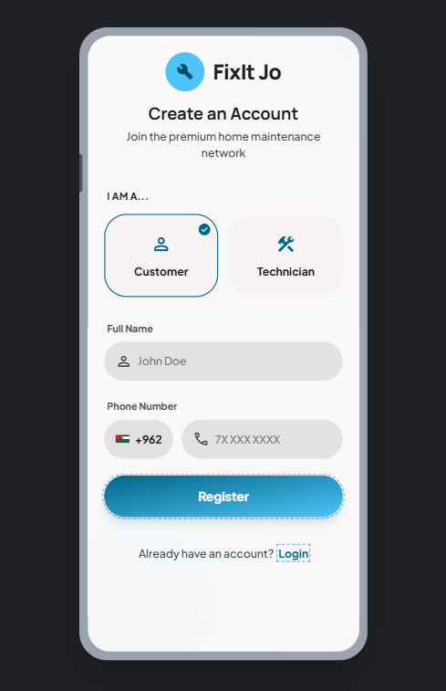
Figure 2.1: Customer Register Screen
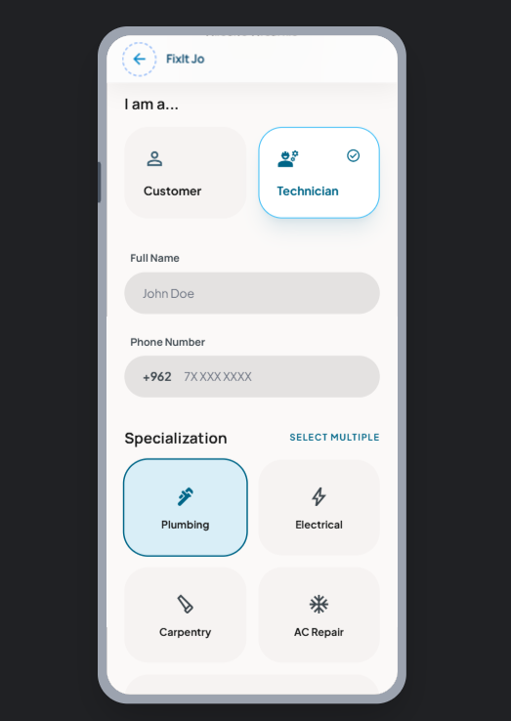
Figure 2.2: Technician Register Screen
Figure 3 shows the Customer Home Screen, which is the main dashboard accessible after
login. The screen greets the user by name at the top with a notification bell icon. A promotional
banner reads "Need a fix? We've got the pros for you." Below the banner, a search bar allows
customers to search for services directly. The screen features a Categories section displaying
service types in a grid layout, including Plumbing, Electrical, Carpentry, and AC Repair, each represented with an icon. A bottom navigation bar provides quick access to Home, Request, Map,
Chat and Profile sections.
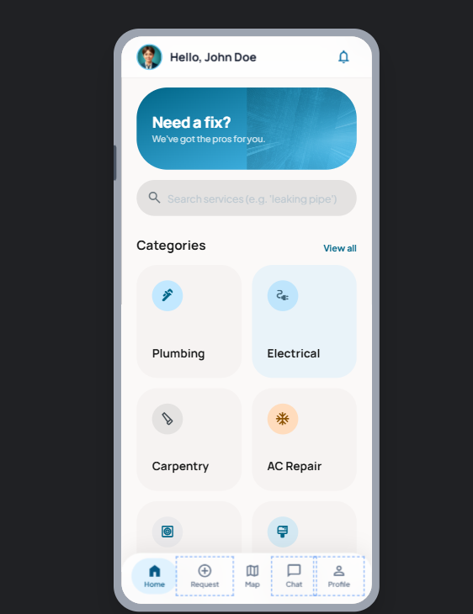
Figure 3: Customer Home Screen

Figure 4 illustrates the Technician Home Screen, which provides an overview of the
technician's performance and incoming service requests. The screen displays key statistics
including Earnings, Jobs Done, Rating, and Efficiency in a card-based layout. Below the
statistics, an Incoming Requests section shows a map preview with a request pin and details of
the customer's request, including the customer’s name, service type, location, and expected time.
The technician can Accept or Decline the request directly from this screen. A bottom navigation
bar provides access to Home, Requests, Map, and Profile sections.
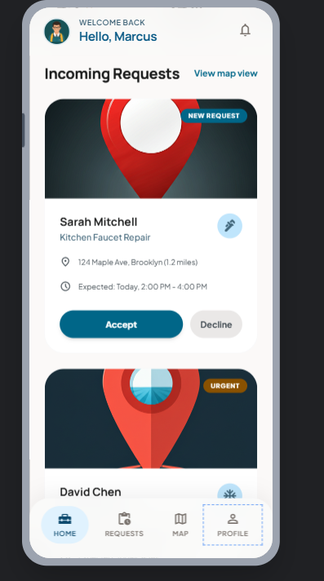
Figure 4: Technician Home Screen
Figure 5 shows the Request Service Screen. It allows customers to submit a new service request
by selecting a service category from a horizontal scrollable list including Plumbing, Electrical,
Carpentry, and Cleaning. Below the category selection, the customer can enter a description of the
issue in a text field. A Location section displays a map showing the customer's current
location, with an option to edit the location manually. A bottom navigation bar provides access to
Home, Requests, Chat, and Profile sections.
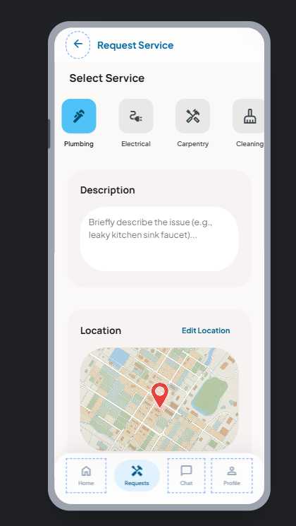
Figure 5: Request Service Screen
Figure 6 shows the AI Chatbot Screen. It allows the customer to describe their maintenance issue
through a chat interface, where the AI assistant responds by suggesting available technicians or
providing quick fix guidance.

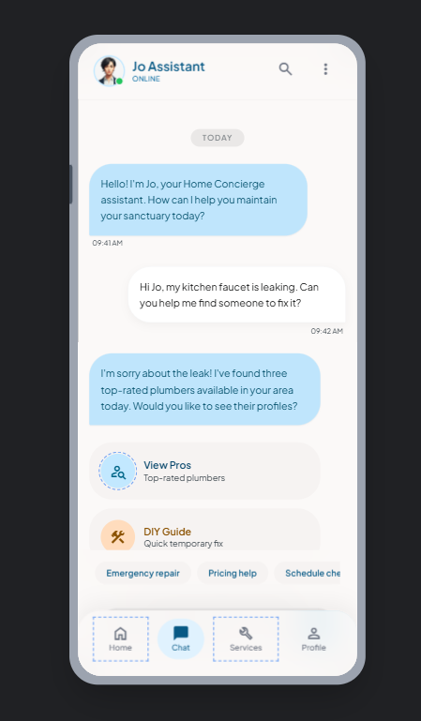
Figure 6: AI Chatbot Screen

Figure 6 shows the Rating Screen. It allows the customer to rate the technician's performance by
selecting a star rating and leaving written feedback after the service is completed.
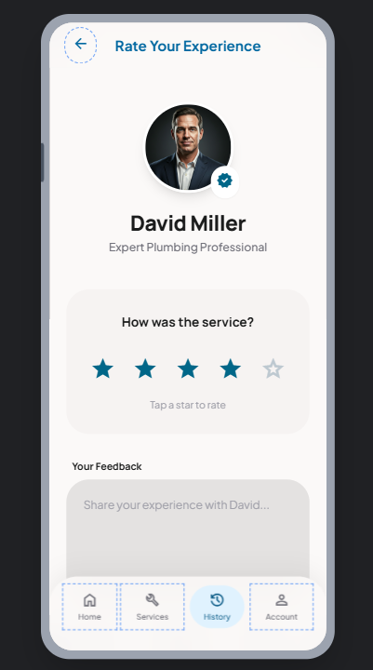
Figure 7: Rating Screen

