Requirements Gathering
The requirements for the FixIt Jo project were collected using questionnaires distributed to potential users and local technicians. This method was selected because it is simple and effective, allowing feedback to be gathered from multiple participants in a short time. The questionnaires focused on common maintenance needs, user expectations, and essential application features. The responses were then analyzed to identify both functional and non-functional requirements of the system.
Functional Requirements:
- The system allow users and technicians to create accounts and login.
- The system shall enable users to request maintenance services by category.
- The system shall display nearby available technicians using GPS.
- The system shall support in-app communication between users and technicians.
- The system allow users to upload photos to explain their issues.
- The system shall provide chatbot assistance to help users select the appropriate service.
- The system shall enable technicians to manage their profiles and availability.
- The system shall allow users to rate and review technicians after service completion.

Non-Functional Requirements:
- Performance: The system shall respond to user requests within an acceptable time and efficiently handle multiple users.
- Security: User data and communication shall be protected using secure authentication and data protection mechanisms.
- Usability: The application shall have a simple and user-friendly interface suitable for users with different technical backgrounds.
- Reliability: The system shall provide accurate GPS matching and ensure service availability information is up to date.
- Scalability: The system shall support future expansion to additional cities and increased numbers of users.
- Availability: The application shall always be accessible except during scheduled maintenance.

Use Case Diagram
Figure 2 shows a Use Case Diagram of the FixIt Jo application. It illustrates the system’s functionality from the perspective of its main users, including the Customer, Technician, and Admin.

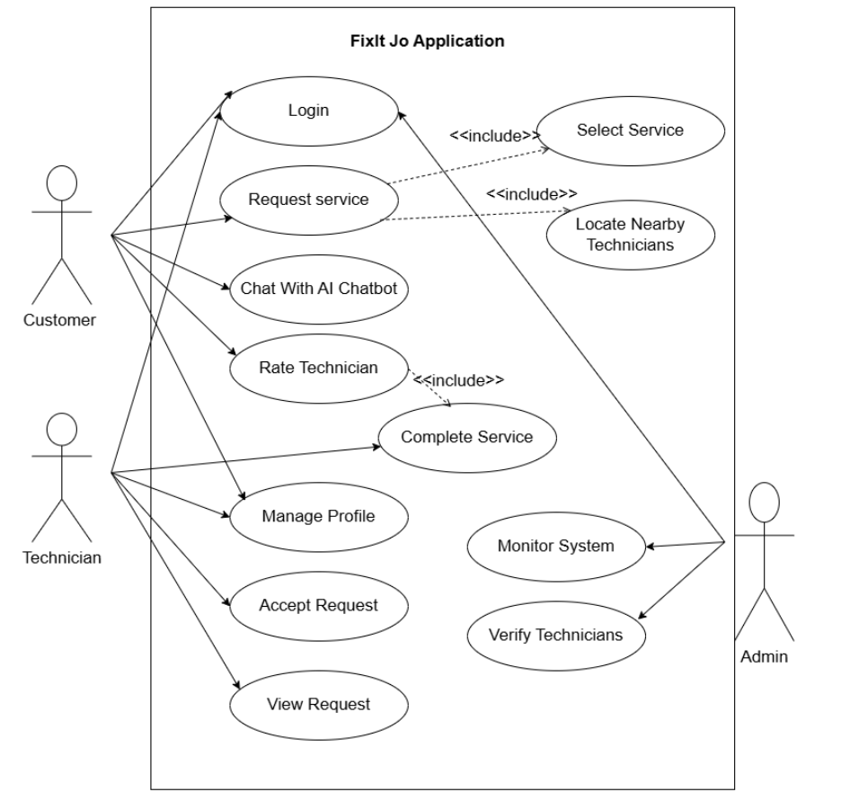
Figure 2: Use Case Diagram

