**CSE 212 – Programming with Data Structures**

**W01 Prove – Response Document**

|  |  |
| --- | --- |
| **Name:** | Ammon Anderson |
| **Date:** | 4/26/2025 |
| **Teacher:** | Brother Alvey |

*It is a violation of BYU-Idaho Honor Code to post or share this document with others or to post it online. Storage into a personal and private repository (e.g. private GitHub repository, unshared Google Drive folder) is acceptable.*

**Question 1: For the rotate right problem, provide a description of how you solved the problem.**

To solve the rotate right problem, I first identified the last amount of elements in the list, since those are the ones that need to move to the front.

I used GetRange to extract those elements, then RemoveRange to delete them from their original position.

Finally, I used InsertRange to insert the extracted elements at the beginning of the list.

This approach modifies the existing list without creating a completely new list.

I also made sure to handle cases where the rotation amount is equal to the list length or larger than the list length by using modulo (%).

**Question 2: For the rotate right problem, draw a picture of how you solved the problem.**

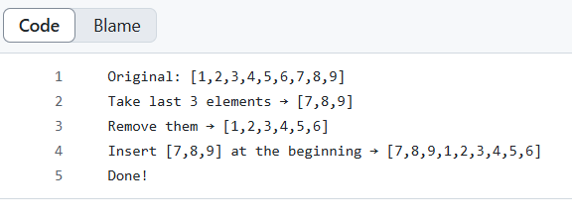

Remember: You need to commit all the changes to the prove-01-<username> repository along with this document. Then submit a link to the repository in I-Learn.