drone-delivery-service API
Spring Boot REST API for drone-based medication delivery service — drone registration, medication loading, and battery/state tracking. **This project serves as my submission for a technical exam on Software Engineer (Java) job application.

Unit Test Cases

Case 1: Registering a drone (/api/drones/register)
A CREATE operation that inserts a new Drone record into the database using the details provided in the request payload (which are serialNumber, and model). If successful, it returns a JSON response reflecting the Drone record that was created.
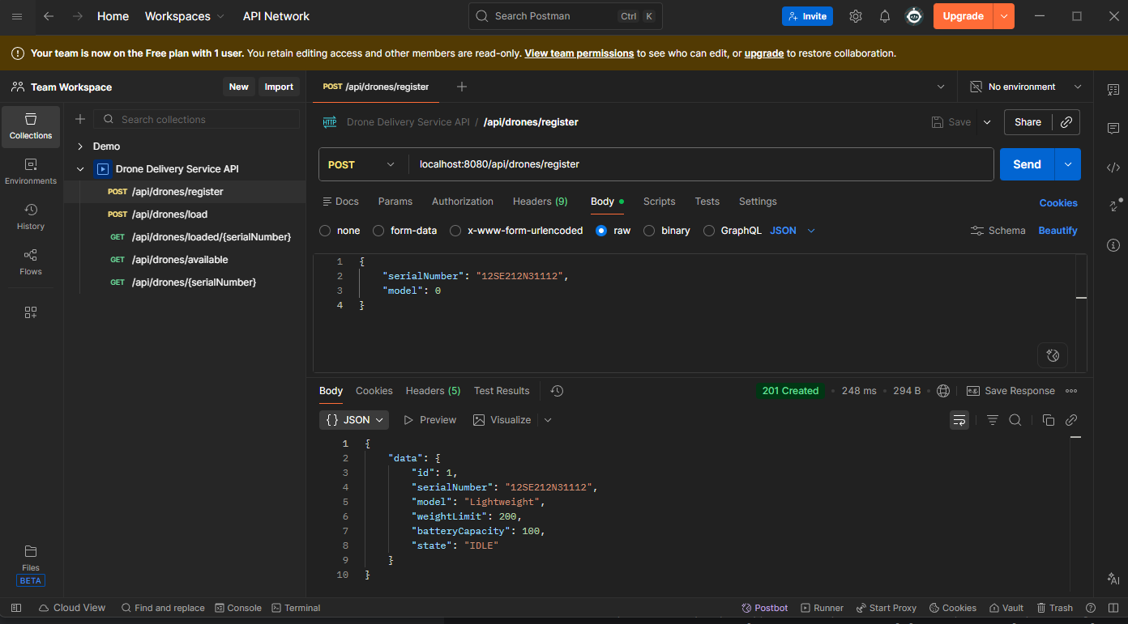
Figure 1: endpoint 1 - Registering a drone (successful)

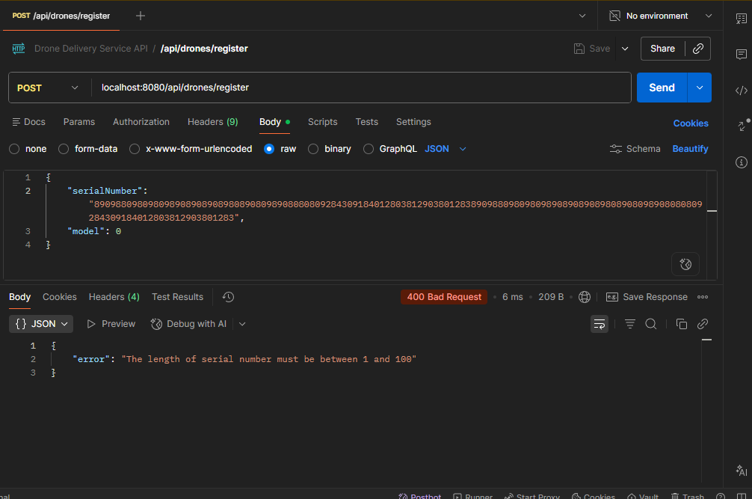
Figure 2: endpoint 1 - Registering a drone (when a validation failure occurs)

Case 2: Loading a drone with medication (/api/drones/load)
Also a CREATE operation that inserts a record into a join table between Drone and Medication – DroneMedicationMapping table – which serves as a delivery instance. It checks first if medication details provided in the request payload already exists in the db. If not, then it inserts a new Medication record into the database.
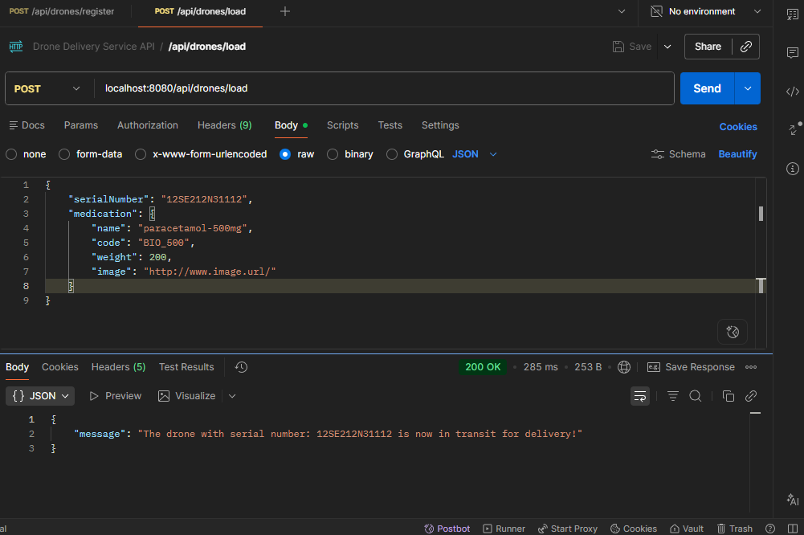
Figure 3: endpoint 2 - Loading a drone with medication (successful)

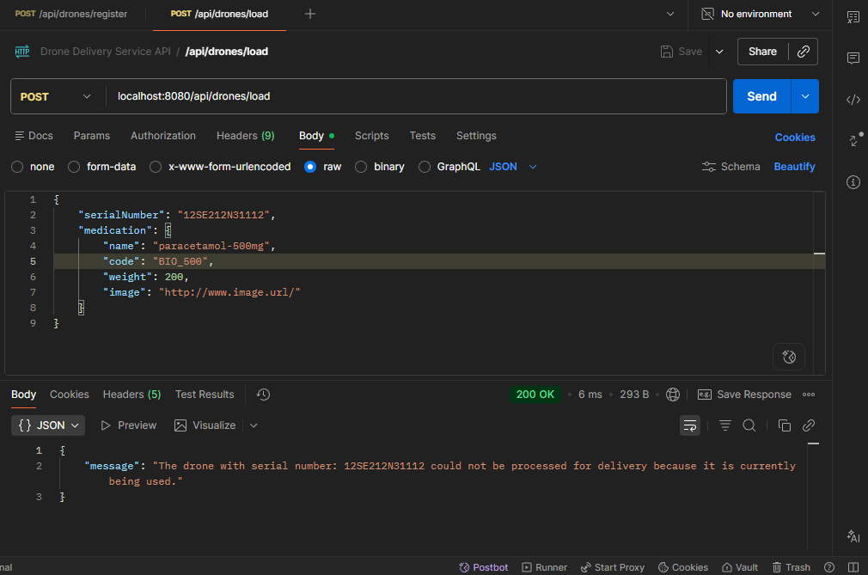
Figure 4: endpoint 2 - Loading a drone with medication (when drone's state is not IDLE)

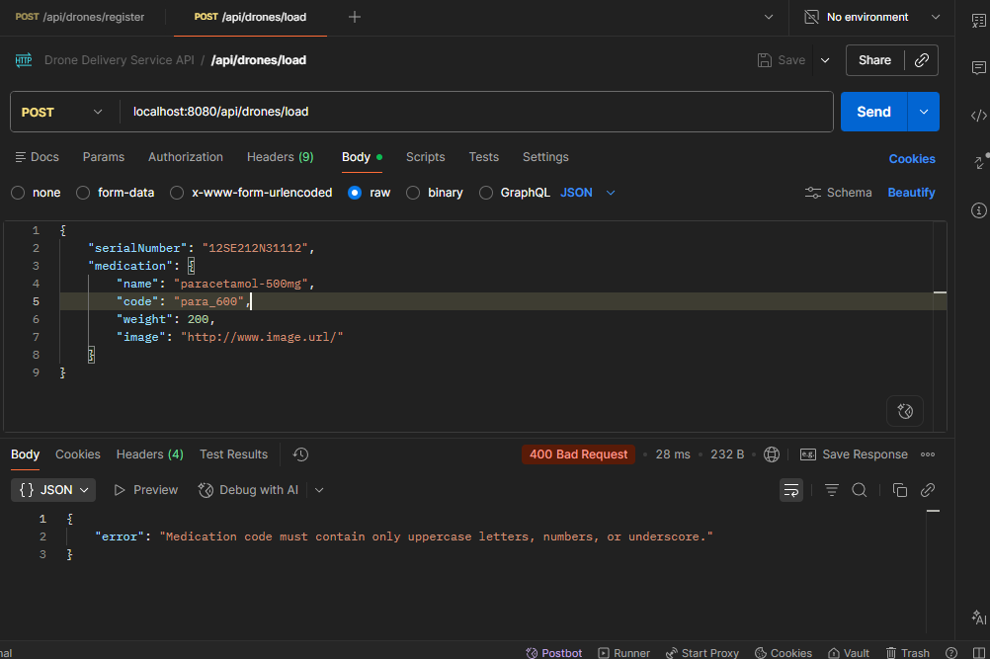
Figure 5: endpoint 2 - Loading a drone with medication (when a validation failure occurs)
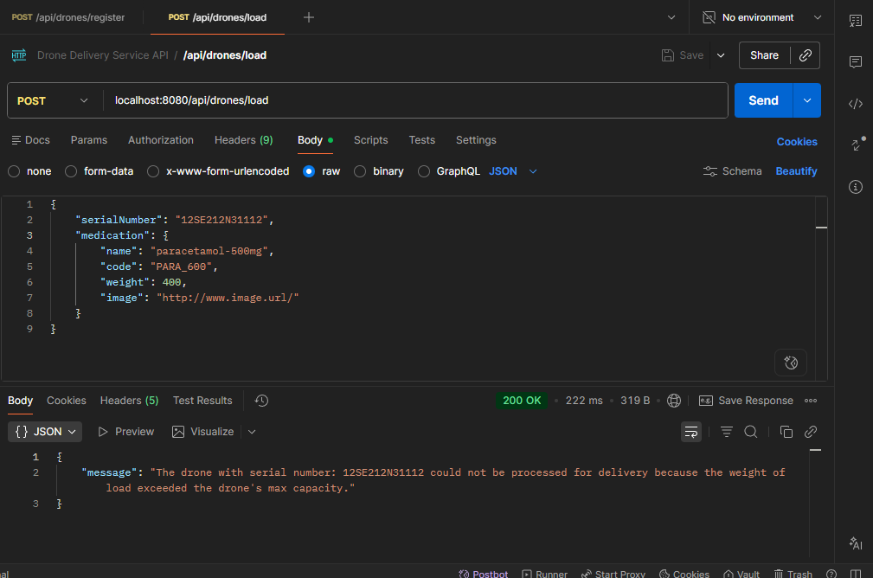
Figure 6: endpoint 2 - Loading a drone with medication (when medication weight exceeds the drone’s max capacity)

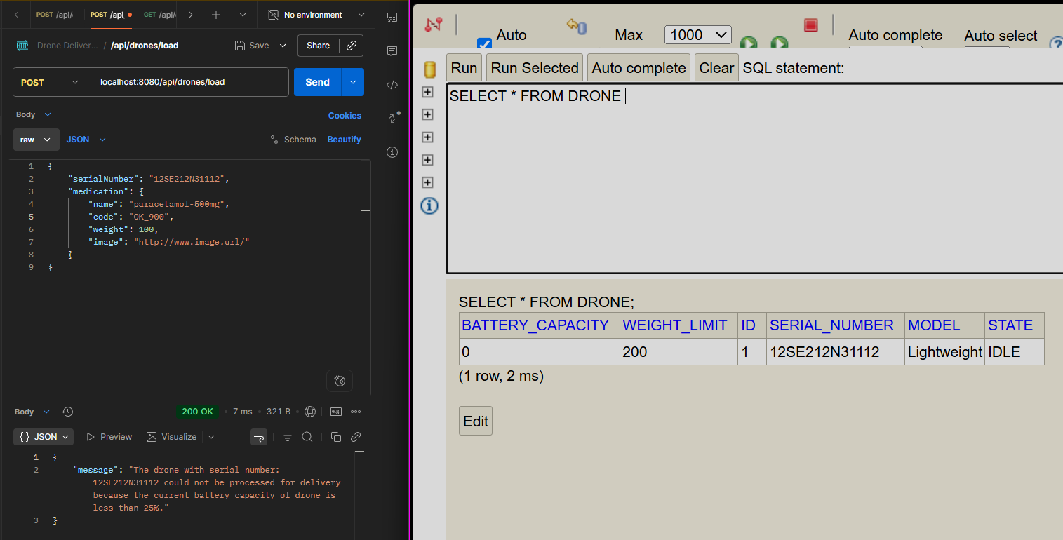
Figure 7: endpoint 2 - Loading a drone with medication (when drone’s battery capacity is under 25%)

Case 3: Checking loaded medications for a given drone (/api/drones/loaded/{serialNumber})
A GET operation that retrieves a record from a join table between Drone and Medication – DroneMedicationMapping table – which serves as a delivery instance. It checks if there is a delivery instance (or a loaded medication) currently on-going on a drone using the serial number provided.
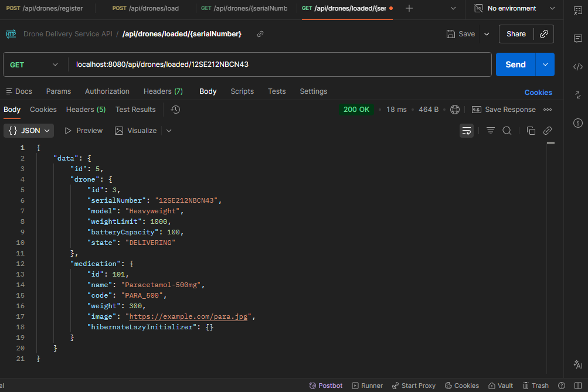
Figure 8: endpoint 3 - Checking loaded medications for a given drone (successful)
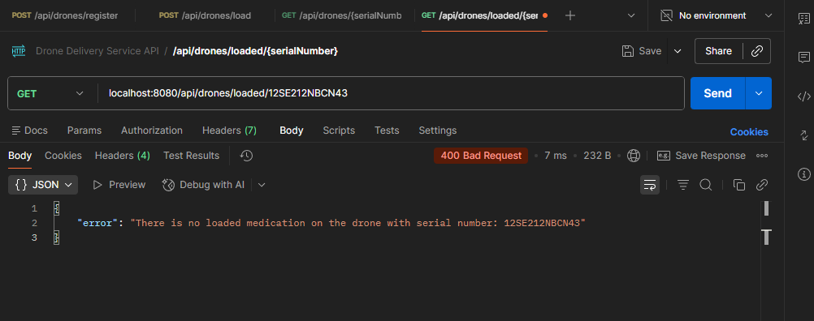
Figure 9: endpoint 3 - Checking loaded medications for a given drone (There is no on-going delivery for the given drone)

Case 4: Check drone availability for loading (/api/drones/available)
A GET operation that simply returns a list of all drone records that are in IDLE state (meaning available for loading/delivery). If no available, it will return an empty response.
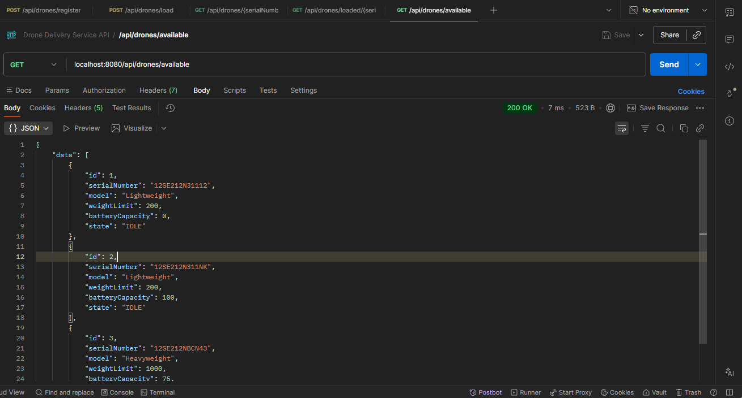
Figure 10: endpoint 4 - Check drone availability for loading (successful)
\

Case 5: Check drone information (Battery) (/api/drones/{serialNumber})
A GET operation that returns the details of a registered drone (which already includes the battery capacity).
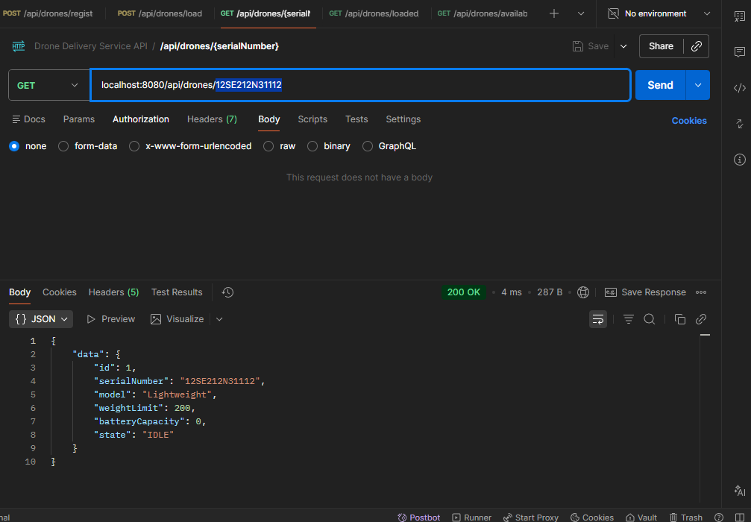
Figure 11: endpoint 5 - Check drone information (successful)

Additional test evidences
The following screenshots showcase the lifecycle of a drone state transition after loading a drone (via /api/drones/load). By the end of the lifecycle, a drone’s state would be back to IDLE, and its battery capacity is reduced.
