**Project Report**

**Bluetooth Controlled obstacle avoiding Car using Arduino**

**Name: Bluetooth Controlled obstacle avoiding Car using Arduino**

This is our first Arduino-based, Bluetooth-controlled RC car. It is controlled by a smart phone application.

**Presented By**

**182-15-2206 A M Meherullah Shahin**

**181-15-2075 Jannatul Moua Rima**

**182-15-2186 Raka Moni**

**182-15-2189 Fahmida Akter**

**182-15-2121 Ehtesum Haque**

**182-15-2165 Md.Hasan Hadiuzzaman**

A remote controlled vehicle is any mobile machine controlled by means that is physically not connected with origin external to the machine. There are many types in it, based on the controls – radio control device, Wi-Fi controlled and even Bluetooth controlled. These devices are always controlled by humans and take no action autonomously. The main target in such vehicles would be to safely reach a designated point, maneuver the area and reach back to the point of origin.

In this project we make use of the Bluetooth technology to control our machine

car. We don’t call this as a robot as this device doesn’t have any sensors. Thereby, sensor less robots are machines. This machine can be controlled by any human using his android mobile phone, by downloading an app and connecting it with the Bluetooth module present inside our car. User can perform actions like moving forward, backward, moving left and right by the means of command using his-her mobile phone app. The task of controlling our car is taken car by the Arduino UNO with micro controller ATMEGA32, 16 MHz processor, 2 KB SRAM (Static Random Accessible Memory) and 32 KB flash memory. Arduino play a major role in the control section and had made it easier to convert digital signals and analogue signals into physical movements. The major reason for using a Bluetooth based tech is that we can change the remote anytime – mobiles phones, tablets and laptops and physical barriers like wall or doors do not affect the car controls.

|  |  |  |
| --- | --- | --- |
| **Materials** | **Model or**  **Specifications** | **Model Picture** |
| **Arduino Board** | **UNO with ATMEGA32**  **micro controller** | **C:\Users\K S Kishore Kumaar.LAPTOP-T5PUTT6M\Desktop\Arduino_Uno_-_R3.jpg** |
| **Bluetooth Modules** | **HC-05** | **C:\Users\K S Kishore Kumaar.LAPTOP-T5PUTT6M\Desktop\hc-05-bluetooth-module-prayogindia.jpg** |
| **Motor Drive Shield** | **L298N H-Bridge Dual Motor Driver** |  |
| **2 Wheel car set** | **12V, 200rpm** |  |
| **Ultrasonic Sensor** | **3.3V / 5V,3cm – 350cm** | |
| **Connecting Wires and Jumper Cables** | **C:\Users\K S Kishore Kumaar.LAPTOP-T5PUTT6M\Desktop\A_few_Jumper_Wires.jpg C:\Users\K S Kishore Kumaar.LAPTOP-T5PUTT6M\Desktop\download (2).jpg** | |
| **Li-Ion Battery** |  | |

# Bluetooth Technology

Bluetooth wireless technology is a short range communications technology intended to replace the cables connecting portable unit and maintaining high levels of security. Bluetooth technology is based on Ad-hoc technology also known as Ad-hoc Pico nets, which is a local area network with a very limited coverage.

WLAN technology enables device connectivity to infrastructure based services through a wireless carrier provider. The need for personal devices to communicate wirelessly with one another without an established infrastructure has led to the emergence of Personal Area Networks (PANs). Bluetooth specification details the entire protocol stack. Bluetooth employs Radio Frequency (RF) for communication. It makes use of frequency modulation to generate radio waves in the ISM band.

The usage of Bluetooth has widely increased for its special features. Bluetooth offers a uniform structure for a wide range of devices to connect and communicate with each other. Bluetooth technology has achieved global acceptance such that any Bluetooth enabled device, almost everywhere in the world, can be connected with Bluetooth enabled devices. Low power consumption of Bluetooth technology and an offered range of up to ten meters has paved the way for several usage models. Bluetooth offers interactive conference by establishing an adhoc network of laptops. Bluetooth usage model includes cordless computer, intercom, cordless phone and mobile phones.

# Arduino UNO Board

The Arduino Uno is an [open-source](https://en.wikipedia.org/wiki/Open-source) [microcontroller board](https://en.wikipedia.org/wiki/Microcontroller_board) based on

the [Microchip](https://en.wikipedia.org/wiki/Microchip_Technology) [ATmega328P](https://en.wikipedia.org/wiki/ATmega328P) microcontroller and developed by [Arduino.cc](https://en.wikipedia.org/wiki/Arduino). The board is equipped with sets of digital and analog [input/output](https://en.wikipedia.org/wiki/Input/output) (I/O) pins that may be interfaced to various [expansion boards](https://en.wikipedia.org/wiki/Expansion_board) (shields) and other circuits. The board has 14 digital I/O pins (six capable of [PWM](https://en.wikipedia.org/wiki/Pulse-width_modulation) output), 6 analog I/O pins, and is programmable with the [Arduino IDE](https://en.wikipedia.org/wiki/Arduino#Software) (Integrated Development Environment), via a type B [USB cable](https://en.wikipedia.org/wiki/USB_cable). It can be powered by the USB cable or by an external [9-volt battery](https://en.wikipedia.org/wiki/9-volt_battery), though it accepts voltages between 7 and 20 volts.

It is similar to the [Arduino Nano](https://en.wikipedia.org/wiki/Arduino_Nano) and Leonardo. The hardware reference design

is distributed under a [Creative Commons](https://en.wikipedia.org/wiki/Creative_Commons) Attribution Share-Alike 2.5 license and is available on the Arduino website. Layout and production files for some versions of the hardware are also available. The word "[Uno](https://en.wiktionary.org/wiki/uno)" means "one"

in [Italian](https://en.wikipedia.org/wiki/Italian_language) and was chosen to mark the initial release of [Arduino Software](https://en.wikipedia.org/wiki/Arduino_Software). The Uno board is the first in a series of USB-based Arduino boards; it and version

* 1. of the Arduino [IDE](https://en.wikipedia.org/wiki/Integrated_development_environment) were the reference versions of Arduino, which have now evolved to newer releases. The ATmega328 on the board comes preprogrammed with a [bootloader](https://en.wikipedia.org/wiki/Bootloader) that allows uploading new code to it without the use of an external hardware programmer. While the UNO communicates using the original STK500 protocol, it differs from all preceding boards in that it does not use the FTDI USB-to-serial driver chip. Instead, it uses the Atmega16U2 (Atmega8U2 up to version R2) programmed as a [USB-to-serial converter](https://en.wikipedia.org/wiki/USB-to-serial_converter).

**L298N H-Bridge Dual Motor Driver**

The Motor Driver is a module for motors that allows you to control the working speed and direction of two motors simultaneously. This Motor Driver is designed and developed based on L293D IC.

L298N is a 16 Pin Motor Driver IC. This is designed to provide bidirectional drive currents at voltages from 5 V to 36 V.

Rotation of motor depends on Enable Pins. When Enable 1/2 is HIGH, motor connected to left part of IC will rotate according to following manner:

|  |  |  |
| --- | --- | --- |
| Input 1 | Input 2 | Result |
| 0 | 0 | Stop |
| 0 | 1 | Anti-Clockwise |
| 1 | 0 | Clockwise |

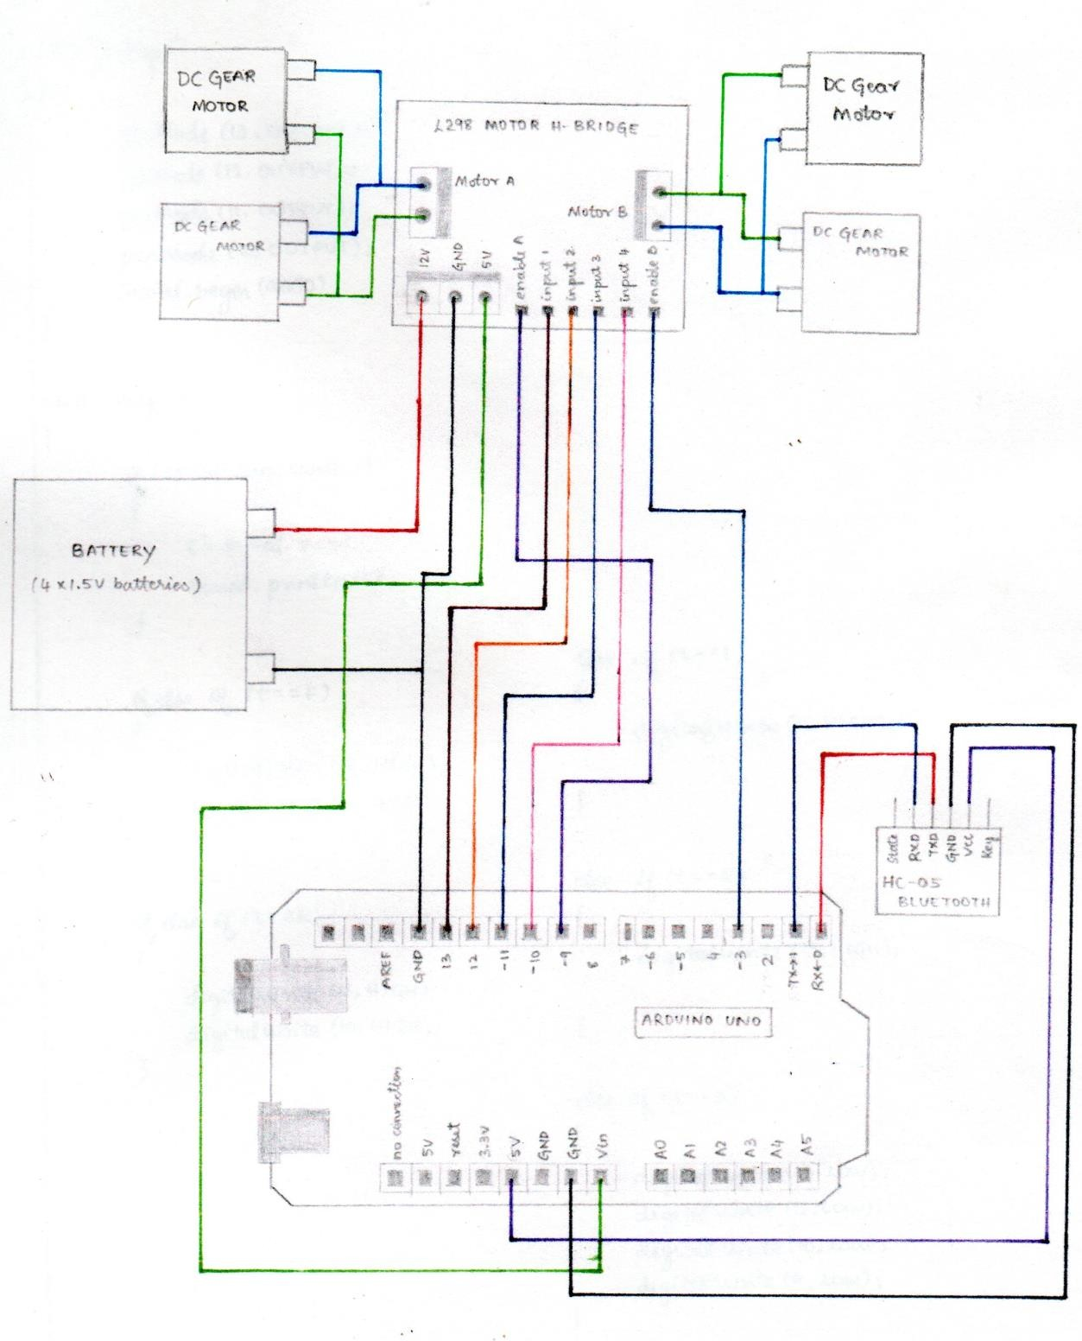

Take a closer look on the Wiring Diagram. We could notice the power source, four 1.5 volt batteries connected to the 12V power pin of L298 Motor Drive and ground of Motor Drive and Arduino UNO. This supplies essential power to the circuit. A total of 6 volts is being supplied to this system, where the maximum permissible amount is 12 volts. Digital wires of Arduino are connected with the input1, input2, input3 and input4 of the motor drive. Motors are connected to the either sides of Motor Drive which are the outputs terminals. To complete the power source circuit, 5V of Motor Drive is connected to Vin power pin of Arduino UNO. Followed by this, HC05 Bluetooth Module’s Vcc is connected to 5V pin of Arduino UNO, which supplies power to Bluetooth Module. Ground to Ground connections are also made. Transistor Transistor logic pins, Transmitter (TX) and Receiver (RX) of Arduino UNO are connected to RXD and TXD of HC05 respectively. The program is uploaded to Arduino before connecting the Bluetooth module.

After all successful connections, switch on the power source. Lights at Motor Drive, Arduino UNO and HC05 would indicate the correct connection. Upon successful connection of your Bluetooth module with any android device, we could control this device. By passing the command, for example, to move forward we pass ‘F’. This command is transmitted by our device to Bluetooth module, which in turn transmits to Arduino UNO. Arduino receives is and passes the same to Motor Drive through its digital pins. Motor Drive will get this through their input pins and exercise them through their output pins were motor is connected.

Github: [ammshahin/Bluetooth-controlled-Obstracle-Avoiding-robot-Arduino-Uno (github.com)](https://github.com/ammshahin/Bluetooth-controlled-Obstracle-Avoiding-robot-Arduino-Uno)

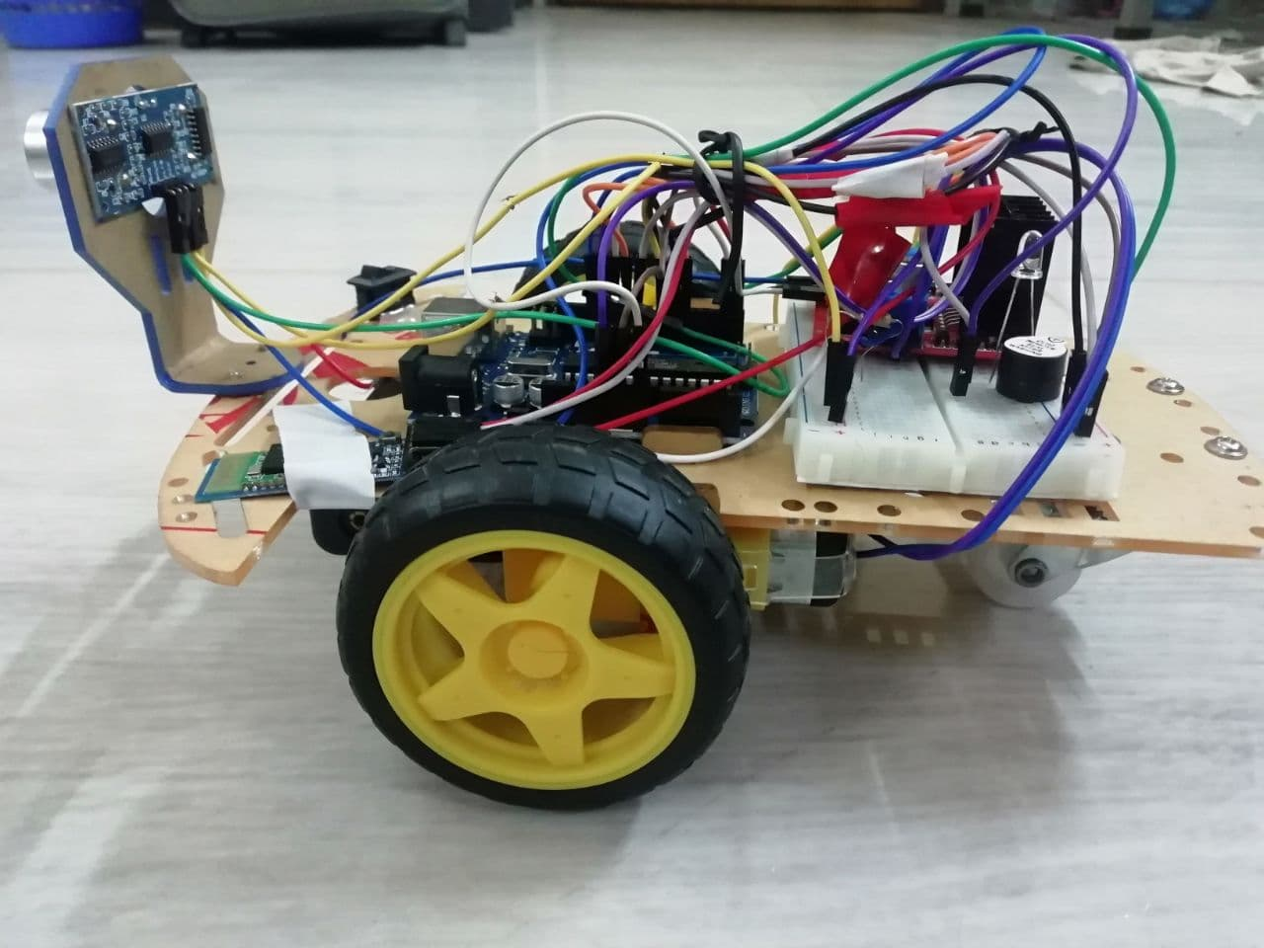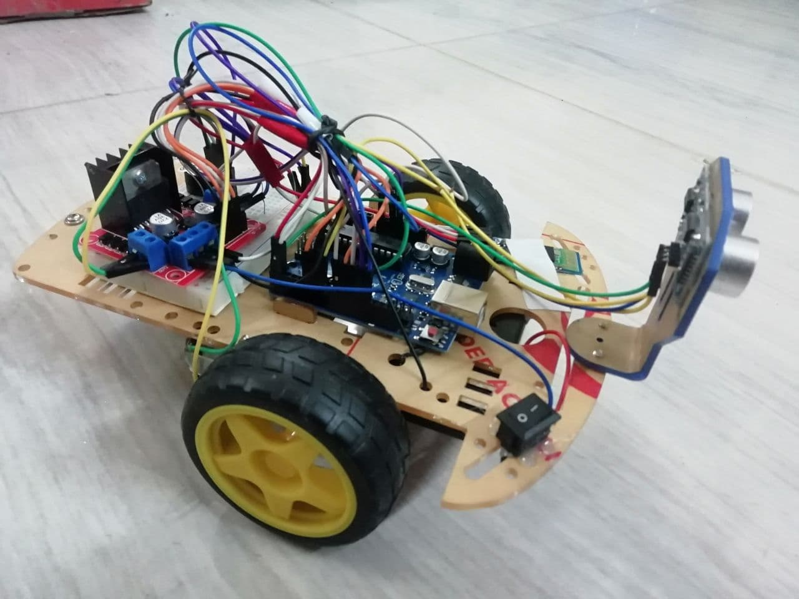

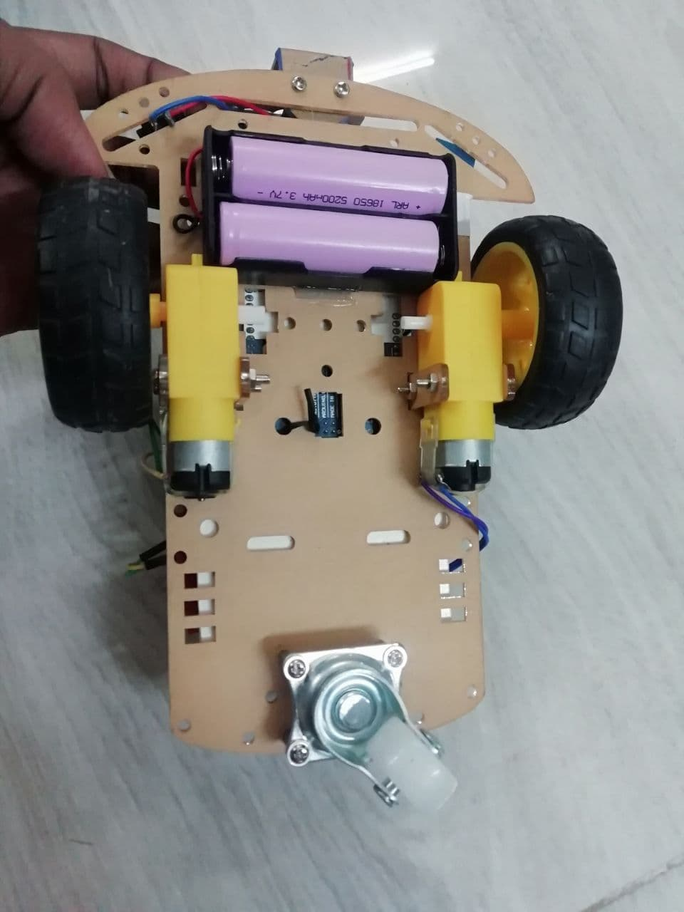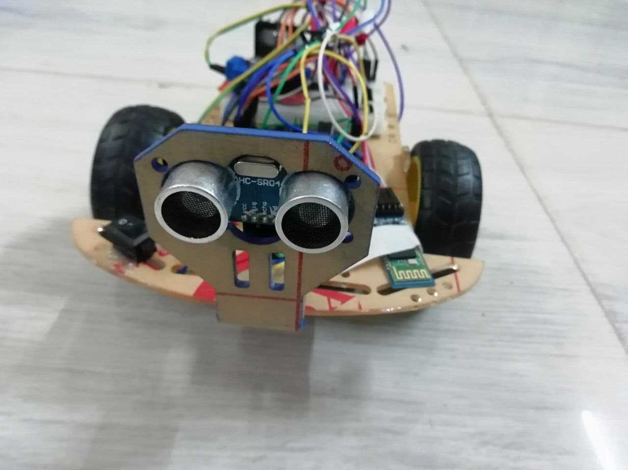

The final product we obtained is just the skeleton of those Remote Control Cars we see in the market. The mechanical design of this product is also proposed, which could be practically made to give a much better looking commercial product. For future plans, this product could be added with sensors like, accelerometer and humidity sensor, thereby widening their field of use.

The present product however could show some latency. The reason is, due to many connections and least power source of 6V, which result in loss of energy. So in future, we could use rechargeable batteries like Ni-Cd Battery or Li-ion battery that could avoid the present disadvantage.

Also, we could make use of this RC Motor Car as a surveillance system or rovers by adding a few more sensors and updating the code. This would make them into robots. These robots could self-monitor under any human supervision, thereby reducing man power. These are just the alternatives, on which this project could be improvised and updated.

* + 1. [https://create.arduino.cc/projecthub/samanfern/bluetooth-controlled- car-d5d9ca](https://create.arduino.cc/projecthub/samanfern/bluetooth-controlled-car-d5d9ca)
    2. [https://create.arduino.cc/projecthub/JANAK13/bluetooth-controlled- car- 2c60e9?ref=search&ref\_id=Elelctric%20Car%20with%20Bluetooth%20c ontrol&offset=2](https://create.arduino.cc/projecthub/JANAK13/bluetooth-controlled-car-2c60e9?ref=search&ref_id=Elelctric%20Car%20with%20Bluetooth%20control&offset=2)
    3. <https://www.engpaper.net/arduino.htm>
    4. [https://www.shutterstock.com/search/car+drawing](https://www.shutterstock.com/search/car%2Bdrawing)
    5. [https://www.instructables.com/Smartphone-Controlled-RC-Car-Using- Arduino/](https://www.instructables.com/Smartphone-Controlled-RC-Car-Using-Arduino/)