Facial Filter Impact on Face Recognition
Final Project Report
National University of Computer and Emerging Sciences
FAST School of Computing
Computer Vision - Spring 2026
Based on: A Comprehensive Evaluation Framework for the Study of the Effects of Facial Filters on Face Recognition Accuracy
Generated: May 31, 2026

Abstract
This project studies how face filters change face recognition results. The system follows the main idea of the selected paper. It prepares face image pairs, applies filters, extracts face embeddings, checks if two faces match, measures errors, and shows the result in a live web app. The project uses the LFW dataset and six filter types. On the 600 pair test set, ArcFace reached 58.81% average accuracy on filtered images. The improved model path reached 77.86%.

1. Introduction and Problem Definition
Face recognition systems are used in phones, apps, online accounts, and identity checks. Many people also use face filters. These filters can change light, color, skin texture, eyes, or face shape. The problem is to check how these filters affect face verification. Face verification means checking if two images show the same person.

2. Literature Review
The main paper by Ozturk et al. gives a framework to study face filters and face recognition. It uses a dataset, filters, FNMR, FMR, and DET curves. ArcFace is a strong face recognition baseline. AdaFace is useful because it is quality-aware. LFW is a public dataset used for face verification tests.

3. Methodology and System Architecture
The system steps are dataset setup, filter creation, embedding extraction, face pair scoring, metric calculation, correction, plotting, and web demo.
Stage | File | Work done
Dataset setup | src/01_setup_dataset.py | Prepare LFW and pair CSV files.
Filter creation | src/02_apply_filters.py | Create six filter types.
Embedding | src/04_extract_embeddings.py and 04b | Save face embeddings.
Evaluation | src/05_evaluate_recognition.py | Compute accuracy, FNMR, FMR, and DET curves.
Demo | app/app.py | Run the Gradio web app.

The system uses cosine similarity to compare embeddings. FNMR means same-person pairs that are rejected. FMR means different-person pairs that are accepted.

4. Dataset Description
The project uses LFW. It has 13,233 original images and 5,749 identities. The submitted test uses 300 same-person pairs and 300 different-person pairs. It creates 4,842 filtered images from 807 unique images.
Dataset item | Value
Original images | 13,233
Identities | 5,749
Same-person pairs | 300
Different-person pairs | 300
Filtered images | 4,842
Filters | blur, brightness, skin_smooth, eye_enlarge, face_slim, color_tone

LFW is public research data. It should be used only for academic work. This project is not a real identity or surveillance system.

5. Implementation Details
The code uses Python, OpenCV, PIL, DeepFace, NumPy, pandas, scikit-learn, matplotlib, seaborn, and Gradio. ArcFace is the baseline. The improved path tries AdaFace, but uses GhostFaceNet fallback on this machine. The correction methods are mean-shift and Ridge linear correction.
- Blur blends Gaussian blur with the original image.
- Brightness increases brightness and saturation.
- Skin smooth smooths skin-like pixels.
- Eye enlarge changes the eye region slightly.
- Face slim compresses the face area sideways.
- Color tone makes the image warmer.

6. Experiments and Results

6.1 ArcFace baseline
ArcFace original image accuracy is 58.17%. Average filtered accuracy is 58.81%. Average FNMR at FMR=1% is 94.78%.
Filter | Accuracy | FNMR at FMR=1% | FNMR at FMR=0.1%
original | 58.17% | 94.00% | 99.33%
blur | 58.83% | 94.33% | 97.33%
brightness | 58.83% | 94.33% | 98.67%
skin_smooth | 59.67% | 98.33% | 99.33%
eye_enlarge | 58.83% | 93.33% | 99.00%
face_slim | 58.67% | 96.67% | 100.00%
color_tone | 58.00% | 91.67% | 100.00%

6.2 Improved model path
The improved model path original image accuracy is 79.33%. Average filtered accuracy is 77.86%. Average FNMR at FMR=1% is 65.17%.
Filter | Accuracy | FNMR at FMR=1% | FNMR at FMR=0.1%
original | 79.33% | 63.33% | 83.33%
blur | 77.17% | 67.33% | 75.33%
brightness | 78.67% | 61.67% | 80.00%
skin_smooth | 77.00% | 64.67% | 75.33%
eye_enlarge | 78.50% | 65.00% | 82.67%
face_slim | 77.50% | 71.33% | 74.00%
color_tone | 78.33% | 61.00% | 80.33%

6.3 Mitigation results
Mean-shift and linear correction try to reduce filter effects. On average, the improved model plus linear corrector lowers FNMR by 40.2 percent compared with the ArcFace baseline. The result is mixed for some filters because the subset is small.
Filter | ArcFace FNMR | Mean-shift | Improved model | Linear corrector
blur | 94.33% | 60.00% | 67.33% | 46.67%
brightness | 94.33% | 80.00% | 61.67% | 46.67%
skin_smooth | 98.33% | 62.22% | 64.67% | 80.00%
eye_enlarge | 93.33% | 68.89% | 65.00% | 46.67%
face_slim | 96.67% | 62.22% | 71.33% | 73.33%
color_tone | 91.67% | 66.67% | 61.00% | 46.67%

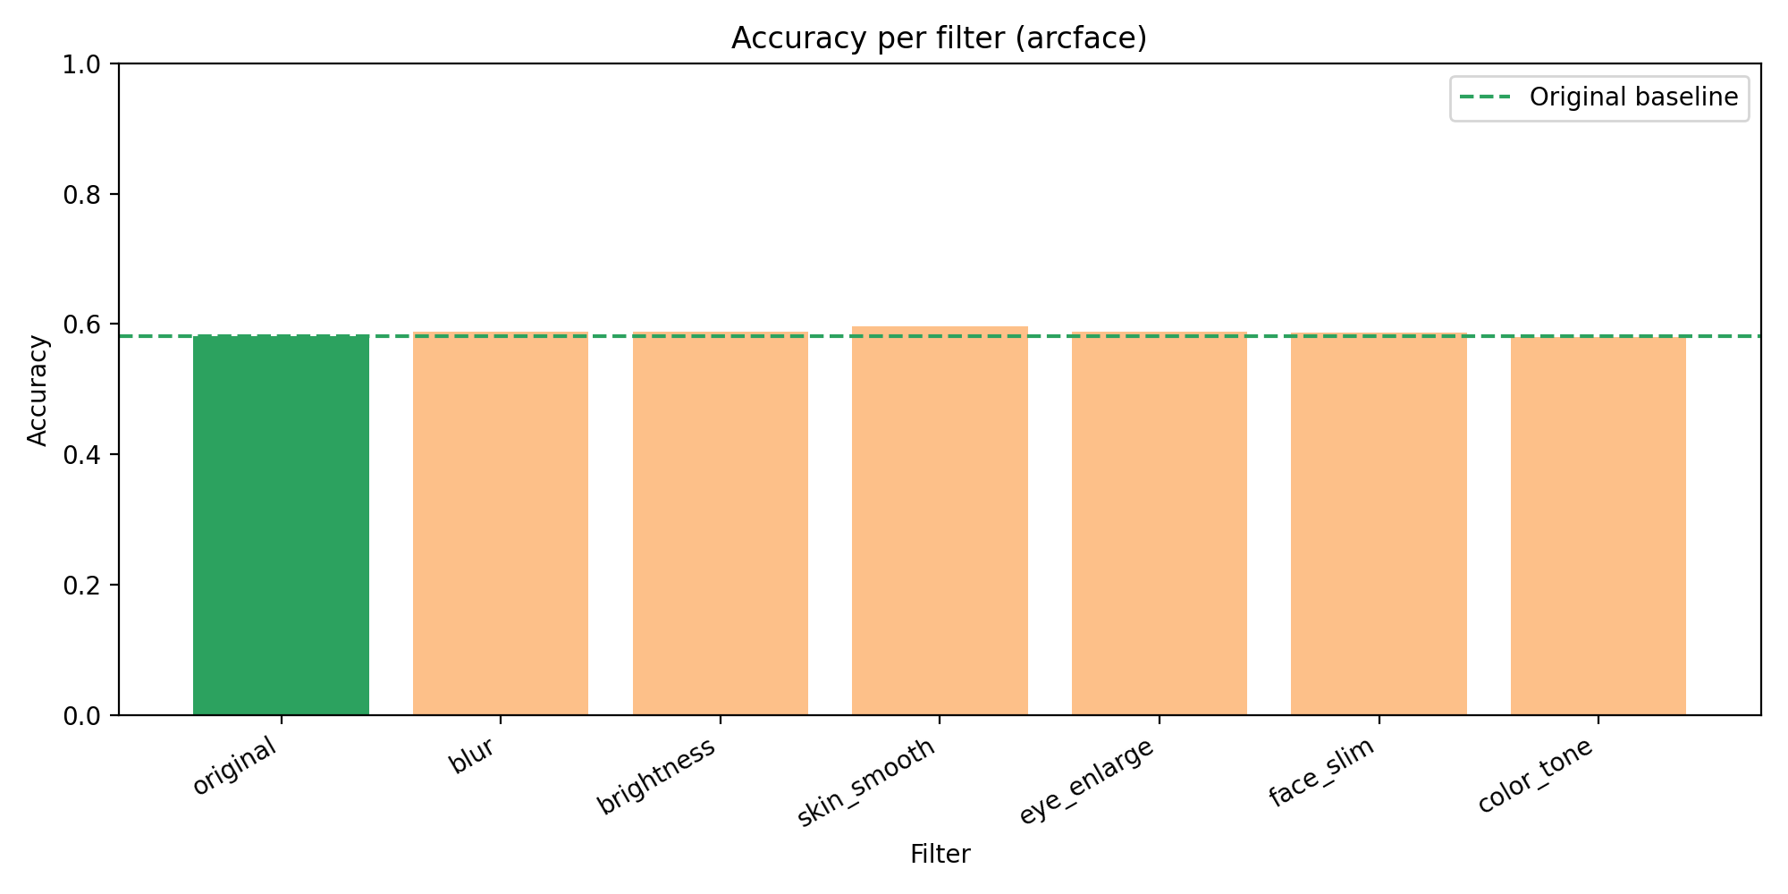
ArcFace accuracy per filter.
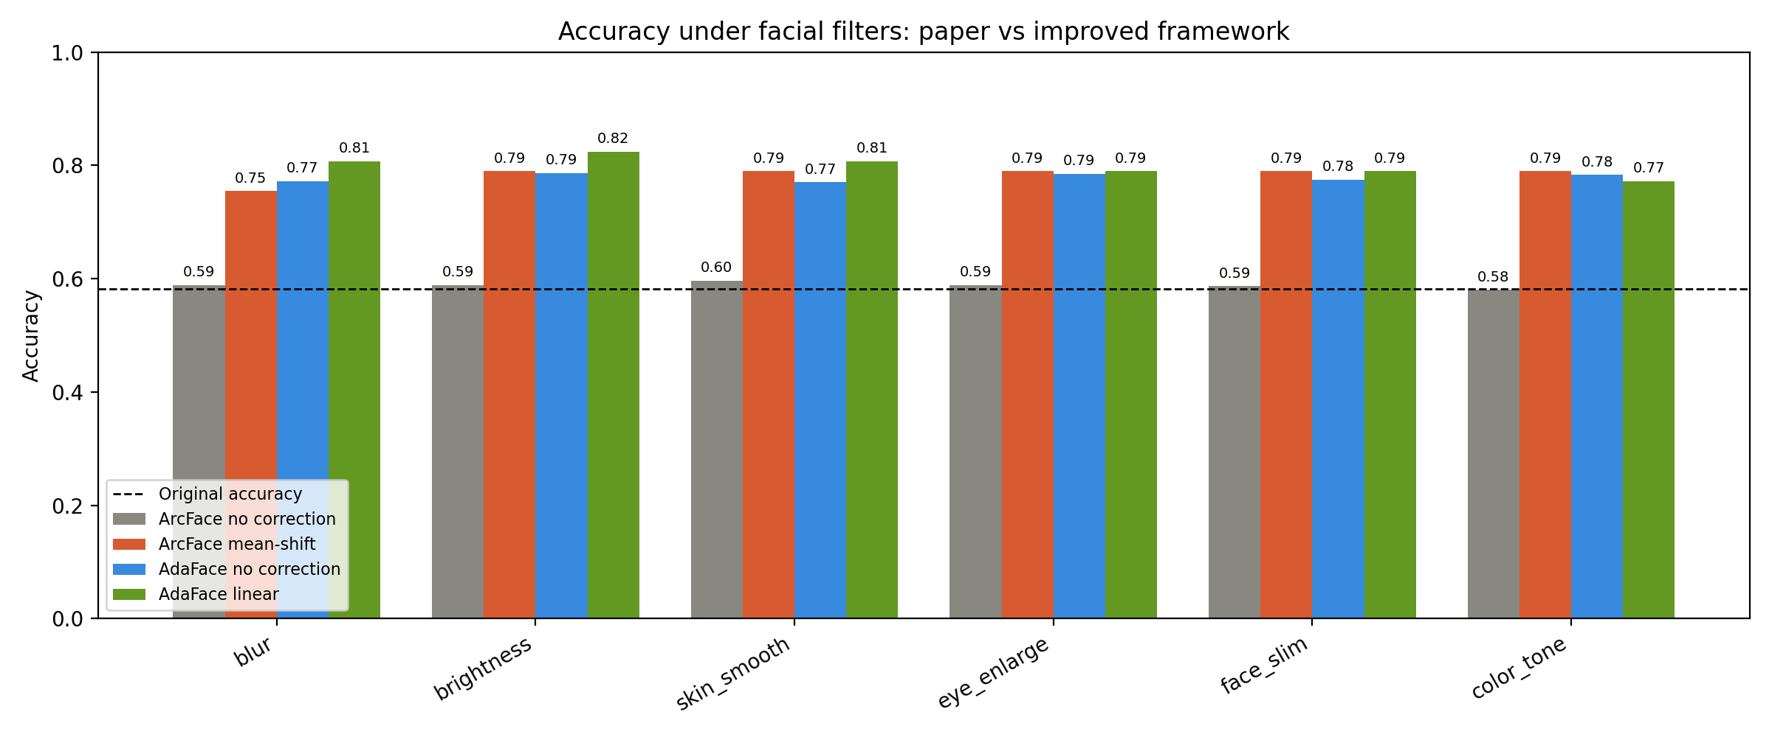
Accuracy comparison.
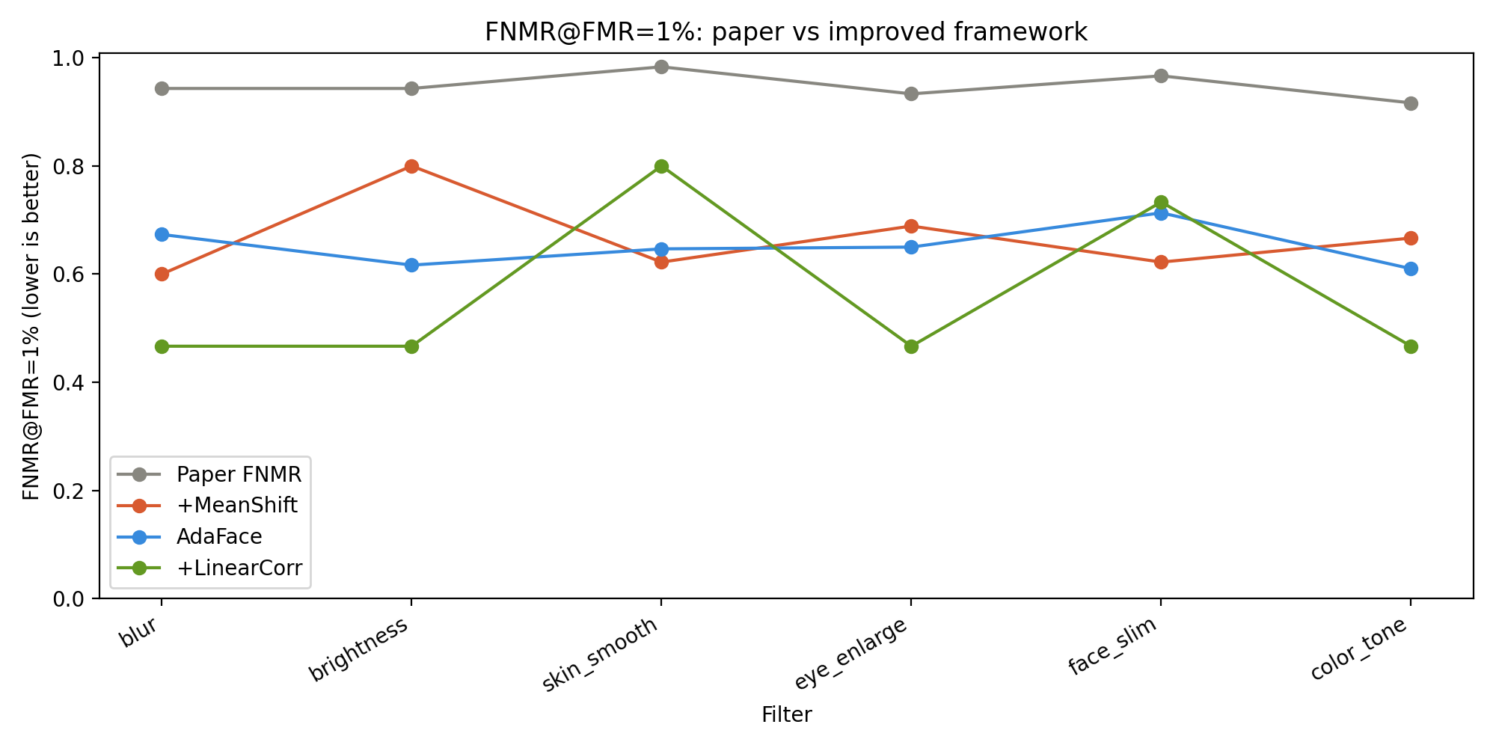
FNMR comparison.

7. Discussion and Limitations
The results show that filters can change face recognition scores. The improved model path works better than ArcFace on this test set. The correction methods help on average, but they are not perfect for every filter.
- The original paper used FRGC, but this project uses LFW.
- The original paper used real mobile filters, but this project uses programmatic filters.
- The test uses 600 pairs to keep runtime practical.
- AdaFace was not available in Python 3.13, so GhostFaceNet fallback was used.
- The project does not test fairness across groups.

8. Conclusion and Future Work
This project builds a full computer vision system for the selected problem. It prepares data, applies filters, extracts embeddings, measures face verification, tests correction methods, creates plots, and runs a live demo. Future work can use FRGC, real mobile filters, more pairs, one correction model for all filters, and fairness testing.

9. References
[1] K. Ozturk, L. Conwill, J. Gutierrez, K. Bowyer, and W. J. Scheirer. A Comprehensive Evaluation Framework for the Study of the Effects of Facial Filters on Face Recognition Accuracy. IJCB 2025 / arXiv:2507.17729.
[2] J. Deng, J. Guo, N. Xue, and S. Zafeiriou. ArcFace: Additive Angular Margin Loss for Deep Face Recognition. CVPR 2019.
[3] M. Kim, A. K. Jain, and X. Liu. AdaFace: Quality Adaptive Margin for Face Recognition. CVPR 2022.
[4] G. B. Huang, M. Ramesh, T. Berg, and E. Learned-Miller. Labeled Faces in the Wild: A Database for Studying Face Recognition in Unconstrained Environments. UMass Technical Report 07-49, 2007.
[5] P. Riccio et al. OpenFilter: A Framework to Democratize Research Access to Social Media AR Filters. NeurIPS 2022.

