Model Optimisation for Edge Deployment
Quantisation (PTQ, QAT) and Pruning (unstructured, structured) of a CIFAR-10 ResNet-18
Assignment 03 — Edge Computing & Intelligent Systems
Platform: Apple M4 (macOS), PyTorch 2.8, Python 3.9, ONNX-Runtime 1.19. All CPU timings use 1 thread unless stated.

1. Summary of results
All five models were evaluated on the full 10,000-image CIFAR-10 test set with one automated script (benchmark.py). Sizes are the state-dict checkpoints on disk; latency is batch-1 on one CPU thread; throughput is batch-128.
Model | Acc % | Drop (pts) | Size MB | Gzip MB | Params | Sparsity % | MACs (M) | Lat. bs1 (ms) | Img/s bs128 | Speed-up
FP32 baseline | 93.43 | 0.0 | 44.77 | 41.49 | 11173962 | 0.0 | 555.4 | 5.253 | 175.8 | 1.0
PTQ INT8 | 93.53 | -0.1 | 11.31 | 9.97 | 11173962 | 0.0 | 555.4 | 4.395 | 242.8 | 1.2
QAT INT8 | 93.24 | 0.19 | 11.22 | 8.83 | 11173962 | 0.0 | 555.4 | 4.361 | 251.4 | 1.2
Unstructured pruned | 93.47 | -0.04 | 44.77 | 7.09 | 11173962 | 90.0 | 555.4 | 5.45 | 174.8 | 0.96
Structured pruned | 93.34 | 0.09 | 15.72 | 14.56 | 3913470 | 0.0 | 293.2 | 3.524 | 303.6 | 1.49

- PTQ-INT8: 3.96x smaller, 1.20x faster at batch 1, accuracy 93.53% (FP32 93.43%).
- QAT-INT8: 3.99x smaller, 1.20x faster, accuracy 93.24%.
- Unstructured pruning (90% sparse): accuracy 93.47%, gzip size 5.8x smaller, but NO speed-up on a dense CPU runtime (0.96x).
- Structured pruning: 65% fewer parameters, 47% fewer MACs, 1.49x faster, accuracy 93.34%.
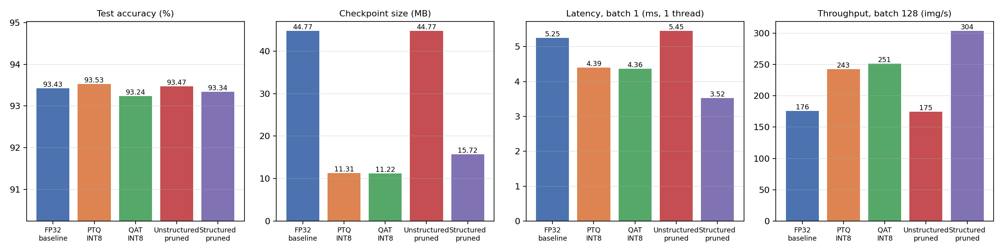
Figure 1 - accuracy, size, latency and throughput of the five models.
Statistical caveat: with 10,000 test images the binomial standard error of an accuracy near 93% is about 0.25 percentage points, and every result is a single run with a fixed seed. Differences of a few tenths of a point between the five models (including PTQ appearing 0.10 pts 'better' than FP32) are therefore within noise and should be read as 'no measurable accuracy loss', not as one method being better.

2. Implementation

2.1 Common infrastructure (common.py)
- Data: CIFAR-10 held in memory as uint8; per-batch normalisation and random-crop (4 px padding) + horizontal-flip augmentation done on the accelerator. The test set is only used for evaluation, never for training or calibration.
- Model: CIFAR-style ResNet-18 (3x3 stem, no max-pool, 11.17 M parameters, 555 M MACs). Every residual add+ReLU uses FloatFunctional.add_relu so the network can be quantised in eager mode; the block constructor takes the inner width as an argument so a physically smaller network can be rebuilt after channel pruning.
- Reproducibility: fixed seed 42, run_all.sh runs the whole pipeline, every step logs to logs/.

2.2 Baseline FP32 (train_baseline.py)
20 epochs, SGD (Nesterov momentum 0.9, weight-decay 5e-4), one-cycle LR schedule with peak 0.1, batch 128, on the Apple GPU (MPS). The final-epoch model is saved (no best-epoch selection on the test set). Result: 93.43% test accuracy (training took 53 minutes).
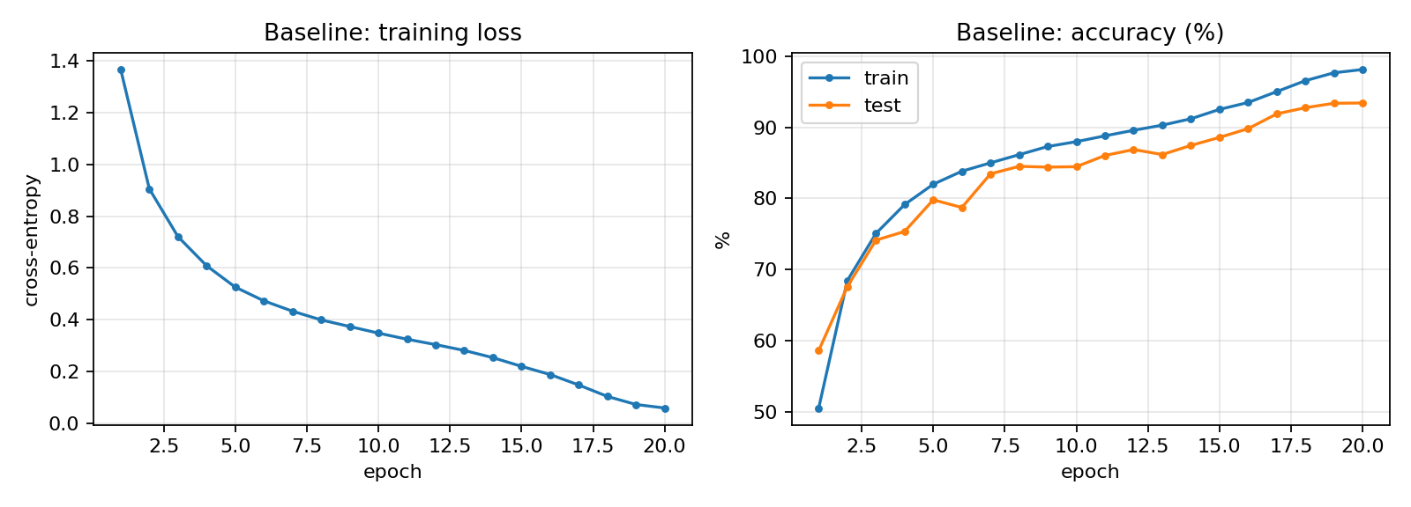
Figure 2 - baseline training curves.

2.3 Post-training static quantisation (ptq.py, calibration.py)
- Fusion: Conv+BN+ReLU, Conv+BN (including the 1x1 shortcut convolutions) are fused with fuse_modules (eval mode).
- Backend: torch.backends.quantized.engine is chosen at run time - FBGEMM on x86, QNNPACK on this ARM machine (FBGEMM is not available on Apple silicon).
- QConfig: per-channel symmetric INT8 weights, UINT8 activations with a HistogramObserver.
- Calibration: 2,000 randomly chosen TRAINING images (no augmentation) are passed through the observed model.
- Convert + save: converted to INT8, evaluated, saved both as state_dict and as self-contained TorchScript; the script reloads the TorchScript file and checks that it reproduces the in-memory accuracy exactly.
Result: 93.53% test accuracy, 11.31 MB (3.96x smaller).

2.4 Quantisation-aware training (qat.py)
- Initialised from the pretrained FP32 checkpoint; Conv+BN+ReLU fused with the QAT fusion (train mode); FakeQuantize modules inserted with prepare_qat (QNNPACK QAT qconfig).
- Fine-tuning: 3 epochs x 20,000 random training images, SGD lr 0.005 with cosine decay. BatchNorm statistics are frozen from epoch 2 and the observers from epoch 3. QAT runs on the CPU because the fused fake-quant operator is not implemented for the Apple GPU (MPS); this limited the budget to ~15 minutes per epoch.
- Convert to INT8, evaluate, save state_dict + TorchScript (+ the fake-quant model for reference).
Result: 93.24% test accuracy, 11.22 MB. In this experiment QAT did not beat PTQ: the FP32 model is quantisation-friendly (per-channel weights + histogram calibration already lose nothing measurable), so there is little for QAT to recover, and QAT used per-tensor weights and a very short schedule. We report this as measured rather than tune toward the textbook expectation.

2.5 Unstructured pruning (prune_unstructured.py)
- Global L1-magnitude pruning over all Conv2d and Linear weights (torch.nn.utils.prune), with masks (weight_orig + weight_mask) active during fine-tuning.
- Iterative: 5 pruning iterations on a cubic sparsity schedule (43.9 -> 70.6 -> 84.2 -> 89.3 -> 90.0 %), one fine-tuning epoch after each, then 6 final fine-tuning epochs.
- Permanent: prune.remove bakes the mask into the weight tensors; the script checks that sparsity (90.00%) and accuracy are unchanged by this step.
Observation: global pruning removes far more from the wide, redundant last stage (layer4 convolutions 93-99.9% sparse) than from the early layers (40-45%), and the first conv and fully-connected layer are barely pruned.
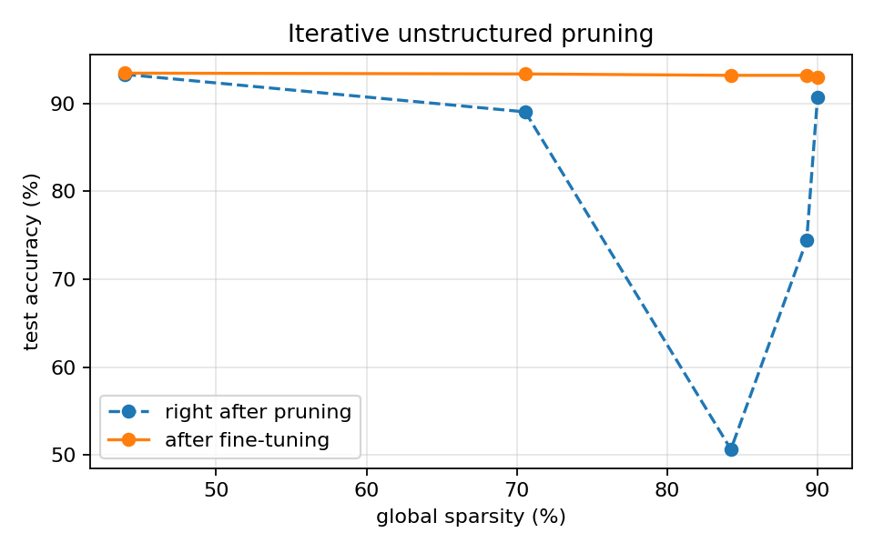
Figure 3 - accuracy right after each pruning step and after fine-tuning.

2.6 Structured channel pruning (prune_structured.py)
- Scope: the inner width of each of the 8 residual blocks (conv1 output = conv2 input). The residual-stream width is tied to the shortcut connections and the next block's input, so leaving it untouched keeps every addition dimensionally valid without touching other layers.
- Ranking: L1 norm of each conv1 filter. Pruned fraction per block: 25/25/40/40/60/60/70/70 % (more in the later, wider stages).
- Reconstruction: a new, physically smaller ResNet-18 is instantiated with the reduced widths [48, 48, 77, 77, 102, 102, 154, 154] and the surviving weights (conv1 filters, bn1 channels, conv2 input channels) are copied in. No masks and no zero-valued channels remain.
- Verification: the rebuilt network's logits equal those of the original network with the pruned channels masked to zero (max difference 0 on a test batch). The script asserts this before fine-tuning.
- Fine-tuning: 12 epochs, SGD lr 0.02 with cosine decay. Accuracy fell to 30.2% straight after pruning and recovered to 93.34%.
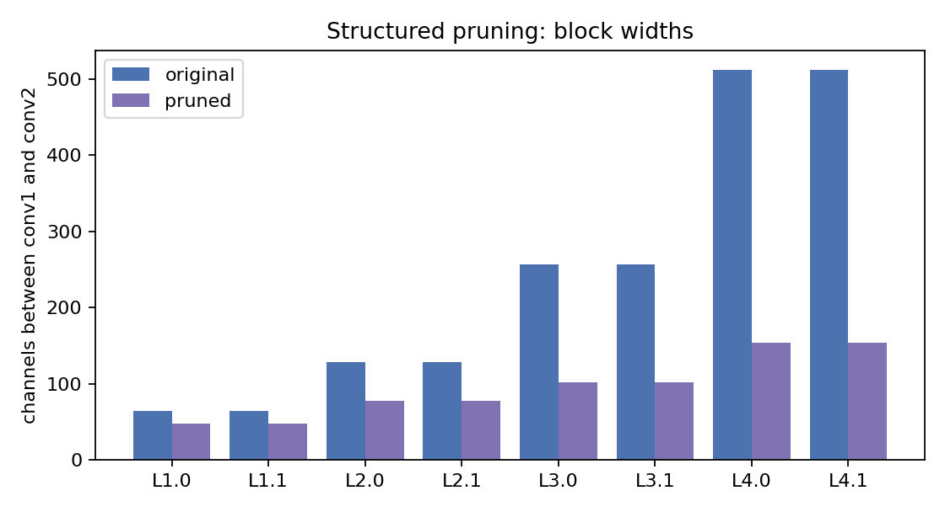
Figure 4 - internal block widths before / after structured pruning.
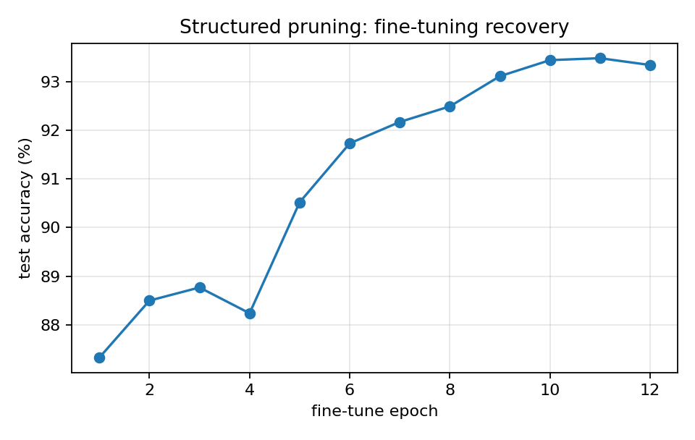
Figure 5 - recovery of the structured-pruned model during fine-tuning.

2.7 Inference pipeline (inference.py)
A single entry point loads any of the five models (FP32 / PTQ-INT8 / QAT-INT8 / unstructured / structured) through load_model(key): float models are rebuilt from their checkpoint (the structured checkpoint stores its channel widths), INT8 models are loaded from TorchScript with the right quantisation backend selected first. It classifies CIFAR-10 test samples or arbitrary image files (resized to 32x32) and prints a side-by-side table.
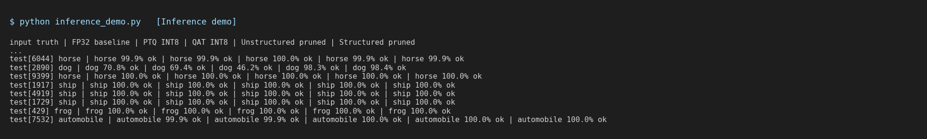
Figure 6 - inference.py on 8 random test images, all five models.

2.8 Benchmark (benchmark.py)
Evaluates all five models on the full test set and writes: results/benchmark_results.csv (summary), results/predictions.csv (per-image label, prediction and confidence for each model), and the per-question subsets q1_quantization_results.csv, q1_quantization_predictions.csv, q2_pruning_results.csv. Latency is the mean of 200 batch-1 runs after 30 warm-up runs (p50/p95 also recorded); throughput is measured over 768 test images at batch 128.
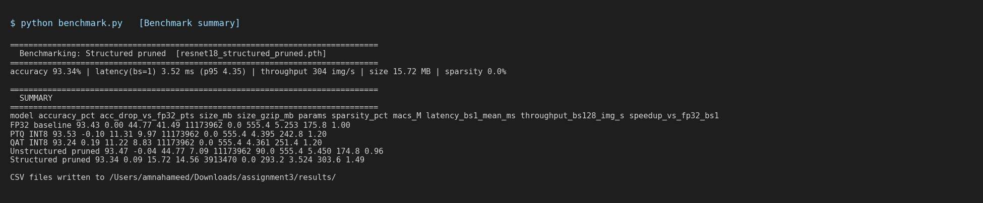
Figure 7 - benchmark.py console output.

3. ONNX deployment
export_onnx.py exports all five models; onnx_inference.py runs them with ONNX-Runtime's CPU provider (no PyTorch needed for inference) and writes results/onnx_benchmark.csv.
- FP32, unstructured and structured models: direct torch.onnx.export (opset 13, dynamic batch).
- INT8 models: PyTorch eager-mode quantised operators have no ONNX representation. The converted INT8 model is therefore re-expressed as a QDQ graph: the exact INT8 weights, per-channel scales, activation scales and zero-points are read from the converted PyTorch model and written as QuantizeLinear/DequantizeLinear nodes around Conv/Gemm/Add/ReLU, then weight Quantize nodes are constant-folded to real INT8 initialisers. The ONNX INT8 models therefore carry the PTQ-calibrated / QAT-learned parameters (not a re-calibration).
- Fidelity: the QDQ twin agrees with the PyTorch INT8 model on 99.6% (PTQ) / 99.8% (QAT) of 500 test images; small differences come from the float emulation of integer arithmetic.
ONNX model | Acc % | Agreement w/ FP32 % | Size MB | Lat. bs1 (ms) | Img/s | Speed-up
FP32 baseline | 93.43 | 100.0 | 44.69 | 11.29 | 92.7 | 1.0
PTQ INT8 (QDQ) | 93.42 | 99.66 | 11.24 | 12.048 | 91.1 | 0.94
QAT INT8 (QDQ) | 93.27 | 97.88 | 11.22 | 12.016 | 90.2 | 0.94
Unstructured pruned | 93.47 | 96.78 | 44.69 | 11.281 | 92.8 | 1.0
Structured pruned | 93.34 | 95.53 | 15.65 | 6.14 | 166.4 | 1.84

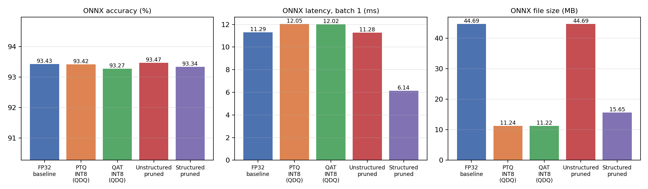
Figure 8 - ONNX-Runtime CPU results.
Honest finding: ONNX accuracies match PyTorch (93.43% / 93.42% / 93.27% / 93.47% / 93.34%). The INT8 ONNX files are 4.0x smaller but are NOT faster under ONNX-Runtime on this Apple CPU (0.94x), unlike PyTorch's QNNPACK kernels (1.2x). ONNX-Runtime's FP32 convolutions are well optimised for this CPU and its QDQ execution adds quantise/dequantise overhead; INT8 speed-ups depend strongly on the target CPU and runtime. The structured-pruned model gives the largest real speed-up (1.84x) because it simply has fewer operations.

4. Discussion
- Quantisation (PTQ/QAT) gives a reliable ~4x reduction in model size with no measurable accuracy change, and a modest 1.2x speed-up on this CPU in PyTorch. Calibration with 2,000 images was enough; PTQ took about a minute.
- Unstructured pruning reaches 90% sparsity with no accuracy loss, but the zeros live inside dense tensors: the file is the same size and the dense kernels do the same work, so latency does not improve. The benefit shows up only with compression (gzip: 41.5 -> 7.1 MB) or a sparse-aware runtime/hardware.
- Structured pruning delivers genuine compute savings with standard dense kernels (-65% parameters, -47% MACs, 1.5x faster in PyTorch, 1.8x in ONNX-Runtime), at the cost of a larger accuracy hit directly after pruning (30%) that needs a proper fine-tuning budget; after 12 epochs it is within 0.1 pts of the baseline.
- The techniques are complementary (e.g. structured pruning followed by INT8 quantisation) but combining them was outside the assignment's scope and was not evaluated.

5. Limitations
- Single seed, single run per method; the test set doubled as the monitoring set during training (no separate validation split), though no model selection was done on it (final-epoch models are saved).
- Timing is from one Apple M4 laptop, 1 thread, with other applications running; use it for relative comparison only. INT8 checkpoints are QNNPACK-specific and must be regenerated (ptq.py / qat.py) for an x86 FBGEMM deployment.
- QAT used a short schedule (3 x 20k images) because it must run on the CPU; a longer schedule or per-channel QAT weights may change the PTQ-vs-QAT ordering.
- Structured pruning prunes only the inner width of residual blocks; pruning the residual stream would give larger savings but needs coupled pruning across a whole stage.
- The 'screenshots' in the appendix are the saved console logs of each run rendered to images, not operating-system screen captures.

6. Deliverables map
Deliverable | Files
1 Baseline | train_baseline.py, checkpoints/resnet18_fp32.pth
2 PTQ | ptq.py, calibration.py, quant_utils.py, checkpoints/resnet18_ptq_int8(.pth, _ts.pt)
3 QAT | qat.py, checkpoints/resnet18_qat_int8(.pth, _ts.pt)
4 Unstructured pruning | prune_unstructured.py, checkpoints/resnet18_unstructured_pruned.pth
5 Structured pruning | prune_structured.py, checkpoints/resnet18_structured_pruned.pth
6 Inference pipeline | inference.py (all five models)
7 Benchmarking | benchmark.py, results/*.csv
8 ONNX | export_onnx.py, onnx_inference.py, onnx_models/*.onnx, results/onnx_benchmark.csv
9 Report | report/Technical_Report.pdf / .docx
10 README | README.md, requirements.txt, run_all.sh

Appendix - console output of each step
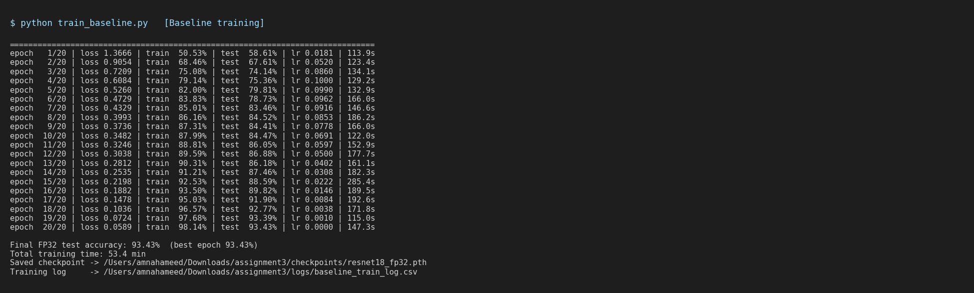
A1 - baseline training (last epochs)
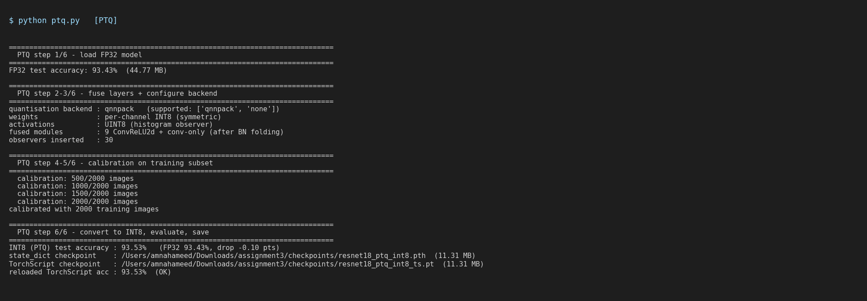
A2 - PTQ
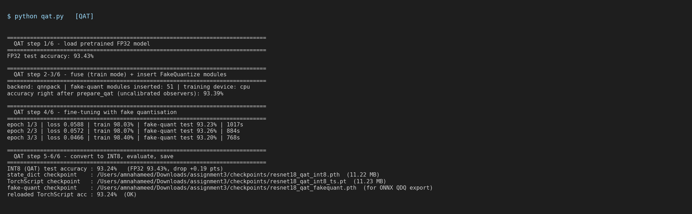
A3 - QAT
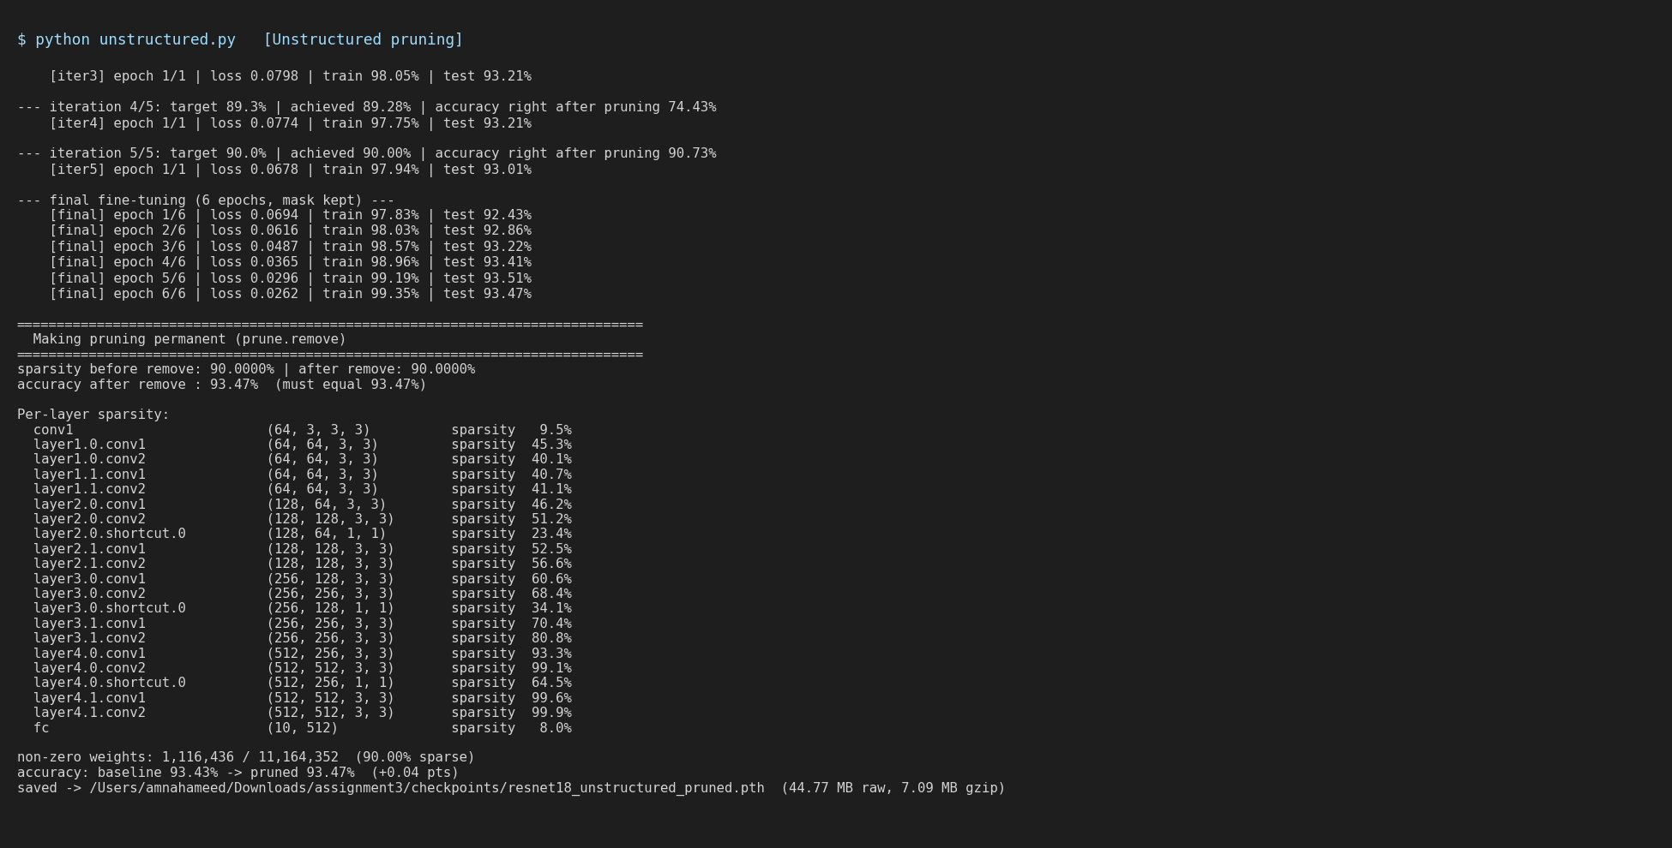
A4 - unstructured pruning
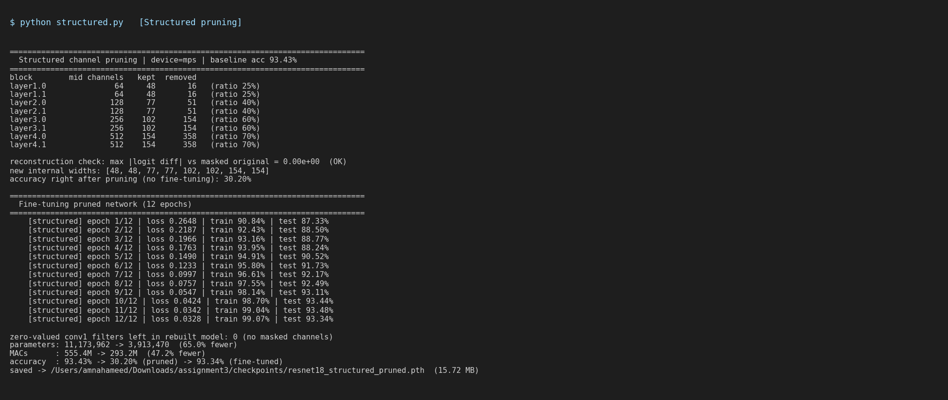
A5 - structured pruning
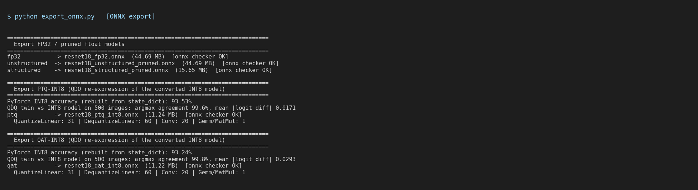
A6 - ONNX export
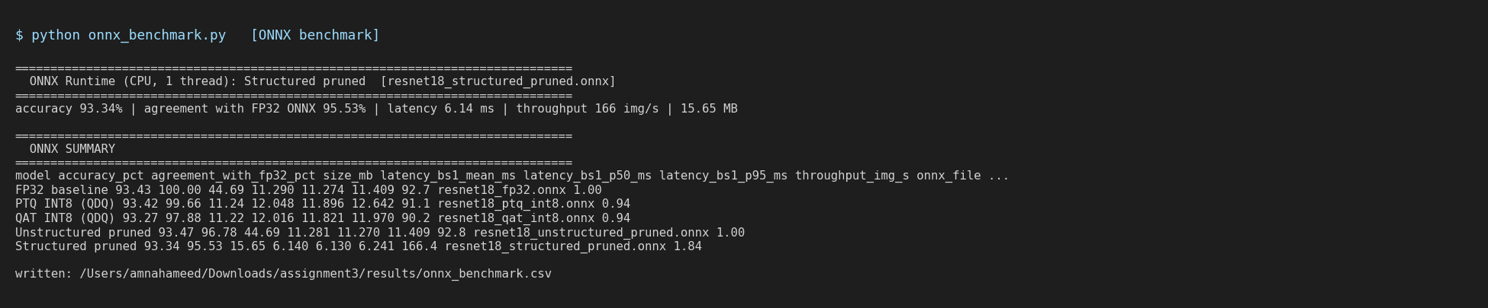
A7 - ONNX-Runtime benchmark

