***Project: Fizz Buzz game***

The **Fizz Buzz Game** is a simple and classic programming exercise that is often used to test problem-solving and logical thinking skills. The game works by printing numbers in order, but with a twist:

* If a number is **divisible by 3**, print "**Fizz**".
* If a number is **divisible by 5**, print "**Buzz**".
* If a number is **divisible by both 3 and 5**, print "**Fizz Buzz**".
* Otherwise, just print the number itself.

**Code logic:**

* We use **modulus (%)** to check divisibility.
* We check **divisible by both 3 and 5 first** (using and) because if we check them separately first, then numbers like 15 would only print "Fizz" or "Buzz", not "Fizz Buzz".
* Using **if-elif-else** ensures only one condition runs at a time.

**Code Explaination:**

• **for number in range (1, 101):** This loop goes through all numbers starting from **1 up to 100** (since range (1, 101) stops before 101)

• **if number % 3 == 0 and number % 5 == 0:** % is the **modulus operator**. It gives the remainder when one number is divided by another.

* Here we check: If the number is divisible by **both 3 and 5**, then we print **"Fizz Buzz"**.

• **elif number % 3 == 0:** If the number was not divisible by both, we check if it is divisible by **only 3**.

* If yes, then print **"Fizz"**.

• **elif number % 5 == 0:** Next, we check if the number is divisible by **only 5**.

* If yes, then print **"Buzz"**.

• **else:** If the number is not divisible by 3 or 5, we just print the number itself.

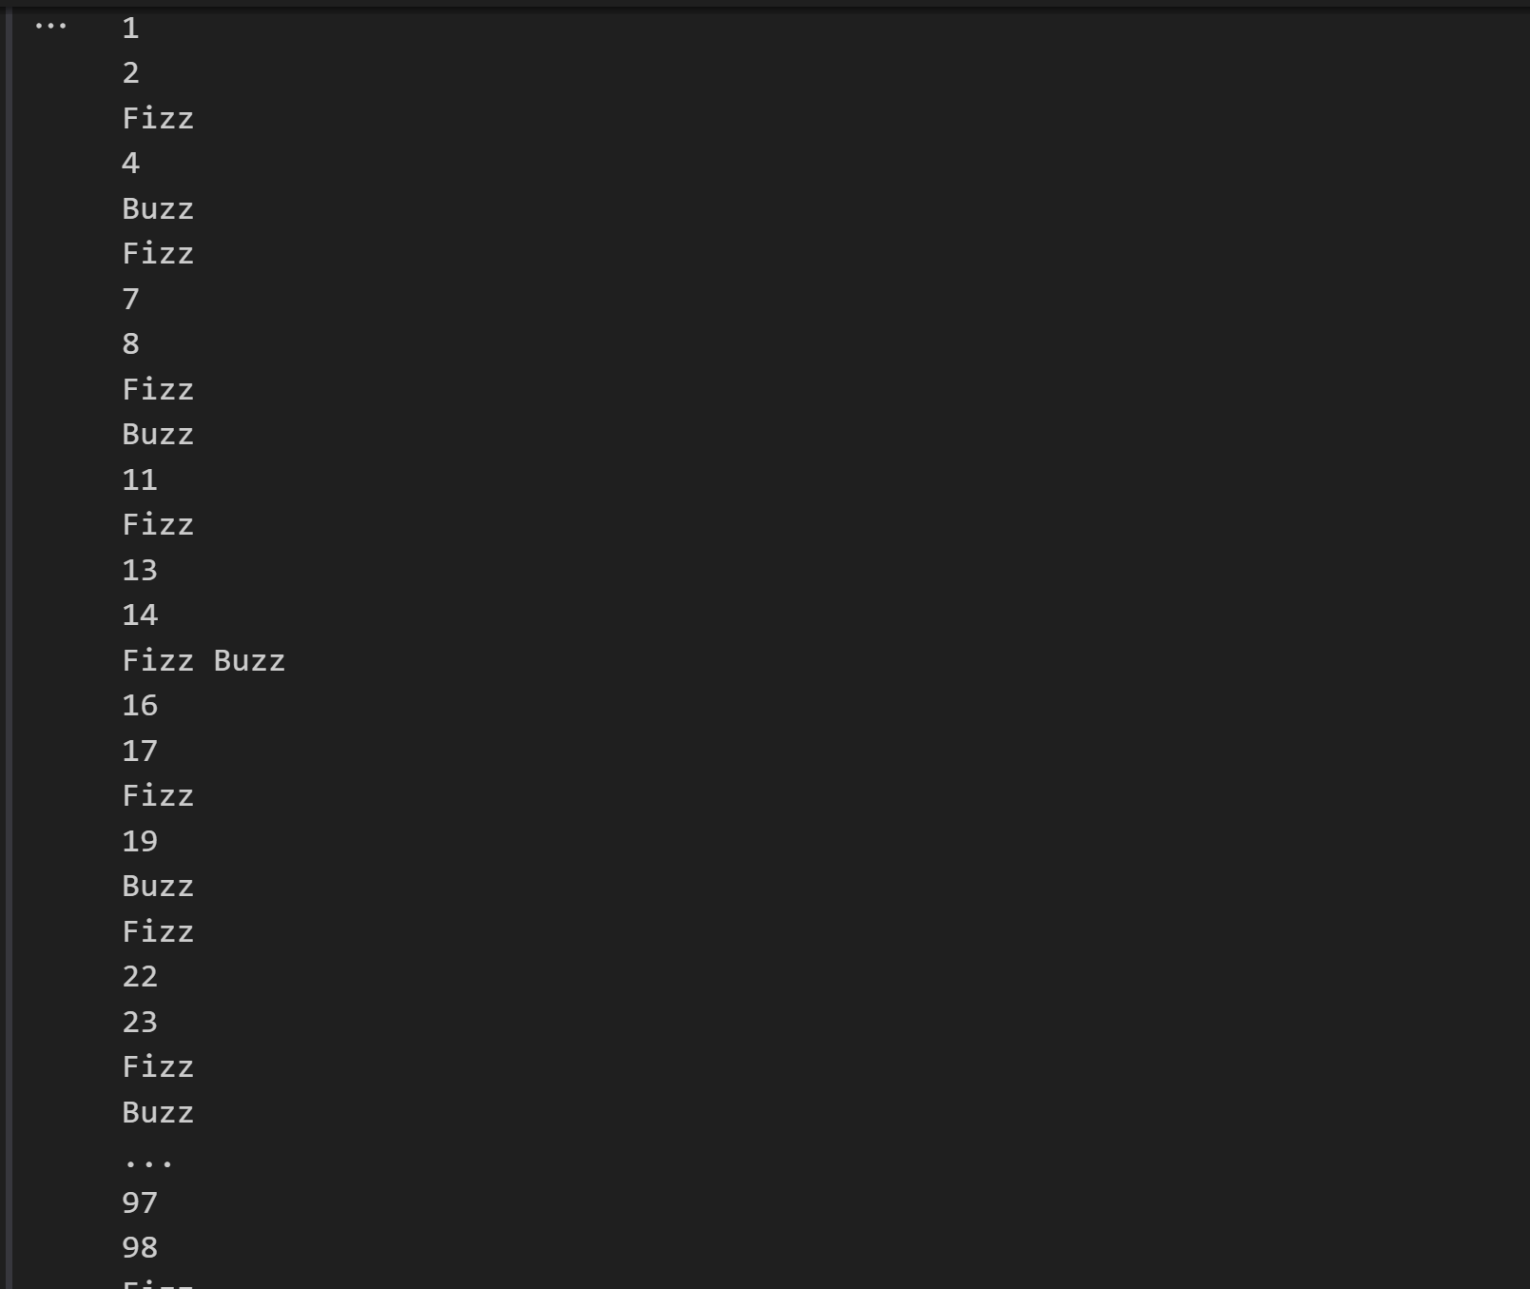

***Project: Movie Budget Analyzer***

*This project focuses on analyzing the budgets of different movies. The program first calculates the* ***average budget*** *of all the movies in the given dataset. After that, it identifies and prints the movies that have a budget* ***higher than the average****, along with the difference in amount. Finally, it also tells how many movies had a budget above the average.*

**Logic of the Project:**

The main logic of this project is based on **average calculation and comparison**.

* First, we calculate the **average budget** of all movies by dividing the total budget by the number of movies.
* Then, we use a **conditional check (if condition)** to compare each movie’s budget with the average.
* If a movie’s budget is **greater than the average**, we identify it as a **high-budget film**.
* We also calculate the **difference** between that movie’s budget and the average to see **how much higher it is**.
* Finally, we **count** how many movies are above the average.

