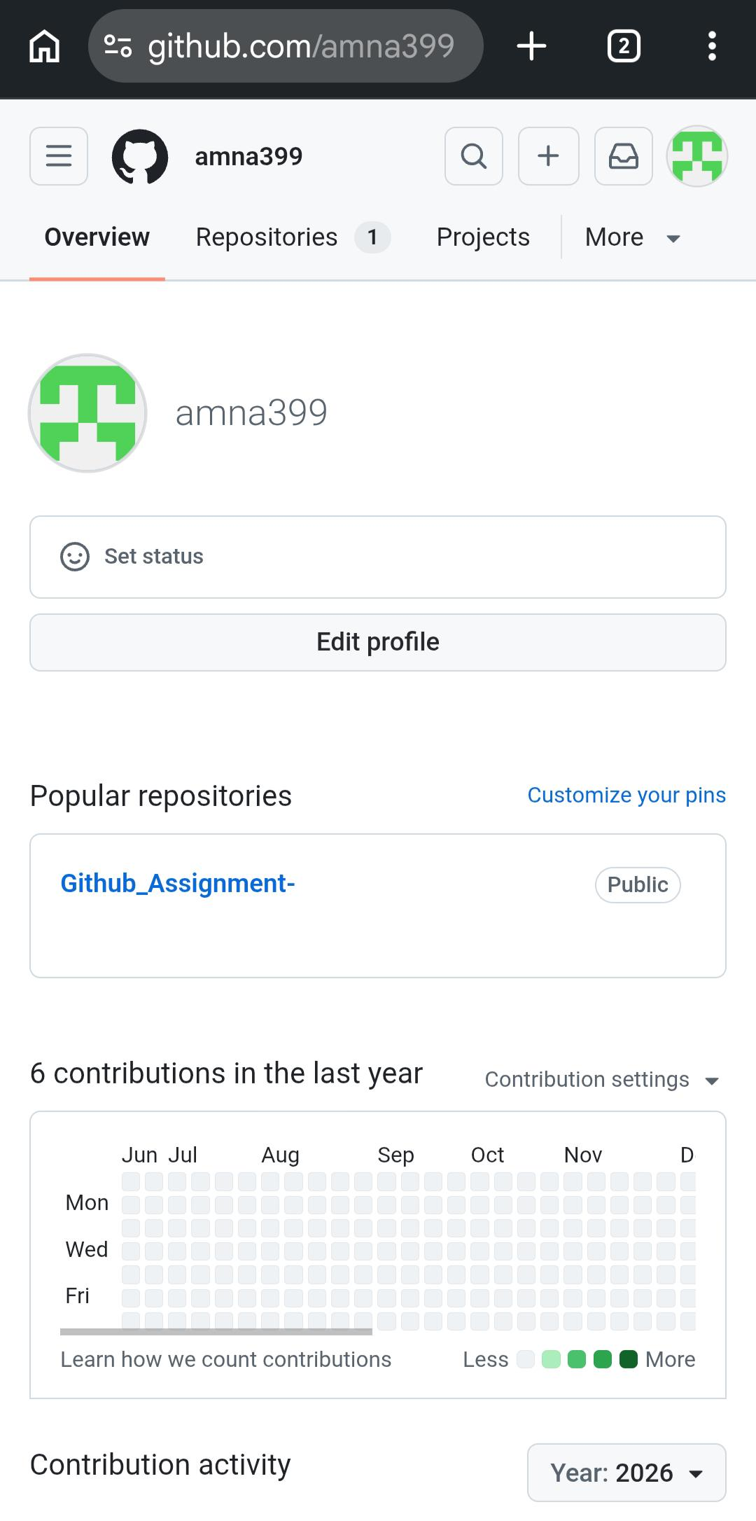
https://github.com/amna399/Github_Assignment-

