Submitted by Amna Abdul Rehman

https://github.com/amna5297/xyz

During this assignment I learned about lexicographical data structure; Tier. In this data structure the word in dictionary are split in characters and then stored in an array.

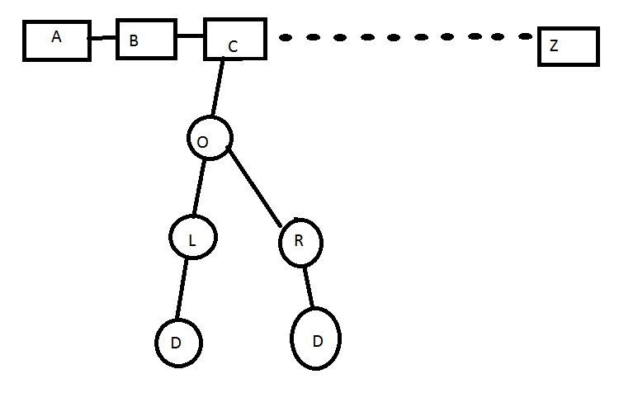

In tier there is a Boolean check that down the tree if there is a word or not. Its used to read a heavy file.

Also there was another data structure in which all the dictionary word can be stored in a linked list. In the word ladder function if it finds the word formed in dictionary then it can show the ladder formed. This however takes a lot of time.