SkillBridge
Learning Management System
Full Stack MERN Application — Final Project

Course | MERN Stack Web Development
Assessment | Final Project (Full Stack Application)
Total Marks | 100
Stack | MongoDB · Express.js · React.js · Node.js

1. Project Overview
SkillBridge is a full-featured Learning Management System built using the MERN Stack (MongoDB, Express.js, React.js, Node.js). The platform supports three distinct user roles — Student, Instructor, and Admin — each with dedicated dashboards and role-based permissions.
The system enables students to browse and enroll in courses with progress tracking, instructors to create and manage educational content with lessons, and administrators to oversee the entire platform with analytics and user management.
Key Features
• Role-Based Access Control (Admin, Instructor, Student) with JWT authentication
• Full CRUD operations for courses and lessons with category filtering
• Student enrollment system with progress tracking and personal dashboard
• Instructor course management with lesson upload capability
• Admin analytics dashboard with platform-wide statistics
• Search and category-based filtering on the course catalog
• Protected routes with role-based middleware authorization
• Responsive, professional UI design with custom CSS and Bootstrap 5
• Password hashing with Bcrypt and environment variable configuration

2. Technologies Used
Frontend Technologies
Technology | Purpose
React 18 | Component-based UI with hooks and context API
React Router v6 | Client-side routing with protected route guards
Axios | Promise-based HTTP client for REST API calls
Bootstrap 5 | Responsive grid system and utility classes
React Icons | Scalable vector icon library (Feather Icons)
Custom CSS | Professional design system with CSS variables, gradients, and animations
Backend Technologies
Technology | Purpose
Node.js | JavaScript server runtime environment
Express.js 4 | Minimal and flexible REST API framework
Mongoose 8 | MongoDB object data modeling (ODM) library
JSON Web Tokens | Stateless authentication and authorization
Bcrypt.js | Password hashing and comparison
dotenv | Environment variable management
CORS | Cross-origin resource sharing middleware
Database
• MongoDB — NoSQL document database for flexible schema design

3. Installation Steps
Prerequisites
• Node.js v16 or higher installed
• MongoDB (local instance or MongoDB Atlas cloud account)
• npm (included with Node.js)
Step 1: Clone the Repository
git clone <repository-url>
cd lms
Step 2: Backend Setup
cd backend
npm install
Create a .env file inside the backend/ directory with the following variables:
PORT=5000
MONGO_URI=mongodb://localhost:27017/lms_db
JWT_SECRET=your_jwt_secret_key_here
Start the backend server:
npm run dev # Development (with auto-reload via Nodemon)
npm start # Production mode
The API server will run on http://localhost:5000
Step 3: Frontend Setup
cd ../frontend
npm install
npm start
The React application will run on http://localhost:3000
Step 4: Access the Application
Open http://localhost:3000 in your browser. Register a new account as Student or Instructor to begin using the platform.

4. Screenshots of Major Modules
Below are screenshots of all major modules demonstrating the complete functionality of the SkillBridge Learning Management System.
1. Home Page
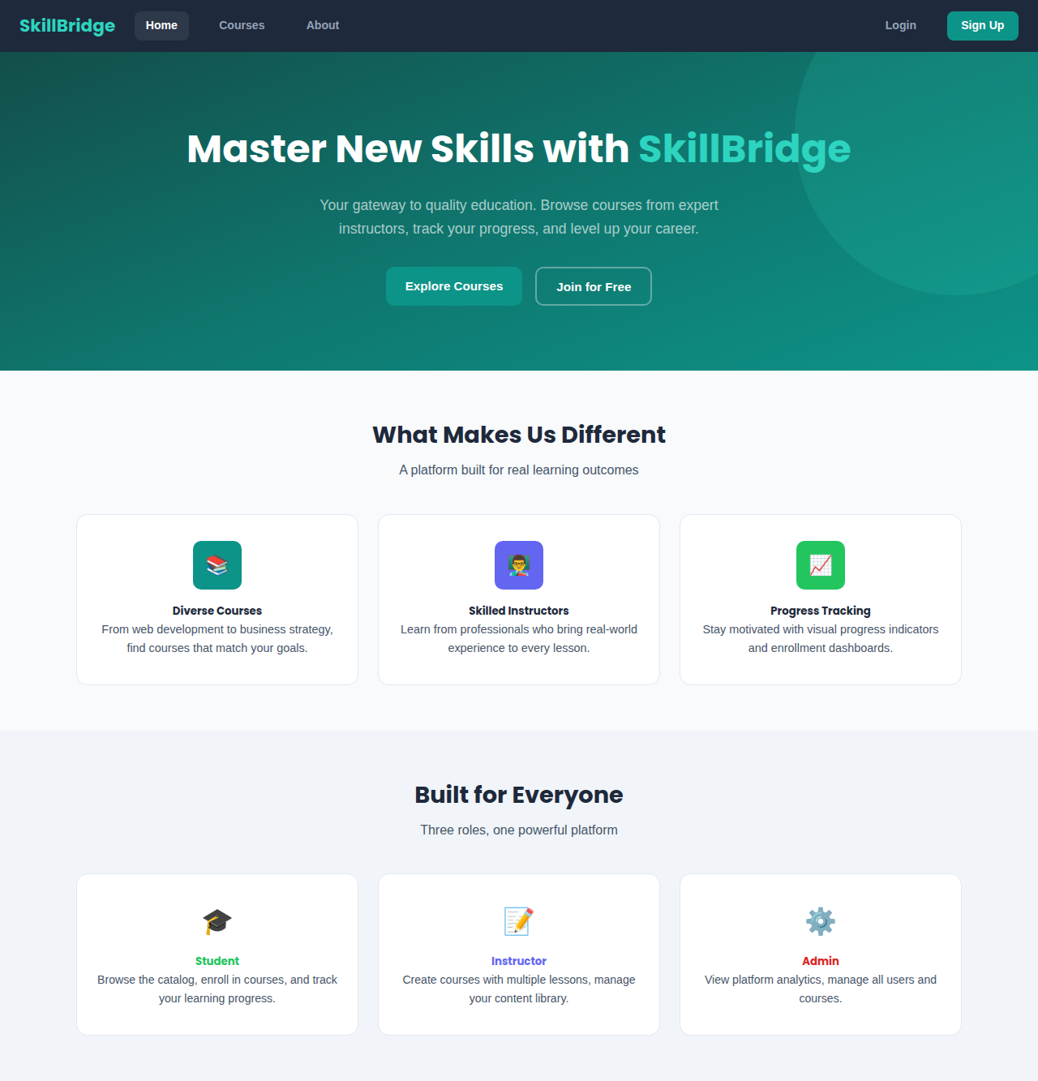
2. Login Page
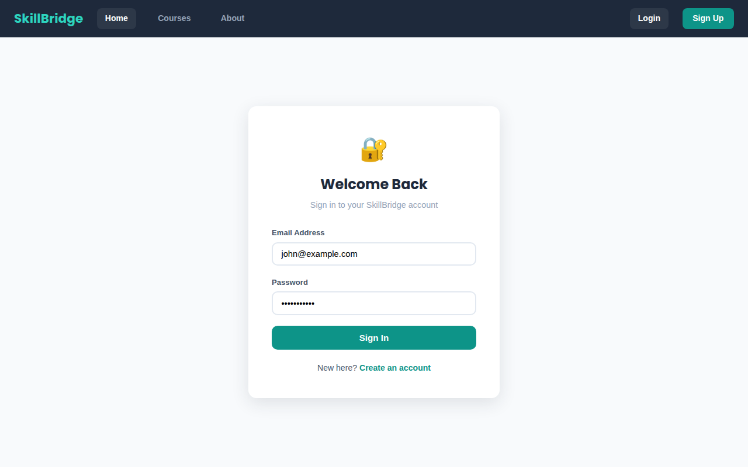

3. Registration Page
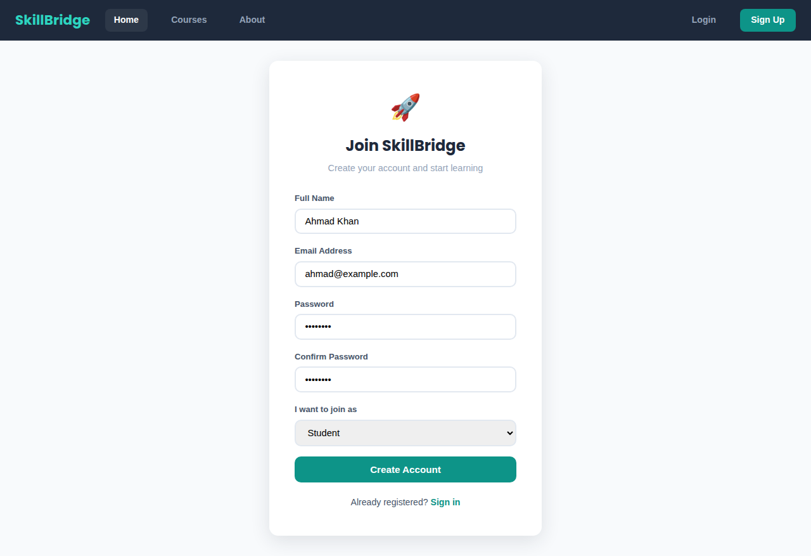
4. Course Catalog
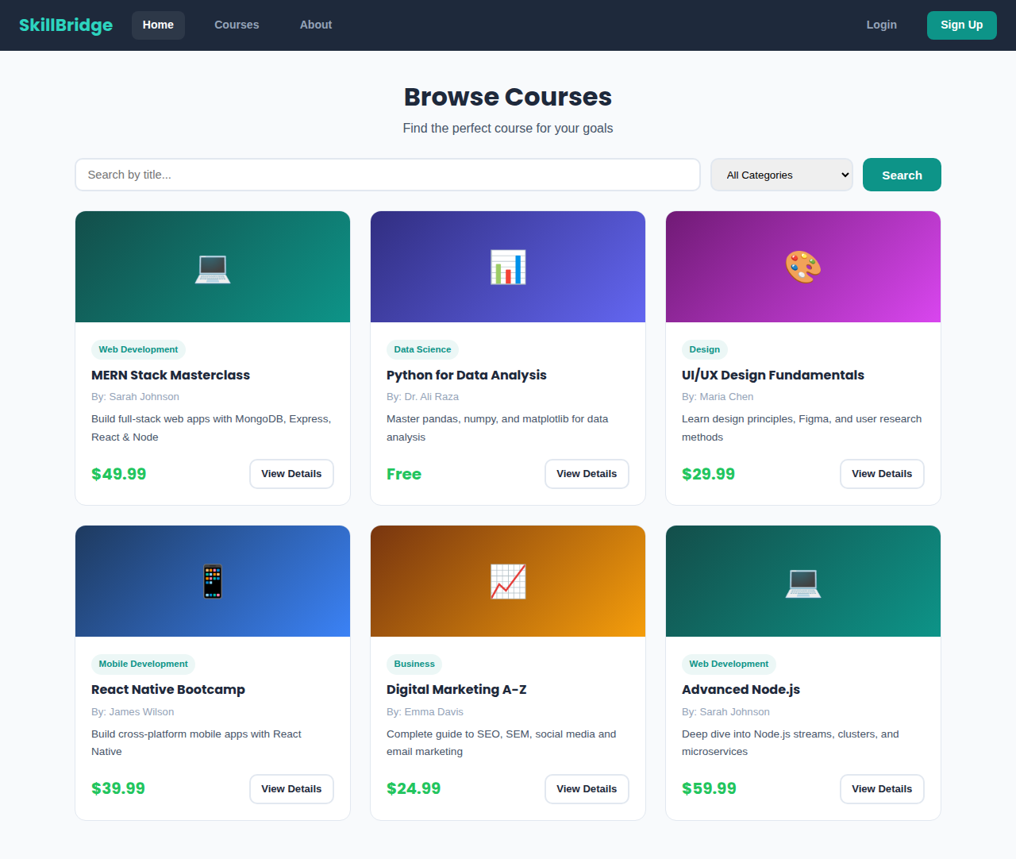

5. Course Detail Page
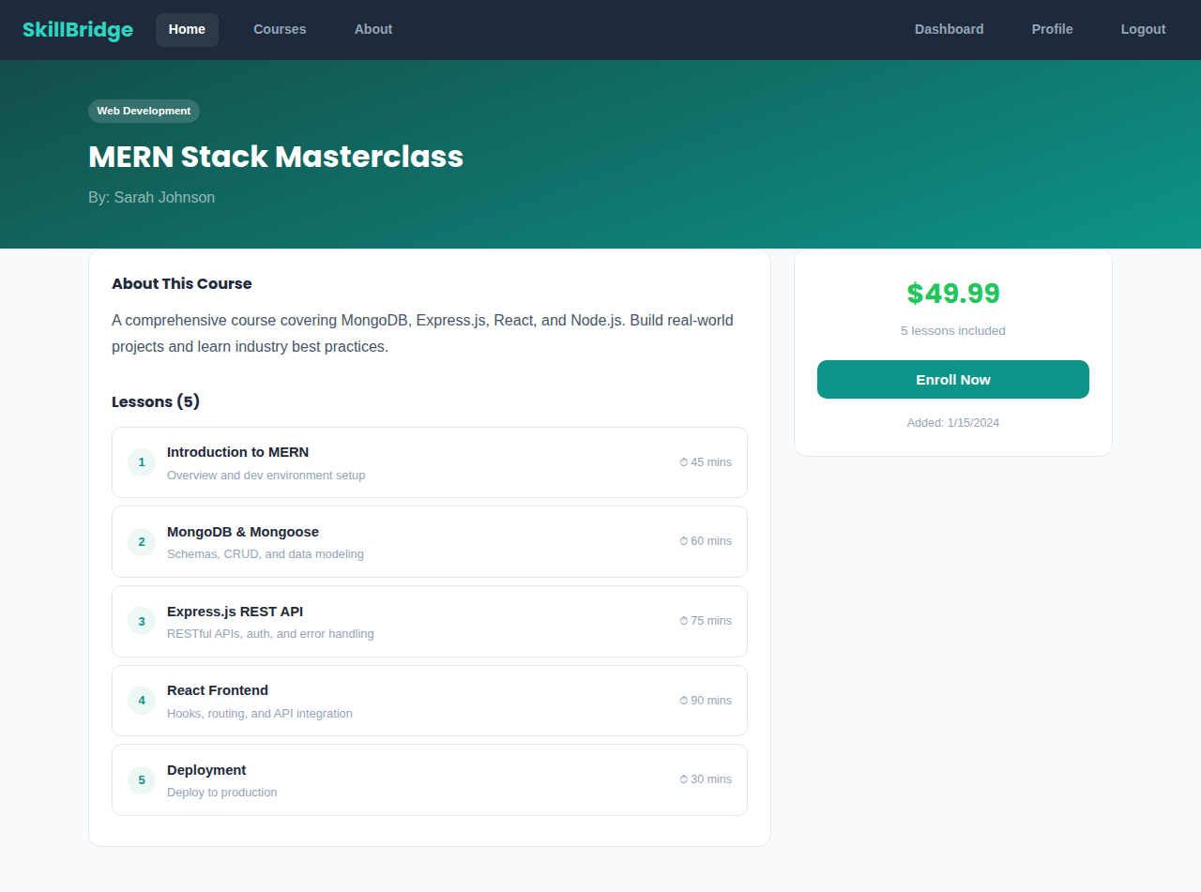
6. Student Dashboard
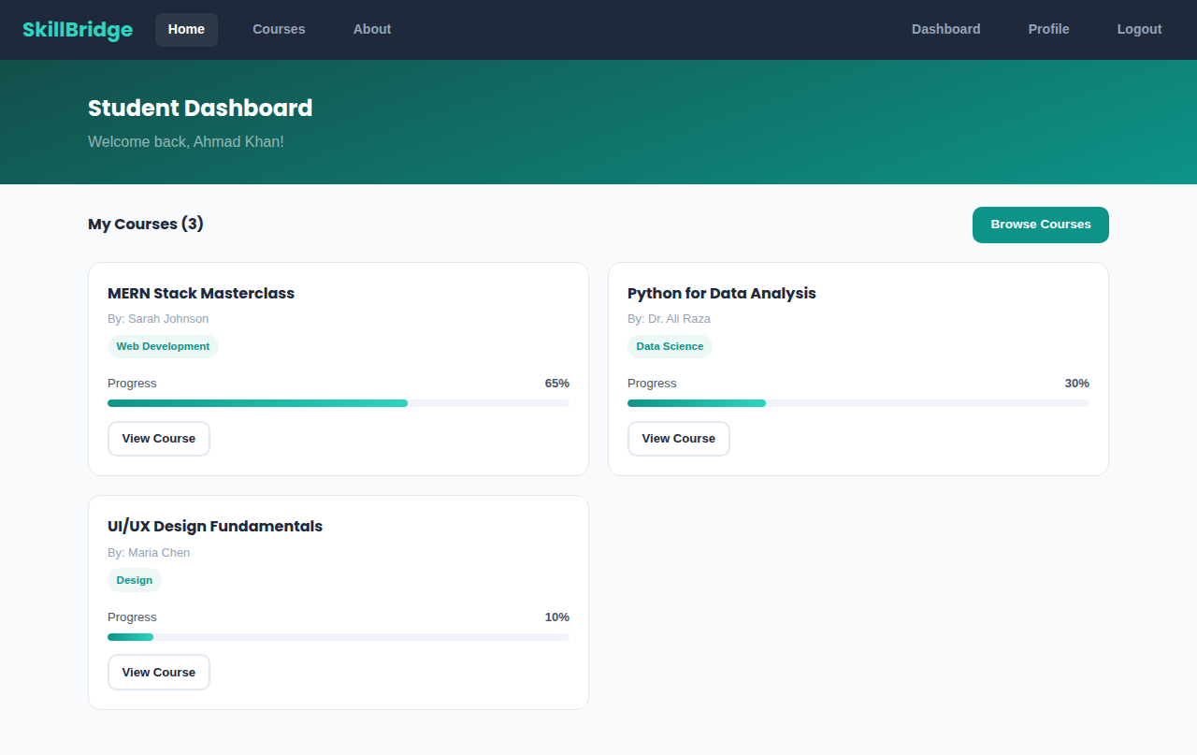

7. Instructor Dashboard
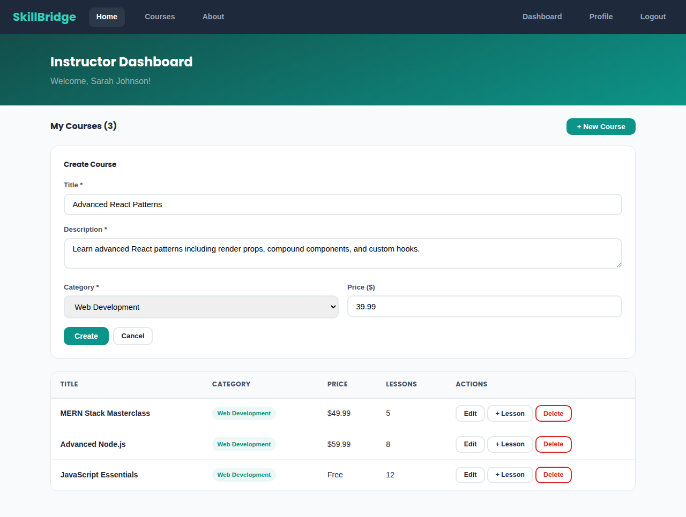
8. Admin Dashboard
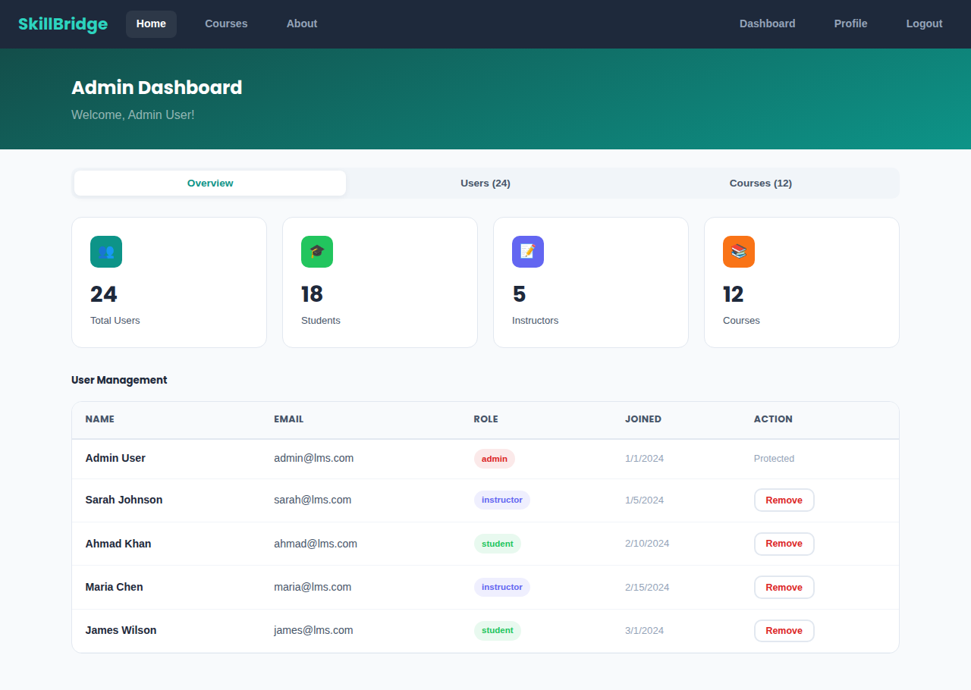

9. User Profile
