**A Vision for an Evidence-Based Framework for AI Governance:**

**A Systematic Review**

**Planning and Conducting the Review**

1. **The need for a systematic review:**

This study aims to summarize and synthesize current AI governance solutions (i.e. frameworks, tools, models, and policies), examine challenges in existing AI governance solutions, and offer a novel AI governance framework for ethical and responsible AI.

1. **The Research Question(s):**

RQ1: What governance frameworks, models, tools, standards, and Policies (regulations, ethics principles, or guidelines) for AI are offered in the literature?

RQ2: What are the limitations and challenges of AI governance discussed in the literature?

1. **Developing a Review Protocol and Conducting the Review**

* Background Knowledge: Added to Section Two of the SLR Paper.
* RQs: Added above.
* Search Strategy: Search terms, databases (resources):

Table 1: Search Strategy

|  |  |  |  |  |  |
| --- | --- | --- | --- | --- | --- |
| **Database** | **Search String** | **Search within** | **Timeframe** | **No of papers returned** | **Filters** |
| SCOPUS | (ai OR artificial AND intelligence) AND (governance) | Title and abstract | 2013 - 2023 | 1485 | English language  Conference and journal papers/articles |
| Google Scholar | allintitle: AI Governance | Title only | 2013 - 2023 | 764 | - |
| Google Scholar | allintitle: Artificial Intelligence Governance | Title only | 2013 - 2023 | 669 | - |
|  |  |  |  | Total: 2918 |  |

The keywords used to search for the articles in search engines and digital libraries include AI, artificial intelligence, and governance. In the beginning, additional search terms like AI algorithm OR ai algorithms were added, but this only produced a number of articles that used various AI algorithms for the development or verification of health-related and other domain applications, including artificial neural networks (ANN), support vector machines (SVM), deep deterministic policy gradient (DDPG) algorithms, and so on [1], [2], and [3]. In order to have the distinct papers concentrate on AI governance structures and models and use the time to study the core notion of this research, the keyword algorithm was eliminated. The final keywords used to collect the data from digital libraries are AI, artificial intelligence, and governance in Google Scholar and Scopus databases as shown in Table 1. The search terms resulted in a total of 2918 papers.

* Selection criteria: Inclusion Criteria: Papers published in English language, between year 2013 - 2023, and are relevant to research topic (frameworks, models, tools, standards, challenges) are included. Exclusion Criteria: Secondary studies including reviews, book chapters, reports, etc. are excluded. Papers not in English language also excluded. Papers not relevant to the research area are also excluded. The inclusion and exclusion criteria applied to abstracts of **2918** papers after checking for duplicates, resulted in **225** articles. The same selection criteria have been applied to full papers (225), which resulted in **61** papers.
* Selection Procedure: The test-retest approach was followed by inviting two experts of SLR to review the selected set of 61 papers in three rounds. The first round of review resulted in 35 studies after reviewing the research methodology used in each study. The second round of the selection procedure resulted in 22 studies after reviewing the full papers. There were traditional reviews, which were removed in both rounds. The traditional reviews are not omitted; instead, they were reviewed and analysed for the AI-targeted domains used in each study and the ethical and RAI principles used, as all traditional reviews were on AI governance, and the results of the analysis are added in Figure 1 of Section two of this SLR. In ensuring the comprehensiveness of the systematic literature review, the stopping criterion of peer review or expert consultation was applied, which resulted in the advice of stopping the selection process and advising to proceed with the next steps.
* The snowballing approach (forward and backwards) applied to 22 sets of studies resulted in 33 studies. The forward and backwards snowballing helped in determining more primary studies. The final round of selection procedure, in which two experts reviewed each set of papers, resulted in **28** papers, as again, there were a few traditional reviews that were examined and added to Figure 1.
* Quality Assessment: In this SLR, the five-question evaluation criteria put forward by Liu et al. [4] has been used to evaluate the quality of the 28 selected papers. These questions evaluate the study's empirical or non-empirical nature, limitations and future work description, findings and contributions clarity, research design suitability, and clarity. Every question was rated from 0 to 1, where 0 meant "no," 0.5 meant "partially," and 1 meant "yes." The papers were categorised as Good if the score was between 3 and 4, Fair if it was between 2 and 3, and Poor if it was between 0 and 2. The total quality score was determined by adding the scores of the five questions. Out of the 28 selected papers, 20 were deemed “Good” quality, 8 were “Fair” quality, and 0 were “Poor” quality, demonstrating the robustness of this review.
* Data Extraction: Demographic and content-related information from the 28 chosen papers on AI governance was extracted using an Excel spreadsheet. Demographic data encompassed paper title, abstract, publication year, venue, citation, and research method (Empirical or Non-Empirical). The demographic analysis of the publication years of 28 papers indicated that the highest number of studies, i.e., 13 (A1, A2, A7, A8, A9, A10, A14, A17, A19, A20, A21, A22, and A26), were published in 2023, and the lowest number of studies, i.e., 1 (A27), were published in 2017. The remaining are as follows: 4 (A11, A12, A15, A18) in 2022, 5 (A5, A6, A16, A25, A28) in 2021, 1 (A4) in 2019, and 4 (A3, A13, A23, A24) in 2018. The analysis of the citation count of 28 studies found that 3 studies (A13, A24, and A27) have received more than 200 to 500 citations. On the other hand, the remaining 25 studies got less than 100 citations. The Content-related data involved extracting AI governance solutions (frameworks, models, tools, policies, and guidelines), the AI governance challenges, and targeted AI domains discussed in the studies. The first author performed manual coding for data extraction, which was cross-checked in weekly meetings with the other authors.
* Data Synthesis: The 4W1H approach used to analyse and synthesize the data. It has been added to the section four of the SLR paper.

References:

1. Yang K, Wang Q, Wu L, Gao QC, Tang S. Development and verification of a combined diagnostic model  
   for primary Sj ̈ogren’s syndrome by integrated bioinformatics analysis and machine learning. Scientific  
   Reports. 2023;13(1):8641.
2. Odhiambo P, Okello H, Wakaanya A, Wekesa C, Okoth P. Mutational signatures for breast cancer  
   diagnosis using artificial intelligence. Journal of the Egyptian National Cancer Institute. 2023;35(1):1-  
   14.
3. Guo D, He W, Wei L, Song Y, Qi J, Yao Y, et al. The Zhu-Lu formula: a machine learning-based  
   intraocular lens power calculation formula for highly myopic eyes. Eye and Vision. 2023;10(1):1-10
4. Liu, Y., Lu, Q., Zhu, L., Paik, H.-Y., Staples, M.: A systematic literature review on blockchain governance. Journal of Systems and Software, 111576 (2022)

Figure 🡪

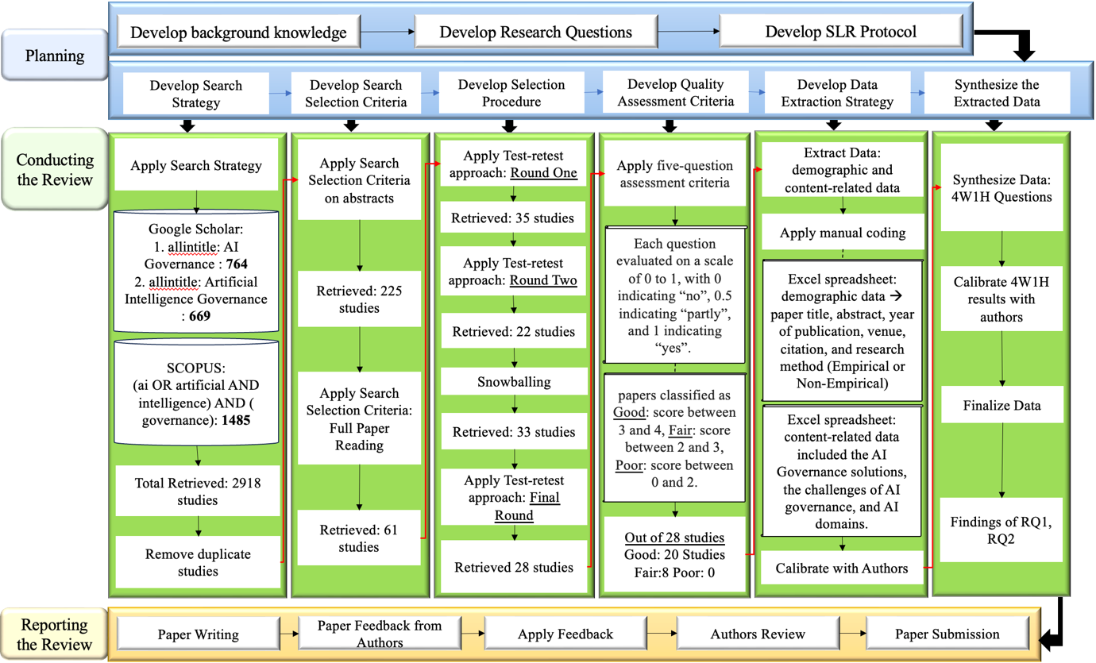

Figure 1: Research Methodology