BIG DATA ANALYTICS PROJECT
Pakistani Social Media Content Detective
What type of social-media content gets Pakistani audiences to engage? A sentiment and engagement analysis of YouTube comments on five Pakistani fashion brands.
Amna Bashir
Student ID: F2023376429 | Section A3
BSAI, 7th semester | University of Management and Technology (UMT)

1. Executive summary
Business question. As a junior digital-marketing data scientist, I looked at what type of social-media content gets Pakistani audiences to engage with fashion and retail brands.
Data. 1,794 public comments from 35 YouTube videos about Khaadi, Gul Ahmed, Sapphire, J. Junaid Jamshed and Alkaram Studio, collected with the official YouTube Data API in October 2026. Usernames were not stored.
Main findings
- Audiences are mostly positive. 75% of all comments were positive, 15% neutral and 10% negative (sentiment model checked on 60 hand-labelled comments: 75–78% accuracy).
- Brand sentiment differs. Without song comments, the positive share was Khaadi 90%, J. Junaid Jamshed 87%, Gul Ahmed 69%, Sapphire 67% and Alkaram Studio 55%. Alkaram also had the most negative comments (21%).
- Content type. Creator/reviewer videos had a higher average engagement rate (2.41%) than brand-official videos (1.53%). Review/haul (2.78%) and sale (2.30%) videos beat new-collection videos (1.38%). These are indicative: there are only 35 videos.
- Music drives conversation on one brand. 39% of Gul Ahmed's comments, and all 10 of the most-liked comments in the dataset, were about the soundtrack of its official lawn ads, not about the clothes.
- Customers ask questions that brands should answer. Order/availability comments were the least positive topic (15% positive, 60% neutral, 25% negative); price/sale comments were only 51% positive.
- Sentiment and engagement. The positive-comment share and engagement rate were weakly related (Spearman 0.39), and the link shrank to 0.24 after removing the effect of view count. View count was the strongest factor (−0.81). We do not claim that sentiment drives engagement.
- Audience segments. Four comment-based segments were found. Alkaram Studio was over-represented among Roman Urdu, question-asking and mixed-language commenters.
The report ends with six AI-assisted marketing recommendations, using Alkaram Studio as the main example, and a list of limitations. The most important limitation is size: 35 videos, with 6–8 per brand.

2. Introduction and objectives
Pakistani fashion brands such as Khaadi, Gul Ahmed, Sapphire, J. Junaid Jamshed and Alkaram Studio spend heavily on social media. Before deciding what to post, a marketing team needs to know which content makes audiences react and in what mood. This project answers the question: "What type of social-media content gets Pakistani audiences to engage?"
The project brief asked for the following analyses, which this report covers:
- Compare platform and brand performance (Section 7.1).
- Find which content types get the most engagement (Section 7.2).
- Identify popular topics and hashtags (Section 7.4).
- Run sentiment analysis on comments (Sections 5, 6 and 7.3).
- Relate sentiment to engagement (Section 7.5).
- Find responsive audience segments and the best posting days and times (Sections 7.6 and 7.7).
- Give AI-assisted marketing recommendations for a Pakistani brand (Section 8).
Scope note. The brief suggested 60–100 posts with 10–20 visible comments each. This project uses 35 YouTube videos with up to 60 comments each (1,794 comments in total). The number of comments is inside the requested range of about 600–2,000, but the number of posts is below 60. The reason is explained in Section 3.

3. Data collection

3.1 From Instagram to YouTube
The first plan was to collect Instagram posts and comments with a scraping library. Logging in with a dummy account triggered an Instagram security checkpoint, and automated scraping also goes against the platform's rules and risks an account block. After discussing the problem with my teacher, I moved the project to YouTube, which offers an official API for reading public comments. No Instagram data is used in the analysis.

3.2 Collection procedure
- Tool: YouTube Data API v3 (search and commentThreads endpoints), run from Python scripts. Region code: Pakistan.
- First attempt on official channels: the 20 most recent videos of each brand's official channel were checked. All 100 had fewer than 30 comments (or comments switched off), so official channels alone could not give enough comments.
- Second approach: for each brand, several searches such as "<brand> lawn collection", "review", "haul", "fashion show" and "sale" were run. This brings in both official videos and videos by creators and reviewers, which also makes it possible to compare the two.
- Video filters: the brand name had to appear in the video title or channel name; the video had to contain fashion words (lawn, suit, haul, sale, Eid, and so on); videos with unrelated words (cars, phones, gaming, recipes, religious talks) were excluded; and a video needed at least 20 comments.
- Comments: top-level comments only, up to 60 per video (40–50 in the top-up runs), in YouTube's "relevance" order, with a target of about 400 comments per brand. Replies were not collected.
- Top-up runs: Khaadi and Sapphire needed extra videos after cleaning (Section 4), so two small extra collection scripts were run for them.

3.3 Data points recorded
Each row is one comment together with information about its video. YouTube videos are the equivalent of the "posts" in the brief.
Required data point | Field in the dataset
Brand name | brand
Post text / caption | video_title (and channel_title, tags)
Post category | video_category (from title keywords: Sale/Discount, Festive/Wedding, Review/Haul, Fashion Show, New Collection, Ad/Other); source_type (Brand Official or Creator/Reviewer)
Collection date | collection_date; published_utc (upload date and time)
Likes | likes (video), comment_likes (comment)
Comments count | comments_count (video)
Comment text | comment_text (usernames removed)

3.4 Final dataset
Table 1. Final dataset by brand
Brand | Videos | Brand official | Creator/Reviewer | Comments
Alkaram Studio | 8 | 2 | 6 | 397
Gul Ahmed | 6 | 3 | 3 | 360
Khaadi | 7 | 0 | 7 | 357
Sapphire | 8 | 1 | 7 | 342
J. Junaid Jamshed | 6 | 0 | 6 | 338
Total | 35 | 6 | 29 | 1,794

The videos were uploaded between 2017 and 2026 (2017: 1, 2018: 4, 2019: 7, 2020: 6, 2021: 5, 2022: 2, 2024: 2, 2026: 8). Khaadi and J. Junaid Jamshed have no official-channel video in the final data.

3.5 Privacy
Only public comments were collected. Author names and channel IDs of commenters were never stored, and any @mention inside a comment was replaced by "@user". The API key used for collection is kept out of the project repository.

4. Data cleaning and preparation

4.1 Removing wrong videos
The first collection gave 2,000 comments. Reading every video title showed videos that were about several brands at once (for example "Khaadi, Sapphire, Silk Avenue haul") and videos that had nothing to do with the fashion brand (a cartoon film, a tailoring tutorial). Mixed-brand videos would blur the brand comparison, so 220 multi-brand comments and 480 unrelated comments were removed, leaving 1,455 comments from 26 videos.
The word "Sapphire" is also a gemstone, a graphics card and a car colour, so Sapphire needed a second, stricter collection run. The first Sapphire top-up returned only unrelated videos (graphics cards, a car, phones) and was discarded. A second run with fashion-specific searches added 6 relevant videos, and one more mixed-brand haul was removed. Khaadi received 117 more comments from 3 haul, try-on and sale-haul videos; a fourth video, a business interview about the company, was left out because it is not fashion content. After these steps every brand has 338–397 comments.

4.2 Text cleaning
- Duplicate comments (same video and same text), empty comments and comments of one character were removed.
- Text was lower-cased; links and extra spaces were removed. Emojis were kept because they carry sentiment.
- Upload times were converted from UTC to Pakistan time (UTC+5) to get day of week and time of day.
- Engagement of a video = likes + comment count. Engagement rate = engagement / views × 100. Likes, views and comment counts belong to the whole video, so engagement analysis is at video level (n = 35).

4.3 Language type
Comments are written in English, Roman Urdu (Urdu typed in English letters), Urdu script, or a mix. Roman Urdu has no standard spelling ("bohat", "bht", "buhat"), so no ready-made detector is reliable. A rule-based detector was built from Roman Urdu and English word lists plus script detection. In a check of 20 comments labelled "English", 17 were correct, so the detector is about 85% accurate. Language is used only to describe the data; it does not change the sentiment result.
Table 2. Comments by language type
Language type | Comments | Share
English | 1,202 | 67%
Roman Urdu | 369 | 21%
Mixed (Urdu + English) | 180 | 10%
Emoji / other | 28 | 2%
Urdu script | 15 | 1%

About 31% of the comments are Roman Urdu or mixed. Only 15 comments are in Urdu script, so no conclusion is drawn for that group.

4.4 Topic tags
Each comment received one topic by keyword matching, checked in this order: Music/Song, Price/Sale, Order/Availability, Product/Style, Praise/Dua, otherwise Other. The first matching topic is used.
Table 3. Comments by topic
Topic | Comments | Share
Other | 709 | 40%
Praise/Dua | 447 | 25%
Product/Style | 326 | 18%
Music/Song | 149 | 8%
Price/Sale | 95 | 5%
Order/Availability | 68 | 4%

Of the 149 song comments, 140 came from three official Gul Ahmed lawn ads, 8 from one Alkaram ad and 1 from a Sapphire video. Because song comments say little about the brand, they are left out of the brand sentiment comparison (but kept elsewhere).

5. Methods

5.1 Sentiment analysis
A simple English lexicon tool such as VADER does not understand Roman Urdu or Urdu script, so a multilingual transformer model was used: cardiffnlp/twitter-xlm-roberta-base-sentiment. It labels each comment Positive, Neutral or Negative, and gives a score (probability of positive minus probability of negative). It was run on Google Colab with a GPU, because the Python version on my laptop could not install PyTorch.
A small correction rule was added after reading the model's mistakes (Section 6): a comment labelled Negative that contains a praise word (spelling variants of "zabardast", "lajawab", "khoob", "mashallah" and similar) and no complaint or negation word is changed to Positive. This changed 16 comments. After the rule the dataset has 1,344 Positive, 277 Neutral and 173 Negative comments.

5.2 Statistics
- Spearman rank correlation was used for sentiment versus engagement because the data are skewed and the sample is small. With 35 videos, a correlation smaller than about 0.33 (in either direction) cannot be told apart from zero.
- A rank-based partial correlation was used to remove the effect of view count.
- Averages by group are reported with the number of videos (n), because several groups are very small.

5.3 Audience segments
KMeans clustering (K = 4, with k-means++ starting points, written in NumPy) was run on comment features: language type, topic, sentiment, log of comment likes, log of comment length and number of emojis, all standardised. There is no clear elbow (inertia fell steadily from 26,387 at K = 2 to 18,499 at K = 7), so K = 4 was chosen because four groups are easy to interpret. This is an exploratory segmentation.

6. How accurate is the sentiment model?
To check the model, I labelled 60 comments by hand without seeing the model's answer: 20 English, 20 Roman Urdu, 15 mixed and 5 Urdu script. I used Positive for praise, thanks, prayers and happiness; Negative for complaints, high price or bad quality; and Neutral for questions, greetings or no opinion about the brand.
Table 4. Model accuracy on 60 manually labelled comments
Measure | Result
Overall accuracy of the model | 75.0% (45 of 60)
Overall accuracy after the correction rule | 78.3% (47 of 60)
Baseline: calling every comment Positive | 61.7% (37 of 60)
English / Roman Urdu / Mixed / Urdu script | 75% / 80% / 67% / 80% (only 20, 20, 15 and 5 comments)
Positive comments found correctly | 95% (35 of 37)
Neutral comments found correctly | 43% (10 of 23)
Negative comments in the sample | 0, so negative accuracy could not be measured
Table 5. Confusion matrix before the correction rule (rows: my label; columns: model)
My label | Model: Negative | Model: Neutral | Model: Positive
Positive (37) | 2 | 0 | 35
Neutral (23) | 4 | 10 | 9
Negative (0) | 0 | 0 | 0

What the 15 mistakes were. Nine were Neutral comments that the model called Positive, mostly about a song, a celebrity or a prayer (for example "Love you ayeza" or "Ramadan Mubarak"). The model reads the feeling in them correctly; I labelled them Neutral because they say nothing about the brand, so this is partly a difference of definition. Four were Neutral comments called Negative (for example "Please dhaky apni froks", "Purani video to nai"). Two were misspelt Roman Urdu praise called Negative (for example "Bhot LaJawob .Bhot khob"). The correction rule fixes the last kind.
Reading the model's Negative comments. In a read-through of 15 Negative Alkaram comments, about 10 were real complaints (doubts about original versus replica products, no cash on delivery, items sold out) and about 5 were questions. Among 10 Negative comments from the other brands, only about 1 was a clear complaint; three were misspelt praise and the rest were questions or jokes.
What this means. The positive label is reliable. The split between Neutral and Negative is weaker, so the positive share is used as the main number for comparing brands, and negative percentages are called indicative. The correction rule was designed on the same 60 comments, so 78.3% is probably a little optimistic; 75–78% is the fair range.

7. Findings

7.1 Platform and brand performance
All data come from one platform, YouTube, so the comparison is between brands. Table 6 puts engagement and sentiment side by side (sentiment without song comments).
Table 6. Brand summary
Brand | Videos | Comments | Avg engagement rate | Positive | Neutral | Negative
Khaadi | 7 | 357 | 2.92% | 90% | 6% | 4%
J. Junaid Jamshed | 6 | 338 | 1.92% | 87% | 9% | 4%
Gul Ahmed | 6 | 360 | 1.04% | 69% | 21% | 10%
Sapphire | 8 | 342 | 3.30% | 67% | 21% | 12%
Alkaram Studio | 8 | 397 | 1.79% | 55% | 24% | 21%

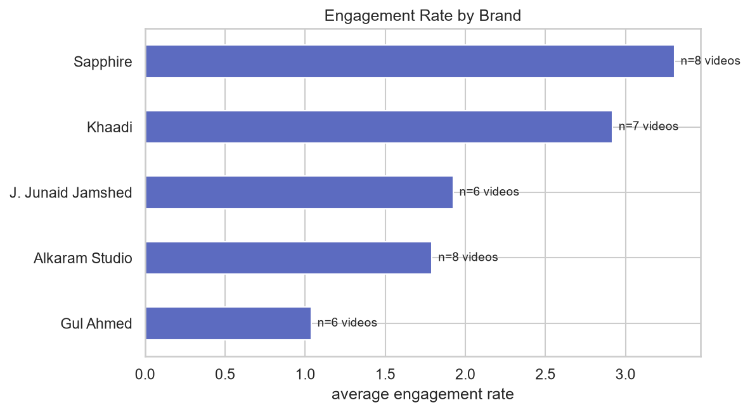
Figure 1. Average engagement rate per video, by brand (n = number of videos).
Sapphire (3.30%) and Khaadi (2.92%) have the highest engagement rates and Gul Ahmed (1.04%) the lowest. The engagement ranking is different from the sentiment ranking: Khaadi is first for sentiment, Sapphire first for engagement. The low rate for Gul Ahmed fits with very high view counts on its official ads (582,097 and 485,667 views): the rate divides by views, so very popular videos get low rates (Section 7.5).
Table 7. Highest and lowest engagement rates (video titles shortened)
Video | Source | Views | Engagement rate
Sapphire Season Sale on Unstitched | Creator | 6,526 | 5.5%
Sapphire: Try-on haul with Skye | Official | 27,607 | 5.2%
Sapphire New Collection winter 2026 | Creator | 2,319 | 5.2%
Khaadi: Eid haul and look book | Creator | 108,648 | 4.8%
Sapphire shopping haul, flat 50% off | Creator | 159,574 | 4.5%
Gul Ahmed Summer Lawn 2021 | Official | 582,097 | 0.4%
Gul Ahmed #PakistanKiPehchan Summer Lawn 2020 | Official | 485,667 | 0.6%
J. Junaid Jamshed Summer Gala 50% sale haul | Creator | 565,953 | 0.6%
Sapphire sale Pakistan (YouTube Short) | Creator | 886,981 | 0.6%
Alkaram Studio 50% Sale 2019 shopping haul | Creator | 160,489 | 0.7%

The five highest rates belong to videos with 2,000 to 160,000 views, and the five lowest to videos with 160,000 to 887,000 views.

7.2 Which content types get the most engagement?
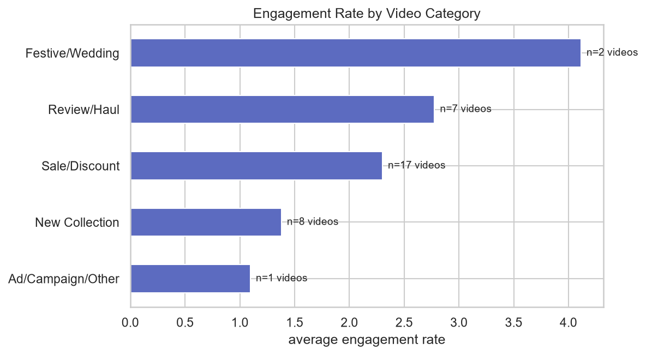
Figure 2. Average engagement rate by video category (n = number of videos).
Review/haul videos (2.78%, 7 videos) and sale videos (2.30%, 17 videos) had higher engagement rates than new-collection videos (1.38%, 8 videos). Festive/wedding (4.11%) has only 2 videos and ad/other only 1, so these two are too small to trust. Categories come from title keywords, and "Sale" is checked first, which is why it is the biggest group.
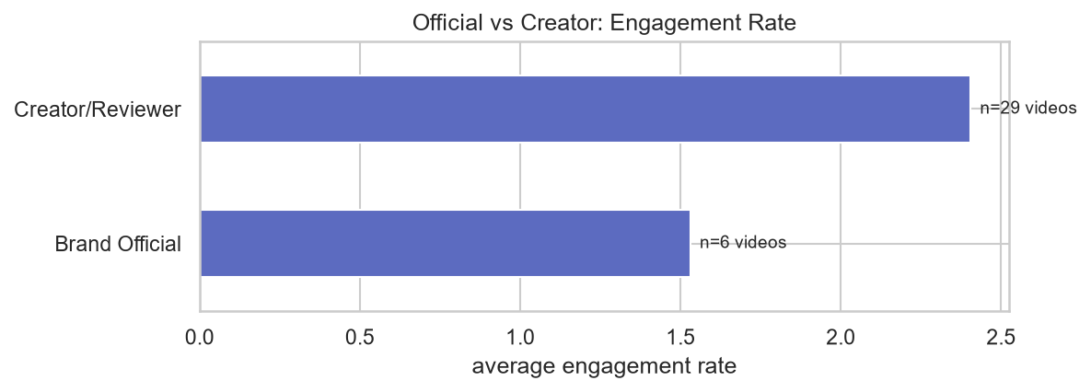
Figure 3. Average engagement rate: brand-official videos versus creator/reviewer videos.
Creator and reviewer videos (2.41%, 29 videos) had a higher average rate than brand-official videos (1.53%, 6 videos). Only 6 official videos exist, so this is a pointer, not a proof.

7.3 Sentiment by brand
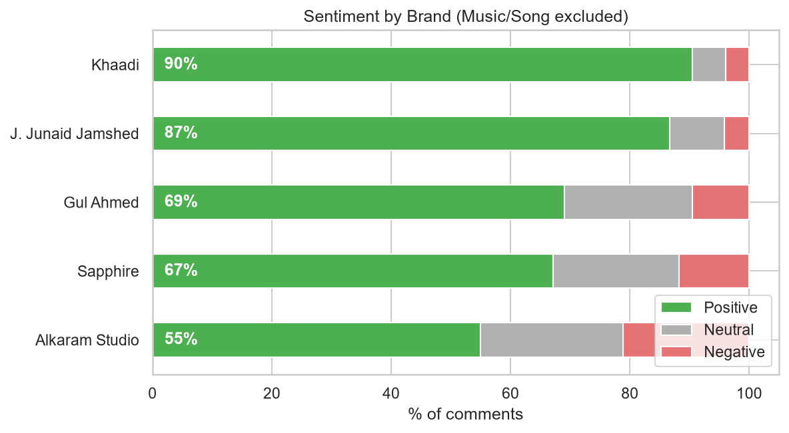
Figure 4. Share of positive, neutral and negative comments by brand (song comments excluded).
Khaadi (90% positive) and J. Junaid Jamshed (87%) are far ahead of Gul Ahmed (69%), Sapphire (67%) and Alkaram Studio (55%). Alkaram also has the most negative comments (21%). Including song comments would raise Gul Ahmed from 69% to 77%, which shows how much the soundtrack comments inflate its positivity.
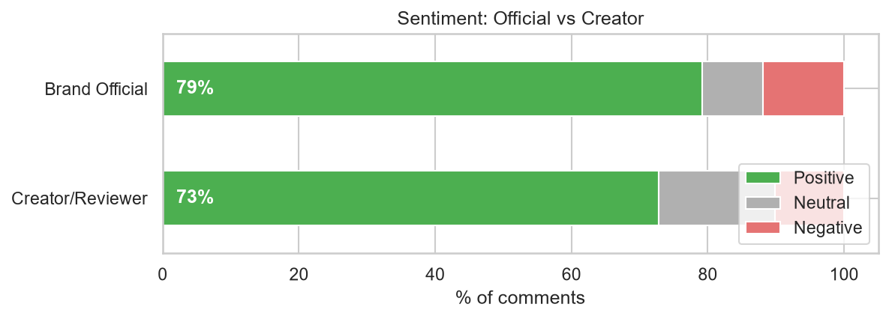
Figure 5. Sentiment of comments on official videos versus creator/reviewer videos.
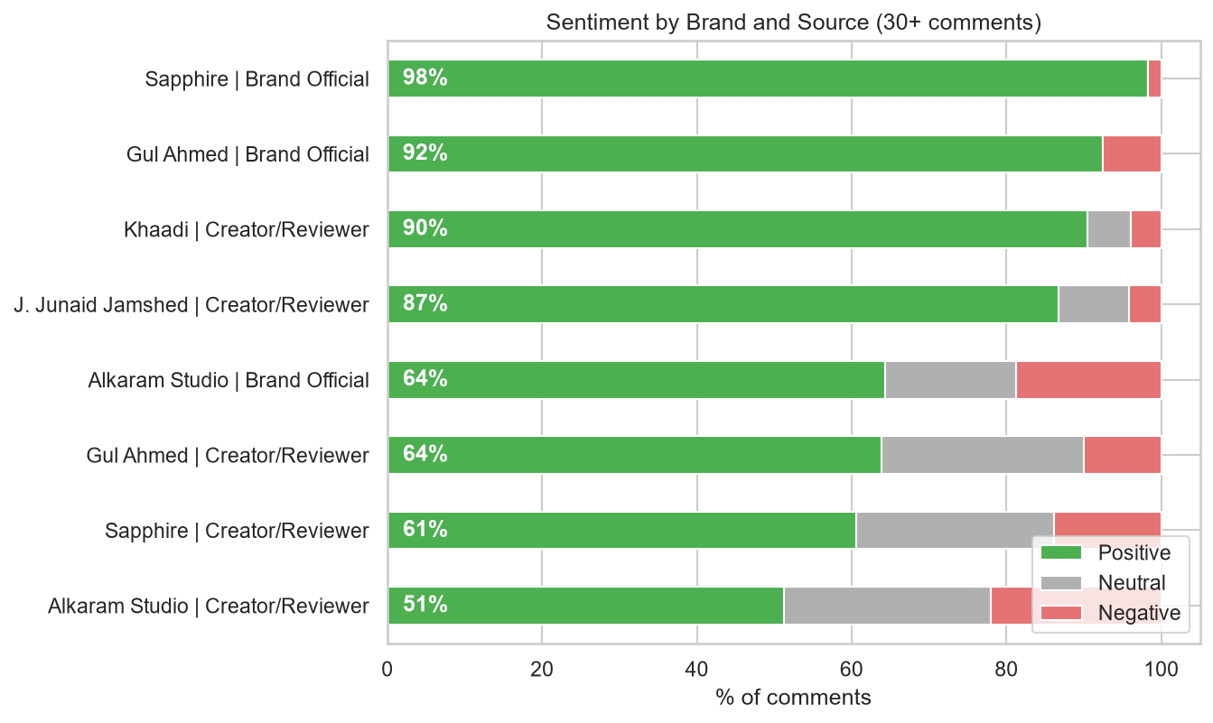
Figure 6. Sentiment by brand and video source (groups with 30 or more comments).
Official videos look slightly more positive (79% against 73%), but the picture is mixed: official videos for Sapphire (98%, 59 comments) and Gul Ahmed (92%, 40 comments) are very positive, while Alkaram's official videos are not (64%). Looking only at creator videos, the brand ranking stays the same (Khaadi 90%, J. Junaid Jamshed 87%, Gul Ahmed 64%, Sapphire 61%, Alkaram 51%), so the brand differences are not just a result of video type.
Table 8. Videos with the highest share of negative comments
Video | Comments | Negative | Positive
Alkaram Studio: Hira Mani's shopping | 60 | 32% | 40%
Sapphire sale Pakistan (YouTube Short) | 48 | 31% | 15%
Alkaram Studio 3-piece lawn dupatta, wholesale price | 59 | 31% | 34%
Sapphire sale today / lawn collection 2024 | 49 | 29% | 16%
Alkaram Studio 50% Sale 2019 haul | 58 | 29% | 29%

Five of the eight videos with the highest share of negative comments (Table 8 shows the top five) belong to Alkaram Studio, so its low score is not caused by one video. The comments show complaints about authenticity ("Stemp kesy lga li jab ye orignal nhn he", meaning how can a stamp be put on something that is not original), about cash on delivery ("Bahi ap cash on delivry kun nahi krty"), and about sold-out items. One of the videos is about a wholesaler selling copy products, so part of that negativity may not be about the brand itself. For Sapphire, the two sale videos are mostly jokes about crowds (for example, a comment saying it looks like a queue to buy flour, followed by laughing emojis), not complaints about clothes.
Caution. Khaadi and J. Junaid Jamshed have only creator videos, and many comments on creator videos praise the vlogger ("you look beautiful", prayers for the creator). Sentiment towards a brand cannot be fully separated from sentiment towards the creator.

7.4 Popular topics, words, emojis and hashtags
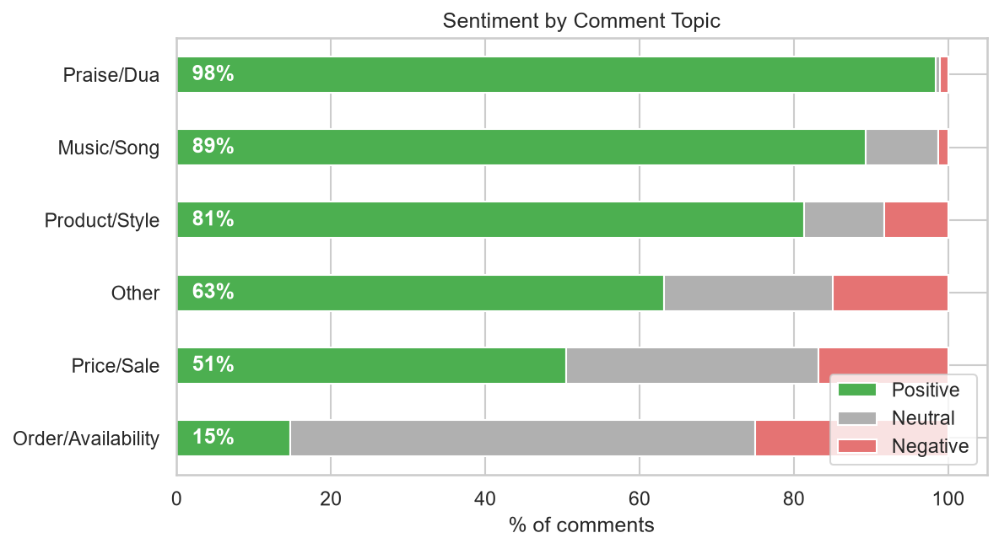
Figure 7. Sentiment by comment topic.
Praise/Dua is 98% positive and Music/Song 89%. Product/Style is 81% positive. The weak spots are Price/Sale (51% positive, 33% neutral, 17% negative) and Order/Availability (15% positive, 60% neutral, 25% negative): people ask where to buy, how to order and what the price is, and some are annoyed when the answer is missing.
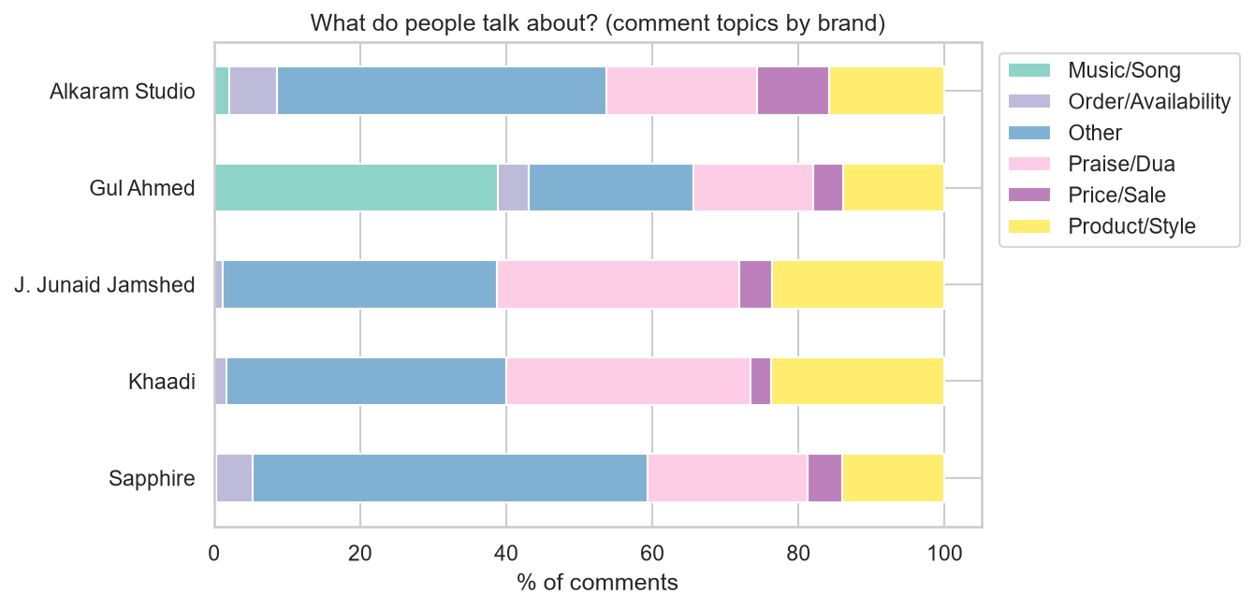
Figure 8. Share of comment topics by brand.
Gul Ahmed stands out with 39% of its comments about music. Alkaram Studio has the highest share of order/availability comments (7%) and price comments (10%); for the other brands these are 1–5% and 3–5%. Khaadi and J. Junaid Jamshed have the most praise/dua comments (33% each), which often is praise for the vlogger.
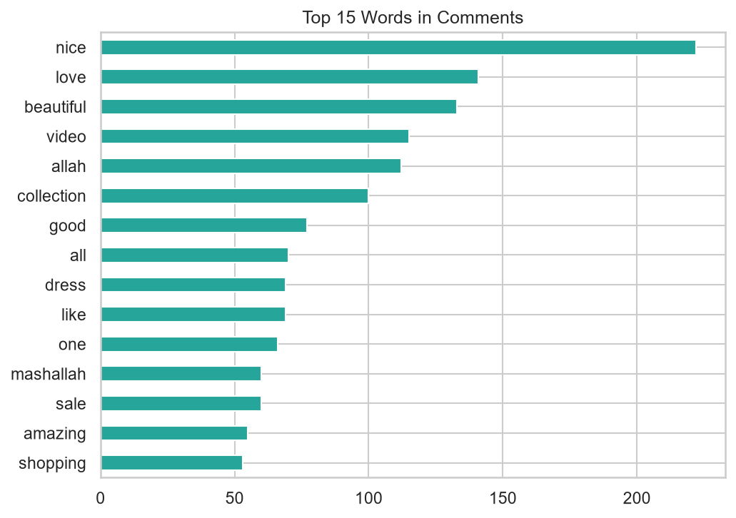
Figure 9. The 15 most frequent words in comments (song comments excluded).
The most common words are "nice" (222), "love" (141), "beautiful" (133), "video" (115), "allah" (112) and "collection" (100), followed by "mashallah" (60), "sale" (60) and "shopping" (53). Most comments are simple praise and say little about specific products. The most used emojis are ❤ (482), 😍 (253), 👍 (124), 👌 (93), 🎉 (73) and 😂 (68).
Hashtags. Only 8 hashtags appear in the 35 video titles, each once (for example #PakistanKiPehchan, #ytshorts, #sale), so popular hashtags cannot be ranked. The video tags are more informative: the most common tag words are "sale" (35), "collection" (29), "summer" (20), "shopping" (17), "haul" (16) and "winter" (16), which agrees with the finding that sale and haul content is common.

7.5 Does sentiment go with engagement?
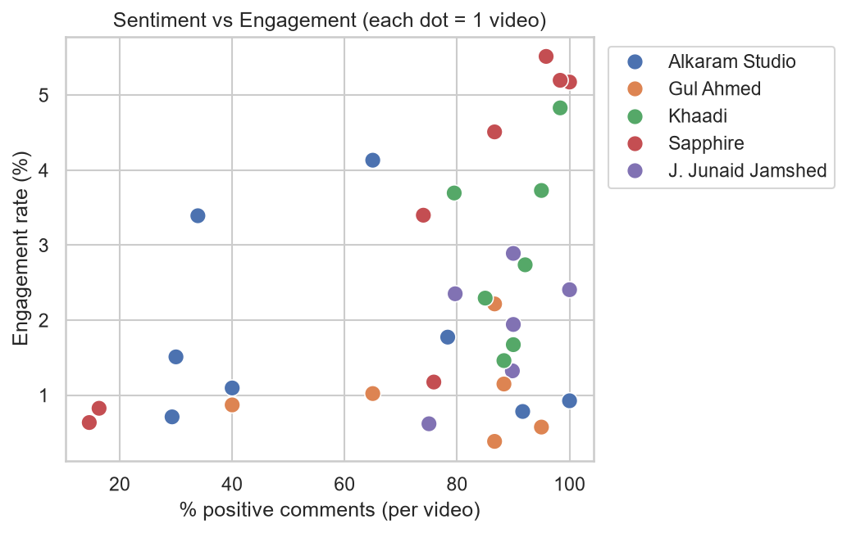
Figure 10. Share of positive comments against engagement rate. Each dot is one video.
Table 9. Spearman correlations with engagement rate (35 videos)
Measure | Correlation
Share of positive comments | 0.39
Average sentiment score | 0.32
Share of negative comments | −0.27
View count | −0.81
Share of positive comments, after removing the effect of views | 0.24

The share of positive comments and the engagement rate move together only weakly (0.39). After removing the effect of view count the link falls to 0.24, which is below the 0.33 needed to tell it apart from zero with 35 videos. The strongest pattern is with views: the more views a video has, the lower its engagement rate (−0.81). Videos also come from different years, so older videos have had longer to collect likes and views. These are associations only; they do not show that positive sentiment causes engagement.
Comment likes. Sentiment made no difference to comment likes (average 2.5–2.6 for positive, neutral and negative; the median is 0 in every group). Song comments had the highest average (18.3), driven by a few very popular comments (their median is 1). All of the 10 most-liked comments (83 to 426 likes) came from Gul Ahmed's official lawn ads and were about the soundtrack, such as "everyone is here for this song" or requests for a full-length song. English comments have the highest average likes (3.3 against 0.8 for Roman Urdu), but this is mostly the same Gul Ahmed song comments, so it should not be read as a language effect.

7.6 Responsive audience segments
KMeans grouped the 1,794 comments into four comment-based segments. Because usernames were removed, they describe how people comment, not who they are.
Table 10. Comment-based audience segments
Segment | Share | Avg words | Avg comment likes | Pos / Neu / Neg | What they write
Happy English Fans | 57% (1,017) | 7.6 | 3.0 | 100 / 0 / 0 | Short English praise ("Last one is best"), most emojis (1.3 per comment)
Roman Urdu Chatters | 16% (296) | 11.1 | 0.8 | 70 / 0 / 30 | Longer Roman Urdu comments with prayers, requests and some complaints
Curious Askers | 16% (289) | 7.0 | 3.5 | 0 / 84 / 16 | Short questions about brand, price and ordering ("Ap ny last suit ki price share nhe ki"); highest likes
Mixed-Language Chatters | 11% (192) | 10.9 | 1.2 | 62 / 18 / 19 | Urdu and English mixed, praise and questions together

Alkaram Studio makes up 22% of all comments but 32% of the Roman Urdu Chatters, 34% of the Curious Askers and 28% of the Mixed-Language Chatters. This matches its lower positive share and its higher share of price and order questions. Language and sentiment were inputs to the clustering, so the segments differ mainly by these two things and are a descriptive picture rather than a deep finding.

7.7 Best posting days and times
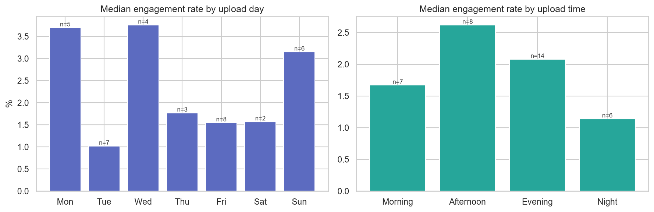
Figure 11. Median engagement rate by upload day and time of day (Pakistan time). n = number of videos.
Table 11. Engagement rate by upload day and time slot (mean, videos in brackets)
Upload day | Mean rate | Upload time | Mean rate
Monday | 3.73% (5) | Morning, 5 am–12 pm | 1.98% (7)
Tuesday | 1.09% (7) | Afternoon, 12–5 pm | 2.64% (8)
Wednesday | 3.28% (4) | Evening, 5–10 pm | 2.43% (14)
Thursday | 2.03% (3) | Night, 10 pm–5 am | 1.65% (6)
Friday | 1.51% (8) | Weekdays (Mon–Fri) | 2.13% (27)
Saturday | 1.57% (2) | Weekend (Sat–Sun) | 2.67% (8)
Sunday | 3.04% (6)

Videos uploaded on Monday, Wednesday and Sunday had higher engagement rates than Tuesday and Friday uploads, and afternoon and evening uploads did better than night uploads. However, each day has only 2–8 videos, the videos span 2017–2026, view count strongly affects the rate, and most videos are creator uploads, not brand schedules. This is an idea to test, not a posting rule.

8. AI-assisted marketing recommendations
These recommendations were drafted with the help of an AI assistant (Claude) from the results above and checked against the data by me. They are hypotheses to test, not proven effects. Alkaram Studio is used as the main example because it has the lowest positive share and the most order and price questions.
- Make buying easier in the comments. Order/availability comments were the least positive topic (15% positive, 60% neutral, 25% negative), and Alkaram had the highest share of order (7%) and price (10%) comments. In a sample of 15 negative Alkaram comments that were read, about 10 were real complaints: sold-out items, no cash on delivery and doubts about original versus replica products. Action: pin a comment under every video with the website link, store locator, delivery and payment options; answer "price?" and "available?" within 24 hours; mention sold-out items in the description.
- Build trust in authenticity. Several negative comments questioned original products, stamps and replicas (some may relate to one wholesaler's video). Action: publish a short "how to spot an original" post and a list of authorised stores.
- Partner with creators for haul, review and sale videos. Creator videos had a higher average engagement rate than official ones (2.41% against 1.53%), and review/haul (2.78%) and sale (2.30%) videos beat new-collection videos (1.38%). Action: fund a small series of creator hauls around sales and Eid and track the engagement rate per video. Only 6 official videos were analysed, so test before scaling up.
- Use music, but add a product hook. 39% of Gul Ahmed's comments, and all 10 of the most-liked comments, were about the campaign soundtrack, and viewers asked for the full song. None of these were about the clothes. Action: release the full track on music platforms and pin a comment that links to the collection.
- Prepare for sale-day crowds and explain prices. Price/sale comments were only 51% positive, and two Sapphire sale videos had about 30% negative and 15% positive comments; in the comments that were read, many joked about the crowds. Action: offer early access or an online queue, and state discounts and end dates clearly.
- Listen and reply in Roman Urdu, and test posting times. About 31% of the comments were Roman Urdu or mixed, which English-only tools often misread (our model reached 75–78% accuracy). Action: add Roman Urdu spellings to social listening and reply in the commenter's language. Afternoon and evening uploads and Monday, Wednesday and Sunday had higher engagement rates, but with only 2–8 videos per day and a strong view-count effect, run a one-month A/B test before changing the schedule.
KPIs to track: share of positive comments, response time to questions, and engagement rate per video.

9. Limitations
- Small sample. 35 videos (6–8 per brand) and 1,794 comments, fewer posts than the 60–100 in the brief. Most results at video level are indicative, not conclusive.
- YouTube only. The Instagram attempt gave no data, so no cross-platform comparison was possible.
- Mixed sources and years. Videos are from 2017 to 2026, 29 of 35 are from creators, and Khaadi and J. Junaid Jamshed have no official video. Sentiment towards a brand cannot be fully separated from sentiment towards the creator.
- Top comments, not random comments. Comments were taken in YouTube's relevance order, up to 60 per video, which probably favours popular and positive comments. One Alkaram video (and possibly more) came from a reseller or wholesaler, not the brand.
- Engagement is per video. Likes, views and comment counts belong to the whole video, so engagement results rest on 35 data points. View count has a very strong effect (−0.81), and older videos had more time to collect likes. Correlations show association, not cause.
- Sentiment model. Accuracy was 75% (78% after the correction rule) on only 60 comments labelled by one person (me), with no Negative comments in the sample, so negative accuracy is unknown. Neutral comments are often labelled Positive. The model was not trained specifically on Roman Urdu. The rule was tuned on the same 60 comments. Negative percentages are indicative.
- Language and topic tags are keyword-based. The language detector is about 85% accurate in a small check, and 40% of comments fall in "Other". Only 15 comments are in Urdu script. Video categories come from title keywords.
- Segments are exploratory. There is no clear elbow in the clustering, and language and sentiment were inputs. The time-of-day results use 2–8 videos per group.
- Popular hashtags. Hashtags are rare in titles (8 in 35 videos), so video tag words were used instead.

10. Conclusion
Pakistani fashion audiences on YouTube mostly respond with praise: three out of four comments are positive. In this data, the content that attracted the strongest reactions was (1) creator-made haul, review and sale videos, which had higher engagement rates than brand-made new-collection videos, and (2) music, since one soundtrack produced 39% of Gul Ahmed's comments and every one of the most-liked comments. The weakest point for brands is the buying journey: questions about price, availability and ordering got the least positive and most unanswered reactions, and Alkaram Studio showed this most strongly. Sentiment itself did not reliably predict engagement once view count was taken into account.
The conclusions come with clear limits: a small sample of 35 videos, a sentiment model that is right about three times in four, and mostly creator content. The recommendations in Section 8 are therefore best used as ideas to test, for example with a one-month A/B test, before a brand changes its strategy.

11. Reproducibility and AI assistance
- Code and data are in the project repository: three collection scripts (youtube_collector.py, youtube_topup.py, youtube_sapphire.py), the analysis notebook (youtube_analysis.ipynb), the Colab sentiment notebook (colab_sentiment.ipynb), the data and outputs folders, and a README. The YouTube API key is not included.
- Collecting again will return different videos and comments, because search results and comments change over time.
- AI assistance. I used an AI assistant (Claude, by Anthropic) for help with code, debugging and drafting text. I collected the data, ran all the code, labelled the 60 validation comments and checked the outputs.

