Prompt Log: Mitti Dhaba Website
Name: Amna Hameed | Roll No: i263058 | Section: B Theme: Café / Dhaba Menu | AI tool used: ChatGPT Live site: https://amnahameedwork.github.io/mitti-dhaba-menu/

Prompt 1: Introduction
Prompt: Hi, my name is Amna Hameed, roll number i263058, Section B. I am a 1st semester BS Software Engineering student at FAST-NUCES Islamabad. In my ICT lab I made a single web page for a dhaba called “Mitti Dhaba” using only HTML, CSS and JavaScript. Today I need to turn it into a website with at least three pages. Please keep everything simple and beginner friendly, using only HTML, CSS and JavaScript, no frameworks.
Screenshot:
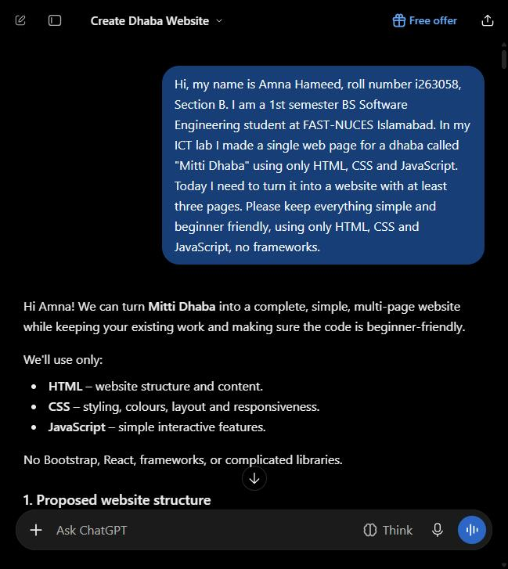
Result: ChatGPT suggested four pages (Home, Menu, About Us, Contact) and a folder layout with separate css/ and js/ folders, then asked me to share my existing code.

Prompt 2: Sharing my Lab 11 code and planning pages
Prompt: Here is my Lab 11 code. My theme is a dhaba menu. My colours are cream #fdf6e3, brown #7f4f24 and red #d62828. My fonts are Georgia for headings and Arial for body text. All styling must stay in one style.css file in the main folder (not a css folder), with no inline styles. Keep each page’s JavaScript in a script tag before the closing body tag. Suggest the pages my website should have. I am thinking of Home, Menu, Gallery and Contact. (I pasted my full index.html and style.css below this.)
Screenshot:
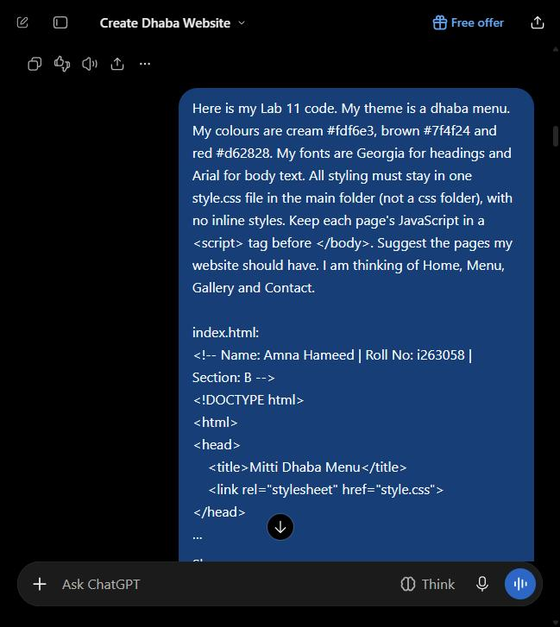
Result: ChatGPT agreed with Home, Menu, Gallery and Contact, changed the folder structure so style.css stays in the main folder, and showed the navigation bar code it would add to every page.

Prompt 3: Navigation bar and updated home page
Prompt: Add a navigation bar under the header with links to Home (index.html), Menu (menu.html), Gallery (gallery.html) and Contact (contact.html). Use the same brown and cream colours. On the home page, replace the full menu table with a short “Today’s Specials” table of 3 items and a link to the Menu page. Keep the existing Order button and its placeOrder() function, and keep the name, roll number and section comment at the top of each file. Please give me the complete updated index.html and the complete updated style.css, not just the changes.
Screenshot:
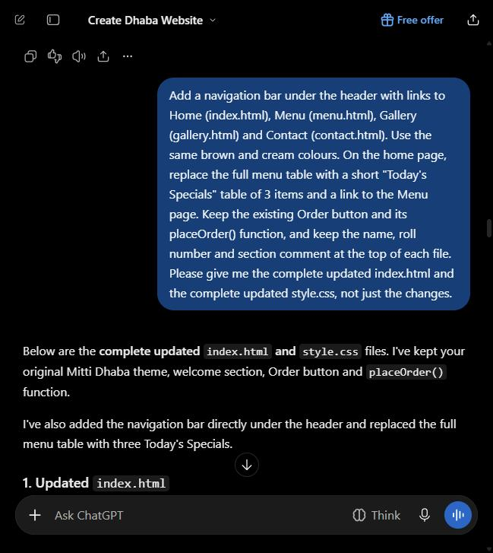
Result: Got a full index.html with the nav bar and a 3-item specials table, plus a full style.css with nav styles and a mobile layout. It worked first time. Commit: Add navigation bar and specials table to home page.

Prompt 4: Menu page
Prompt: Great, that works. Now create menu.html for my dhaba website. Use the same header, navigation bar, footer and style.css as index.html. Show the full menu split into sections: Chai, Breakfast, Main Course, Breads and Drinks. Each section should have a table with Item, Description and Price (Rs.) columns. Under each table add an “Order” button that calls one JavaScript function with the section name, which shows a window.alert() saying that category was ordered and prints a console.log() message. Give me the complete menu.html, and if you need new CSS, give me the complete updated style.css.
Screenshot:
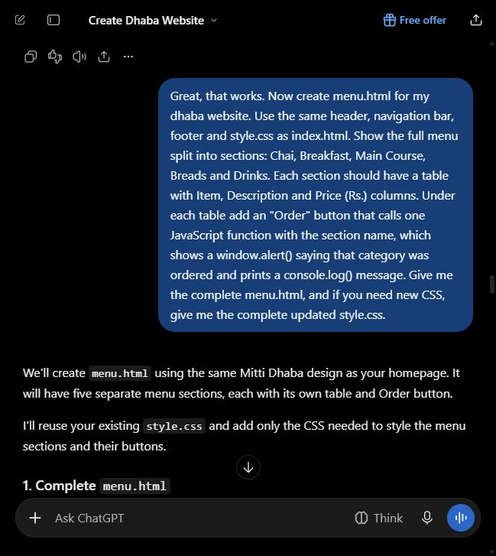
Result: Got menu.html with five category tables and an orderCategory() function, plus style.css with new menu-category styles. It worked first time. Commit: Add menu page with category tables.

Prompt 5: Contact page
Prompt: The menu page works. Now create contact.html with the same header, navigation bar, footer and style.css. Include the dhaba’s address (Blue Area, Islamabad), phone number, opening hours in a small table, and a simple form with Name, Phone and Message fields. Add a “Send” button that calls a function which shows “Thank you, we will contact you soon!” with window.alert() and logs the message in the console. Do not let the form reload the page. Give me the complete contact.html and the complete updated style.css.
Screenshot:
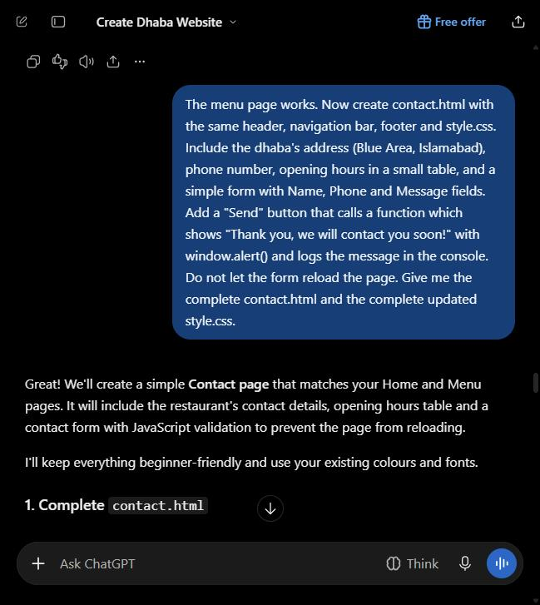
Result: Got contact.html with the address, an opening hours table and a form. sendMessage() uses event.preventDefault() so the page doesn’t reload. Commit: Add contact page with opening hours and form.

Prompt 6: Gallery page (made on branch feature-gallery)
Prompt: The contact page works. Now create gallery.html with the same header, navigation bar, footer and style.css. Show six food pictures in a grid of 3 columns with a caption under each. The images are saved in my images folder as karahi.svg, paratha.svg, chai-cup.svg, halwa-puri.svg, daal.svg and roti.svg. Add a “Like this dish” button under each image that calls one JavaScript function with the dish name, which shows an alert with the dish name and prints a console.log() message. Give me the complete gallery.html and the complete updated style.css.
Screenshot:
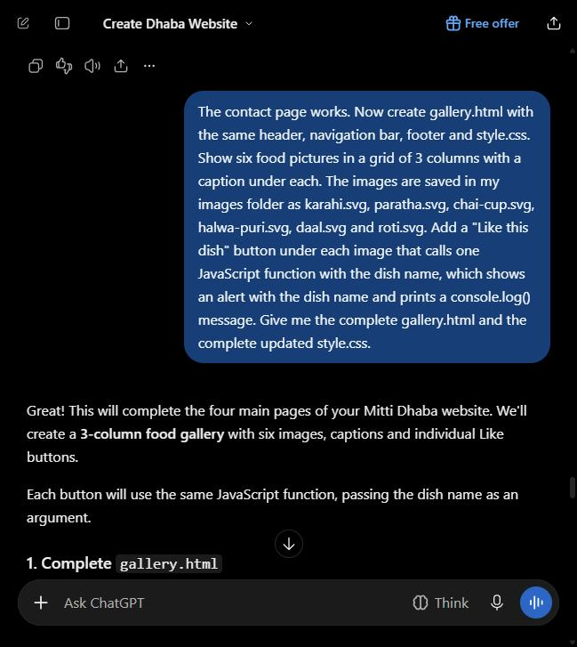
Result: Got gallery.html with a 3-column grid and a likeDish() function, plus the grid CSS. I made a branch called feature-gallery and committed Add food images for gallery page and Add gallery page with image grid there, then merged it into main with a pull request.

Prompt 7: Checking the whole website
Prompt: I now have index.html, menu.html, gallery.html, contact.html and style.css, all exactly as you gave them to me above. Please check them together: does every page have the same header, navigation bar and footer, do all links use lowercase file names that match exactly (GitHub Pages is case sensitive), and does every button work? Tell me anything that is broken or inconsistent and give me the fix. If everything is fine, just say so.
Screenshot:
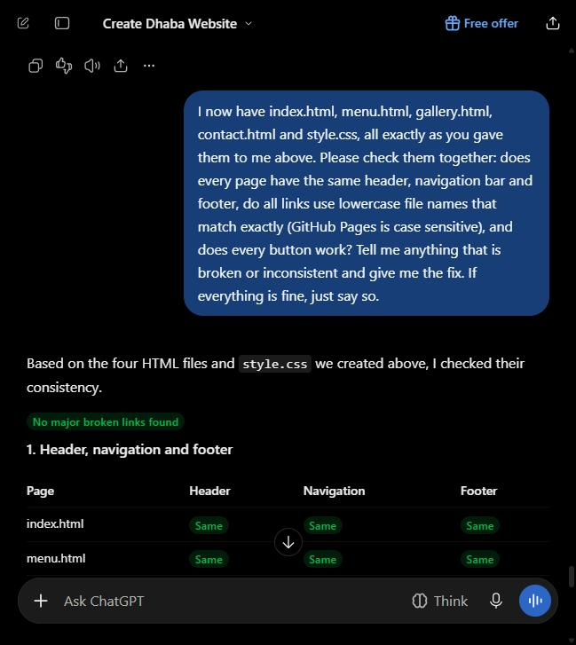
Result: ChatGPT said all four pages match, every link is lowercase and every button works. It reminded me to check that all the image files exist. I tested the live site and every page, image and button works, so no fix was needed.

Manual change (no AI)
What I changed by hand: Added a Doodh Soda row (Chilled milk with soda, Rs. 130) to the Drinks table in menu.html, using the GitHub editor without any AI help.
Commit message: Manual: add doodh soda to drinks table

