###### 

|  |
| --- |
|  |



**Project Title: “STS Portal”**

**Project ID:** BSEF14-517

**Project Proposal  
  
Submitted To:** Ms. Samreen Javed

**Group members:**

Bsef14m539-Amna  
 Bsef14m511-Sana  
 Bsef14m551-Aliha

Bsef14m515-Sonia

Punjab University College of InformationTechnology

**LETTER OFTRANSMITTAL**

**Date:** December 11, 2017

Punjab University College of Information Technology,

Lahore.

Ms Samreen Shahid,

Lecturer, PUCIT, Lahore.

**SUBJECT:** Student Teacher Portal

Respected Madam,

The purpose of this proposal is to convince an institute to implement the newest technology in their organization. This is the need of the hour to adopt new technology to become the part of competition. Existing system is not compatible with students and teachers need. Main objectives of this website is to provide single place to the students where they can do all programming related activities without logging on to different websites.

Our project is a Php website with two main modules. One module provides open source online material to beginners of the world to learn programming in the form of online books, lecture slides, video tutorials and online quizzes with the comfort of home. Another module links student and teacher of particular university on a single platform. Teacher can upload lectures, quizzes and assignments and mark sheets and students can view and download that material.

**Regards**

**Sonia Hayat BSEF14M515**

Aliha Tayyab BSEF14M551

Amna Mukhtar BSEF14M539

Sana Anwar BSEF14M511

**EXECUTIVE SUMMARY**

Our Php website includes two main modules. One module serves as a support to the students sitting at home. Beginners will get free material uploaded on site to learn programming. Site contains lectures, step by step video tutorials and quizzes for them.

The second module is student teacher portal. It links students and teacher of specific class and any kind of material uploaded by teacher is viewed and downloaded by specific class students.

Main objectives of this website is to provide single place to the students where they can do all programming related activities without logging on to different websites.

To develop a new student web portal accessible through student owned devices and through a variety of locations (home, university, public) To encourage students and teachers to use  the new online portal to support teaching and learning

To extend dialogue beyond the classroom by providing access to web. Teachers will acknowledge the online, real-time environment where students “live”. Helps in easy learning of concepts of programming to the beginners from any area of the world. The portal will enhance communication and collaboration beyond classroom walls (teachers-students, students-students).

Contents

**1 Introduction………………………………………………………………………5**

**2-Methodology/Technical details…………………………………………….........5**

**3- Cost and budget…………………………………………………………………6**

**4- timeline of project……………………………………………………………….8**

**5-appendix………………………………………………………………………….12**

**1-Introduction:**

STS portal is the website to provide common platform for teachers and students for interacting and portable access through variety of locations. Our main objective is to extend dialogue beyond the classroom by providing access to web. Teachers will acknowledge the online, real-time environment where students “live”. Our project will have the following main modules

* + Open source material(beginners))
  + Attendance
  + Gradebook
  + Lectures sharing
  + Students uploading assignment
  + Assignments plagiarism
  + Automatic Quiz Evaluation
  + Time table
  + Add /drop course
  + Course evaluation
  + Announcements/posts
  + Challan form

**2-Methodology/Technical details:**

**Agile** is an iterative, team-based approach to development. This approach emphasizes the rapid delivery of an application in complete functional components. Rather than creating tasks and schedules, all time is “time-boxed” into phases called “sprints.” Each sprint has a defined duration (usually in weeks) with a running list of deliverables, planned at the start of the sprint. Deliverables are prioritized by business value as determined by the customer. If all planned work for the sprint cannot be completed, work is reprioritized and the information is used for future sprint planning.  
As work is completed, it can be reviewed and evaluated by the project team and customer, through daily builds and end-of-sprint demos. Agile relies on a very high level of customer involvement throughout the project, but especially during these reviews.

Architecture is the highest-level concept of a system in its environment. As this is a web based application for teachers and students

|  |  |
| --- | --- |
| **Tool** | **Reason** |
| MS Office 2016 | Used for documentation purposes. |
| MS project 2016 | Used to Create Gantt Chart. |
| MS Visio 2016 | Used for Design Diagrams. |

|  |  |
| --- | --- |
| **Technologies** | **Reason** |
| Notepad++ , XAMPP, PHPMYADMIN | This will be used as application tools and development platform |
| PHP, HTML | For Code Behind |
| Java Script | For Client Side validation at some points |
| MySQL Server | As a database management system |
| LARAVAL | A Frame work used to create Php websites |
| CSS | For designing web pages layout |
|  | |

**Management Profile:**

|  |  |  |
| --- | --- | --- |
| **Name** | **Roll Number** | **Skills** |
| Sonia Hayat | BSEF14M515 | Management, Software Development, |
| Amna Mukhtar | BSEF14M539 | Software Development, Documentation, testing |
| Aliha Tayyab | BSEF14M551 | Documentation, Support, Testing |
| Sana Anwar | Bsef14m511 | Documentation, Testing, |

**3-Cost and Budget:**

**Functional Points:**

|  |  |  |  |  |  |
| --- | --- | --- | --- | --- | --- |
| **Measurement Parameters** | **Count** | **Low** | **Average** | **High** | **FP**  **Count** |
| **Number of Inputs** | 11 | 3x 1= 3 | 4 x 7= 28 | 6 x3= 18 | 49 |
| **Number of Outputs** | 9 | 4 x 4 = 16 | 5x3 = 15 | 7 x2 = 14 | 45 |
| **Number of Inquiries** | 4 | 3x1 = 3 | 4 x2= 8 | 6 x1= 6 | 17 |
| **Number of Files** | 3 | 0 x 7 = 0 | 0 x 10 = 0 | 3 x 15 = 45 | 45 |
| **Number of External Interfaces** | 20 | 5 x 5 = 25 | 10 x 7 =7 0 | **5** x 10 = 50 | **145** |

Total Adjusted Function Points: 301

|  |  |
| --- | --- |
| Data Communication | 5 |
| Distributed Data Processing | 4 |
| Performance | 5 |
| Heavily Used Configuration | 3 |
| Transaction Rate | 4 |
| On-Line Data Entry | 4 |
| End User Efficiency | 4 |
| On-Line Update | 4 |
| Complex Processing | 3 |
| Reusability | 4 |
| Installation Ease | 5 |
| Operational Ease | 5 |
| Multiple Sites | 2 |
| Facilitate Change | 4 |
| Total = ∑Fi | 56 |

**FP est. = Count Total * [0.65 + 0.01 * (Fi)]**

**FP est. = 301 * [0.65 + 0.01 * (56)]**

**FP est. =364.21**

Finally, Total Project Cost and Total Project Effort are calculated given the average productivity parameter for the system.

**Cost / FP = 500 Rs.**

**Total Project Cost = 364.21 * 500 = 182,105 Rs**

**Total Estimated Effort = 364.21/7= 45.52 = 46 pm**

Basic COCOMO

Type Effort Schedule

Organic PM= 2.4 (2) 1.05 = 5.25 TD= 2.5(2.5) 0.38 = 4.7months

The schedule is determined using the Basic COCOMO schedule equations.

People Required = 45.5/4.7 = 9.6

**4- Timeline of project:**   
  
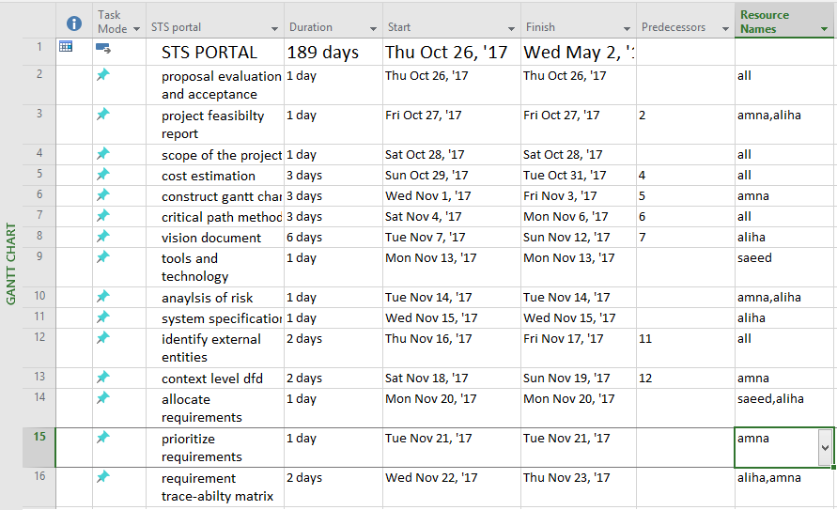  
  
  
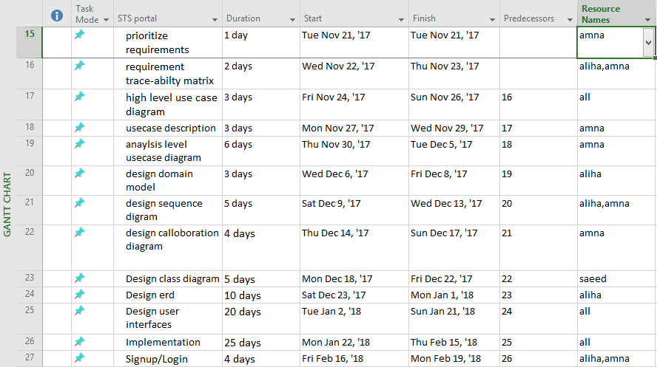  
  
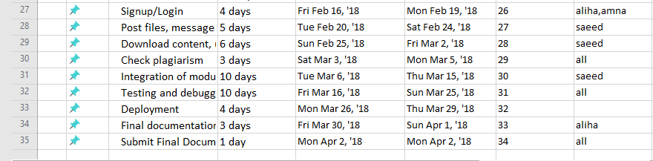

**Gantt chart:**  
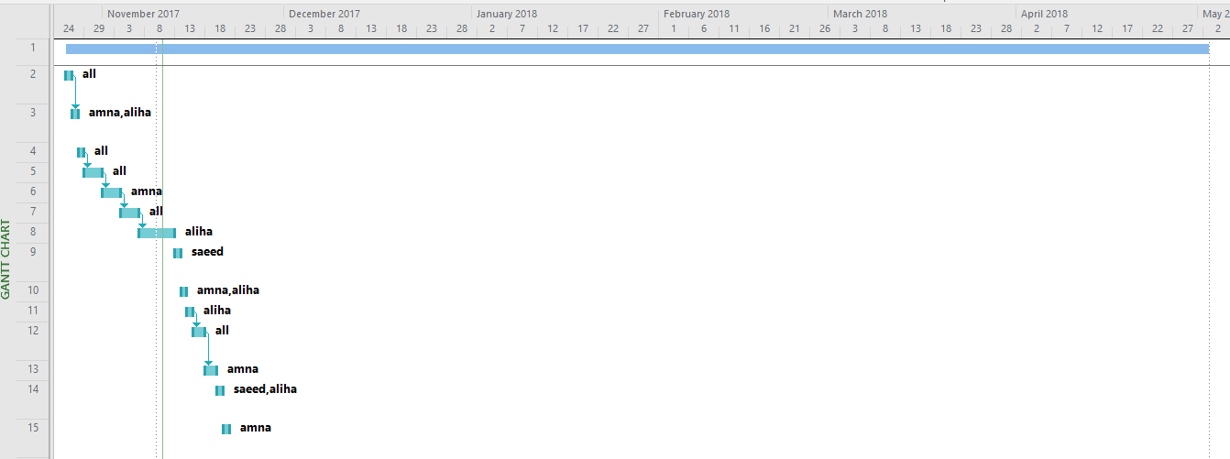  
  
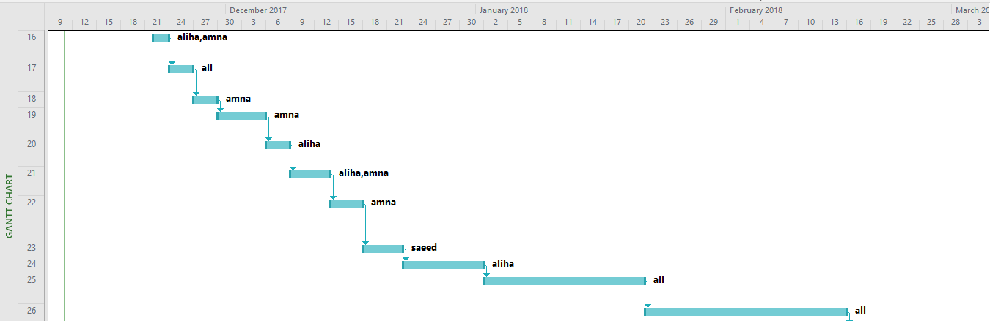  
  
  
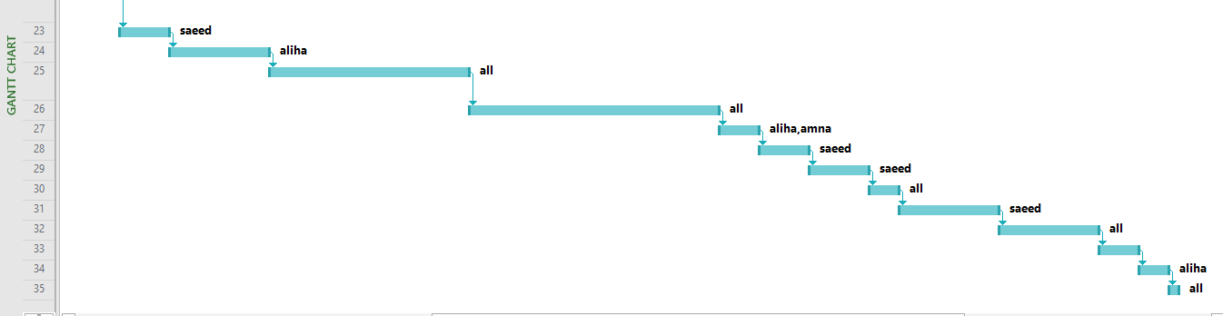

**5-Appendices:**

|  |  |
| --- | --- |
| **Members** | **Skills** |
| Sonia Hayat | she is a team leader and she is   * Good in planning and modeling * Good in programing * Doing help in developing and managing the database * Doing help in developing components related to OOAD in project |
| Amna Mukhtar | she has Leading role in Graphics-Designing and she is   * Good in programing * Good in management skills * Keen observer and is responsible for domain study of product * Good in design and planning |
| Aliha Tayyab | she has Leading role in programing and she is   * Good in presentation * Good in documentation * Good in Design * Good in debugging |
| Sana anwar | she has Leading role in documentation and she is   * Good in documentation * Good in Design * Good in debugging |

