Q1:
amnawali@DESKTOP-7ENTIK9:~$ pwd
/home/amnawali
Q2:
amnawali@DESKTOP-7ENTIK9:~$ ls
final_project.txt main.cpp note.txt project_alpha server.conf statix website
Q3:
amnawali@DESKTOP-7ENTIK9:~$ ls -a
. .bash_logout .config .local .profile final_project.txt project_alpha website
.. .bashrc .git .main-backup.cpp.swp .vim main.cpp server.conf
.bash_history .cache .landscape .motd_shown .viminfo note.txt statix

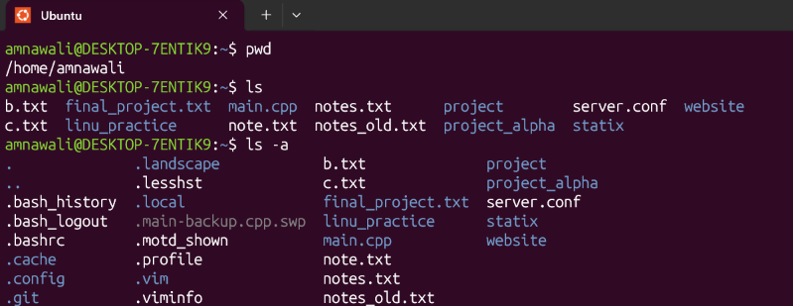
Q4:amnawali@DESKTOP-7ENTIK9:~$ ls -la
total 96
drwxr-x--- 13 amnawali amnawali 4096 Oct 10 00:42 .
drwxr-xr-x 3 root root 4096 Sep 26 15:15 ..
-rw------- 1 amnawali amnawali 3099 Oct 10 00:42 .bash_history
-rw-r--r-- 1 amnawali amnawali 220 Sep 26 15:15 .bash_logout
-rw-r--r-- 1 amnawali amnawali 3771 Sep 26 15:15 .bashrc
drwxr-x--- 4 amnawali amnawali 4096 Sep 26 15:37 .cache
drwxr-x--- 3 amnawali amnawali 4096 Sep 26 15:37 .config
drwxr-xr-x 6 amnawali amnawali 4096 Oct 3 15:05 .git
drwxr-xr-x 2 amnawali amnawali 4096 Sep 26 15:37 .landscape
drwx------ 3 amnawali amnawali 4096 Oct 9 14:00 .local
-rw------- 1 amnawali amnawali 12288 Oct 5 14:51 .main-backup.cpp.swp
-rw-r--r-- 1 amnawali amnawali 0 Oct 10 13:31 .motd_shown
-rw-r--r-- 1 amnawali amnawali 807 Sep 26 15:15 .profile
drwxr-xr-x 2 amnawali amnawali 4096 Oct 10 00:42 .vim
-rw------- 1 amnawali amnawali 6792 Oct 10 00:42 .viminfo
drwxr-xr-x 2 amnawali amnawali 4096 Oct 9 13:28 final_project.txt
drwxr-xr-x 2 amnawali amnawali 4096 Oct 5 14:06 main.cpp
-rw-r--r-- 1 amnawali amnawali 50 Oct 9 14:37 note.txt
drwxr-xr-x 3 amnawali amnawali 4096 Oct 9 14:49 project_alpha
-rw-r--r-- 1 amnawali amnawali 407 Oct 9 14:16 server.conf
drwxr-xr-x 2 amnawali amnawali 4096 Oct 5 14:18 statix
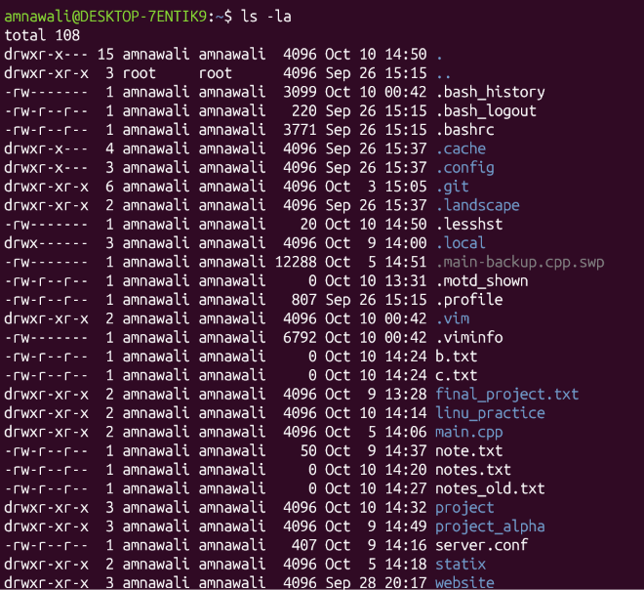

drwxr-xr-x 3 amnawali amnawali 4096 Sep 28 20:17 website
Q5:amnawali@DESKTOP-7ENTIK9:~$ whoami
Amnawali
Q6:
amnawali@DESKTOP-7ENTIK9:~$ hostname
DESKTOP-7ENTIK9
Q7:
amnawali@DESKTOP-7ENTIK9:~$ date
Sat Oct 10 13:48:16 PKT 2026
Q8:
amnawali@DESKTOP-7ENTIK9:~$ cal
October 2026
Su Mo Tu We Th Fr Sa
1 2 3
4 5 6 7 8 9 10
11 12 13 14 15 16 17
18 19 20 21 22 23 24
25 26 27 28 29 30 31
Q9:
amnawali@DESKTOP-7ENTIK9:~$ uname -a
Linux DESKTOP-7ENTIK9 6.18.33.2-microsoft-standard-WSL2 #1 SMP PREEMPT_DYNAMIC Thu Jun 18 21:54:43 UTC 2026 x86_64 GNU/Linux
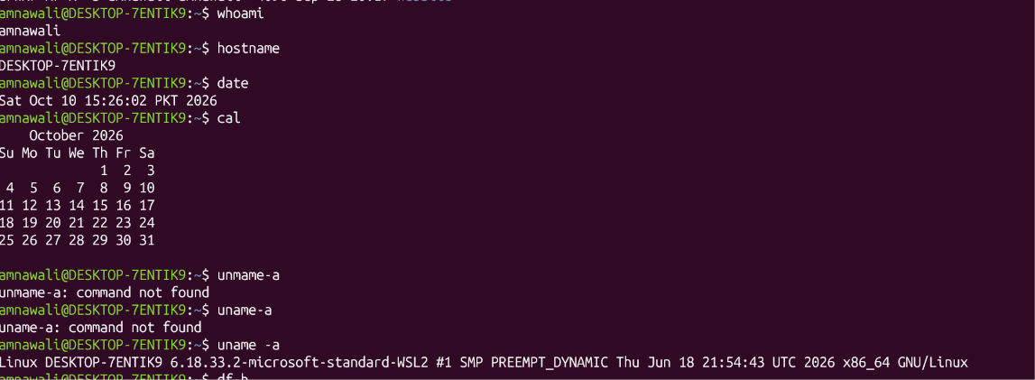

Q10:
amnawali@DESKTOP-7ENTIK9:~$ df -h
Filesystem Size Used Avail Use% Mounted on
none 1.9G 0 1.9G 0% /usr/lib/modules/6.18.33.2-microsoft-standard-WSL2
none 1.9G 4.0K 1.9G 1% /mnt/wsl
drivers 101G 84G 17G 84% /usr/lib/wsl/drivers
/dev/sdd 1007G 1.9G 954G 1% /
none 1.9G 36K 1.9G 1% /mnt/wslg
none 1.9G 0 1.9G 0% /usr/lib/wsl/lib
rootfs 1.9G 2.8M 1.9G 1% /init
none 1.9G 512K 1.9G 1% /run
none 1.9G 0 1.9G 0% /run/lock
none 1.9G 0 1.9G 0% /run/shm
none 1.9G 80K 1.9G 1% /mnt/wslg/versions.txt
none 1.9G 80K 1.9G 1% /mnt/wslg/doc
C:\ 101G 84G 17G 84% /mnt/c
D:\ 69G 8.8G 60G 13% /mnt/d
E:\ 69G 59G 9.4G 87% /mnt/e
tmpfs 1.9G 0 1.9G 0% /tmp
none 1.0M 0 1.0M 0% /run/credentials/systemd-journald.service
none 1.0M 0 1.0M 0% /run/credentials/systemd-resolved.service
none 1.0M 0 1.0M 0% /run/credentials/getty@tty1.service
tmpfs 381M 12K 381M 1% /run/user/1000
Q11:amnawali@DESKTOP-7ENTIK9:~$ free -h
total used free shared buff/cache available
Mem: 3.7Gi 480Mi 3.2Gi 3.5Mi 163Mi 3.2Gi
Swap: 1.0Gi 0B 1.0Gi

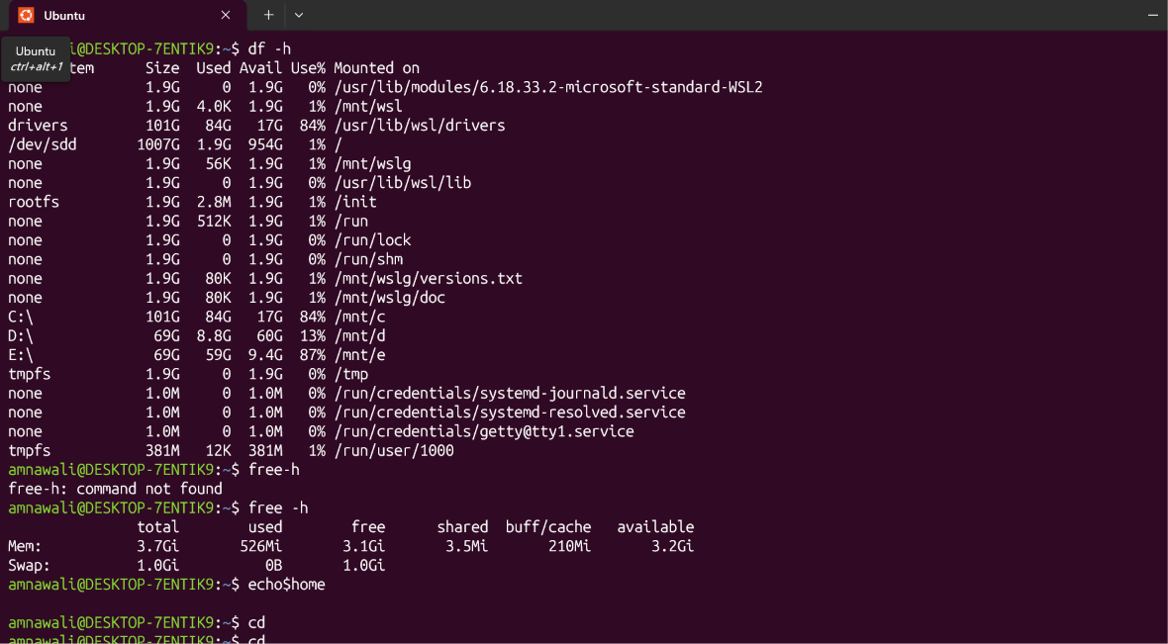

Q12:amnawali@DESKTOP-7ENTIK9:~$ echo $home

amnawali@DESKTOP-7ENTIK9:~$ echo
Q13 :
amnawali@DESKTOP-7ENTIK9:~$ cd
amnawali@DESKTOP-7ENTIK9:~$
Q14:
amnawali@DESKTOP-7ENTIK9:~$ cd ..
amnawali@DESKTOP-7ENTIK9:/home$
Q15:
amnawali@DESKTOP-7ENTIK9:~$ mkdir linu_practice
amnawali@DESKTOP-7ENTIK9:~$ ls
final_project.txt linu_practice
Q16:
amnawali@DESKTOP-7ENTIK9:~$ mkdir -p project/src
Q17:
amnawali@DESKTOP-7ENTIK9:~$ touch notes.txt
amnawali@DESKTOP-7ENTIK9:~$ ls
final_project.txt linu_practice main.cpp note.txt notes.txt

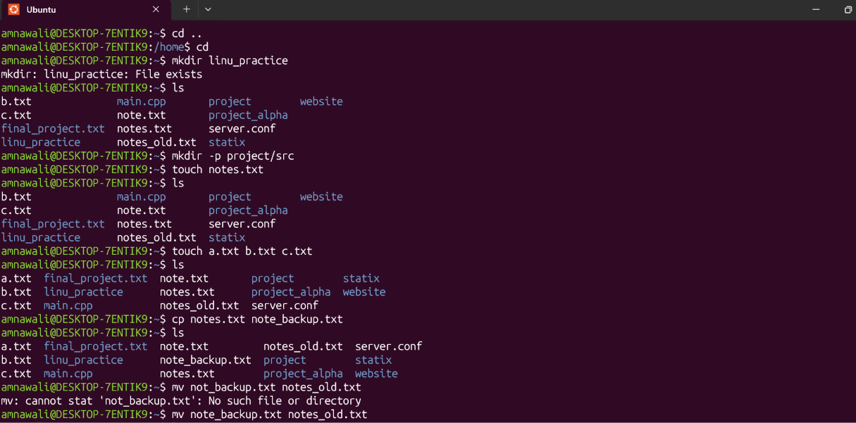
Q18:
amnawali@DESKTOP-7ENTIK9:~$ touch a.txt b.txt c.txt
amnawali@DESKTOP-7ENTIK9:~$ ls
a.txt c.txt linu_practice note.txt project server.conf website
b.txt
Q19:
amnawali@DESKTOP-7ENTIK9:~$ cp notes.txt note_backup.txt
amnawali@DESKTOP-7ENTIK9:~$ ls
a.txt c.txt linu_practice note.txt notes.txt project_alpha statix
b.txt final_project.txt main.cpp note_backup.txt
Q20:
amnawali@DESKTOP-7ENTIK9:~$ mv note_backup.txt notes_old.txt
amnawali@DESKTOP-7ENTIK9:~$ ls
a.txt c.txt linu_practice note.txt notes_old.txt
Q21:
amnawali@DESKTOP-7ENTIK9:~$ mv a.txt project/
amnawali@DESKTOP-7ENTIK9:~$ ls
b.txt final_project.txt main.cpp notes.txt project
Q22
amnawali@DESKTOP-7ENTIK9:~$ mkdir temp_dir
amnawali@DESKTOP-7ENTIK9:~$ ls
b.txt final_project.txt main.cpp notes.txt project server.conf temp_dir
c.txt linu_practice note.txt notes_old.txt project_alpha statix website
amnawali@DESKTOP-7ENTIK9:~$ rmdir temp_dir/
amnawali@DESKTOP-7ENTIK9:~$ ls
b.txt final_project.txt main.cpp notes.txt project server.conf website
c.txt linu_practice note.txt notes_old.txt project_alpha statix
Q23:
amnawali@DESKTOP-7ENTIK9:~$ touch unwanted.txt
amnawali@DESKTOP-7ENTIK9:~$ ls
b.txt final_project.txt main.cpp notes.txt project server.conf unwanted.txt
c.txt linu_practice note.txt notes_old.txt project_alpha statix website
amnawali@DESKTOP-7ENTIK9:~$ rm unwanted.txt
amnawali@DESKTOP-7ENTIK9:~$ ls
b.txt final_project.txt main.cpp notes.txt project server.conf website
c.txt linu_practice note.txt notes_old.txt project_alpha statix
amnawali@DESKTOP-7ENTIK9:~$

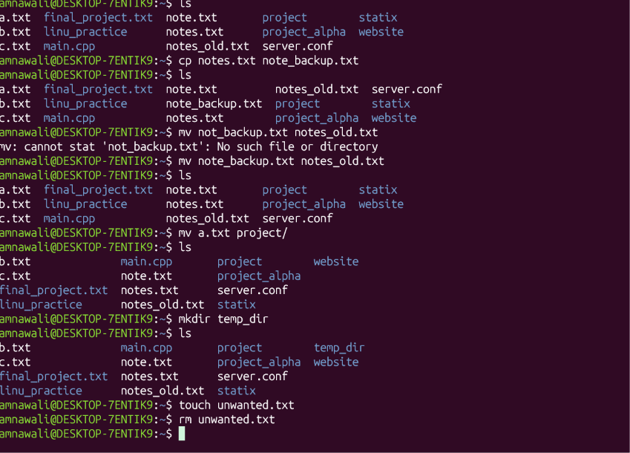
Q24:
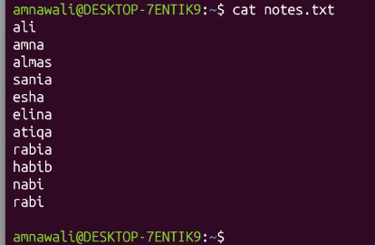

Q25:
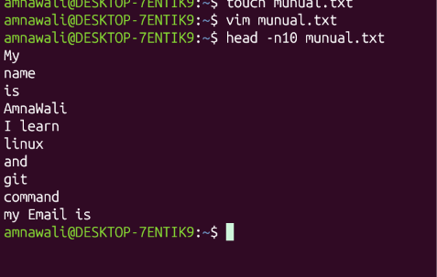

Q26:

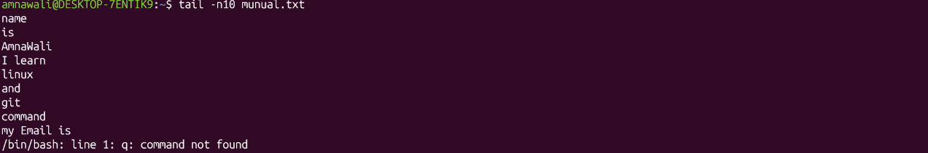

Q27:
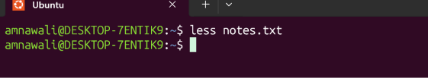
Q28:

Q29:

Q30:
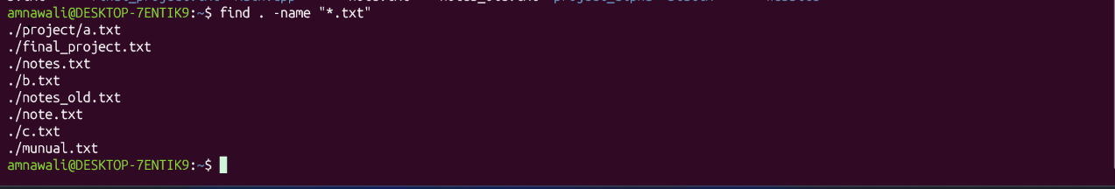

Q31:

Q32: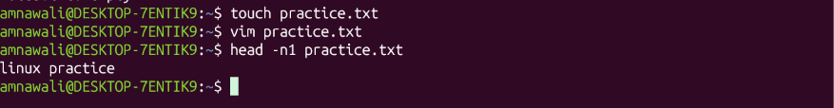
Q33:

Q34:

Q35:

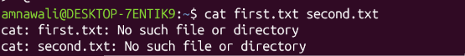

Q36:
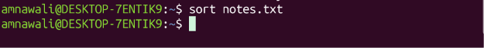

Q37:

Q38:
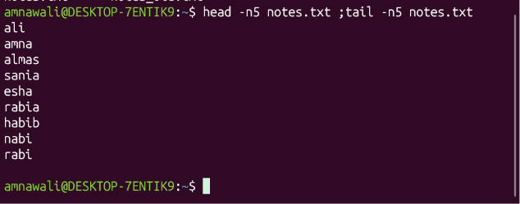

Q39:
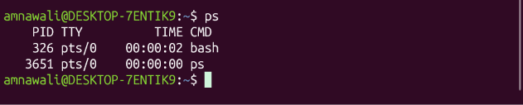

Q40:
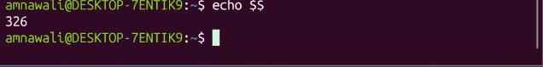

Q41:
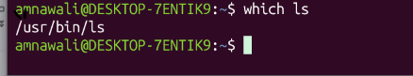
Q42:
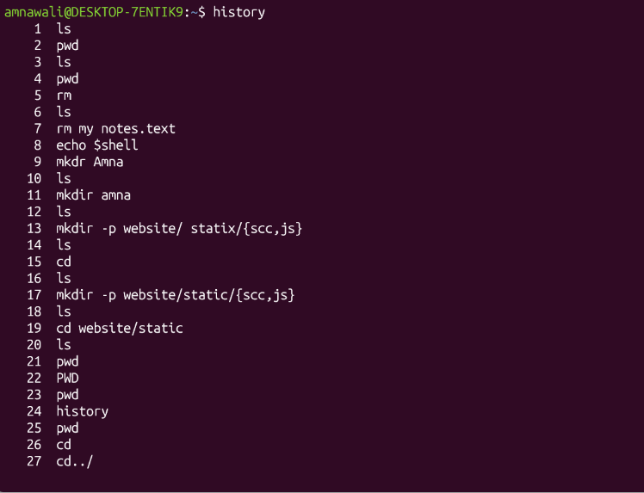

q43:

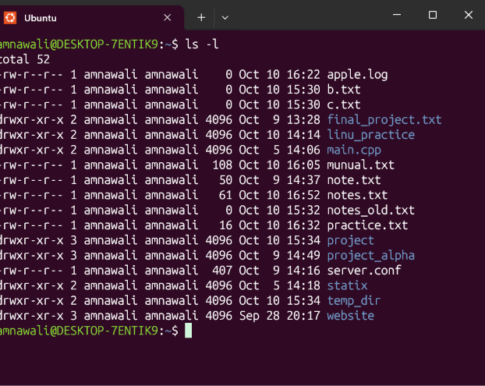

q44:

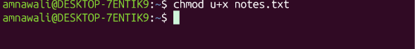

Q45:
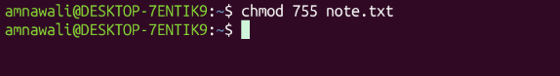

Q46:

Q47:
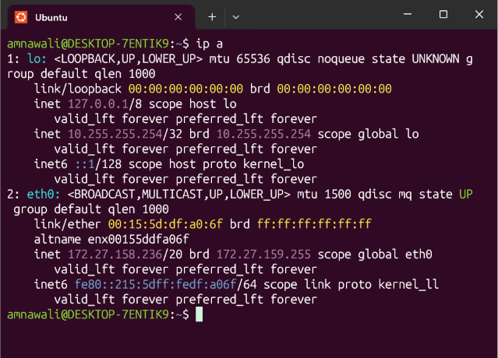

Q48:

Q49:
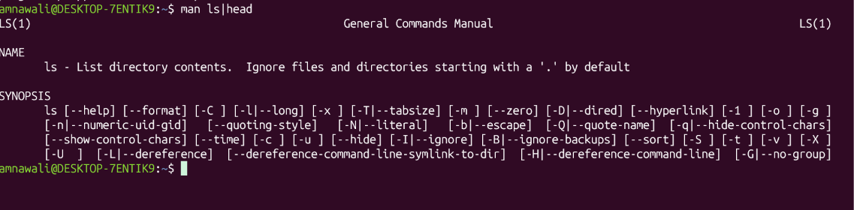

Q50:
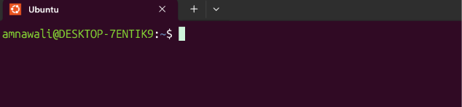

GIT QUESTIONS
Q1:
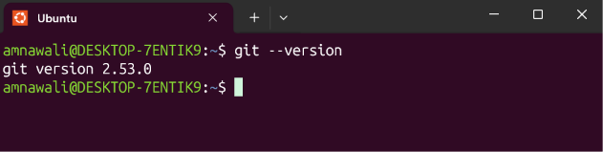

Q2:
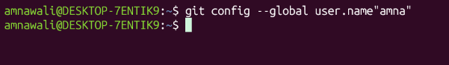

Q3:

Q4:

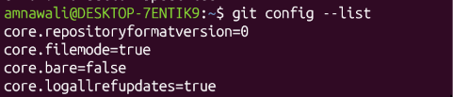

Q5:

Q6:
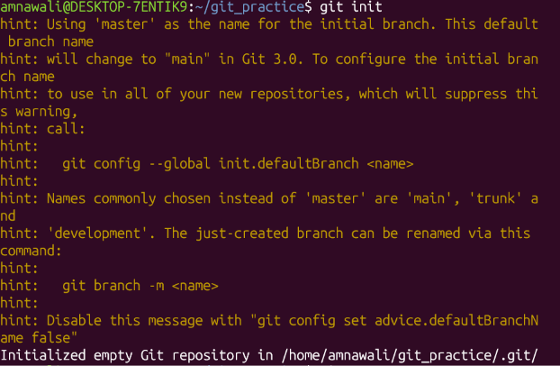

Q7:

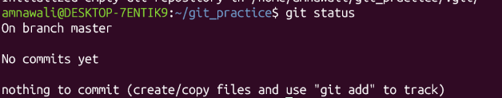
Q8:

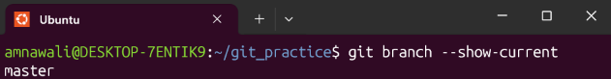

Q9:

Q10:

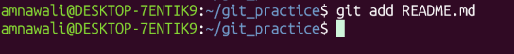

Q11:
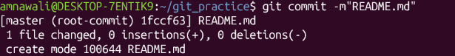

Q12:
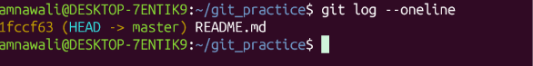

Q13:
Q14:

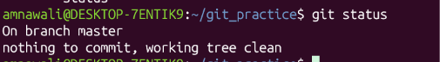
Q15:
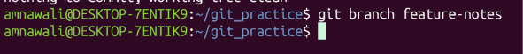

Q16:

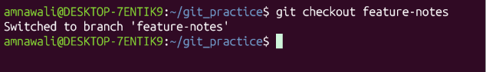

q17:

Q18:

Q19:

