Comparison of Spinoffs vs StartsUps in innovation capabilities
Study of factors affecting innovation methods of spinoffs and startups

Abstract
In recent years , our lives have been drastically improved by revolutionary technologies and innovations. This has been made possible by visions of entrepreneurs and leaders working in businesses like spin-offs and start-ups. Both spin-offs and start-ups have been widely adopted in entrepreneurial world and have been proven to be highly successful in terms of competitiveness, innovation, growth, and economical development. However, there is still a gap in understanding the major differences in innovation methods adopted by spin-offs and start-ups. This research will focus on finding the major factors which affect the adoption of different innovation processes by start-ups and spin-offs. This will help weave the path for future theoretical and experimental research on comparing start-ups with spin-offs.

Introduction
In this world of technological development and innovativeness, we have seen a continuous evolution in types of businesses. Though the objective of each type of firm is same i.e. to generate revenue by creating value for customers, there are differences in their approach to innovate and maintain sustainability. The two types of businesses which have been the focus of attention to entrepreneurs in recent years are spin-offs and start-ups. Both businesses have contributed to improve nation’s economies and employment rates. However, there are differences in their innovation capabilities and their establishment processes. Researchers have been trying to narrow the gap between theoretical understanding of their processes and their practical implications. Lately, they have been the focus of research in entrepreneurial literature. Researches are being done on understanding the taxonomy and formation of spin-off firms and start-ups. Both businesses have been studied to understand their topologies, reasons of success and failures [1], and their affects on the economical growth [2]. There are also numerous comparative studies between spin-offs and start-ups based on technological development [3], resource inheritance and exploitation [4], and survival and growth rate [5]. However, there has little research on finding the major factors which affect the innovation processes of start-ups and spin-offs.
The purpose of this paper is to investigate major factors which affect the innovation methods of spin-offs and start-ups. It has addressed this problem by using reviewing existing research and literature and analyzing results of two qualitative interviews with founders of spin-offs and start-ups. This research will guide the future research in this domain and facilitates business owners to develop strategies for their business’s success.

The remainder of this article is summarized as follows. In section 2, prior research will be discussed in order to lay foundations of the problem in hand. Based on the theoretical discussion, section 3 will describe theoretical framework which will help to identify major factors for comparison and derive hypotheses. In section 4, methodology of collecting data for testing hypotheses will be discussed. Section 5 will analyze the data and derive the meaningful results. The final section concludes the research , discusses its potential benefits and identifies the opportunities for future work.

Literature Review
This section explains the important definitions and previous research on start-ups and spin-offs to gain better understanding of purpose of this research.

2.1 Definitions of Start-Ups
According to wikipedia[6]:
“A startup company (startup or start-up) is an entrepreneurial venture which is typically a newly emerged, fast-growing business that aims to meet a marketplace need by developing or offering an innovative product, process or service.”
According to Steve Blank [8]
“A startup is a temporary organization designed to search for a repeatable and scalable business model”.
“A startup is a company working to solve a problem where the solution is not obvious and success is not guaranteed,” says Neil Blumenthal, cofounder and co-CEO of Warby Parker. [9]
TechCrunch writer Alex Wilhelm defines startup by"50-100-500" rule as follows:
"If your company has, or is any of the following, you have to hang up your Startup Uniform, and realize that you are just another technology company either hunting for or actively avoiding an IPO," Wilhelm writes. "$50 million revenue run rate (forward 12 months); 100 or more employees;Worth more than $500 million, on paper or otherwise." [10]
In a nutshell, there exists no single definition of start-up. Having read many definitions and views of people about start-ups, I have come up with my own definition:
“A start-up is an entrepreneurial venture aimed at creating value for itself and its customers by solving a specific problem and embracing risks and failures on its way to become a stable business. It is the outcome of efforts of individuals who work on their own resources without inheriting any support from other organizations.”

2.2 Definitions of Spin-Offs
According to wikipedia[7]:
“Spin-offs are divisions of companies or organizations that then become independent businesses with assets, employees, intellectual property, technology, or existing products that are taken from the parent company.”
According to Merriam Webster Dictionary[11]
“spin-off is the distribution by a business to its stockholders of particular assets and especially of stock of another company; also: the new company created by such a distribution”
The Economist Group Limited published in blog “The art of the spin-off” in May 4,2013 [12]
“In business, spin-offs are the offspring of established companies. You take a division and turn it into a free-standing firm.”
A number of other studies define a spin-off as a firm whose intellectual capital originates in its parent, for example, a university, research institute, or another companies.[13]
The definition of spin-off varies depending upon the type of spin-off we are referring to. Broadly speaking, there are two types of spin-offs i.e. Academic spin-offs and Corporate spin-offs. These two types are further classified by researchers based on resource transfer, parental support and reasons of their creation.[14].

2.3 Previous Research on Start-Ups
Research on Start-ups have been going on since 1980’s (see Storey, 1982; Wever, 1984). The relationship between innovativeness and success of firms has been the focus of research in literature for many decades. Schumpeter [16] described that innovativeness increased market power of a firm. [16]. Porter [17] explained that innovation improved the ability of firms to break competition. Zahra and George [18] had credited innovativeness for enhancing absorptive capacity of a company. However, a lot of researchers also described negative affects of innovativeness. Samuelsson and Davidsson [19] found that perusing innovations leads to introducing risks in success of start-ups. Amason, Shrader and Tompson have declared innovativeness and novelty a great liability in the path of start-ups’ success [20]. John Freeman and Jerome S. Engel have compared start-ups with corporate companies in their innovation models [15]. They have discussed that big companies have more capital, scientists and engineers, brand presence, strategic alliances, evolving organizational structures, and well established business processes. On the other hand, young firms are a victim of newness and are at higher risks of failure in the beginning. However, they have also mentioned that big companies can fail in developing innovative products due to immobility in resources and misalignment of incentives. In such scenarios, start-ups could evolve into sustainable, growing and profitable businesses. Ari Hyytinen , Mika Pajarinen and Petri Rouvinen [21] suggested that a startup's innovativeness might in fact hurt its survival prospects. Their research has found that survival rate for innovative startups is approximately 6–7 percentage points lower than that of non-innovators. They also find that the interaction of innovativeness and entrepreneurs' greater appetite for risk further reduces the prospects for survival.
In view of extensive research done in field of finding affects of innovativeness on start-ups, it seems that innovativeness might have either a positive or negative affect on start-ups’ success rate. However, empirical literatures mostly states that results are positive [21].

2.4 Previous Research on Spin-Offs
No one can deny the importance of spin-offs in recent economic developments. Forbes calculates that American companies completed more than 80 spin-offs worth at least $500m each between 2002 and 2012. The parent companies (or “spinners”) have delivered a return of 35%, compared with 22% for the S&P 500. The “spun” have delivered a return of 70%. Returns for firms in the Bloomberg Spin-Off Index were 47% over the past 12 months compared with 16% for the S&P 500 [12]. Research have been done on understanding corporate spin-offs topology [23]. Helmut Fryges and Mike Wright discusses topology of spin-offs with respect to their environmental contexts as shown in Figure 1 and defines four types of spin-offs i.e. Academic spin-off, Corporate spin-off, Privatization buyout/buy-in of university research and Management buy-out/buy-in of division [24].
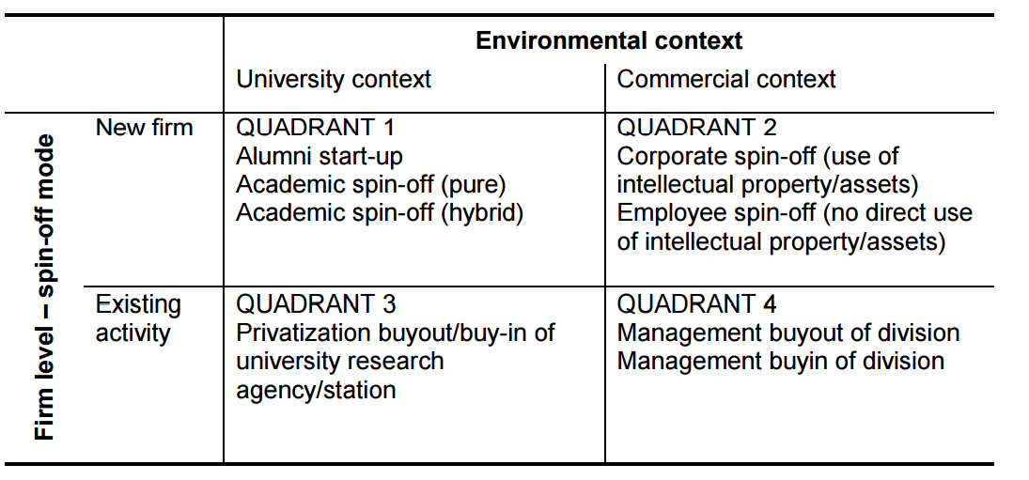

Figure 1
Sierdjan Koster did a survey of the founders of new companies and found that existing companies had a positive impact on creation of new businesses and provides a basis for the new company to build on. However, supported companies are less innovative [5].
In 1999, Institute for Prospective Technological Studies (IPTS) delivered a report “The Impact of Corporate Spin-Offs on Competitiveness and Employment in the European Union” in which seven countries were investigated ( United Kingdom, Sweden, Spain, Italy, Germany, France, and Denmark ) based on two types of Corporate Spin-offs i.e. Restructuring-driven Spin-Off and Entrepreneurial Spin-Offs [26]. The results have shown that Corporate Spin-Off processes represent a valuable mechanism for the transfer of technological and business knowledge and can produce considerable impacts on competitiveness and the socio-economic environments .Andreas Stephan, in his research, compared research based spin-offs with comparable knowledge-intensive firms created in other ways. He found that out of 121 research spin-offs investigated have more patent applications and more radical product innovations, on average, compared to similar firms. [22] Research has also been done in understanding the taxonomies of research based spin-offs based on type of resources, the business model and institutional links [27]. Guido Buenstorf has compared characteristics of spin-offs formed on basis of triggering events as necessity and opportunity spin-offs [28]. He described four types of useful knowledge which employees can learn in parent companies. These are knowledge about technology, markets and customer needs, organizational processes, and personal skills.

2.5 Previous Research on Comparison of Spin-Offs with Start-Ups
Peter and Viliam [29] provided a theoretical framework for comparing start-ups and spin-offs in terms of different types of support they need.
Sierdjan Koster [30] has compared start-ups and spin-offs based on resource theory using empirical study of American entrepreneurs and showed that spin-offs are indeed a step ahead of firms that do not receive support from a third party company. He identified four different types of firms based on resource sharing and parental support as shown in Figure 2.
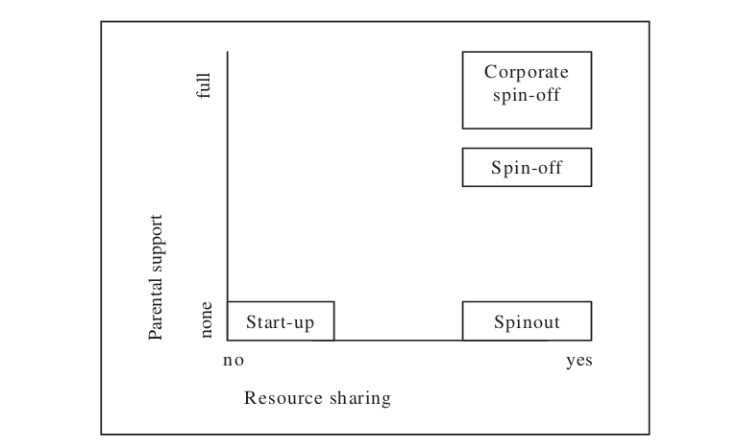

Fig. 2 Difference between Start-up and spin-off based on resource and parental support
Source: KOSTER, 2014 [30]

James and Dennis have done research on different forms of incentives ,in form of property rights and sufficient funds, faced by employees and employers which results in creation of either a start-up or a spin-off. [31]

Theoretical Framework
In this section, four major theories, used in entrepreneurial literature, will be discussed. For each of these theories, a hypothesis will be developed in order to conduct research in this paper.

3.1 Resource-Based Theory
Success of firms have always been linked to their valuable and strategic resources which provide them capabilities to perform better than their competitors. Jay Barney (1991) described four empirical indicators of potential of firm’s strategic resources to generate sustained competitive advantage. These are greater value, rareness, difficulty to imitate and lack of substitutability [32]. Lewin and Phelan stated that the value of any economic organization (firm, business, company) derives from and reflects the value to it of the resources under its control, that is resources that it owns or rents.[33] .In short, resource-based theory states that performance of a company depends upon the quality and nature of resources managed effectively to increase its production of values and services.
Resources can be classified as tangible or intangible . Tangible resources include physical assets like buildings, capital and codified knowledge. Intangible resources include knowledge in form of management and technological skills and routines used for planning and controlling an organization.
Alexander Tubke (2004) [34] has found that spin-offs have higher success rate than any other form of corporate venture. Transfer of resources and knowledge from parent company to spin-off is the main reason for this higher success rate. Maintaining the connection between spin-off and parent company can have both positive and negative affects on future development of spin-off. On one side, spin-off can take advantage of stable resources of parent company, reducing their risks of financial crisis and lack of support at making important decisions. But on the other hand, continuing the relationship with parent firm causes the spin-off to use the already established procedures and strategies of parent company. This can cause unwillingness in spin-offs to accept to new technologies and methods leading to failure in innovative development.
There has be research [35] that spin-offs with indirect relations to parent company performs better than spin-offs with direct relations. Ideas can be developed and implemented in company and experimented with new business models and innovations in spin-offs [36]. On the other side, there has also been a research on negative influences of parental support on spin-offs as its unwillingness to seek for new customers and making investments in new products while having parent company as a secure source of business [37].
Based on the above research, following hypothesis has been developed which will be tested in later sections.
Hypothesis 1. Transfer of tangible and intangible resources from mother companies to spin-offs enhances their innovation.

3.2 Human Capital Theory
According to Becker (1975), investments on human capital in the form of general training, technical skills learning and increase in their productive wages leads to higher productivity and success of businesses. Human capital theory states that a company success depends upon skills, training, experience, education and talents of its employees and its ability to effectively deploy them to create value for its customers. Human capital vary depending upon the type of firms and their targeted markets. There has been several researches describing the importance of human capital on business’s success. For achieving competitive advantage, the role of human capital is greater than ever before because it is considered to be the wealth success and major source of competitive advantage [38]. Credibility and competence of organizations are indicated by their investment on human capital [39]. Continuous investment in human capital is required for a company to maintain its position in market. Human capital becomes less valuable if it is not updated over time [40]. In view of above arguments, human capital covers a broad scope in terms of its characteristics. For this research, human capital in form of previous industry experience, managerial skills and technical knowledge is considered. Following hypothesis is developed for comparing innovation in start-ups and spin-offs based on human capital theory:
Hypothesis 2. Previous employment experience and managerial skills help spin-offs to innovate better than start-ups

3.3 Social Capital Theory
In book “Social Capital: An International Research Program” [41], social capital is defined as “ the capital captured in social relations and its production is a process by which surplus value is generated through investment in social relations.”
Social capital refers to the resources invested in maintaining social relationships to provide benefits to individuals and collective actors. The success or failure of a firm depends upon its networks to other businesses and customers. These relationships are developed by long term investments and trust. It helps businesses to achieve their goals and reach out to the market places which would be impossible without their network connections.
Peter Witt [42] has found a positive relation between the networking activities of founders and their start-ups success. He stated that networking allow entrepreneurs to get resources cheaper than they could be obtained on markets and to secure resources that would not be available on markets at all, e.g. reputation, customer contacts, etc. In a recent study of university incubation support on academic spin offs, it has been found that networking support has positive influence on the performance of spin-offs [43]. There has been many studies [44][45] stating that firms exploit more opportunities and increase their development processes by developing strong networking relationships with other firms and customers. According to Yvonne Bernardt (2002), the reputation of the parent firm is a major factor in success of spin-offs. Through the network of parent company, spin-off can get access to customers, suppliers and finance easily. [46].
In view of above studies, following hypothesis is developed:
Hypothesis 3. Better network capability and collaboration activities of spin-offs improves innovation process.

3.4 Motivational Theory
Behind every accomplishment, there is no doubt a motivation. Motivation is the characteristics that derives us to continue working instead of failures in the path. It is the force that keeps us going on the path with determination to achieve our goals.
According to Maslow’s theory of motivation [47], we have hierarchy of needs which ranges from lower to higher ends. As lower end needs are fulfilled, we tend to other higher end needs. This hierarchy of needs is implemented in a form of pyramid shown in figure below:

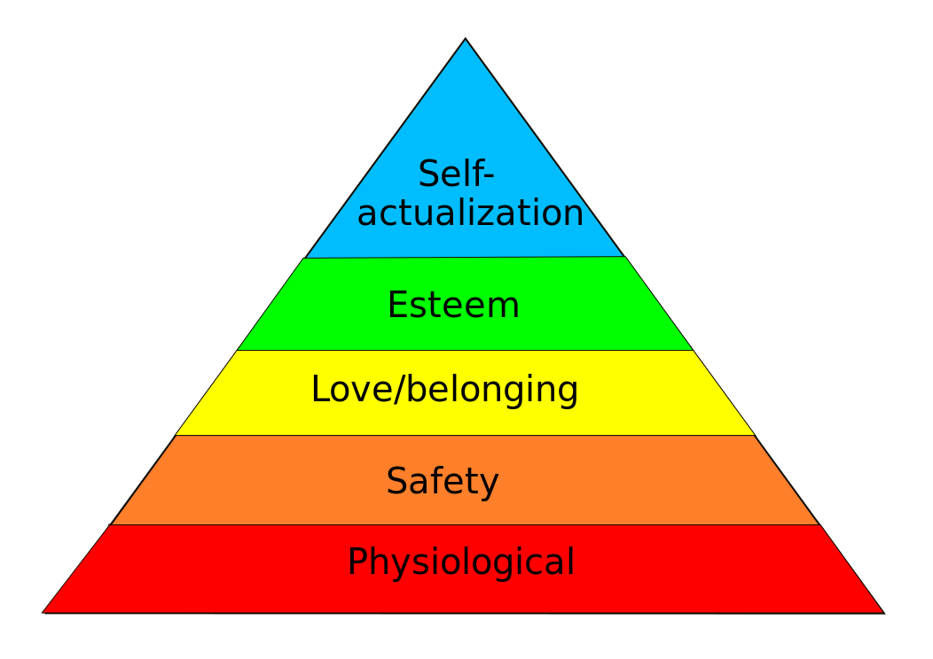

Figure 3. Maslow's hierarchy of needs, represented as a pyramid with the more basic needs at the bottom[47]
All these needs are source of motivation that keep us pushing towards our goals. Motivation has been broadly classified into two types :extrinsic and intrinsic motivation [48]. Extrinsic motivation occurs when we perform a task in order to receive a reward or to avoid some circumstances. Intrinsic motivation involves performing a task for personal fulfillment and internal satisfaction. No matter which type of motivation is used, every successful business needs it in its employees. If employees are not motivated, all the knowledge, skills and professional networks go useless. The results of a survey of 80 academic entrepreneurs [49] has showed that getting extra university salaries is the strongest motivation for its faculty members followed by research-related benefits, the desire for independence and sense of accomplishment. In addition to this materialistic reward, career development, solving research problems , and getting professional recognition are also considered to be important motivations.
In literature, entrepreneurial motivations have been divided into two categories i.e. push and pull motivations. Pull motivations include building career, getting professional reputation and status, need for independence, going after adventures of creating innovative ventures and grabbing market opportunities are classified under pull motivations. Push motivations include dissatisfaction in job or pressure to follow the paths adopted by colleagues. If entrepreneurs are pushed to join spin-offs or start-ups against their desires, chances of success of firms decrease significantly. Buenstorf [28] has described several adverse affects which triggers the development of spin-offs including parent company exit, competitor acquisition and top-level management changes. These triggers fall under pull motivations of employees and affects the spin-offs performance.
In view of above arguments and theories, following hypothesis is developed:
Hypothesis 4. Lack of motivation in employees who are forced to join spin-off hinders the progress in innovation.

Methodology
In this section, methodology used for testing hypothesis is discussed. Both primary and secondary research methods have been used [50]. Primary research method used is exploratory qualitative research which was done using questionnaires, sent to two startups and one spin-off. Secondary research was conducted using qualitative analysis of corresponding literature.

4.1 Data Collection
Questionnaire and literature review were used to find the answers of research questions in this paper. Questionnaire was developed using website https://www.getfeedback.com/ [51]. The complete questionnaire is provided in Appendix A. Respondents to questionnaire include two start-ups and one spin-off.

4.3 Characteristics of Respondents of Questionnaire
Some details on the businesses of respondents involved in questionnaire are provided below:
Name of business | Type of business | Type of work | Location
Imsys [52] | Start-up | Designs and supplies networked control solutions to OEMs in the market of Embedded Control, Telematics, Automation, and the Internet of Things | Stockholm, Sweden
PTX Tech [53] | Start-up | PTX presents 4D MMS automotive solution for connected driving | Berlin, Germany
Conatix [54] | Spin-off | Conatix is reinventing business research, helping companies to do market, investment and strategic research better, faster and cheaper. | Berlin, Germany
Table 1

The persons involved in answering the questions were performing managerial responsibilities in company. Following table illustrates some details on the characteristics of people involved in answering questions.
Name of business | Role of Respondent in company | Years of working at current firm
Imsys [52] | Director Business Development | More than five years
PTX Tech GmbH[53] | CEO | Less than five years
Conatix [54] | CEO | More than five year
Table 2
Data collected for testing each hypothesis is presented in the following section.

4.3 Data For Hypothesis 1
This hypothesis states that transfer of resources from parent company to spin-off improves its innovation capabilities. Start-ups ,on the other hand, are not born from the womb of any parent firm. This independence in terms of physical resources causes start-ups to face challenges in innovation process. Questions asked for testing this hypothesis were about affects of transferring resources from parent companies to spin-offs. Following chart shows the results of primary research conducted for Hypothesis 1.

1. Believe that transfer of resources has positive affect on a firm's innovative capabilities

2. Has received resources from parent company.

Conatix CEO, David Lehrer, said the following about the type resources their spin-off received from parent its oragnization and he believed that that this transfer was helpful in initial development phase of their spin-off:
“We received free and discounted use of office space from Humboldt University Berlin which was valuable in the beginning, also servers and other old and used equipment from the university"
For secondary research, following table shows the resources and their findings used for testing hypothesis 1.
Type of resource | Title | Authors | Publishing Year | Findings
Research Paper | Do direct or indirect relations between incumbent firms and corporate spin-offs affect the performance of spin-offs? | Majbritt Rostgaard Evald, Ann Hojbjerg Clarke, Kent Wickstrom Jensen | 2009 | Resources received by spin-offs through direct or indirect relationships with parent firms help them to perform better than independent start-ups. However, spin-offs with indirect relations to a parent firm perform better than spin-offs having direct relations. [35]
Research Paper | Whose child?: how existing firms foster new firm formation | Sierdjan Koster | 2006 | Transfer of resources between firms does not always guarantee the success of spin-off. Resources lose their previous designations and position and needs to be managed effectively in the receiving firm. [5]

4.4 Data For Hypothesis 2
This hypothesis states that previous industry experience and managerial skills helps spin-offs to innovate better than start-ups. Questions asked to respondents for testing this hypothesis were about previous work experience and managerial skills before joining the current organizations. Following chart shows the results of questions asked for testing Hypothesis 2.

1. Has previous work experiences

2. Believe that previous work experience has positive affect on firm's innovative capabilities

3. Has previous managerial experience

4. Believe that previous managerial skills has positive affect on firm's innovative capabilities

For secondary research, following table shows the resources and their findings used for testing hypothesis 2.
Type of resource | Title | Authors | Publishing Year | Findings
Research paper | The effectiveness of university knowledge spillovers: Performance differences between university spinoffs and corporate spinoffs | Karl Wennberg,  Johan Wiklund,  Mike Wright | 2011 | Previous industry experience in private corporations proves to be potentially more valuable for spin-off performance in than university experience alone [55]
Book | Success Factors of Corporate Spin-Off | Alexander Tübke | 2004 | Author has described transfer of experience as one of the success factors for spin-offs. He has mentioned that managerial skills are more valuable to progressive growth of a business venture than technical skills. He has given importance to different types of experiences transferred in spin-off development process e.g. market and product related, technical, managerial and leadership.

4.5 Data For Hypothesis 3
This hypothesis states that networking and relationships with clients and organizations help spin-offs in their growth and progress. Questions asked to respondents for testing this hypothesis were about previous networking with clients or other firms before starting their ventures. Following chart shows the results of questions asked for testing Hypothesis 3.

1. Has previous networking with clients and partners?

2. Believe that previous networking relationships has positive affect on firm's innovative capabilities

For secondary research, following table shows the resources and their findings used for testing hypothesis 3.
Type of resource | Title | Authors | Publishing Year | Findings
Research Paper | Parent company influence on spin-off performance | Tatsiana Halai | 2015 | Networking provides open access to potential clients, finances and supplies for product development. If the parent company has good reputation. It helps spin-offs to get more faith from clients and external relationships [58]
Research Paper | Spin-off firms and individual start-ups. Are they really  different? | Sierdjan Koster | 2004 | Theoretical ideas, based on resource theory, spin-offs perform better than start-ups based on their capabilities of finding ways to establish networks with relevant businesses. [30]

4.5 Data For Hypothesis 4
This hypothesis states that lacking the desire and passion while joining a spin-off has bad affects on innovation development of business. Questions asked to respondents for testing this hypothesis were about previous their motivations while joining the firms. Following chart shows the results of questions asked for testing Hypothesis 4.

1. Are you forced to join this firm as a reorganization due to result of parent company's?

2. Believe that lack of motivation while joining firm decreases its innovative capabilities.

For secondary research, following table shows the resources and their findings used for testing hypothesis 4.
Type of resource | Title | Authors | Publishing Year | Findings
Book | A Theoretical and Empirical Analysis, with Special Reference to Education, Second Edition | Gary S. Becker | 1975 | Motivation is one of the major factors affecting productivity of employees. Large investments on human capital and increase in earnings affects employees morale which in turn affects company’s growth [59].
Book | Success Factors of Corporate Spin-Off | Alexander Tübke | 2007 | Author has discussed motivational factor as an important factor affecting the performance of spin-off. He has mentioned that when employees are forced to join spin-offs against their will in the times of parent internal crisis, businesses fail badly. [57]

Analysis and Results
In this section, results of primary and secondary research will be analyzed. Based on analysis, hypothesis will be tested and results will be explained.

5.1 Analysis and Findings For Hypothesis 1
In primary research, all respondents of questionnaire agreed to the positive affects of resource transfer on the success of spin-off. However, some researchers believed that transferring of resources could hinders the progress of spin-off if not managed effectively. Some researchers argued that it deprives spin-off from independence and flexibility of performing operations which negatively affects the spin-off performance. However, majority of secondary research results are in favor of hypothesis 1.

5.2 Analysis and Findings For Hypothesis 2
All respondents of questionnaire answered in favor of hypothesis 2. In addition, literature reviews also supported the fact that previous industry experience and management skills help spin-offs to outperform individual start-ups in early stages of development.

5.3 Analysis and Findings For Hypothesis 3
Two respondents (Imsys and Conatix) had previous networking relationships and believed that it helped in innovation development. However, PTX tech GmbH, a Berlin based start-up, has no previous connections with clients and its CEO believed that it had no affect on its innovation capabilities. Results of secondary research are in favor of hypothesis 3. Since majority of results support hypothesis 3, it appears that previous external relations with clients and providers help spin-offs to perform better than start-ups which do not have any networking with potential clients.

5.4 Analysis and Findings For Hypothesis 4
Both primary and secondary research support hypothesis 4. All respondents believed that lack of motivation is a major factor affecting the progress of a firm. In literature, researchers also believed that businesses with motivated and passionate employees flourish with bright colors.

Conclusion
Main purpose of this research was to investigate the differences between innovation capabilities of spin-offs and start-ups. In order to achieve goal of this study, hypotheses were developed regarding major factors affecting innovation capabilities of spin-offs and start-ups. Four major factors were chosen using literary theories which are resource-based theory, human capital theory, social capital theory and motivational theory. In order to test hypotheses, qualitative methodology is used. Questionnaire is sent to three respondents which hold administrative and managerial positions in the spin-offs and start-ups. For secondary research, books and research papers were consulted. The results showed that transfer of resources from parent companies, previous industry experience, management skills and networking relations help spin-offs to perform better than individual start-ups. However, spin-offs which are developed as a result of adverse affects and inefficient driving forces in parent companies, cause lack of motivation in employees which badly affects performance.

6.1 Potential Benefits
The conclusion of this research will help future researchers in comparative studies of spin-offs and start-ups. It will help to further investigate the factors affecting innovation capabilities of firms. Moreover, it can be useful to business owners for understanding the reasons for success and failures of firms ,develop strategies for innovation development accordingly in advance and evaluates main challenges on road of success.

6.1 Future Work
This research can be used for future research in field of investigation of important factors impacting the development of innovation activities of firms. It can be helpful to find more factors impacting the innovation development of firms. More in-depth investigation and interviews can be conducted to make the results of study more reliable. For future work, it be very interesting to investigate factors impacting innovation of spin-offs and start-ups in different countries and in different stages of firm’s development.

Research on spin-offs http://www.startup-book.com/tag/spin-off/
For theories and research based spin-offs
http://www.tandfonline.com/doi/abs/10.1080/0898562042000188423 [networking theory]
For resource based theory figure 7.1 in Whose child paper
KTH paper has a figire success factors
https://www.enterpriseresearch.ac.uk/wp-content/uploads/2015/03/ERC-ResPap26_Wright_Fryges.pdf use this for resoucees
For theores http://www.luiss.edu/dptea/files/reichstein.pdf

References
1. Hoque, Faisal. "Why Most Venture-Backed Companies Fail." Fast Company. Fast Company, 05 Jan. 2014. Web.
2. https://link.springer.com/chapter/10.1007/0-387-24519-7_17
3. https://papers.ssrn.com/sol3/papers.cfm?abstract_id=1400784
4. https://www.researchgate.net/publication/235998970_Ferriani_S_Garnsey_E_Lorenzoni_G_2012_Continuity_and_Change_in_a_Spin-Off_Venture_The_Process_of_Reimprinting_Industrial_and_Corporate_Change_214_1011-1048
5. https://www.researchgate.net/publication/30481390_Whose_child_how_existing_firms_foster_new_firm_formation_individual_start-ups_spin-outs_and_spin-offs?el=1_x_8&enrichId=rgreq-a99509e9c165e2a4ac6e137d1515a59e-XXX&enrichSource=Y292ZXJQYWdlOzI2NTkxMTI1MTtBUzoxNzk3MDQxMDc2NDI4ODBAMTQxOTg1NjIwNjQwNg==
6. https://en.wikipedia.org/wiki/Startup_company
7.https://en.wikipedia.org/wiki/Corporate_spin-off
8.http://steveblank.com/2010/01/25/whats-a-startup-first-principles/
9. https://www.forbes.com/sites/natalierobehmed/2013/12/16/what-is-a-startup/#214c3d904044
10. http://techcrunch.com/2014/12/30/what-the-hell-is-a-startup-anyway/
11. https://www.merriam-webster.com/dictionary/spin-off
12.https://www.economist.com/news/business/21577034-tips-creating-new-companies-out-old-ones-art-spin
13. https://www.researchgate.net/publication/4929782_Conceptualising_the_heterogeneity_of_research-based_spin-offs_A_multi-dimensional_taxonomy?el=1_x_8&enrichId=rgreq-7e2826c1bec27aadc272a3f5099dc6c1-XXX&enrichSource=Y292ZXJQYWdlOzI2NTkxMTI1MTtBUzoxNzk3MDQxMDc2NDI4ODBAMTQxOTg1NjIwNjQwNg==
14. http://econpapers.repec.org/article/kapjtecht/v_3a41_3ay_3a2016_3ai_3a5_3ad_3a10.1007_5fs10961-016-9486-3.htm

15. http://www.haas.berkeley.edu/groups/online_marketing/facultyCV/papers/engel_paper2007.pdf
16. Schumpeter, J.A., 1934. The Theory of Economic Development. Oxford University Press, London. http://refhub.elsevier.com/S0883-9026(14)00091-3/rf0385
17. Porter, M.E., 1980. Competitive Strategy: Techniques for Analyzing Industries and Competitors. The Free Press, New York.http://refhub.elsevier.com/S0883-9026(14)00091-3/rf0335
18 .Zahra, S.A., George, G., 2002. Absorptive capacity: a review, reconceptualization, and extension. Acad. Manag. Rev. 27, 185–203. http://refhub.elsevier.com/S0883-9026(14)00091-3/rf0420
19. Samuelsson, M., Davidsson, P., 2009. Does venture opportunity variation matter? Investigating systematic process differences between innovative and imitative new ventures. Small Bus. Econ. 33, 229–255.
http://refhub.elsevier.com/S0883-9026(14)00091-3/rf0365

20. Amason, A.C., Shrader, R.C., Tompson, G.H., 2006. Newness and novelty: relating top management team composition to new venture performance. J. Bus. Ventur. 21, 125–148 http://refhub.elsevier.com/S0883-9026(14)00091-3/rf0015
21. http://www.sciencedirect.com/science/article/pii/S0883902614000913
22. Small Bus Econ (2014) 43:353–368 DOI 10.1007/s11187-013-9539-z Are public research spin-offs more innovative?
23. http://www.inderscienceonline.com/doi/abs/10.1504/IJTTC.2004.005083
24.https://www.enterpriseresearch.ac.uk/wp-content/uploads/2015/03/ERC-ResPap26_Wright_Fryges.pdf
25. https://www.researchgate.net/publication/30481390_Whose_child_how_existing_firms_foster_new_firm_formation_individual_start-ups_spin-outs_and_spin-offs?el=1_x_8&enrichId=rgreq-7e2826c1bec27aadc272a3f5099dc6c1-XXX&enrichSource=Y292ZXJQYWdlOzI2NTkxMTI1MTtBUzoxNzk3MDQxMDc2NDI4ODBAMTQxOTg1NjIwNjQwNg==
26 ftp://ftp.jrc.es/pub/EURdoc/eur19040en.pdf
27. https://www.researchgate.net/publication/4929782_Conceptualising_the_heterogeneity_of_research-based_spin-offs_A_multi-dimensional_taxonomy
28 Opportunity vs Necessity Spin-offs https://www.econstor.eu/handle/10419/31808
29. Start-up and Spin-off Does They Require Different Support? 5 th Central European Conference in Regional Science – CERS, 2014
30. Conference PaperSpin-off firms and individual start-ups. Are they really
different? 44th Congress of the European Regional Science Association: "Regions and Fiscal
Federalism", 25th - 29th August 2004, Porto, Portugal
31. Start-ups, Spin-offs and internal projects Article in Journal of Law Economics and Organization February 1995
32. Barney, J. B. 1991. Firm resources and sustained competitive advantage. Journal of Management,17, 99–120 http://www.bms.lk/download/PGD/slides/Strategic-Planning-Materials/Barney-1991-strategy.pdf
33. http://citeseerx.ist.psu.edu/viewdoc/download?doi=10.1.1.23.4582&rep=rep1&type=pdf
34. Towards a first spin‐off typology and a new concept for corporate spin‐off research Article in International Journal of Technology Transfer and Commercialisation 3(3) · January 2004https://www.researchgate.net/publication/262967919_Towards_a_first_spin-off_typology_and_a_new_concept_for_corporate_spin-off_research
35. https://www.researchgate.net/publication/264442030_Do_direct_or_indirect_relations_between_incumbent_firms_and_corporate_spin-offs_affect_the_performance_of_spin-offs
36.http://econpapers.repec.org/article/kapsbusec/v_3a43_3ay_3a2014_3ai_3a2_3ap_3a245-259.htm
37 From a corporate venture to an independent company: A base for a taxonomy for corporate spin-off firms https://www.researchgate.net/publication/223392435_From_a_corporate_venture_to_an_independent_company_A_base_for_a_taxonomy_for_corporate_spin-off_firms

38 https://www.researchgate.net/profile/Riaz_Mangi/publication/259032973_Human_Capital_a_Source_of_Competitive_Advantage_Ideas_for_Strategic_Leadership/links/0deec529c950135246000000/Human-Capital-a-Source-of-Competitive-Advantage-Ideas-for-Strategic-Leadership.pdf
39. https://papers.ssrn.com/sol3/papers.cfm?abstract_id=1504506
40. http://econpapers.repec.org/article/eeelabeco/v_3a16_3ay_3a2009_3ai_3a1_3ap_3a97-106.htm
41. https://books.google.de/books?hl=en&lr=&id=lRoUDAAAQBAJ&oi=fnd&pg=PA1&dq=Social+capital+Marx+(1849/1933)&ots=v9kq7UNlsG&sig=CKYWDDAT0ZUGYoexgO9PHuk347I#v=onepage&q=Social%20capital%20Marx%20(1849%2F1933)&f=false
42. http://www.tandfonline.com/doi/abs/10.1080/0898562042000188423
43. The impact of university-based incubation support on the innovation
strategy of academic spin-offs Danny Soetanto n , Sarah Jack
Institute for Entrepreneurship and Enterprise Development Lancaster University Management School, LA1 4YX Lancaster, United Kingdom
44. Grandi, A., Grimaldi, R., 2003. Exploring the networking characteristics of new venture founding teams. Small Business Economics 21, 329–341.
45. Perez, M.P., Sanchez, A.M., 2003. The development of university ´ spin-offs: early dynamics of technology transfer and networking. Technovation 23, 823–831.
46.http://ondernemerschap.panteia.nl/pdf-ez/b200106.pdf
47. https://en.wikipedia.org/wiki/Maslow%27s_hierarchy_of_needs
48. https://www.verywell.com/differences-between-extrinsic-and-intrinsic-motivation-2795384
49. https://www.researchgate.net/publication/311590567_Academic_Entrepreneurship_in_Eastern_Europe_Motivations_and_Success_of_University_Spin-Offs_in_Hungary
50. http://businesscasestudies.co.uk/food-standards-agency/market-research-and-consumer-protection/primary-and-secondary-research.html
51. https://www.getfeedback.com/r/3bhdpFJT
52. http://www.imsystech.com/
53. http://ptx-tech.de/de_DE/
54. http://www.conatix.com/
55. THE EFFECTIVENESS OF UNIVERSITY KNOWLEDGE SPILLOVERS:
PERFORMANCE DIFFERENCES BETWEEN UNIVERSITY SPINOFFS AND
CORPORATE SPINOFFS
56. Whose Child?
How existing firms foster new firm formation:
individual start-ups, spin-outs and spin-offs
57. https://books.google.de/books?id=6TwURkc7kqYC&pg=PA41&lpg=PA41&dq=previous+work+experience+spin-offs&source=bl&ots=5ffY0VR0Nc&sig=Ijkxk8xvOTNVD0XevAcNEu0esLI&hl=en&sa=X&ved=0ahUKEwji6Izuj7HVAhUIU1AKHSzyDkgQ6AEIKDAA#v=onepage&q=previous%20work%20experience%20spin-offs&f=false
58. Parent company influence on spin-off performance
59. http://www.nber.org/chapters/c3733.pdf
60. https://books.google.de/books?id=6TwURkc7kqYC&pg=PA191&lpg=PA191&dq=Success+Factors+of+Corporate+Spin-Off&source=bl&ots=5ffY5WQ1Sc&sig=X4uHnnlgmaw-3ez4FLYj67M6iO8&hl=en&sa=X&ved=0ahUKEwiZh4bM-L_VAhVII1AKHb8NCeIQ6AEIVTAH

