100%

1. Practice Question #1

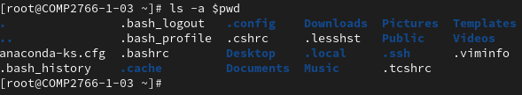

1. Practice Question #2



1. Practice Question #3



1. Practice Question #4



1. Practice Question #5

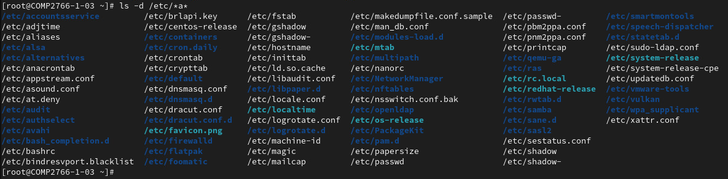

1. Practice Question #6



1. Practice Question #7



1. Practice Question #8

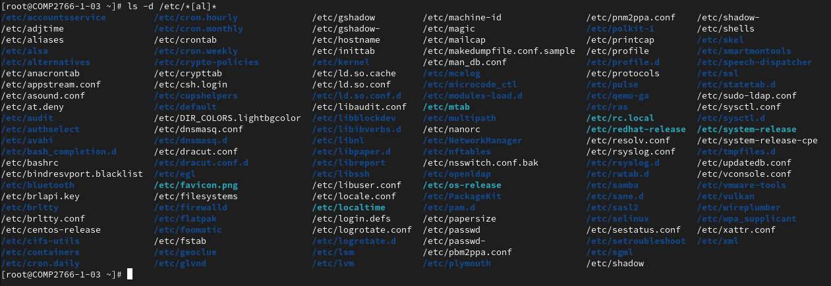

1. Practice Question #9



1. Practice Question #10

