100%

1. Question 1 :

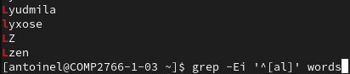

1. Question 2 :

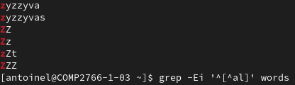

1. Question 3 :

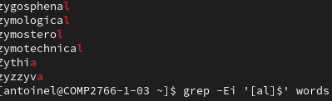

1. Question 4 :



1. Question 5 :

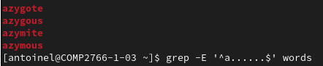

1. Question 6 :

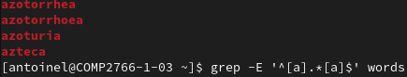

1. Question 7 :



1. Question 8 :



1. Question 9 :

