**COMP 2766: Introduction to Linux**

**Assignment #1**

**INSTRUCTIONS**: Refer to chapter 5 and 6 and Lab 05 and Lab 06 in the NDG Linux Essentials Course in the Cisco Network Academy and the session 1 and 2 slide sets under Learning Hub, Content, for help. Submit this assignment with the required screenshots to the *Assignment 1* dropbox before 6:00pm (PDT), Friday, September 29, 2023. **NO SCREENSHOT, NO MARK!**

If your command line generates too much output to capture in a single screenshot, press UpArrow to retrieve your command line from history and screenshot the command line at the bottom of your screen along with the partial output that appears above it in your terminal window.

1. Log in to the CentOS 9 (Stream) VM in Educloud or on your own computer as **user root**.
2. Open a terminal window.
3. Create a user based on your actual first name and last initial by entering the following command line and replacing *firstnameLastInitial* with your first name and last initial. For example, if your name is Justin Trudeau, create a user named **justint**

useradd *firstnameLastInitial*

Set your user’s password by entering the following command line and replacing *firstnameLastInitial* with your first name and last initial. Note that when you enter the password, it does not appear on the screen and the cursor does not move. Ignore any warnings that appear about the password being too short or based on a dictionary word:

passwd *firstnameLastInitial*

1. Log out the root user by clicking the power button at the top-right of your terminal window and, then, click the arrowhead next to the Power Off/Log Out option and, then, click Log Out (***DO NOT use the su command to switch users!***):

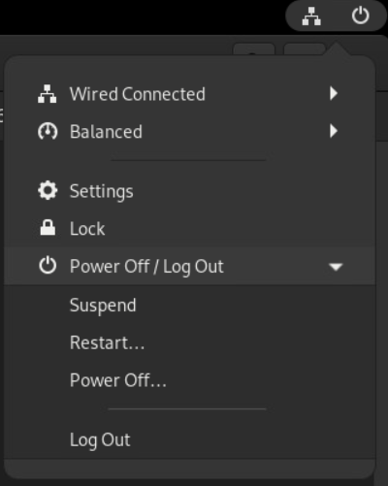

1. Login as the user based on your actual first name and last initial. ***If you do not do this assignment while logged in as your own user, you will receive a mark of zero. Your own user name must appear in every command line prompt in your screenshots.***
2. At the top-left of your terminal window, click Activities to reveal the terminal window icon at the bottom-centre and, then, click that icon.
3. (**1 mark**) Create a local shell variable named after ***your first name*** (ex: anna) and assign it a value that consists of the last two digits in ***your BCIT student #*** (ex: 47). Take a screenshot showing the command line that you entered and its output and insert it here. If there is no output, your screenshot must show the cursor on the following command line:



1. (**1 mark**) Enter a command line that outputs the contents of the local shell variable that you created in the previous step. Take a screenshot showing the command line that you entered and its output and insert it here:



1. (**1 mark**) Enter a command line that converts the local shell variable, the contents of which you output in the previous step, into an environment variable. Take a screenshot showing the command line that you entered and the output and insert it here:



1. (**1 mark**) Enter a command that outputs a list of only all the environment variables. Scroll through that list and notice that it contains your environment variable as well as others that we have discussed. Take a screenshot showing showing the command line that you entered and the output and insert it here.

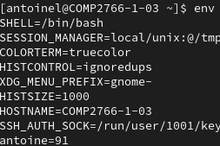

1. (**1 mark**) Enter a command line that proves that the chgrp command is an external command (that is, not built into the shell). Take a screenshot showing the command line that you entered and the output and insert it here:



1. (**1 mark**) Enter a command line that outputs the location where the chage command is stored as a file. Take a screenshot showing the command line that you entered and the output and insert it here:



1. (**1 mark**) Enter a command line that creates an alias named after your first initial and your last initial (ex: jt, if your name is Justin Trudeau) and map it to the command line that outputs a long listing. Your first initial is the first letter of your first name (ex: **j**ustin). Your last initial is the first letter of your last name (ex: **t**rudeau). Take a screenshot showing the command line that you entered and the output and insert it here:

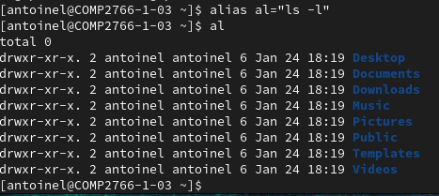

1. (**1 mark**) **Using an appropriate set of quotation marks around the entire string** (that is, sentence), enter a command line that literally outputs the following with ***your name*** in place of Justin:

$HOME refers to the home directory of Justin

Take a screenshot showing the command line that you entered and its output and insert it here:



1. (**1 mark**) Repeat the previous step **using the escape character instead of quotation marks** to obtain the same result.

Take a screenshot showing the command line that you entered and its output and insert it here:



1. (**1 mark**) **Using an appropriate set of quotation marks around the entire string and the name of the appropriate variable**, enter a command line that outputs the following sentence with the contents of the environment variable that contains a list of directories that the shell looks through to find commands that a user enters. The output will look like this, with ???? and the ellipses replaced appropriately:

The ???? variable contains ………

Take a screenshot showing the command line that you entered and the output and insert it here:



Correction : il faut utiliser des “”.

1. (**2 marks**) **Using two forms of command substitution** and the command discussed in section 5.2.5 of **Lab 05 in NDG Linux Essentials**, enter a command line that outputs the following, where your present working directory will be determined by command substitution:

The present working directory is /home/yourFirstName

Take a screenshot showing the ***two*** command lines that you entered and their output and insert it here:

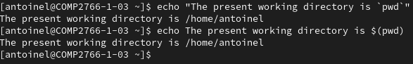

1. (**1 mark**) Combine the three commands discussed in sections 5.2.3, 5.2.4, and 5.2.5 of **Lab 05 in NDG Linux Essentials** into one command line, so that each of the three commands is executed independently, consecutively, and unclsonditionally:

Take a screenshot showing the command line that you entered and its output and insert it here:

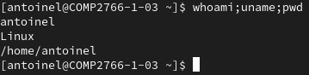

1. (**1 mark**) Using the ls command and /usr as an argument to the ls command, enter a command line that outputs *Success,* ***ONLY*** if that ls command line succeeded (that is, did not output an error). Take a screenshot showing the command line that you entered and its output and insert it here:

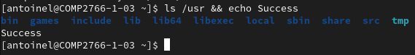

1. (**1 mark**) Using the ls command and /temp as an argument to the ls command, enter a command line that outputs *Success,* ***ONLY*** if that ls command line succeeded (that is, did not output an error). Take a screenshot showing the command line that you entered and its output and insert it here:

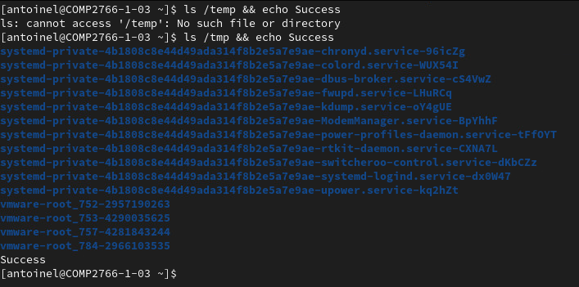

1. (**1 mark**) Using the ls command and /temp as an argument to the ls command, enter a command line that outputs *Failure,* ***ONLY*** if that ls command line failed (that is, output an error). Take a screenshot showing the command line that you entered and its output and insert it here:

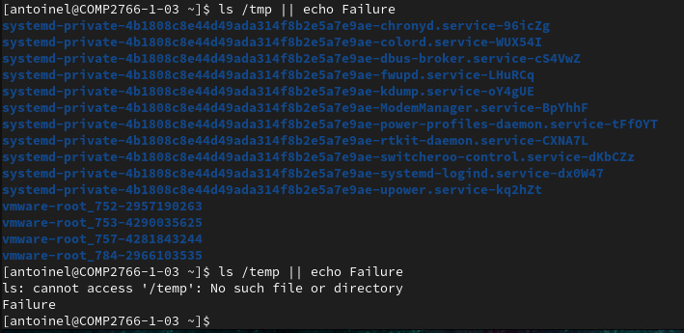

1. (**1 mark**) Using the ls command and /usr as an argument to the ls command, enter a command line that outputs *Failure,* ***ONLY*** if that ls command line failed (that is, output an error). Take a screenshot showing the command line that you entered and its output and insert it here:



1. (**2 marks**) Read section 5.4.3 of **Lab 05 in NDG Linux Essentials**. On the NDG Ubuntu virtual machine on the right half of the screen, (**NOT the CentOS 9 VM on your own computer or on EduCloud**), modify the variable discussed by adding the /home/yourUserName directory to the end of that variable’s existing contents (use your actual user’s name). Then, output the contents of that variable. Take a screenshot showing how you modified that variable and the modified contents of that variable and insert it here:

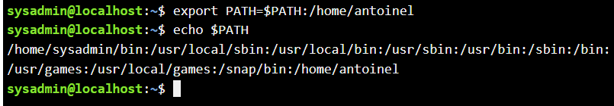

1. (**1 mark**) Load the manual page for the chmod command. From the top of that manual page, press the appropriate key to search forward for *sticky*. Then, press the appropriate key to look for the next occurrence of *sticky*. Then, press the appropriate key to look for the following occurrence of *sticky*. If you make a mistake, quit the manual page and start over. Insert a screenshot, here, showing everything that appears in your terminal window after you have found the third occurrence of *sticky*

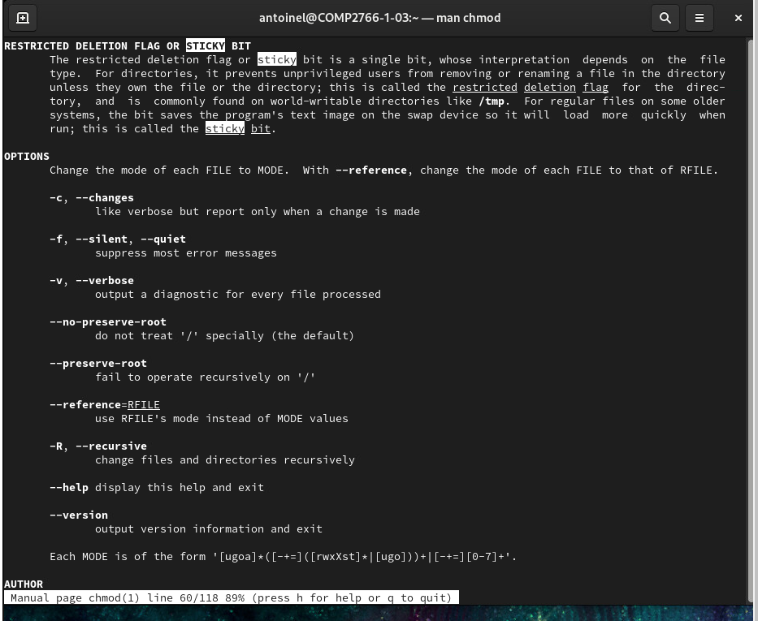

1. (**1 mark**) You are writing a skills quiz and you forgot the name of the command that removes a file. Linux allows you to do a keyword search, similar to using a search engine like Google. Before doing a keyword search, you must logout your user and login as user root. Then, as user root, enter the mandb command to generate an index that is used for keyword searches of the manual pages. **Remember to logout root and log back in as your user**. When searching for a term that consists of multiple words, enclose the term inside a pair of quotation marks. For example, “computer science”

Enter a command line to do an appropriate keyword search to find the name of the command to change group ownership of a file. Your result **must** be from the section of the manual pages that pertains to commands.

Insert a screenshot, here, showing the command line you entered to perform your keyword search and its output:



1. (**1 mark**) Enter a command line that will help you determine what is stored in the third field in /etc/shadow (NOTE: Each line in /etc/shadow contains several pieces of data, each of which is stored in a field separated from adjacent fields by a colon.)

Insert a screenshot, here, showing the explanation of the contents of the third field in /etc/shadow Do ***NOT*** show your command line in the screenshot.

Correction : mettre le screenshot.

1. (**1 mark**) Enter the command line shown in step 6.2.8 of **Lab 06 in NDG Linux Essentials** on your CentOS 9 Stream VM (**NOT the Ubuntu machine**) to find the command that is used to change a user’s password. Take a screenshot showing the command line that you entered and its output and insert it here:

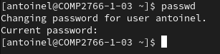

Correction : il faut utiliser la commande suivante : apropos passwd.

1. (**1 mark**) Enter the command lines shown in step 6.2.9 and 6.2.11 of **Lab 06 in NDG Linux Essentials** on your CentOS 9 Stream VM (**NOT the Ubuntu machine**) to view the man pages for the word passwd. Take a screenshot showing the command lines that you entered and its output and insert it here:

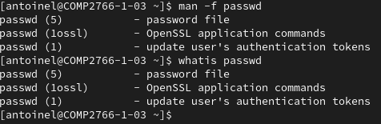

1. (**1 mark**) Use the command shown in step 6.2.16 of **Lab 06 in NDG Linux Essentials** on your CentOS 9 Stream VM (**NOT the Ubuntu machine**) to obtain help for the chage command. Take a screenshot showing the command line that you entered and its output and insert it here:

