**COMP 2766: Introduction to Linux**

**Assignment 2: Navigating the Filesystem**

**INSTRUCTIONS**: Refer to chapter 7 in the NDG Linux Essentials Course on Cisco Network Academy, as well as the session 3 slide set in Learning Hub, Content, for help. Submit this assignment with the required screenshots to the *Assignment 2* dropbox before 6:00pm, Friday, February 2, 2024. **NO SCREENSHOTS, NO MARK!**

1. Log in as the user based on your first name and last initial that you created for assignment #1 on your CentOS Stream VM or switch from user root to your own user by entering the following command line:

su - *yourFirstNameLastInitial*

(NOTE: To revert to user root, enter either the logout or exit command.)

***You MUST do this assignment while logged in as your own user. Otherwise, you will receive a mark of zero. Your own user’s name must appear in every command line prompt in your screenshots. Some screenshots will not show the command line prompt.***

1. (**1 mark**) Draw a filesystem hierarchy tree that shows the directory /v/d/x/. You may use any tool to do this, such as Microsoft Paint, the flowchart maker available at <http://draw.io>, Microsoft Word’s built-in drawing tools (click Insert, Shapes), or anything else of your choice. Insert your tree, here:

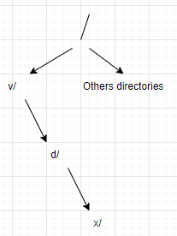

1. (**1 mark**) On the same filesystem hierarchy tree that you drew for the previous question, draw the directory /v/7/z/. Insert your tree, here:

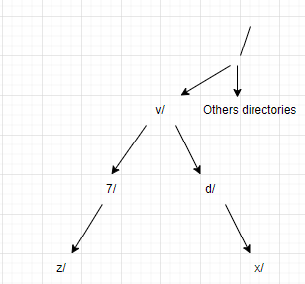

1. (**1 mark**) Enter a command line that outputs the absolute pathname of your present working directory and insert a screenshot, here, showing the command line you entered and its output:

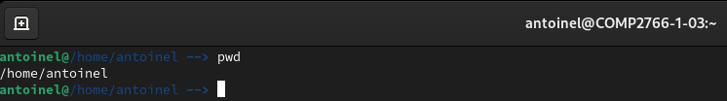

1. (**1 mark**) Enter a command line that changes your present working directory to the root directory at the top of the filesystem hierarchy. Insert a screenshot, here, showing the command line you entered and its output. If there is no output, your screenshot must show the cursor at the start of the next line.

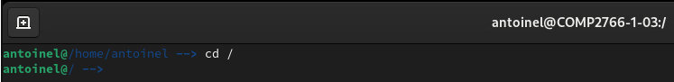

1. (**1 mark**) Enter the shortest command line possible that changes your present working directory to your user’s home directory. Insert a screenshot, here, showing the command line you entered and its output. If there is no output, your screenshot must show the cursor at the start of the next line.

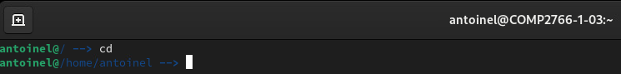

Later in the course, we will formally discuss the /etc/passwd file, which configures the users on your Linux system. It contains one row per user, including the root user, system users, and human non-root users. Examine the file’s contents by entering the following command line which uses the less command to pause the output page by page (when you are finished, press q to quit, just like when in a man page). No screenshot needed.

less /etc/passwd

1. (**2 marks**) Enter the ls command without any switches or arguments to output the names of the visible (that is, non-hidden) files in your present working directory. Insert a screenshot, here, showing the command line you entered and its output:

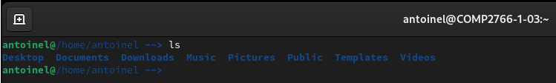

Now, enter the following two command lines which uses the head command which we will soon learn and insert a screenshot below showing the command lines that you entered and their output:

pwd

head -n2 passwd

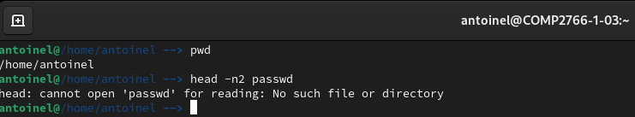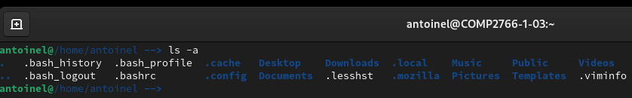

Q: Does the head command line work (yes/no)?: no

Q: What type of pathname is passwd (relative/absolute)? relative

Q: Explain why that type of pathname works (or not) given your present working directory’s contents. Your explanation must refer to the contents of your present working directory, which are shown in your screenshot above.

Use this template for your answer: “*This (you specify the type of) pathname does (or does not) work, because my present working directory which is (you specify what your pwd is) does (or does not) contain a file named (you specify the file name)*.”

Give your answer, here:

This relative pathname does not work, because my present working directory which is /home/antoinel/ does not contain a file named passwd.

1. (**2 marks**) Enter the following two command lines and insert a screenshot below showing the command lines that you entered and their output:

cd /etc

head -n2 passwd

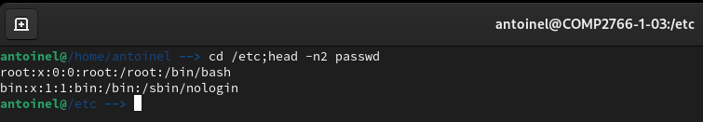

Q: Does the head command line work (yes/no)?: yes

Q: What type of pathname is passwd (relative/absolute)? relative

Q: Explain why that type of pathname works (or not) given your present working directory’s contents. Your explanation must refer to the contents of your present working directory.

Use this template for your answer: “*This (you specify the type of) pathname does (or does not) work, because my present working directory which is (you specify what your pwd is) does (or does not) contain a file named (you specify the file name)*.”

Give your answer, here:

This relative pathname does work, because my present working directory which is /etc/ does contain a file named passwd.

1. (**2 marks**) Enter the following two command lines and insert a screenshot below showing the command lines that you entered and their output:

cd /

head -n2 etc/passwd

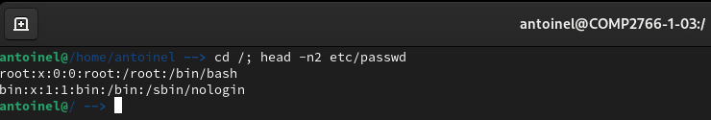

Q: Does the head command line work (yes/no)?: yes

Q: What type of pathname is passwd (relative/absolute)? relative

Q: Explain why that type of pathname works (or not) given your present working directory’s contents. Your explanation must refer to the contents of your present working directory.

Use this template for your answer: “*This (you specify the type of) pathname does (or does not) work, because my present working directory which is (you specify what your pwd is) does (or does not) contain a file named (you specify the file name)*.”

Give your answer, here:

This relative pathname does work, because my present working directory which is / does contain a file named etc/passwd.

1. (**2 marks**) Enter the following two command lines and insert a screenshot below showing the command lines that you entered and their output:

cd /usr

head -n2 etc/passwd

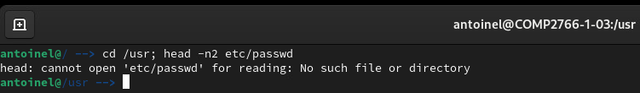

Q: Does the head command line work (yes/no)?: no

Q: What type of pathname is passwd (relative/absolute)? relative

Q: Explain why that type of pathname works (or not) given your present working directory’s contents. Your explanation must refer to the contents of your present working directory.

Use this template for your answer: “*This (you specify the type of) pathname does (or does not) work, because my present working directory which is (you specify what your pwd is) does (or does not) contain a file named (you specify the file name)*.”

Give your answer, here:

This relative pathname does not work, because my present working directory which is /usr/ does not contain a file named etc/passwd.

1. (**2 marks**) Enter the following two command lines and insert a screenshot below showing the command lines that you entered and their output:

cd /etc

head -n2 /passwd

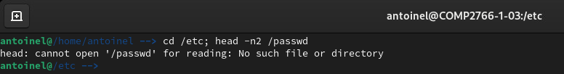

Q: Does the head command line work (yes/no)?: no

Q: What type of pathname is passwd (relative/absolute)? absolute

Q: To better understand why the head command line works (or not), draw a filesystem hierarchy tree that shows /etc/passwd and /passwd and insert your tree here:

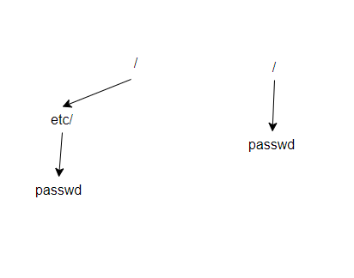

1. (**1 mark**) Enter a command line that uses an ***absolute*** path (a.k.a. absolute pathname) to change your present working directory to the directory named home that is shown in blue in this diagram:

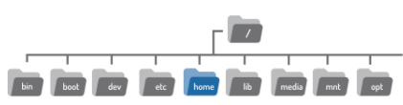

Insert a screenshot, below, showing the command line you entered and its output. If there is no output, your screenshot must show the cursor at the start of the next line.

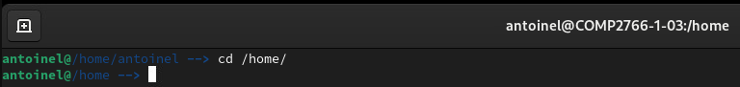

1. (**1 mark**) While you are in /home/, enter a command line that uses a ***relative*** path (a.k.a. relative pathname) to list the contents of your user’s home directory. Insert a screenshot, below, showing the command line you entered and its output. If there is no output, your screenshot must show the cursor at the start of the next line.

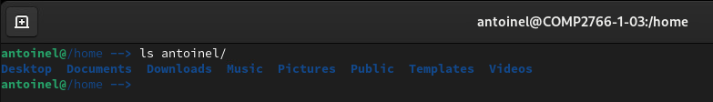

1. (**1 mark**) While you are in your own user’s home directory, enter the shortest command line possible that changes your present working directory to its parent directory. Insert a screenshot, below, showing the command line you entered and its output. If there is no output, your screenshot must show the cursor at the start of the next line.

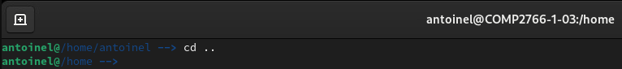

1. (**1 mark**) While you are in your own user’s home directory, enter a command line that outputs a long listing (ls -l) of /usr/share/dict/words by using a ***relative*** path (a.k.a. relative pathname) to refer to that file. Insert a screenshot, below, showing the command line you entered and its output. If there is no output, your screenshot must show the cursor at the start of the next line.

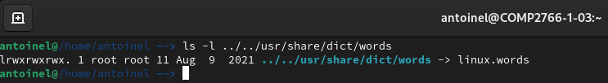

1. (**1 mark**) Enter the following command line:

cd /

While you are in the / directory, enter a command line that uses a ***relative*** path (a.k.a. relative pathname) to output a long listing of /bin/ls and insert a screenshot, below, showing the command line you entered and its output:

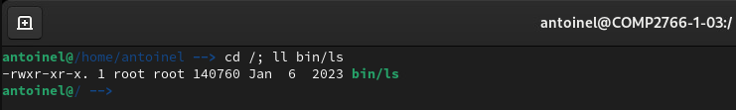

1. (**1 mark**) Enter the following command line:

cd ~

While you are in ~, enter a command line that uses a switch and no arguments to output the names of *all* the files – visible and hidden – that are in that directory. Insert a screenshot, here, showing the command line you entered and its output:

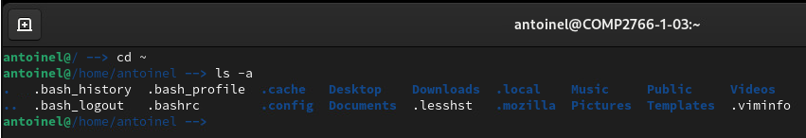

1. (**1 mark**) Enter a command line that outputs a recursive listing of /etc/

As the output is too long to display entirely in one screenshot, press Up Arrow to retrieve your command line from command line history. Insert a screenshot, here, showing that command line and the partial output that appears above it in the terminal window:

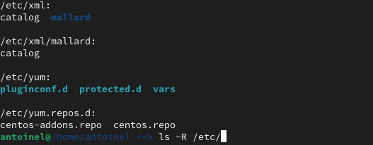

1. (**1 mark**) Enter a command line that outputs a long listing of /boot with the file sizes shown in units of K for kilobytes, M for megabytes, G for gigabytes, etc. Insert a screenshot, here, showing the command line you entered and its output:

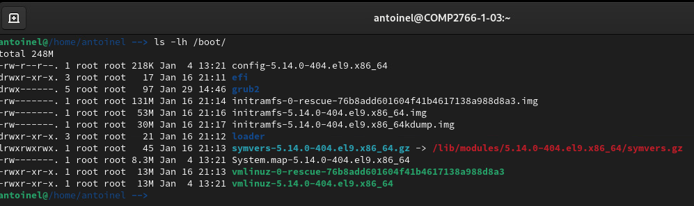

1. (**1 mark**) Enter a command line that outputs a long listing of the /boot directory, itself, ***not*** its contents. Insert a screenshot, here, showing the command line you entered and its output:

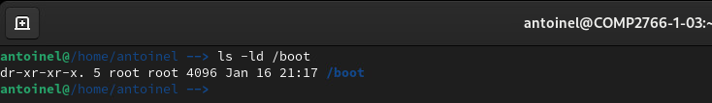

1. (**1 mark**) Refer to your NDG Linux Essentials course, section 7.4.6 (Sort a Listing) and find the command line that produced the sorted output in this screenshot:

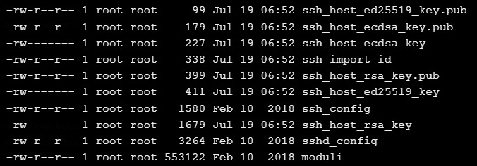

Change to the /etc directory and enter the command line from section 7.4.6 that produced the above output. Insert a screenshot, here, showing the command line you entered and its output.

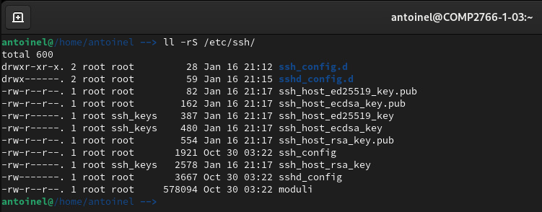

Correction : même commande mais à réaliser dans le dossier /etc.

As the output is too long to display entirely in one screenshot, press Up Arrow to retrieve your command line from command line history. Insert a screenshot, here, showing that command line and the partial output that appears above it in the terminal window:

