**COMP 2766: Introduction to Linux**

**Assignment 3: Managing Files and Directories**

**INSTRUCTIONS**: Refer to chapter 8, sections 8.3 to 8.7, inclusive in the NDG Linux Essentials Course on Cisco Network Academy, as well as Session 4 slides for help. Submit this assignment with the required screenshots to the *Assignment 3* dropbox before 6:00pm (PDT), Friday, February 9, 2024. **NO SCREENSHOT, NO MARK!**

1. Log in as user root on your CentOS Stream VM on Educloud or your own computer.
2. Open a terminal window.
3. Create a user based on your actual first name and last initial by entering the following command line and replacing *firstnameLastInitial* with your first name and last initial. For example, if your name is Justin Trudeau, create a user named **justint**

useradd *firstnameLastInitial*

Set your user’s password by entering the following command line and replacing *firstnameLastInitial* with your first name and last initial. Note that when you enter the password, it does not appear on the screen and the cursor does not move. Ignore any warnings that appear about the password being too short or based on a dictionary word:

passwd *firstnameLastInitial*

1. Log out the root user by clicking the power button near the top-right of your terminal window and, then, click the arrow next to root, and then select Log Out (***DO NOT select Switch User and DO NOT use the su command!***):

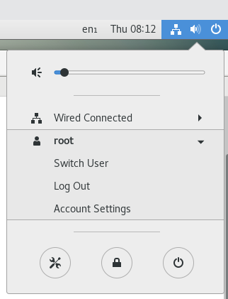

1. Login as the user based on your actual first name and last initial. ***If you do not do this assignment while logged in as your own user, you will receive a mark of zero. Your own user name must appear in every command line prompt in a screenshot.***
2. Open a terminal window.
3. (**1 mark**) In your own user’s home directory, enter a ***single (that is, one)*** command line that creates a directory named homework and two directories in homework named linux and windows. You may ***not*** use any special characters to combine multiple command lines together. Capture and insert a screenshot, here, showing the command line that you entered and the output. If there is no output, you must show the cursor at the start of the following line.

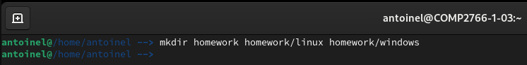

1. (**1 mark**) In your own user’s home directory, enter the following command line to create four new empty files:

touch index.html reunion.jpg birthday.jpg social.jpg

Now, enter a ***single (that is, one)*** command line that moves index.html and social.jpg into the linux directory. You may ***not*** use any special characters to combine multiple command lines together. Capture and insert a screenshot, here, showing the command line you entered and the output. If there is no output, you must show the cursor at the start of the following line

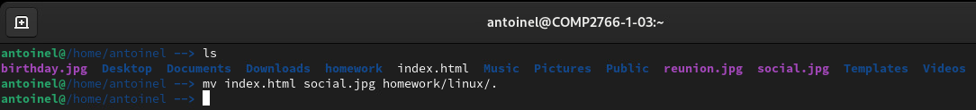

1. (**1 mark**) Enter a ***single (that is, one)*** command line that copies reunion.jpg and birthday.jpg into the windows directory and ensures that the copies have the same name as the originals. You may ***not*** use any special characters to combine multiple command lines together. Capture and insert a screenshot, here, showing the command line you entered and the output. If there is no output, you must show the cursor at the start of the following line.

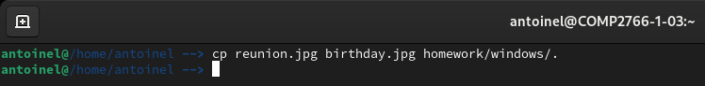

1. (**1 mark**) Enter a ***single (that is, one)*** command line that copies social.jpg into the windows directory such that the copy is named party.jpg. You may ***not*** use any special characters to combine multiple command lines together. Capture and insert a screenshot, here, showing the command line you entered and the output. If there is no output, you must show the cursor at the start of the following line.

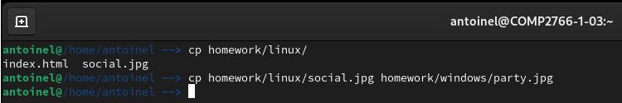

1. (**1 mark**) Enter a command line that renames the linux directory to centos and uses a switch that outputs confirmation of the successful operation. Capture and insert a screenshot, here, showing the command line you entered and the output. If there is no output, you must show the cursor at the start of the following line.

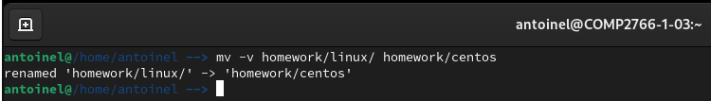

1. (**1 mark**) Enter ***a single (that is, one)*** command line that makes a copy of /usr/share/eog/ in your home directory and names the copy eog.bak. You may ***not*** use any special characters to combine multiple command lines together. Capture and insert a screenshot, here, showing the command line you entered and the output. If there is no output, you must show the cursor at the start of the following line.

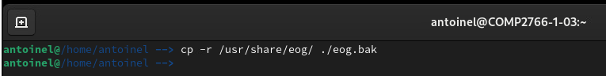

1. (**1 mark**) Enter ***a single (that is, one)*** command line that removes the icons/hicolor/22x22/ directory from your eog.bak directory. You may ***not*** use any special characters to combine multiple command lines together. Capture and insert a screenshot, here, showing the command line you entered and the output. If there is no output, you must show the cursor at the start of the following line.

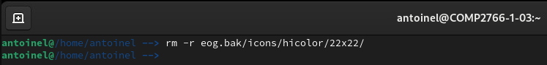

1. (**1 mark**) Enter this command line to change your present working directory to /bin:

cd /bin

Then, enter a command line that outputs only the names of visible files in the /bin directory that contain at least 20 characters in their name. Capture and insert a screenshot, here, showing the command line you entered and its output. (***NOTE: Use the ls command with the –d switch***)

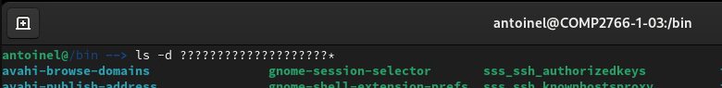

1. Enter the following command lines. The first two command lines force Linux to respect case when you are doing file globbing. The third command line changes to a directory that contains many files that are perfectly suited for testing file globbing. That’s the lowercase letter **l**, not the digit 1, in **lib64**:

**LC_COLLATE=C**

**export LC_COLLATE**

**cd /usr/lib64/gconv**

Questions #16 to #21 assume that you are working in the **/usr/lib64/gconv/** directory. Your answers must be generalized and work for whatever new files might be added to that directory.

1. (**1 mark**) In /usr/lib64/gconv/, enter a command line that uses a file globbing pattern to output the names of only those files that begin with your ***first initial, uppercase*** (that is, the first letter in your first name; for example, Justin Trudeau’s first initial is uppercase J). Note that you might not find any files that match, but you still must try. Capture and insert a screenshot, here, showing the command line you entered and its output. (***NOTE: Use the ls command with the –d switch***)

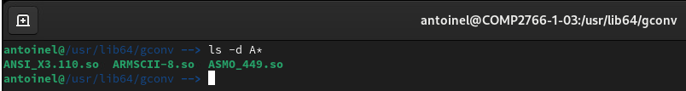

1. (**1 mark**) In /usr/lib64/gconv/, enter ***a single (that is, one)*** command line that uses a file globbing pattern to output the names of only those files that begin with a letter in the range from lowercase a to j or from uppercase Q to Z. You may ***not*** use any special characters to combine multiple command lines together. Capture and insert a screenshot, here, showing the command line you entered and its output. (***NOTE: Use the ls command with the –d switch***)

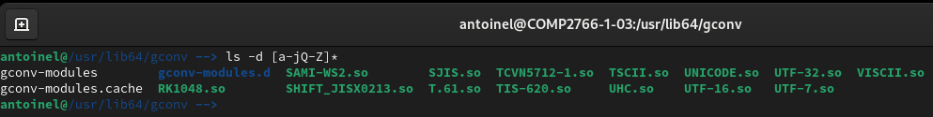

1. (**1 mark**) In /usr/lib64/gconv/, enter a command line that uses a file globbing pattern to output the names of only those visible files that do ***NOT*** end with a lowercase vowel. The lowercase vowels are the letters a, e, i, o, and u. Capture and insert a screenshot, here, showing the command line you entered and its output. (***NOTE: Use the ls command with the –d switch***)

ls -d *[!aeiou]

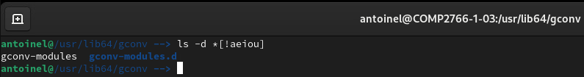

1. (**1 mark**) In /usr/lib64/gconv/, enter ***a single (that is, one)*** command line that uses a file globbing pattern to output the names of only those visible files that contain either of the last two digits in your BCIT student number. That is, if a file name contains the last digit of your student number or the second to last digit of your student number, then it matches the file globbing pattern. Capture and insert a screenshot, here, showing the command line you entered and its output. (***NOTE: Use the ls command with the –d switch***)

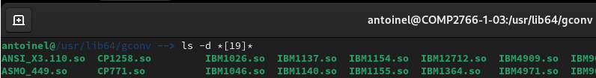

1. (**1 mark**) In /usr/lib64/gconv, enter a command line that uses a file globbing pattern to output the names of only those visible files that end with a **.so** extension. Capture and insert a screenshot, here, showing the command line you entered and its output. (***NOTE: Use the ls command with the –d switch***)

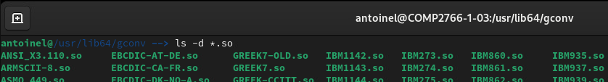

1. (**1 mark**) In /usr/lib64/gconv, enter a command line that outputs the names of only those files that begin **IBM**, immediately followed by a 3-digit number in the range from 800 to 999, and immediately followed by a **.so** extension. For example, files that match this description include IBM800.so, IBM801.so, and so on, up to IBM999.so. Capture and insert a screenshot, here, showing the command line you entered and its output. (***NOTE: Use the ls command with the –d switch***)

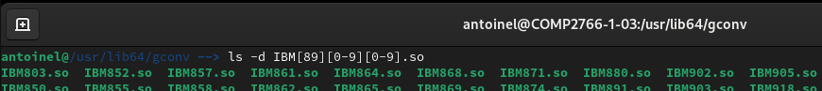

1. (**1 mark**) Enter this command line to change your present working directory to /usr/lib64:

cd /usr/lib64

Then, enter ***a single (that is, one)*** command line that outputs the names of only those hidden files that have at least a total of five dots in their name. You may ***not*** use any special characters to combine multiple command lines together. Capture and insert a screenshot, here, showing the command line you entered and its output. (***NOTE: Use the ls command with the –d switch***)

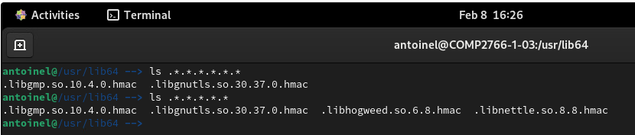

Correction : ls .*.*.*.*.*