**COMP 2766: Introduction to Linux**

**Assignment 4: Viewing Files and Redirection**

**INSTRUCTIONS**: Refer to chapter 10 in the NDG Linux Essentials Course on Cisco Network Academy, as well as the session 5 slide set and Practice Exercises in Learning Hub, Content, for help. **You may only use what has been taught in this course to do this assignment**. Submit this assignment with the required screenshots to the *Assignment 4* dropbox before 6:00pm, Friday, February 16, 2024. **NO SCREENSHOT, NO MARK!**

1. Log in on the CentOS 9 Stream VM in Educloud or installed on your own computer as user root.
2. Open a terminal window.
3. Create a user based on your actual first name and last initial by entering the following command line and replacing *firstnameLastInitial* with your first name and last initial. For example, if your name is Justin Trudeau, create a user named **justint**

useradd *firstnameLastInitial*

Set your user’s password by entering the following command line and replacing *firstnameLastInitial* with your first name and last initial. Note that when you enter the password, it does not appear on the screen and the cursor does not move. Ignore any warnings that appear about the password being too short or based on a dictionary word:

passwd *firstnameLastInitial*

1. Log out the root user by clicking the power button near the top-right of your terminal window and, then, click the arrow next to root, and then select Log Out:

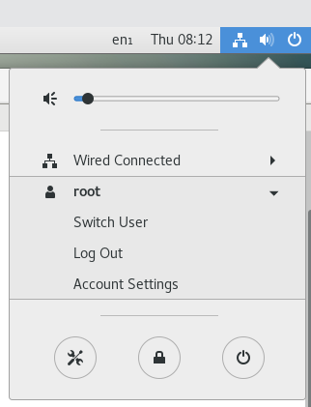

1. Login as the user based on your actual first name and last initial. ***If you do not do this assignment while logged in as your own user, you will receive a mark of zero. Your own user name must appear in every command line prompt in a screenshot.***
2. Open a terminal window.
3. (1 mark) Enter the following command line to create a file named foo using the nano editor:

nano foo

In the editor, enter the following two lines, by replacing Justin Trudeau and A00123456 with ***your actual full name*** and ***your BCIT student number***:

My name is Justin Trudeau

My student number is A00123456

Then, press Ctrl-X to exit and save the file named foo.

Now, redirect stdin for the wc command to determine only the number of lines and number of words in foo. Capture and insert a screenshot showing the command line that you entered and the output, here:

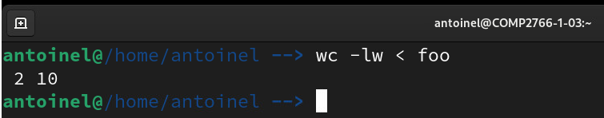

1. (1 mark) Output the entire contents of foo that you created in the previous step including any hidden characters such as Tabs and newline characters and ensure that every line is numbered (starting at 1). Capture and insert a screenshot showing the command line that you entered and the output, here:

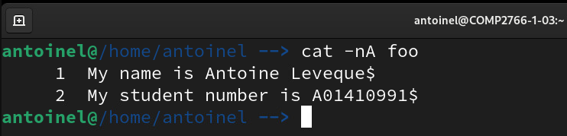

1. (1 mark) Redirect a long listing of your present working directory to a file named FLlonglist (where **FL** are your first and last initials; for example, if your name is Justin Trudeau, use JTlonglist). Capture and insert a screenshot showing the command line that you entered and the output, here. If there is no output, your screenshot must show the cursor on the following command line.

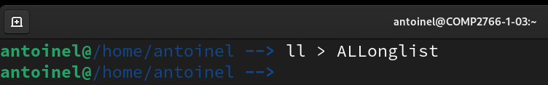

1. (1 mark) Redirect only stderr for the following command line to a file named FLerr (where **FL** are your first and last initials; for example, if your name is Justin Trudeau, use JTerr):

ls /var /fake

Capture and insert a screenshot showing the command line that you entered and the output, here. If there is no output, your screenshot must show the cursor on the following command line.

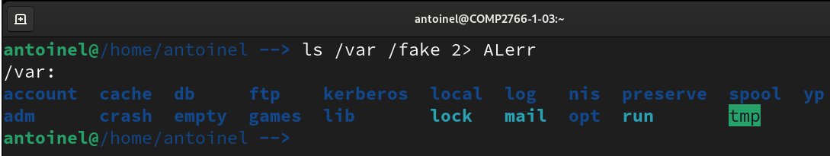

1. (1 mark) Enter ***ONE*** command line that redirects stdout to a file named FL.out and that redirects stderr to a different file named FL.err (where **FL** are your first and last initials; for example, if your name is Justin Trudeau, use JT.out and JT.err) for the following command line:

head -1 /etc/rc.d/*

**NOTE**: You may ***NOT*** combine multiple command lines using a semi-colon, &&, or ||. Capture and insert a screenshot showing the command line that you entered and the output, if any, here. If there is no output, your screenshot must show the cursor on the following command line.

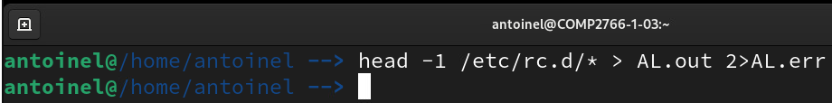

1. (1 mark) Redirect both stdout and stderr to the same file named FL.both (where **FL** are your first and last initials; for example, if your name is Justin Trudeau, use JT.both) for the following command line:

head -1 /etc/rc.d/*

**NOTE**: You may ***NOT*** combine multiple command lines using a semi-colon, &&, or ||. Capture and insert a screenshot showing the command line that you entered and the output, if any, here. If there is no output, your screenshot must show the cursor on the following command line.

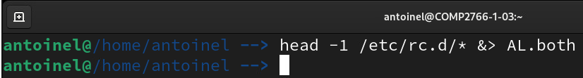

1. (1 mark) Redirect only the last four lines of /etc/group to a file named FL.last (where **FL** are your first and last initials; for example, if your name is Justin Trudeau, use JT.last). Capture and insert a screenshot showing the command line that you entered and the output, if any, here. If there is no output, your screenshot must show the cursor on the following command line.

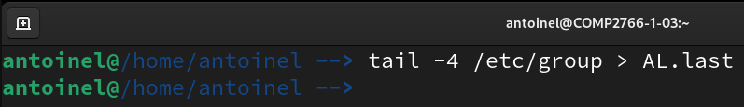

1. (1 mark) Redirect only the first two lines of /etc/passwd to a file named FL.first (where **FL** are your first and last initials; for example, if your name is Justin Trudeau, use JT.first). Capture and insert a screenshot showing the command line that you entered and the output, if any, here. If there is no output, your screenshot must show the cursor on the following command line.

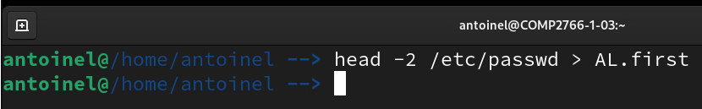

1. (1 mark): Enter a command line that redirects only lines 25 and onwards from /etc/passwd to a file named FL25onwards (where **FL** are your first and last initials; for example, if your name is Justin Trudeau, use JT25onwards). Assume that you do ***NOT*** know how many lines total are in /etc/passwd. Capture and insert a screenshot showing the command line that you entered and the output, if any, here. If there is no output, your screenshot must show the cursor on the following command line.

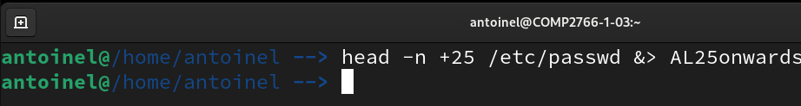

Correction : tail -n +25 /etc/passwd

1. (1 mark): Enter a command line that redirects all but the last 10 lines from /etc/passwd to a file named Flexceptlast10 (where **FL** are your first and last initials; for example, if your name is Justin Trudeau, use Jtexceptlast10). Assume that you do ***NOT*** know how many lines total are in /etc/passwd. Capture and insert a screenshot showing the command line that you entered and the output, if any, here. If there is no output, your screenshot must show the cursor on the following command line.

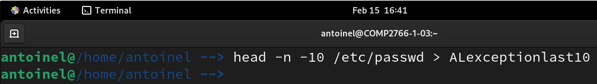

Correction : head –n -10 /etc/passwd > ALexceptlast10

1. (1 mark): Enter a pipeline that redirects a listing of only the visible files in /bin/ to the wc command to output only the quantity of visible files in /bin/. Your output must consist of only one number. Capture and insert a screenshot showing the command line that you entered and the output, here:

