 

**INSTITUTE FOR**

**ADVANCED COMPUTING**

**AND SOFTWARE**

**DEVELOPMENT AKURDI,**

**PUNE**

Documentation On

**“SELLERKART”**

PG-DAC SEP 2021

*Submitted By:*

**Group No: 7**

# Akshata Naik (219014)

# Aman Giri(219017)

**Mr. Prashant Karhale Mr.Chetan Pardeshi**

**Centre Coordinator Project Guide**

**Table of Contents**

1. **Introduction** ..............................................................................................................................3 Problem Statement......................................................................................................................3 Aim & Objectives........................................................................................................................3
2. **Overall Description**...................................................................................................................4 Proposed Methodology...............................................................................................................4

Operating Environment...............................................................................................................4

Design and Implementation Constraints......................................................................................4

1. **Requirements Specification**....................................................................................................6

External Interface Requirements................................................................................................6

1. **System Diagram**........................................................................................................................7

Data Flow Diagram....................................................................................................................8

Use Case Diagram .....................................................................................................................9

ER Diagram .............................................................................................................................10

**5. Table Structure**........................................................................................................................ 13

Users ........................................................................................................................................13

Address ....................................................................................................................................13

Products ...................................................................................................................................13

Orders ......................................................................................................................................14

Wholesaler Products.................................................................................................................14

Retailer products……...............................................................................................................14

**6.** **Conclusion**........................................................................................................................... 15

Future Scope ...................................................................................................................... 15

**7. References** ...........................................................................................................................16

**List of Figures**

Figure 1 Flow chart…………………………........................................................................................7

Figure 2 Level 0 Data Flow Diagram ....................................................................................................8

Figure 3 Level 1 Data Flow Diagram ................................................................................................... 8

Figure 4 Use Case Diagram for Admin ................................................................................................ 9

Figure 5 Use Case Diagram for Wholesaler...........................................................................................9

Figure 6 Use Case Diagram for Retailer...............................................................................................10

Figure 7 ER Diagram ........................................................................................................................... 11

**1. INTRODUCTION**

**Introduction:**

Portal is a web system that provides the function and features to authenticate and identify the users and provide then with easy, intuitive, personalized and user-customizable web-interface for facilitating access to information and services that are of primary relevance and interests to the users.sellerkart is meant to serve the relationship between the wholesalers and the retailers. Looking at the growing virtual systems there is a need to have a business to business communication website which will solve a problem of shortage of product on retailer’s side and to get the products on time and have a fruitful communication with the wholesalers in timely manner solving the real time issues.

**Problem Statement:**

In this modern era still entire business model between retailer and wholesaler are either rely on past relations they maintain or just verbal convincing approach by wholesaler which means no confirmation of delivery date and rate of product.

For not knowing different wholesalers available in the market, retailers buy products only from the wholesalers they know and end up giving high rate.Many times due to late delivery of product by wholesaler the retailer has to return their valuable customer which substandard the customer relation.

**Aims and Objective:**

The main purpose is to serve the relationship between the wholesalers and the retailers. Looking at the growing virtual systems there is a need to have a business to business communication website which will solve a problem of shortage of product on retailer’s side and to get the products on time and have a fruitful communication with the wholesalers in timely manner solving the real time issues.

In other words, our SellerKart portal has, following objectives:

* Simple database is maintained.
* Easy operations for the user and the admin of the system.
* User interfaces are user accommodating and attractive; it takes very less time for the operator to use the system.
* This system will provide one click online order placing for the retailer and the business growth to the wholesaler.

**2. OVERALL DESCRIPTION**

**Proposed Methodology:**

This system is designed especially for large, premium and small retailer business and the local wholesalers. E-retailer portal provide the complete functionality of placing the order from the retailer and acknowledgement from the same and getting the orders accepted from the wholesaler. This system is going to provide ease of comparison with the price of the same product and also the location with the different wholesalers. This system will have Retailer, wholesaler and the Admin. Retailer can update the quantity they have in their shop according to the quantity the items/products will be sorted for “Placing-order” function, like if the item has reached the threshold level of the quantity then that will come under the list of orders to be placed. Retailer will chose the item to place an order and according to the item/product, wholesaler list will be filtered & displayed to the retailer. Wholesaler can update the product list on their site and can accept the order request or deny and once the order has been accepted and delivered to the retailer then retailer will send the acknowledgement. Wholesaler will be able to see the list of retailers whose order they are going to fulfil. Admin will be able to delete the retailer/wholesaler depending on the reviews.

**OPERATING ENVIRONMENT:**

Server Side:

**Processor:** Intel® Xeon® processor 3500 series

**HDD:** Minimum 500GB Disk Space

**RAM:** Minimum 4GB

**OS:** Windows 10

**Database:** MySQL

Client Side (minimum requirement):

**Processor:** Intel Dual Core

**HDD:** Minimum 80GB Disk Space

**RAM:** Minimum 2GB

**OS:** Windows 7

**Design and Implementation Constraints:**

* The application will use ReactJs, Axios and CSS as main web technologies.
* HTTP protocol is used as communication protocol. FTP is used to upload the web application in live domain and the client can access it via HTTP protocol.
* Several types of validations make this web application a secured one and SQL Injections can also be prevented.
* Since SellerKart is a web-based application, internet connection must be established.

**3. REQUIREMENTS SPECIFICATION.**

**External Interface Requirements:**

User Interfaces:

* All the users will see the same page when they enter in this website. This page asks the users a username and a password.
* After being authenticated by correct username and password, user will be redirect to their corresponding profile where they can do various activities.
* The user interface will be simple and consistence, using terminology commonly understood by intended users of the system. The system will have simple interface, consistence with standard interface, to eliminate need for user training of infrequent users.

Hardware Interfaces:

* No extra hardware interfaces are needed.
* The system will use the standard hardware and data communication resources.

This includes, but not limited to, general network connection at the server/hosting site, network server and network management tools.

Application Interfaces:

**Web Browser:**

The system is a web-based application; clients need a modern web browser such as Mozilla Firebox, Internet Explorer, Opera, and Chrome. The computer must have an Internet connection in order to be able to access the system.

Communications Interfaces:

* This system uses communication resources which includes but not limited to, HTTP protocol for communication with the web browser and web server and TCP/IP network protocol with HTTP protocol.
* This application will communicate with the database that holds all the booking information. Users can contact with server side through HTTP protocol by means of a function that is called HTTP Service. This function allows the application to use the data retrieved by server to fulfil the request fired by the user.

**4. SYSTEM DIAGRAMS.**

* **Flow Chart:**

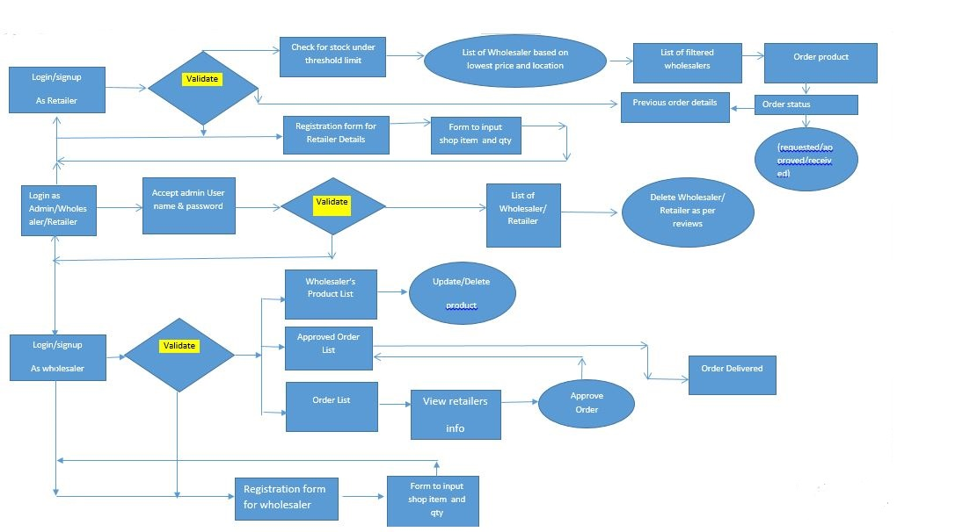

## 

Fig.1

## **Data Flow diagram:**

**First Level DFD:**

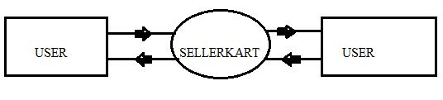

Fig.2

**Second Level DFD:**

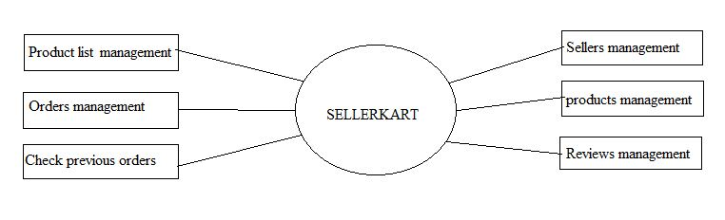

Fig.3

## **Use Case Diagrams:**

* Admin Use Case:

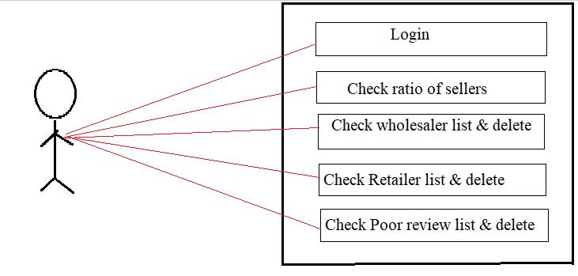

Fig.4

* Wholesaler Use Case:

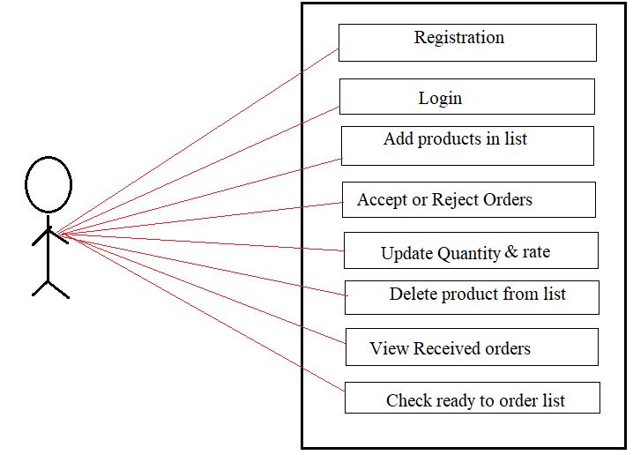

Fig.5

* Retailer Use Case:

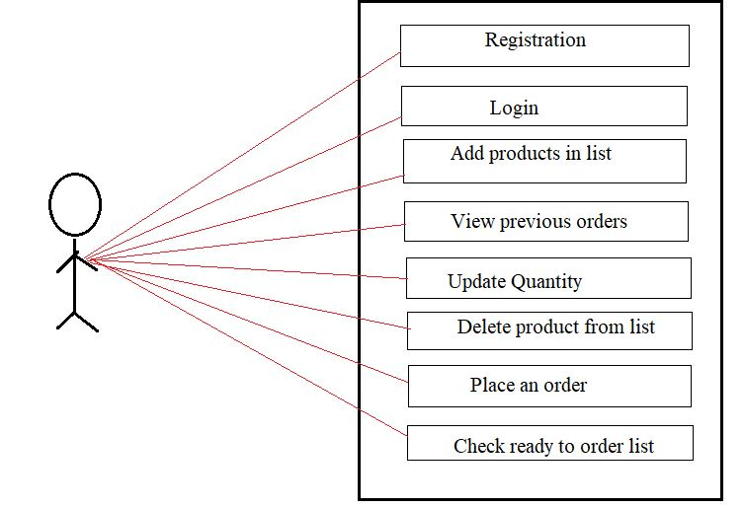

Fig.6

**ER-Diagram:**

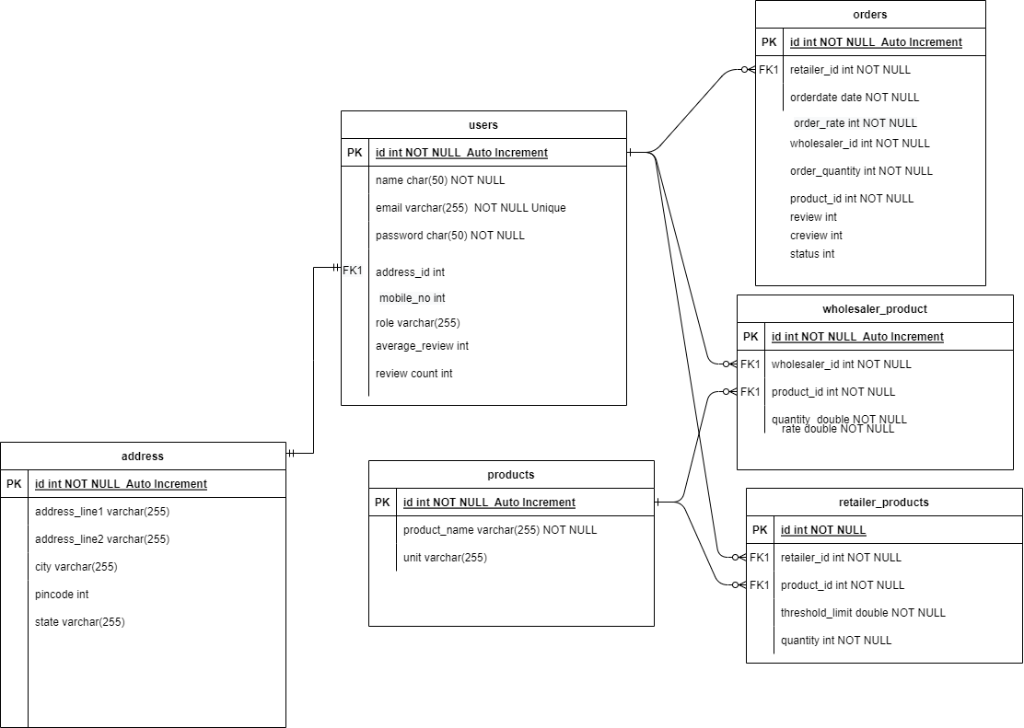

Fig.7

**5. TABLE STRUCTURE**

* Users:

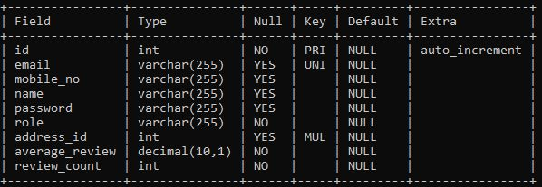

* Address:

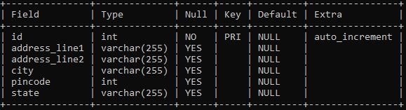

* Products:

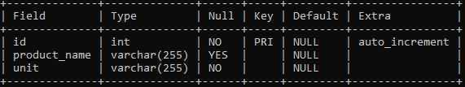

* Orders:

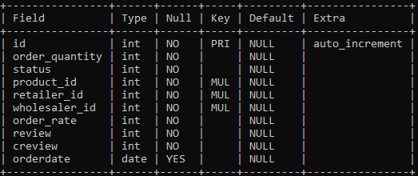

* Retailer-products:

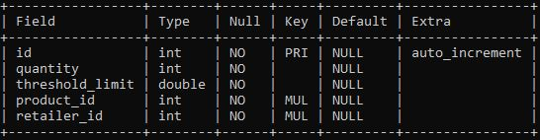

* Wholesaler-products:

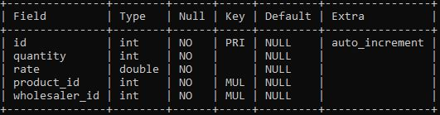

**6. CONCLUSION**

This project aid in online business of wholesaler and retailer.This system brings ease in the communication and business of B2B field. It provides the complete functionality of placing the order from the retailer and acknowledgement from the same and getting the orders accepted from the wholesaler. This system is going to provide ease of comparison with the price of the same product and also the location with the different wholesalers.

## **Future Scope:**

This project can be enhanced further by adding payment gateway to reduce the maintenance of cash for the order amount at retailers end and also can be used to implement B2C in the same to have efficient loop of business. The software is flexible enough to be modified and implemented as per future requirements. We have tried our best to present this free and user–friendly website to Institutes.

**6.REFERENCES**

* **References:**
* [React – A JavaScript library for building user interfaces (reactjs.org)](https://reactjs.org/)
* [Bootstrap · The most popular HTML, CSS, and JS library in the world. (getbootstrap.com)](https://getbootstrap.com/)
* [Recharts](https://recharts.org/en-US/)
* [React Tutorial (w3schools.com)](https://www.w3schools.com/react/)
* [Learn Spring Boot | Baeldung](https://www.baeldung.com/spring-boot)
* [Spring Data JPA - Reference Documentation](https://docs.spring.io/spring-data/jpa/docs/current/reference/html/)