550 844 01

PD 3950 Wiring Diagram

USB
The PD 3950 can be connected to any standard USB port or USB HUB.
The USB cable delivered together with the module must be used to connect the PD 3950 to the PC.

P-NET RS485
It is recommended to use the 2 x twisted pair or 1.5 x twisted pair cable type. This offers the best noise immunity and the most convenient installation.
- 2 x twisted pair: the second pair is connected to the 'S' terminal. The cable shield is connected to the shield clamp.
- 1.5 x twisted pair (3-wire cable): the 3rd wire is connected to the ‘S’ terminal. The cable shield is connected to the shield clamp.
1.5 x twisted pair (3-wire cable)
When using bus cables with 1.5 x twisted pairs (3 twisted wires), the wire interconnecting 'S' terminals must be connected to ground at one point only. This avoids the 'S' reference potential to be free floating.
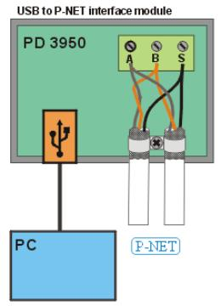
1 x twisted pair: the shield is connected to the 'S' terminal.
To avoid loose threads from the shield interfering within the module is it advisable to install a separate wire from the shield clamp to the 'S' terminal.
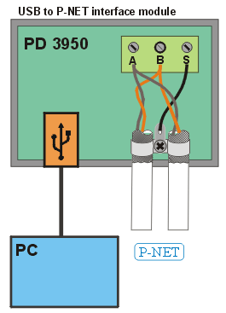
P-NET wiring
P-NET shield connection

Related topics
P-NET Installation Guide
Ordering Information

