AIMAN HAMBALI BIN AMRAN  FRESH GRADUATE ENGINEER · ELECTRONIC & IOT SYSTEMS  Kota Bharu, Kelantan | aimannhambalii@gmail.com  +60 11-2550 7190 | Malaysian | 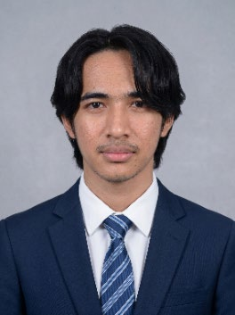

SUMMARY
Fresh Electronic Engineering Technology graduate (CGPA 3.61) with hands-on exposure to semiconductor test equipment and IoT-based sensor systems. Comfortable working with Python, Arduino, and ESP32 on embedded projects, from wiring the hardware to getting the logic right.
EDUCATION
Universiti Kuala Lumpur British Malaysian Institute Sept 2022 – Mar 2026
Bachelor of Electronic Engineering Technology with Honours, CGPA 3.61 · Gombak, Selangor
- Dean's List for 5 of 6 semesters.
- Final-year project: IoT-based sensor system for monitoring and controlling growing conditions for Volvariella mushroom cultivation.
- Mini projects: Intelligent Laundry Clip (IoT); Baby Guard Beacon (IoT).
Politeknik Ungku Omar Dec 2018 – Aug 2021
Diploma of Electronic Engineering (Communication), CGPA 3.60 · Ipoh, Perak
- Dean's List for 4 of 5 semesters.
- Final-year project: Climbing Robot. Mini project: Bluetooth Mobile Robot.
RELEVANT EXPERIENCE
Unisem (M) Berhad, PM Technician (Intern) Jul 2025 – Jan 2026
- Carried out preventive maintenance across 5+ test machine types (ETS-88, ETS-364, ASL-1000, CCT, LTX series) on a semiconductor test line.
- Logged calibration data and assisted troubleshooting during PM cycles, building a practical understanding of how test equipment issues get diagnosed and fixed.
Kejuruteraan Elektrik Usahamaju Sdn. Bhd, Electrical Technician (Intern) Jun 2021 – Aug 2021
- Installed and wired DB (distribution) boxes on residential construction sites.
- Handled conduit piping, cable routing, and full house wiring, including switches, sockets, and power outlets.
SKILLS
- Design & Simulation: Proteus, Quartus II, Ni Multisim (experienced); Microwind, L-Edit IC, AutoCAD (skillful); MATLAB (beginner).
- Programming & Hardware: Python; Arduino and ESP32 microcontrollers for embedded/IoT projects.
- Microsoft Office: Word, Excel, PowerPoint, Outlook.
- Language: Native Bahasa Melayu; intermediate English.
EXTRA-CURRICULAR ACTIVITIES
- Member, Robotics Club at Politeknik Ungku Omar; competed in FIRA 2019 robotics competition, Port Dickson.
- Selected for a student exchange visit with Fukuoka, Japan, during Diploma studies.
- Participated in Pitch Perfect 5.0 innovation project and a MIMOS field trip (Analog & Digital IC Design) at UniKL BMI.
REFERENCES
Available upon request.

