Shivam Nigam
Student ID: 29573437

Course: COMP 6461
By Prof. Chadi Assi
Fall 2016

Requirement 1. In this requirement we simulate a FTP File transfer from server to client and analyze the throughput and delay of a wireless user.

Setup:
To study this requirement, we create following scenario in Figure1 in NS3. A wireless LAN consisting of an Access Point (AP) and several wireless users. One particular user(10.1.2.1) access a server (FTP ) in the same network. The AP is connected to a (Ethernet) switch 1 . The switch in turn is connected to a router which connects to another switch2. The sever is attached to the subnet. The wireless user is connected to accesspoint in lossy channel i.e. with increase in the distance between access point and user, the connection will become weak and eventually drop.

The mobile user establishes a TCP session with the FTP server and downloads the file.
The FTP server is created by installing an application named BulkSendApplication in NS3. It acts like a traffic generator. This traffic generator simply sends data as fast as possible up to MaxBytes or until the application is stopped. Once the lower layer send buffer is filled, it waits until space is free to send more data, essentially keeping a constant flow of data.
Mobile User has an application PacketSink (in NS3) that receives and consumes the traffic generated to an IP address and port. In our case the traffic comes from FTP server.
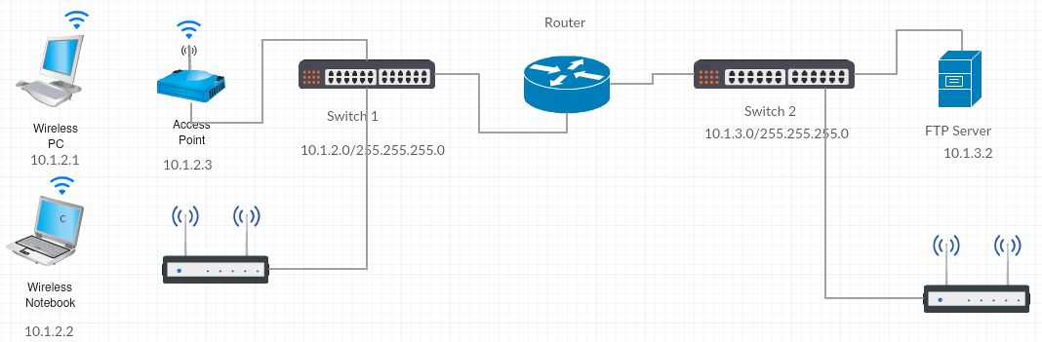
Figure 1 Network Diagram

Simulation: We perform the simulation in two steps
1. Run a very short simulation to understand the working of network protocols. This gives an idea on how the network devices discover each other and gets connected.

A 2 byte file is sent from FTP server(10.1.3.2) to Wireless PC user(10.1.2.1) .

Output: from the simulation program. These results are obtained by using Flow Monitor class in NS3

FTP_SERVER_IP: 10.1.3.2
CLIENT_IP: 10.1.2.1
PacketSink:PacketSink(0xab7140)
PacketSink:StartApplication(0xab7140)
PacketSink:HandleAccept(0xab7140, 0xac25e0, 03-07-0a:01:03:02:01:c0:00)
PacketSink:HandleRead(0xab7140, 0xac25e0)
At time 2.94205s packet sink received 2 bytes from 10.1.3.2 port 49153 total Rx 2 bytes
PacketSink:HandlePeerClose(0xab7140, 0xac25e0)
Flow 1 (10.1.3.2 -> 10.1.2.1)<-------------FTP SERVER TO CLIENT
Tx Packets: 4
Tx Bytes: 214
TxOffered: 0.0001712 Mbps
Rx Packets: 4
Rx Bytes: 214
Throughput: 0.637329 Kbps
Delay: +631597262.0ns
Flow 2 (10.1.2.1 -> 10.1.3.2)<-------------CLIENT TO FTP SERVER
Tx Packets: 3
Tx Bytes: 160
TxOffered: 0.000128 Mbps
Rx Packets: 3
Rx Bytes: 160
Throughput: 1.24528 Kbps
Delay: +707134353.0ns

In the above output we observe that 2 bytes were sent from server to client in 4 packets. Client received all of them. So there is no packet loss in the medium. In Flow 2 , client sends back acknowledgement to the server.

Wireshark traces:
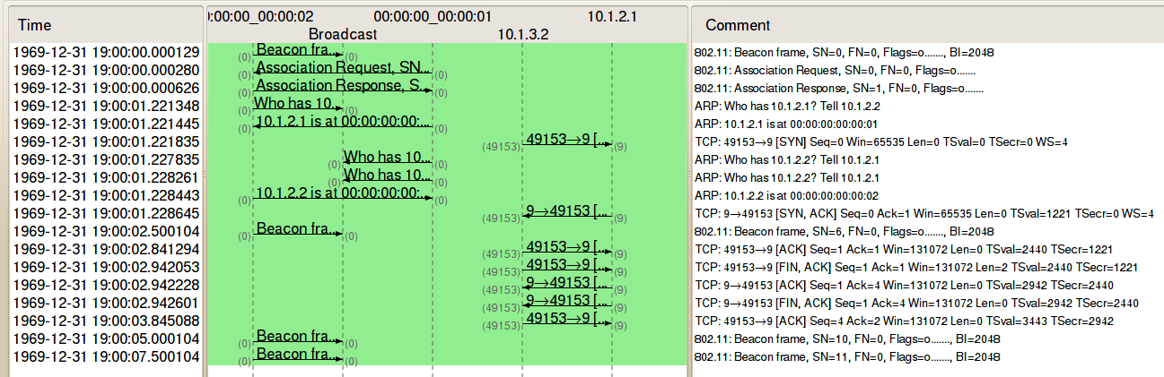
Figure 2 Wireshark trace
For the above simulation, we also create a pcap trace for it. We analyze it with help of wireshark. We see the interaction between the link layers of Access point(AP) and Wireless user and on the other side the communication between IP networks. AP keeps broadcasting its Beacon frames periodically to announce the presence of a wireless LAN. Next packets are the 802.11 associationsthat enable the access point to allocate resources for and synchronize with a radio NIC of . A Wireless user's NIC begins the association process by sending an association request to an access point. After receiving the association request, the access point considers associating with the Wireless User's NIC. It responds with the acceptance. The client is now ready to pass traffic to the access point.
With ARP(Address Resolution Protocol), client and AP discover their mac address and associate it with the IP address's. Once the IP address and the mac address are known then FTP server starts transmitting the data to the client(wireless user). Since it is the TCP transmission, for every packet from server to client , an acknowledgement( ACK )is sent back to the server.

2. In this simulation, we will simulate a transfer of mid-size file ~ 500 KB from FTP server to the wireless user and measure the throughput and delay at the wireless users node. We run the simulation for different number of clients. In the beginning only one client is connected to the AP. In the consecutive simulations, more user connects to the same AP and downloads the same file at same time. Based on the result, we will analyse throughput and delay.

2a) Throughput vs number of Users: We measure the throughput of the user gets as the number of mobile users (which we refer to as load) changes on the same AP.

When only 1 user is connected to the AP
Flow 1 (10.1.3.2 -> 10.1.2.1)
Tx Packets: 1617
Tx Bytes: 948824
TxOffered: 0.759059 Mbps
Rx Packets: 1524
Rx Bytes: 894140
Throughput: 701.925 Kbps
Delay: +211361042.0ns

When 64 users are connected to the AP
Flow 1 (10.1.3.2 -> 10.1.2.1)
Tx Packets: 269
Tx Bytes: 157104
TxOffered: 0.125683 Mbps
Rx Packets: 223
Rx Bytes: 130056
Throughput: 101.606 Kbps
Delay: +435576846.0ns
Lost Packets 46
Packets Dropped 4

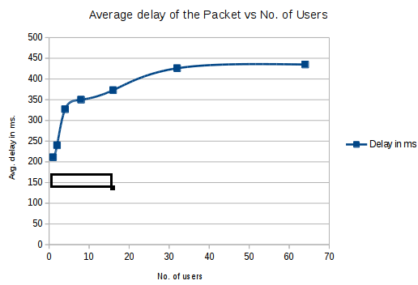

Figure 3. Average delay of the packet at the node vs No. of users
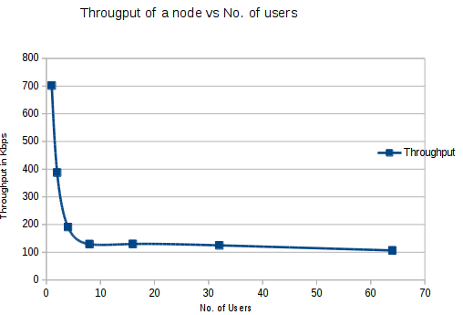

Figure 4. Throughput of a node vs No. of users

Analysis:
From the above graph (figure 3 & 4) we see that throughput of a node decreases with increase of the nodes. And the average delay of the packet at the node increases with increase of the nodes at the same access point. The possible reasons are due to increase retransmissions from the server to client.
More retransmission of the packet decreases the throughput and increases the delay at the node.

Throughput = No. of received Bytes * 8 / Simulation time
Avg Delay = Total Delay of all the packets / No. of received packets

Above two relations are used to calculate the throughput and delay. So when there are more users accessing the FTP server at the same time, the probability of retransmissions increases. This increase of
of retransmission reduces no. of received bytes within a simulation time.

Requirement2 The mobile user may later move to another AP, under the same switch. What happens as the user moves to the other AP?Measure the throughput of the connection. Will there be any service discontinuity?

Setup:
After exhaustive efforts, I was not able to hand-off the wireless user from 1 AP to another AP in the same subnet. For example, in figure 1, wireless user could not be connected to 2nd AP after it moved away from AP1(10.1.2.3). I was stuck here as NS3 was throwing as assert with an error message “Assumed there is at most one exit from the root to this vertex” .

However, I tried to simulate something similar which can prove that under the same subnet their will be no service discontinuity.

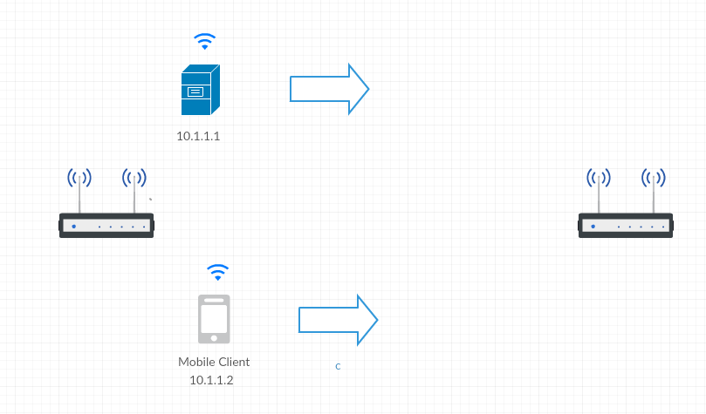
Figure 5 Handoff scenario

The user may move to another AP under a different switch (connected to the same router). What happens as the user moves? Measure the throughput of the connection. Will there be any service discontinuity? You will need to validate though simulations your answers.

Technical Difficulties:

Tool Used:
Gdb : Used extensivily to fix segmentation faults
NS3 : Simulation
Wireshark: Analyze packets and flow diagram

References:
[1] NS3 3.26 documentation
[2] NS3 sample code in path ns-allinone-3.26/ns-3.26/examples/tutorial/third.cc
[3] https://supportforums.cisco.com/document/101431/80211-sniffer-capture-analysis-management-frames-and-open-auth

GitRepo: https://github.com/amnivir/comp6461

