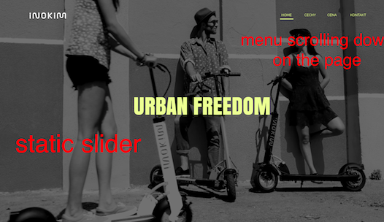
This is static slider, with no changed images...
MENU — should scroll to 1. HOME — up of the page 2. CECHY — CECHY 3. CENA — CENY 4.Kontakt — KONTAKT

scrolling effect like on this page - http://demo.arrowpress.net/riven/
the difference is, we dont want menu when you scroll down the page... it should be only on the top, static...

simple text with graphics — somethings like on this page http://demo.arrowpress.net/riven/ (behind slider)

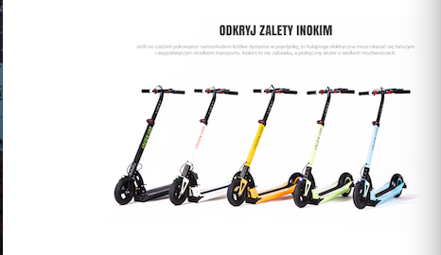
simple text with photo... maybe some animation on photo...not sure

i really do like animation on this page, and all this animation changes while scrolling down the page https://oneplus.net/3 . maybe photo could go up or down while scrolling

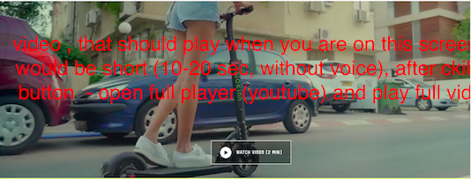
this video, what format should it be, and how mb should take to work smoothly without lag? We will prepare it to you.. also while clicking in Watch video- should open youtube wideo player, something like here
https://boostedboards.com/

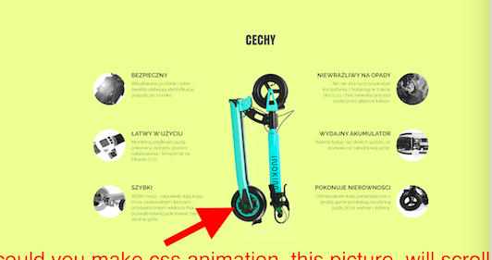
simple text with graphic, and this photo (with red arrow) , could you make something like.... when you are on this page full screen, this photo isn’t there, but when you begin scrolling down bellow it would go up? Something like https://oneplus.net/3 ... to attract people attention if they don’t read this info...

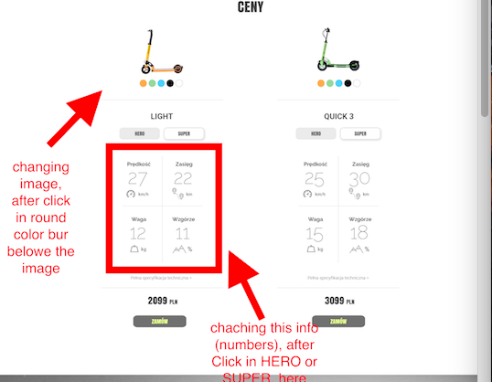

Different numbers which depends on HERO or SUPER version – will send to you tomorrow
also photos of different colors…

when you click on “Pełna specyfikacja techniczna” -should pop – up window with information , will send it to you later, not finished yet

and when click on “ZAMÓW” (buy) – pop- up small contact form, would be great if it would send what option customer choose (color/version) and send to us in contact – email automaticly
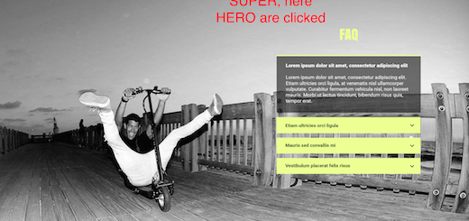

faq – the same as on this web page http://demo.arrowpress.net/riven/#1459304962115-c33eb6e4-e749 , but I don’t have texts yet, so I will ad it later …

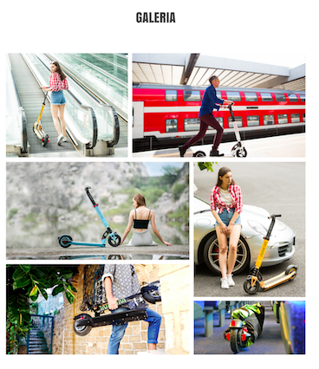
just photos, maybe if you click on them – they can pop up
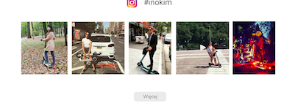

here is links for photos — when you klick, it should open in a new page ....
when you klick Więcej — open “https://www.instagram.com/explore/tags/inokim/”

othet photos - https://www.instagram.com/p/BLgDNGYjp8z/
https://www.instagram.com/p/BKowdppg0U0/
https://www.instagram.com/p/BKcaMY2gDh6/
https://www.instagram.com/p/BJoAM-lBaEG/
https://www.instagram.com/p/BJU8ph6AXLa/

