Applied Machine Learning – Exercise 3 (12.05.17)
Ben Wulf
Task 1.1
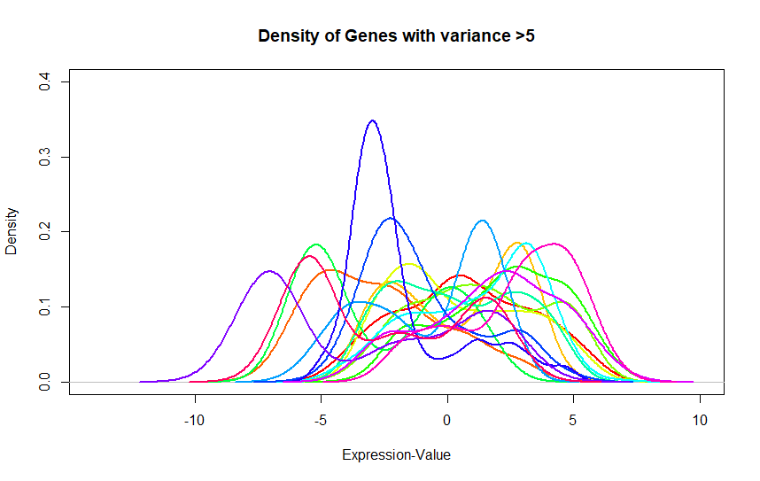
For the plot, we removed all genes which has more than 3 NA values. We selected all genes with a variance bigger than 5 and plot their density.
Figure 1 Density of the all genes with variance >5
Figure 1 shows the density of the genes with the biggest variance. The distributions are not centered and the variance differs. To get them comparable we must center the distribution to 0 and normalize the standard deviation to 1.
Task 1.2
It seems that there is no M<<p components that explains most of the variance. However, the first component explains around 10% of the variance, the second around 5%, and the rest around 2% each.
Task 1.3
contend differs by 0.1% but the N-content is 10times smaller than without trimming.
pc1[1:5]
A_23_P211600 A_23_P201529 A_23_P78976 A_32_P138556 A_23_P250044
0.02452318 0.02408349 0.02336386 0.02319608 -0.02319463

pc2[1:5]
A_23_P211600 A_23_P201529 A_23_P78976 A_32_P138556 A_23_P250044
4.219083e-05 5.781348e-04 4.194760e-04 -2.799018e-03 -7.689996e-03

The absolute values specifies the proportion of contribution to pc1 (/pc2 respectively) of the gene.

Task 2
1. this is a classification task. While we use regression in order to predict value of an unknown instance based on values of previous, instances, here we try to classify an unknown instance into one of two classes (colon vs rectum) based on known classes of previous instances

