Verified my 9 bit counter works:

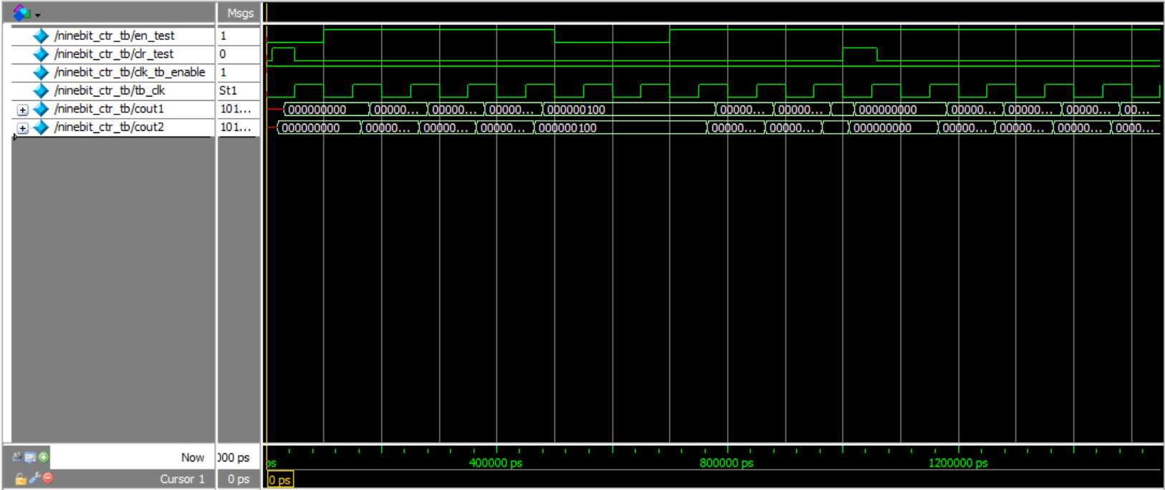Proper response to enable, clear, and clock:

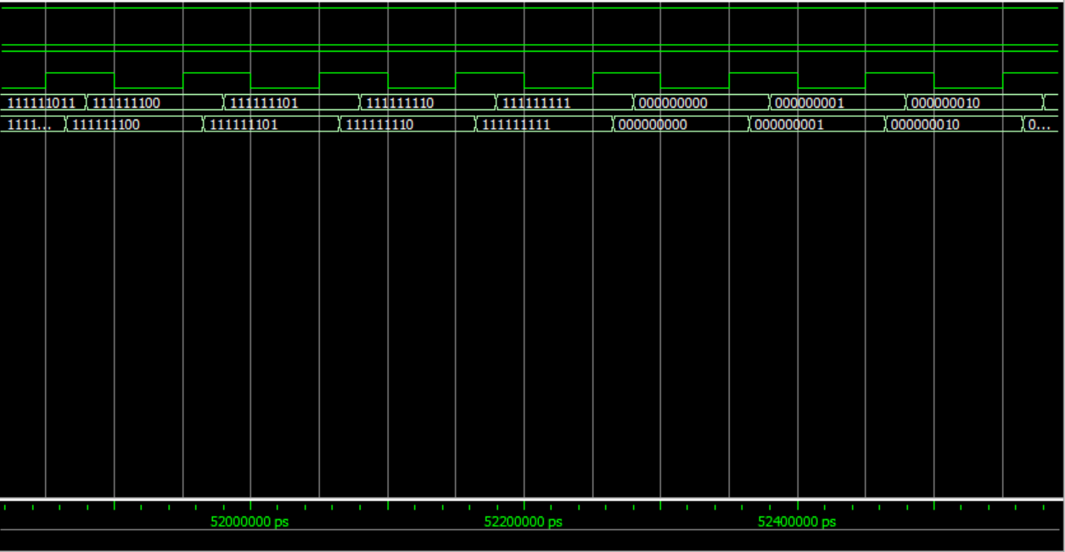Proper transition from max to 0.