Team Othello
Application Design

This file provides a general description of the program and its major components. For additional technical documentation, see the source code documentation.

Source Code Summary:
Class BitUtil:
This class contains miscellaneous bit manipulation algorithms. This library is needed for the bitboard engine.
Interface OthelloBoard:
This interface is a general interface for any Othello Board. This was developed so that modules such as the GUI could be developed concurrently with the main data structure.
class OthelloBitBoard:
This is an implementation of OthelloBoard that uses bitboards to store the board information. Functionality such as enumeration of legal moves and execution of moves is highly optimized using advanced bitboard-based techniques.
Class TableGenerator:
This class precomputes a 512kb table of the effects of any move within a single row of an OthelloBitBoard. A row bitboard is 8 bits. Since both our own and enemy pieces matter here, we need to index over both all 256 combinations of our pieces and 256 combinations of enemy pieces. Since there are 8 places to go, we have another dimension in our array. So, this table is a mapping of [0-255][0-255][0-7] to [0-255]. If nothing changes, the move is illegal, and hence any illegal input such as overlapping friendly and enemy pieces is stored as ‘no change’.
Class Rom:
All precomputed results are accessible from this class.

class BasicGui:
This class provides a GUI that can allow the user to play a game against the sequential iterative MTD(f) algorithm. Features are limited, as this is only for debugging and illustration.

class OthelloAlphaBeta:
Superclass for all searches. It returns the Negamax score for the position. In it’s basic form, it is sequential. This class can perform an alpha beta search in 3 ways:
a) Barebones alpha-beta search
b) Alpha-beta with Memory (transposition table, which is a hash table)
c) Sorted Alpha-Beta with Memory

Nodes near the root benefit from ‘smart’ choices, where nodes near the leaves benefit from raw barebones performance. Additionally, storing all nodes in the transposition table would take an enormous amount of memory (gigabytes), so we do not store past a certain depth in the tree. ‘MinDepthToStore’ (see the User’s Manual) specifies how far we must be from the leaf to store in the table.
Hence we arrange the search in this way, combining all 3 search functions:
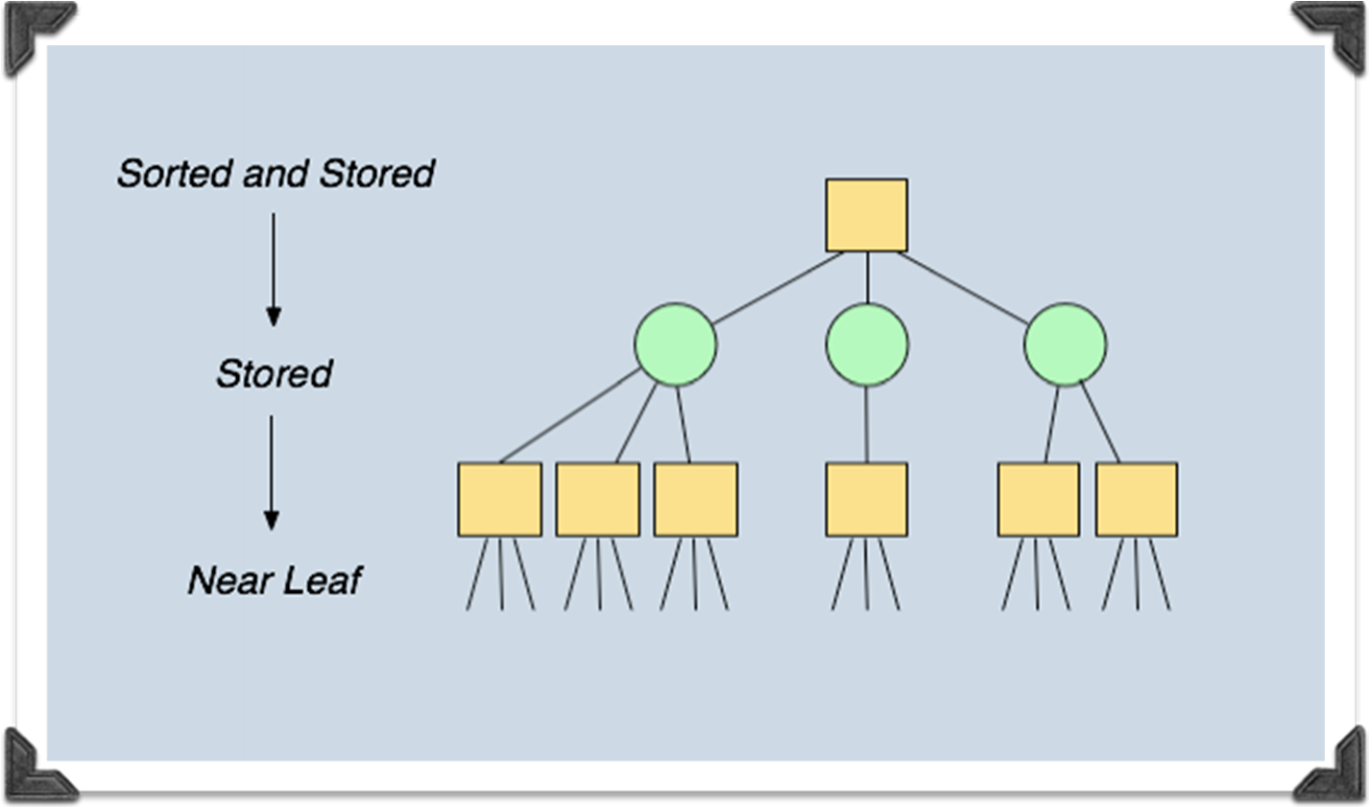

This class also provides a method for “re-searching”, which is a narrow-window alpha-beta search about a known score to acquire the best legal move (as opposed to the score of the position). By using the transposition table, the result is usually instantaneous.
Nodes are sorted based on how likely the score is to be high—hence how likely the score is to produce a cutoff. By searching these first, pruning is more aggressive but still correct.

class OthelloMTDf:
This class inherits from OthelloAlphaBeta. This program is also sequential. It uses a series of null-window Alpha Beta searches to find the score using the MTD(f) algorithm. It also can find the score using MTD(f) in an iterative framework. Because an approximate guess can help, as well as hints in the transposition table for sorting nodes, this performs faster.

class OthelloAlphaBetaSMP:
This class inherits from OthelloAlphaBeta. Using multiple threads, Alpha-Beta is executed in parallel.

All parallel execution in our program occurs because each thread has its own queue of JobRequest objects. Any job inherits from this superclass.

For this algorithm, the uppermost levels of the tree are enumerated as AlphaBetaJobRequest objects. Threads can then execute the jobs in parallel. (The exact number of levels in which we are referring to is set by ‘SharedSearchDepth’; see the User’s Manual). Jobs can be stolen if there is no work for a thread.

These ‘shared’/’parallel’ nodes are stored in 3 data structures.
a) The job queue corresponding to the thread that plans to execute it
b) The transposition table
c) They are linked to each other, forming a sort of ‘linked tree’. This is to pass information and update each other rapidly. Every time a job completes, windows may shrink and jobs may even become obsolete. Thus, this updating should be—and is— accomplished immediately.
There is a shared transposition table that is accessible to all threads. The parameter ‘SharedTableLevel’ (see the User’s Manual) dictates how many levels in the tree are stored and read in the shared table. After this cutoff point, threads have their own, local transposition table for smaller but more rapidly accessed results. This is achieved using the SplitTranspositionTable class.

Here is a visual for the design here:
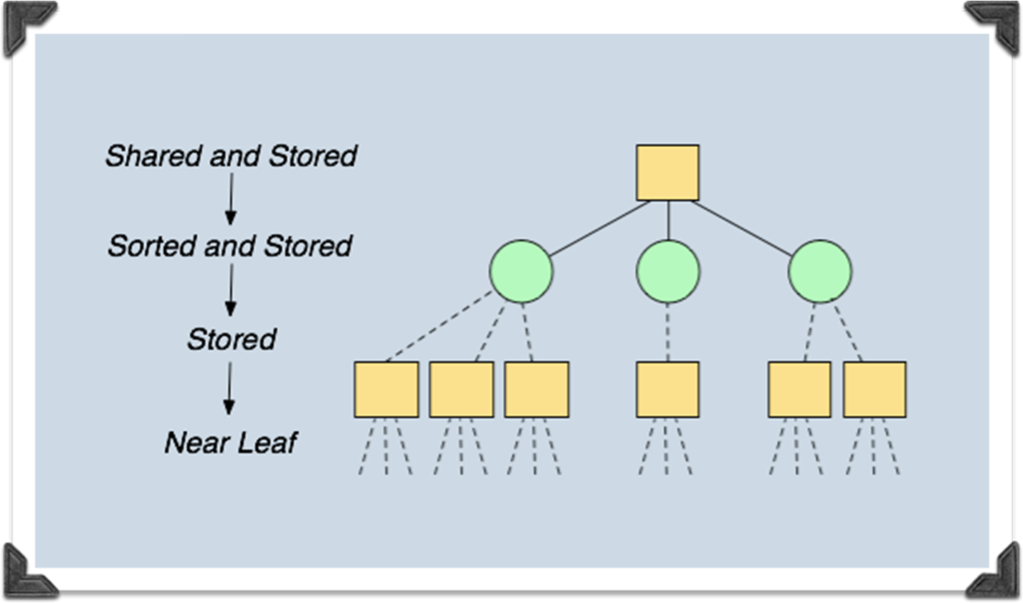

class OthelloMTDfSMP:
This class inherits from OthelloAlphaBetaSMP. It finds the score by making use of several Parallel null-window Alpha Beta calls, according to the MTD(f) algorithm. MTD(f) requests are also jobs, called “MTDfJobRequest”.

Additionally, this search can be done iteratively. If this is done, then an IterativeMTDfJobRequest makes several MTDfJobRequest.

