**I am not able to run the attached python program as it gives the below mentioned error which it should not.**

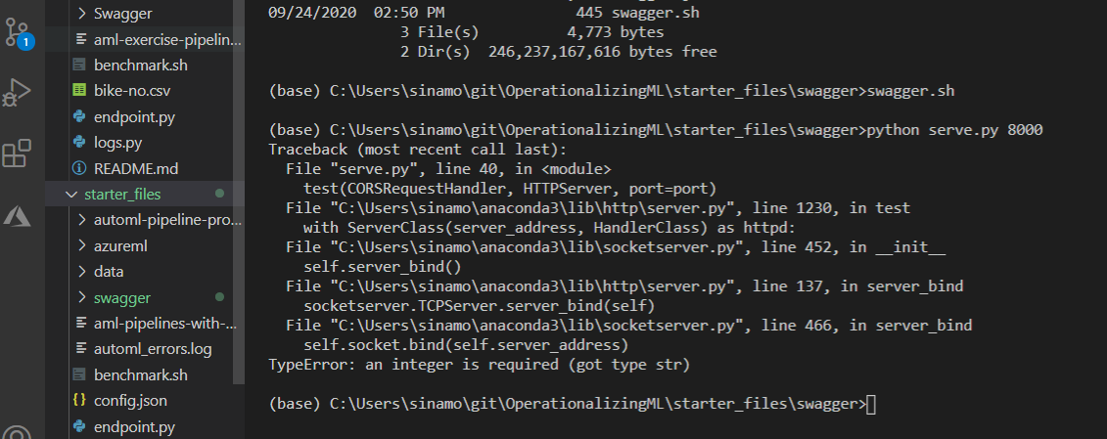

Screen clipping taken: 9/26/2020 7:27 PM

***hostname> python3 serve.py 8000***

***Traceback (most recent call last):***

***File "serve.py", line 40, in <module>***

***test(CORSRequestHandler, HTTPServer, port=port)***

***File "/usr/lib64/python3.6/http/server.py", line 1185, in test***

***with ServerClass(server_address, HandlerClass) as httpd:***

***File "/usr/lib64/python3.6/socketserver.py", line 456, in __init__***

***self.server_bind()***

***File "/usr/lib64/python3.6/http/server.py", line 136, in server_bind***

***socketserver.TCPServer.server_bind(self)***

***File "/usr/lib64/python3.6/socketserver.py", line 470, in server_bind***

***self.socket.bind(self.server_address)***

***TypeError: an integer is required (got type str)***