**Flying is the Still the Safest Way to Travel**   
#airlines #safety

Friday 23 October 2020

**Worldly Impacts**

The airline industry continues to be defined by world events. Misinformation was spread in 2014 following the downing of Malaysian Flight 17 and the disappearance of Malaysian Flight 370. Although 2014 was a bad year for the airline industry, so was 2001, 2008, and now 2020. The impact of the events of September 11, 2001 were devastating to the airlines. The 2008 Recession caused fuel prices to soar, affecting the airline industry. The mass media coverage of the Malaysian Airlines flights in 2014 impacted air travel. The current pandemic is certainly impacting air travel more than ever right now.

Data Source: Economic Impact of Commercial Aviation By State (U.S. Airline Traffic and Capacity), Airlines for America.

**Airline Sales**

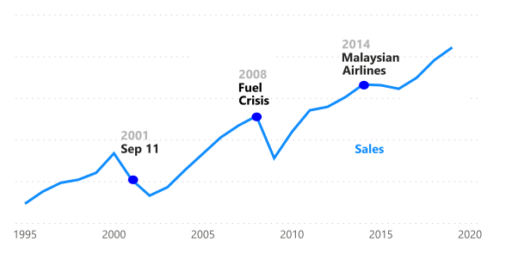

**Air Travel Historically Saves Lives**Highway fatalities have far outnumbered airline fatalities for years. It is clear, given the statistics, that flying is still safer than driving. As you can see, highway travel resulted in over 1 million deaths in the 30-year period from 1985 to 2014.

Data Source: Airline Safety, Aviation Safety Network. Fatality Analysis Reporting System (FARS), NHTSA.

**Fatalities 1985-2014**

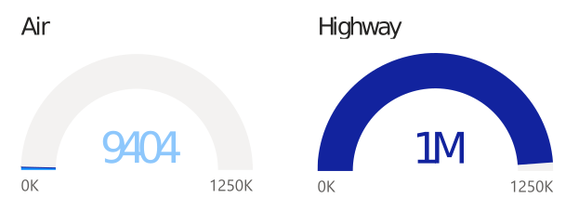

**Air Fatalities Continue to Steadily Decline**There has been a steady decline of fatalities from air travel since 1985. Highway fatalities, however, did not start to decline until 2006 with the impact of texting and driving campaigns. Airlines have always sought continual improvement in safety, resulting in the overall decline in fatalities throughout the years. In contrast, highway fatalities did not start to decline until 2006.

Data Source: Statistics, Bureau of Aircraft Accident Archives. Fatality Analysis Reporting System (FARS), NHTSA.

**Fatalities 1985-2014**

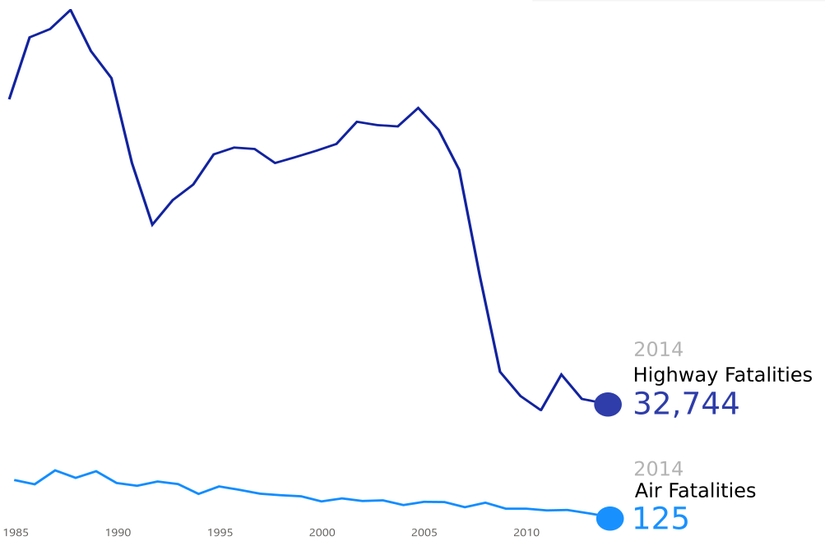

**Safe Crashes**Contrary to popular belief, airline crashes do not always result in death. Aeroflot has had over 80 crashes with around 200 fatalities. Whereas, China Airlines has had far less crashes with almost 3 times the number of deaths. As you can see, many airlines have had very few incidents and no deaths. What car company can say that?

Data Source: Airline Safety, Aviation Safety Network.

**Incidents and Fatalities By Airline 1985-2014**

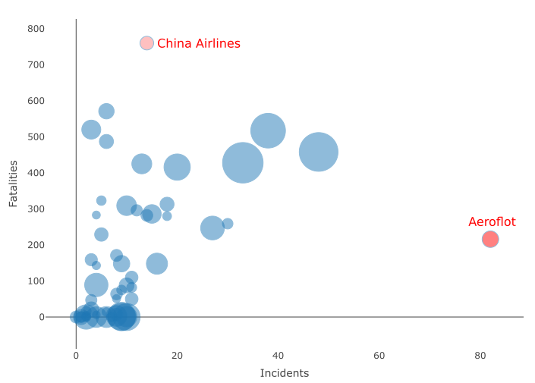

**World's Most Dangerous Airlines**While some dangerous airlines exist, safety is our top priority. Crashes from other airlines are damaging reputations across the airline industry. China Airlines’ fatalities far exceed other airlines with 760 fatal crashes since 1985.

Data Source: Airline Safety, Aviation Safety Network.

**Fatalities By Airline 1985-2014**

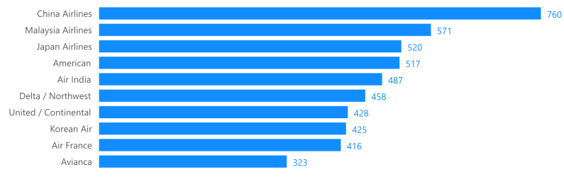

**Most Established Airlines**Although the media focuses on a handful of dangerous airlines, most airlines are safe. We have years of experience with safety as our top priority. Airlines have safely delivered more passengers to their destinations in the last 25 years. Below you will see the most experienced airlines.

Data Source: Traffic and Capacity by Operating Region (Total System Available Seat Miles)

**Airline Traffic**

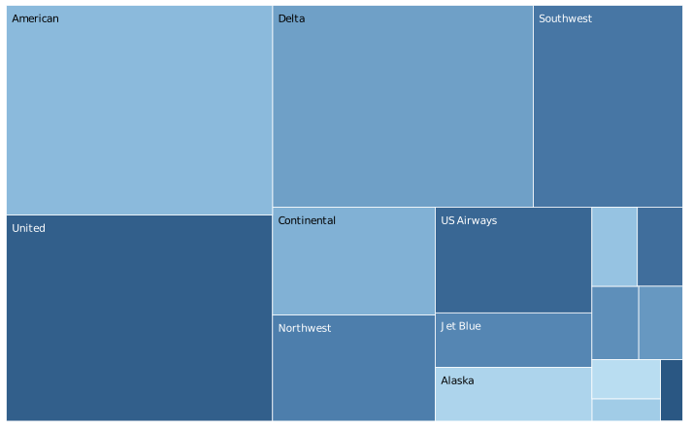

**Don’t Be Afraid to Fly**We are experienced at taking care of our passengers. Due to years of safety compliance experience, we can assure you that out flights are safe. Now, go out and get a plane ticket for the next time you take that trip to your parents’ house. Be rest assured that you will arrive there safe. While we take care of your peace of mind, sit back, bring a good book, and enjoy the ride.

Contact us at 1-800-FLY-SAFE.

**References:**

Silver, N. (2014, July 19). Should Travelers Avoid Flying Airlines That Have Had Crashes in the Past? Retrieved September 22, 2020, from https://fivethirtyeight.com/features/should-travelers-avoid-flying-airlines-that-have-had-c rashes-in-the-past/

US Department of Transportation, Inspector General. (2012). AVIATION INDUSTRY PERFORMANCE​ (Publication No. CC-2012-029). Retrieved from https://www.oig.dot.gov/sites/default/files/Aviation%20Industry%20Performance%5E9-24-12.pdf