3. Methodology
3.1 Modified Polar Pipeline
3.2 Steps In Depth Analysis
3.3 Evaluation
3.4 LLMs
3.1 Modified Polar Pipeline
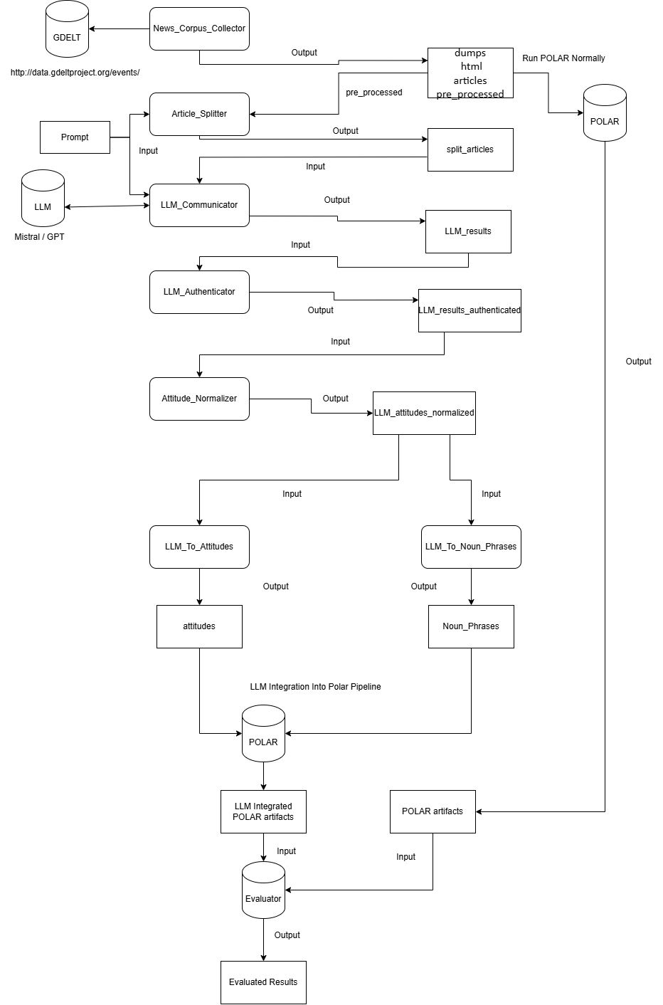
Figure 1 LLM Integrated POLAR Pipeline

3.1.1 Overview and Explanation
The Process begins with Gathering Articles that fit a likely Polarizing topic using Polar’s News Corpus Collector, which based on a set of keywords gathers the articles that match the keywords from the GDELT Database [ ALEX ] and pre-processes them into Json files with their name matching their URL.
The Articles are then processed by a simple algorithm that attempts to cut the Articles so that they all fit into the LLM’s Window Size without hitting it’s limit, thus they are split if necessary into Article Parts, so that the LLM Prompt + the Article Part do not exceed the window size.
The newly Split Articles are then processed into a Request for the LLM with the content being the Prompt which explains in detail to the LLM all of the instructions followed by the Article Part for the analysis. The request is processed and responds with a Json formatted file with all of the necessary data.
The files are then analyzed for any malformed files or non Json formatted requests and cleans them if possible.
After that the attitudes are normalized so that multiple mentions of an entity/topic is clustered accordingly even if their names aren’t a direct match.
The files are then reformatted into Noun_Phrases and into Attitudes, 2 outputs created by Polar and that are necessary for the implementation into the Polar Pipeline.

3.2 Steps in Depth Analysis
3.2.1 Article Gathering
This step is identical to Polar’s News_Corpus_Collector, see Section 2: Figure 1.

3.2.2 Article Splitting
This code processes a set of articles and splits them into Parts small enough to fit into a model’s maximum token limit, taking into account a fixed prompt that will be added onto it. It uses 2 types of models for tokenizing that depend on the model of the LLM, OpenAI models like GPT use tiktoken encoding while HuggingFace models like Mistral use AutoTokenizer.
These tokens are used to accurately count the maximum window size measured in Tokens using the built-in functions of tiktoken (tiktoken.encode()) and AutoTokenizer (tokenizer.tokenize())[ ALEX Probably Source these 2 ].
Once the maximum window size is reached, so once the available tokens + the prompt tokens reach the window size limit, the code uses LangChain to split the articles based on character count, so that it tries to preserve the sentences and words as much as possible in each part, prioritizing paragraph breaks and sentence breaks [ ALEX Source Langchain Here ]. As such the Part is split, assigning Part {i} into it’s filename and keeping the “uid” field and having the split article part in the “text” field.

3.2.3 LLM Communicator
This code takes as input the LLM to request, the Prompt for the LLM as well as the split articles. The prompt consists of detailed instructions and a set of rules for the LLM to follow for our particular case, which is gathering Polarization between Entities, as well as Polarization between Entities and Topics in articles.
3.2.3.1 Request Format
It also consists of a OneShot example for the LLM to be able to easily format its output and boost consistency in its replies, the OneShot example containing as follows:
{ 'topical_attitudes': [ {
'source' : { 'entity' : 'Donald Trump' , 'references' : ['Donald Trump']},
'target' : { 'topic' : 'mask mandate' , 'references' : ['usage of masks']},
'justifications' : [ 'constantly pushing against the usage of masks. '],
'attitude' : 'Negative' }],
'entity_attitudes': [ {
'entity1' : { 'entity' : 'Dr. Anthony Fauci' , 'references' : [ 'Fauci' ]},
'entity2' : { 'entity' : 'Donald Trump' , 'references' : [ 'Donald Trump' ]},
'justifications' : [ 'Donald Trump was in disagreement with Fauci' ],
'attitude' : 'Negative' } ]}

Where the entities and topics as well as the justifications are found in the Sentence / Article provided, it is left onto the LLM to find these pairs and assign onto them the attitude it thinks is accurate.
3.2.3.2 Code Structure
The Code iterates through all of the Article Parts and Sequentially or in Parallel depending on the input, constructs the payload of each Article Part, the payload being the Prompt followed by the text field from the Article, essentially telling the LLM the structure it wants to process the Article, it then sends the request to the LLM with a temperature of 0.2 (Temperature is set low in order to have less variance and some consistency in the outputs, minimizes randomness of responses), and awaits its response which it saves to the Output Directory in the same directory structure as Polar.
Important to note that each request made to the LLM is a Stateless Request, as each Article Part gets its own dedicated request, a small optimization could have been to detect whenever an Article was split by the Article_Splitter and have a Stateful Session for that Article only, this was avoided in order to make the code more easily parallelizable by making each request independent.

3.2.4 LLM_Authenticator
This code Iterates over the responses from the LLM and confirms whether or not the replies are proper Json format, and if not attempts to fix them, otherwise omitting them.
Firstly it checks whether the responses start with “```json” and end with “```”, this is a common pattern for chat based UIs (like ChatGPT, Github, Discord etc.), as it triggers syntax highlighting and preserves formatting, however for our case since we use an API we need to strip it.
It also checks whether the reply is actually a Json formatted reply, omitting additional comments made by the LLM if any, and omitting the file entirely if it isn’t formatted correctly.
3.2.5 Attitude_Normalizer
This code gathers all of the attitudes calculated from the LLM_Authenticator and processes their reference field, which references the appearance of the entity/topic in the article, and attempts to normalize them so that each mention of them in all the articles match.
It does so by checking every mention and utilizing Semantic Similarity and some manual aliasing to attempt to have less noise in the later steps of the pipeline.

3.2.6 LLM_To_Attitudes / LLM_To_Noun_Phrases
These codes are simple and do a similar task, they iterate over the authenticated responses from the LLM and convert the data to the appropriate Polar data format needed (Attitudes / Noun_Phrases) from the response of the LLM, the Attitudes field is required to continue with the Framework and the Noun_Phrases are required for the topics.json.gz generation, which is an earlier step in the Polar pipeline.

3.3 Evaluation

