Chapter 2: Background & Related Work
2.1 Polar
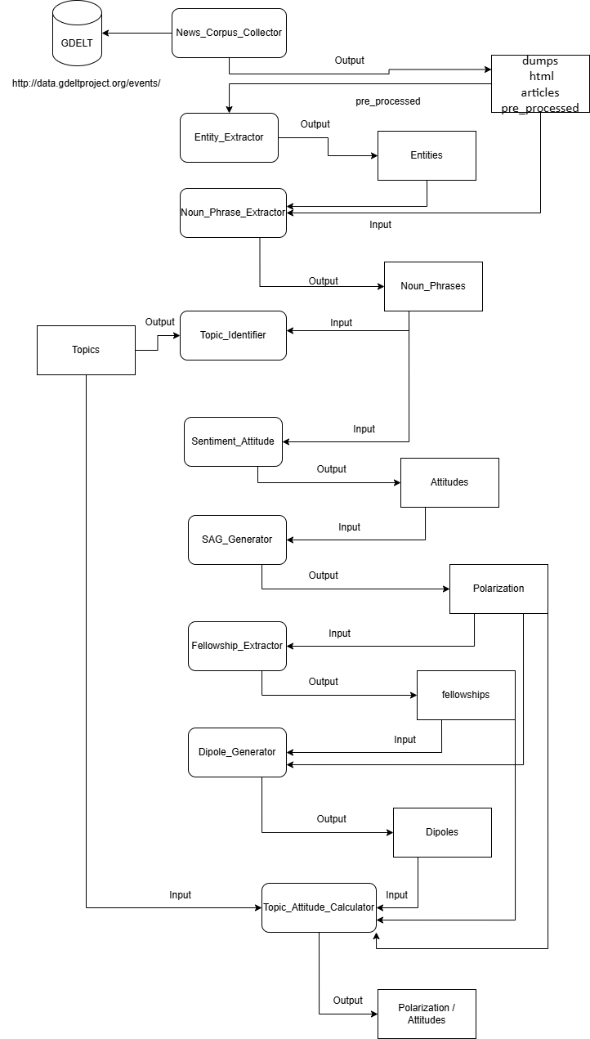
Figure 1: Polar Pipeline
2.1.1 Overview
POLAR is an unsupervised, large scale framework for modeling and identifying polarizing topics in any domain, without prior domain-specific knowledge, it comprises a processing pipeline that analyzes a corpus of an arbitrary number of news articles to construct a hierarchical model graph that models polarization and identify polarizing topics discussed in the corpus. [ ALEX ]
2.1.2 Brief Explanation of Key Steps for our Integration
These Steps are either needed to integrate LLMs into the Polar Pipeline (News_Corpus_Collector, Topic_Identifier) or are the steps planned to be omitted from the pipeline (Entity_Extractor, Noun_Phrase_Extractor, Sentiment_Attitude).

2.1.2.1 News_Corpus_Collector
Articles were collected using topic-specific keywords and date filters, allowing control over corpus size, geographic scope, and relevance. This Class allows for the use of keywords for gathering Articles like max number of articles per request, other variables like actor 1 and 2 country codes, being able to filter the articles by place of origin and most importantly the Start and End Date from which the Articles were published, as well as keywords for the article to contain, these were the noteworthy variables for the scope of this thesis, these fields have to be placed manually, preferably a topic high in Polarization as well as the appropriate Dates for polarizing articles to have been posted.
Examples:
Topic: Brexit -> keywords: 'brexit'
Date: 2016/6 - 7/22 – 10
The Articles are saved as Raw String Json files with this format:
"{\"uid\": \" Filename ",
\"text\": “ Article content “ “}”

2.1.2.2 Entity_Extractor and Noun_Phrase_Extractor
These steps are used in order to extract Named Entities from the set of Articles from the Corpus, it utilizes Named Entity Recognition (NER) [ ALEX ] using SpaCy [ ALEX ] in order to identify the Entities as well as link them to a Dbpedia link [ ALEX ] that matches the entity, it then gathers the noun phrases similarly using SpaCy and cleans them using tokenization and removing stopwords.
These steps are crucial to the Polar Pipeline, however they are error prone and unsupervised, the most common error types being Dictionary Errors and Dependency Parsing Errors.
Dictionary Errors:
this occurs when an NLP component like SpaCy’s NER relies on a fixed lexicon or a static way of assigning components and fails to interpret a word or phrase.
Dependency Parsing Errors:
this refers to a mistake in the syntactical analysis of a sentence, where the parser incorrectly identifies the relationship between words, resulting in incomplete noun phrases and mistaken attitudes.
Example:
entity1: “Howard” -> reference: "http://dbpedia.org/resource/John_Howard"
entity2: "Schneider" -> reference: “http://dbpedia.org/resource/Schneider_Electric”
Sentence: “Participants hold a British Union flag and an EU flag during a pro-EU referendum event at Parliament Square in London Thomson Reuters By David Lawder and Howard Schneider Advertisement WASHINGTON (Reuters)"
Problem: Assigns Howard -> Schneider when Howard Schneider is the full name of the person
Dependency Parsing Error: Incorrectly splits the Entity “Howard Schneider” into 2 subparts “Howard” and “Schneider” and assigns different dbpedia links to them (“John_Howard” and “Schneider_Electric”).
Dictionary Error: Does not correctly link the Entity “Howard Schneider” to a pre-existing dbpedia link, as it does not exist.

2.1.2.3 Sentiment Attitude
This step estimates the sentiment between pairs of entities or noun phrases based on the syntactic paths that connect them in the sentence and then assigns a polarity score to them, being Positive, Neutral or Negative.
It utilizes techniques such as Dependency Parsing via SpaCy, and Lexicon-based sentiment using MPQA [ ALEX ]
This step is highly error prone to Dependency Parsing errors, as the entire process hinges on correct dependency parsers.
This is shown by how POLAR predominantly labels most pairs as Neutral when the pairs are uncertain or ambiguous or face high syntactic complexity, we will go through more in depth in the Results & Analysis section.
Example of Dependency Parsing Error:
entity1: "U.S. monetary policy" -> reference: “http://dbpedia.org/resource/Monetary_policy_of_the_United_States”
entity2: "British" -> reference: “http://dbpedia.org/resource/United_Kingdom”
Sentence: " A vote by Britons to leave the European Union on Thursday may not drag the United States into recession, but its effects on U.S. monetary policy, trade and corporate profits are causing concern in Washington D.C. and boardrooms alike."
attitude: “Positive”
Problem: Attitude is labeled Positive however the Sentence describes how it is causing concern about it’s effects possibly going into a recession, this should be a Negative Pair

2.1.2.4 Topic_Identifier
This class performs automatic topic clustering by analyzing the noun phrases extracted from the articles. Its main job is grouping semantically similar noun phrases together into clusters, based on the sentence embeddings and calculated cosine similarity using Sentence Transformers[ ALEX ].
Outputs the calculated Topics as a compressed Json file, necessary for linking the Attitudes to the calculated pairs in the Topic_Attitude_Calculator.

In the following chapters, we present our modifications to the POLAR pipeline, replacing the traditional NLP modules described above with a unified, LLM-driven extraction approach

