5. Evaluation
5.1 Overview and Explanation
5.1.1 General Overview
5.2 Mistral
5.3 Polar

5.1 Overview and Objectives
This chapter outlines the methodology used to evaluate the different systems designed to extract and represent polarization, including the fine-tuned Mistral model, the original LLM Integrated POLAR Pipeline, and the standard POLAR system.
The goal of this evaluation is to determine how well each system can identify relevant Entity-Topic / Entity-Entity relationship pairs and predict their associated attitudes and justifications for said Attributes and pairs.
Given the inherently subjective and interpretative nature of polarization, traditional classification metrics are complemented by semantic and qualitative analyses as well as further analyses and measures in Chapter 6.
5.2 Evaluation Pipeline
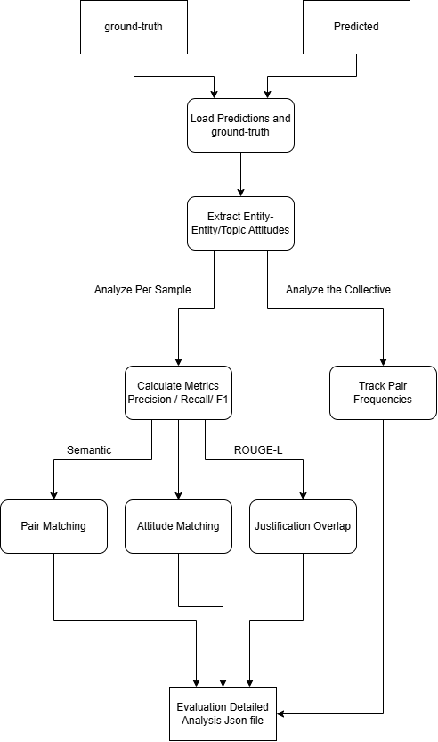

Figure 2: Evaluation Pipeline
To systematically compare systems, we designed a modular evaluation pipeline. Figure 2 illustrates the sequence of steps applied to each pair of ground-truth and predicted Json files:

- Load Data: Import and parse the files of both the ground-truth and predicted set into Json structure and order them such that each entry of the predicted and ground-truth set refer to the same Article.
- Pair Matching: Identify Entity-Topic and Entity-Entity pairs in both sets, and calculate matches using Semantic Similarity with Sentence Transformers [ ALEX ] , comparing each pair from the predicted set with each ground-truth pair, until a match is found or it checks every pair, repeating for each predicted pair. A matched pair being considered when both Source Entities match and both Target Entities/Topics match, using a threshold of 0.7.
Example matches using Sentence Transformers:
Matching Topic Pair: (Britain, United Kingdom)
Matching Topic Pair: (Ukraine, Kyiv)
Matching Entity Pair: (Tony Blair, British prime minister)
Matching Entity Pair: (Trump, Donald Trump)
Matching Entity Pair: (Britain, France)
Matching Topic Pair: (Germany, Russia))
- Attitude Comparison: For all matched pairs, compare the predicted attitude (Positive, Negative, Neutral) against the ground truth, considering the matches as True Positive and the wrong predictions as False Negatives.
- Justification Evaluation: For all matched pairs, ROUGE-L [ ALEX ] is called to compare textual overlap between predicted and true justifications, considering matched Sentences those whose overlap reaches a threshold of 0.5.
ROUGE-L is a metric that measures how similar two sequences of text are based on their Longest Common Subsequence (LCS), considering that if two pieces of text share a long ordered subsequence of words, they are semantically, or structurally similar, with a higher ROUGE-L score indicating greater textual alignment. Especially in our case, since the LLMs and POLAR quote the Article directly in the justification field, if they have similar subsequences, they are likely referring to the same sentence from the Article.
- Pair Frequency Analysis: Count the number of unique Entity-Topic and Entity-Entity pairs and count each of their appearances in both the ground-truth and the Predicted Set. It does so by Normalizing the fields:
Lowercasing the fields
Removing Punctuation like commas and periods
Singularizing the fields, turning plural nouns into singular
Lemmatizing the fields, converting words to their basic forms
Manually aliasing certain words (trump->donald trump, eu->european union)
This is done so in order to more accurately cluster mentions of certain entities throughout multiple Articles and group up certain similar topics.
This showcases the appearance rate of each pair, as well as the frequency of which it is assigned each attitude by both models.

5.3 Metrics Used
5.3.1 Pair Matching Metrics
To assess how well the Predicted dataset identifies the ground-truth Entity-Topic or Entity-Entity pairs, we compute:
- True Positives (TP): Pairs present in both predicted and true sets and correctly matched.
- False Positives (FP): Pairs present in predictions but not in the ground truth.
- False Negatives (FN): Pairs present in ground truth but missed by predictions.
Using these metrics we can calculate:
- Precision: Precision = TP / (TP + FP). Measures the accuracy of the predicted pairs, whenever the prediction detects a pair, how often it is found in the ground-truth.
- Recall: Recall = TP / (TP + FN). Measures the model's coverage of all relevant pairs, shows the percentage of missed pairs undetected from the ground-truth.
- F1 Score: F1 = 2 * (P * R) / (P + R). Harmonic mean of Precision and Recall.

5.3.2 Attitude Prediction Metrics
For all matched pairs, we evaluate the similarity of their Attitude Sentiment:
- True Positives (TP): Sentiment Attitude of Predicted pair matches ground-truth pair
- False Negatives (FN): Sentiment Attitude of Predicted pair does not match ground-truth pair
Using these metrics we can calculate:
- Accuracy: TP / TP + FN. How accurate the Predicted model is at matching the ground-truth model.
5.3.3 Justification Overlap
For all matched pairs, we use ROUGE-L to calculate the textual alignment between the two models and see whether it reaches the threshold (0.5) to be considered a match, using these metrics:
- Matched Justifications (MJ): The ROUGE-L score calculated reaches the threshold, the justifications match.
- Total Justifications (TJ): All the Justifications present in the Matched Pairs.
As such we can calculate:
- Justification Overlap: MJ / TJ. The percentage of the Total Justifications that were successfully matched between both pairs.

5.4 Evaluation Scenarios
We conduct evaluations under the following scenarios:
- GPT vs. POLAR: Evaluates how GPT’s LLM-based extraction compares with POLAR’s rule-based logic.
- GPT vs. Mistral: Measures how well the fine-tuned Mistral model replicates GPT’s outputs.
Each system’s output is evaluated on the same set of articles, using the same pipeline for fairness.

Analysis Characteristics:
Model | Compared To | Type | Size/Setup
Mistral (FT) | GPT | Local LLM | 7B (LoRA FT)
GPT-3.5 Turbo | Ground Truth | API-based LLM | Cloud
POLAR | GPT | Rule-Based/NLP | Python NLP

