6. Results And Analysis
6.1 Overview
6.1.1 What is being evaluated
6.1.2 What systems are compared
6.1.3 Metrics and qualitative measures used
6.2 POLAR Compared to LLMs
6.2.1 Attitudes Comparison
6.2.1.1 Attitudes Evaluation
6.2.1.2 Attitude Comparison Conclusion
6.2.1.3 Discussion
6.2.2 Further analysis
6.2.2.1 Overall Attitude Summary
6.2.2.1.1 Training Dataset
6.2.2.1.2 Brexit Dataset:
6.2.2.2 Overall Attitude Summary Conclusion
6.2.2.2.1 Training dataset
6.2.2.2.2 Brexit Dataset
6.2.3 Attitude Analysis Conclusion
6.2.4 Topics and Pair Frequency Comparisons
6.2.4.1 Topics
6.2.4.2 Pair Frequency
6.2.4.2.1 Overlapping Entity Pairs
6.2.4.2.2 Overlapping Topical Pairs
6.3 POLAR Pipeline End Result Comparison
6.3.1 Fellowships
6.3.2 SAG (Signed Attitude Graph)
6.3.3 Attitude Dipoles
6.3.4 Conclusion
6.4 Fine-Tuned Mistral Evaluation
6.4.1 Evaluation
6.4.2 Conclusion

6.1.1 What is being evaluated
This chapter evaluates the artifacts produced by integrating Large Language Models (LLMs) into the POLAR pipeline. Specifically, it assesses how well GPT-3.5 and a fine-tuned Mistral-7B model replicate or improve upon POLAR’s traditional NLP pipeline. The artifacts evaluated include Entity and Topical attitudes, Signed Attitude Graphs (SAGs), Fellowship groupings, Topic coverage, and Attitude Dipoles.

6.1.2 What Systems are Compared:
The following systems are evaluated:
- POLAR: The baseline pipeline using conventional NLP tools.
- GPT-3.5: A large language model used as a drop-in replacement for several POLAR components.
- Fine-tuned Mistral-7B: An open-weight language model trained to replicate GPT-3.5’s outputs and evaluated for fidelity, efficiency, and practical deployment advantages.

6.1.3 Metrics and Qualitative Measures Used
Evaluation metrics were computed over the subset of articles for which both the GPT-generated ground truth and the Mistral predictions produced valid Json structured outputs. This excluded any malformed responses from both GPT and Mistral for their respective datasets.
Pair matching and attitude evaluation were performed on a per-article basis, with each sample evaluated independently. As such, the same entity or topic pair may appear multiple times across the dataset and is evaluated separately in each occurrence.
Metrics:

In the context of Pair Matching:
“True Positive” : X number of pairs from the Predicted Dataset were matched with pairs from the Ground Truth Dataset
“False Positive” : X number of pairs were found Only in the Predicted Dataset and were not included in the Ground Truth Dataset
“False Negative” : X number of pairs were found Only in the Ground Truth Dataset and were not included in the Predicted Dataset
In the context of Attitude Matching:
“True Positive” X number of Attitudes were correctly predicted to the Ground Truth Attitude
“False Negative” : X number of Attitudes were incorrectly predicted to the Ground Truth Attitude
In the context of Justification Overlap:
Overlap: How similar the model’s justification for the Pair/Attitude were, using ROUGE-L [ALEX ] for the calculation of the similarity with a threshold of 0.7 to be considered matched.

6.2 POLAR Compared to LLMs Evaluation
6.2.1 Attitudes Comparison
6.2.1.1 Attitudes Evaluation
In this section of the evaluation, we aimed to assess the extent to which the POLAR system
could replicate the Attitudes field generated by a large language model (LLM), specifically
GPT-3.5. The Attitudes field comprises entity or topic relationships and the corresponding
sentiment classification (Positive, Neutral, or Negative). The goal was to analyze the degree of
similarity between the attitudes identified by POLAR and those generated by GPT-3.5 for the
same input samples.
To conduct this comparison, we designated GPT-3.5’s output as the reference (or ground truth)
and applied POLAR to the same dataset, which consisted of approximately 404 article segments.
The Attitudes fields produced by POLAR were then treated as predictions and compared against
the GPT-3.5 outputs to evaluate alignment and divergence.
Evaluation - Polar completed in 395.37 seconds. (~6.59 minutes)

“Entity”
Pair Matching
Precision | 0.0787
Recall | 0.0295
F1 | 0.0429
True Positives | 20
False Positives | 234
False Negatives | 658

Attitude Prediction
Accuracy | 0.35
True Positives | 7
False Negatives | 13

Justification Overlap
Overlap | 0.1379
Matched Justifications | 4
Total Justifications | 29

From this data, we can see that from the evaluated dataset, POLAR Successfully manages to predict 20 pairs from the 678 pairs in the Ground Truth dataset == roughly 2.95% of the pairs in Ground Truth were accurately predicted.
Of those 20 pairs, 20 attitudes were compared between the Ground Truth and the Predicted Dataset, with POLAR correctly predicting 7 of them == roughly 35% pairs were correctly attributed.
Of those 20 pairs, the justification was successfully matched using ROUGE-L similarity roughly 13.79% of the time.

“Topical”
Pair Matching
Precision | 0.0300
Recall | 0.0528
F1 | 0.0383
True Positives | 44
False Positives | 1422
False Negatives | 789

Attitude Prediction
Accuracy | 0.1591
True Positives | 7
False Negatives | 37

Justification Overlap
Overlap | 0.0
Matched Justifications | 0
Total Justifications | 0

From this data, we can see that from the evaluated dataset, POLAR Successfully manages to predict 44 pairs from the 833 pairs in the Ground Truth dataset == roughly 5.28% of the pairs in Ground Truth were accurately predicted.
Of those 44 pairs, 44 attitudes were compared between the Ground Truth and the Predicted Dataset, with POLAR correctly predicting 7 of them == roughly 15.91% pairs were correctly attributed.
The Justification Overlap was overlooked for the Topical case here since POLAR does not provide a Sentence for its Noun_Phrase_Attitudes, which are what the Topical Pairs here are.

6.2.1.2 Attitude Comparison Conclusion
From these results, POLAR and GPT, in terms of a per-article basis, have widely different results each, with POLAR failing to emulate GPT’s output.
in terms of Entity Pairs, POLAR matched 20 of its 254 results to GPT, this shows that POLAR is more conservative with what it considers an Entity Pair, when compared to the 678 GPT results. From the Precision we can see that when a POLAR Entity Pair is calculated, it will match GPT 7.87% of the time.
However, the Topical Pairs calculated by POLAR are nearly double GPT’s, with 1466 vs 833 respectively, however only managing to match 44 of them (5.28%), given the precision, we see that when a POLAR Topical Pair is calculated, it will match GPT 3.00% of the time.
In terms of Attitude Prediction and Justification Overlap for the matched pairs, POLAR is also dissimilar to GPT, only having 15-35% similar Pair Attitudes with only roughly 13-14% Justification Overlap.

6.2.1.3 Discussion
These results do Not tell us that POLAR is a worse model than GPT, or vice versa. All this means is that fundamentally, for a per-article basis, these models are completely different in what they consider Pairs and calculating Attitudes.
The issue regarding comparing the calculated Attitudes for a line of text, is that there is no inherent “Absolute”, or “Correct” amount of Pairs to expect these models to output, the same can be said about the attitude between the Entities/Topics to be calculated merely through text.

6.2.2 Further analysis
From an initial comparison, the models differ drastically when comparing their results per article, however we wanted to see their results Overall as well as compare their results in different parts of the POLAR pipeline instead of just their Sentiment Attitude Assignment.

6.2.2.1 Overall Attitude Summary
These graphs show the Overall number of Positive/Neutral/Negative attitudes that GPT assigned to the pairs, as well as the Seaborn Graph [ ALEX ] showcasing the amount of those attitudes assigned for each sample, where each Dot corresponds to one Sample.
6.2.2.1.1 Training Dataset

“True_Data”(GPT):
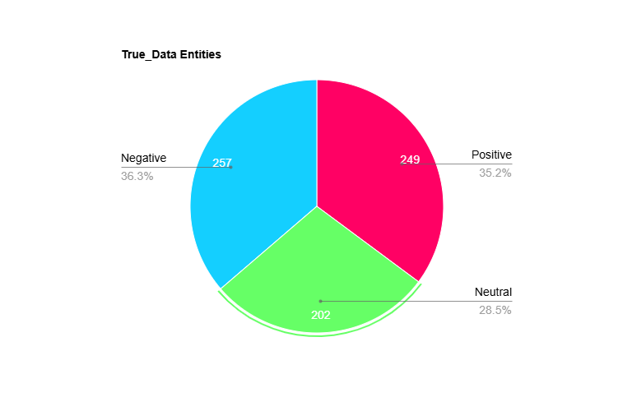
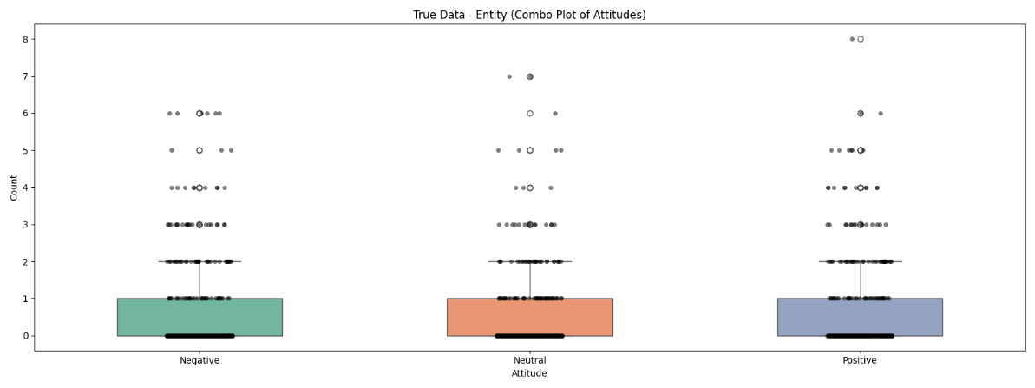
These Graphs show us that for this dataset comprising of Articles from multiple topics, GPT covers both Positive/Neutral/Negative consistently in terms of Entity Pairs, averaging 0-1 of each per Sample with the highest number of assigns being 8 Positive for a single Sample.
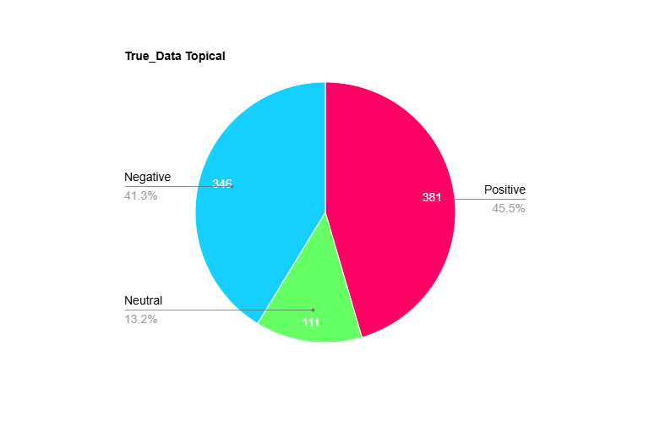
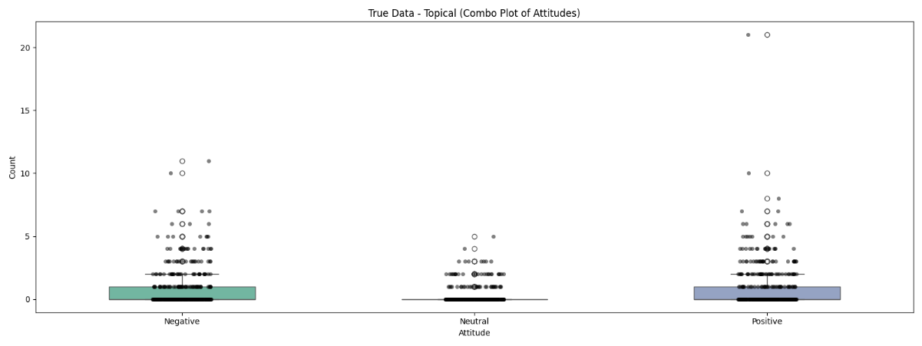
These Graphs show us that for Topical Pairs, GPT covers both Positive /Negative consistently with a few Neutral assigns, averaging 0-1 of each per Sample except Neutral with the highest number of assigns being 20 Positive for a single Sample.

“Pred_Data” (POLAR):
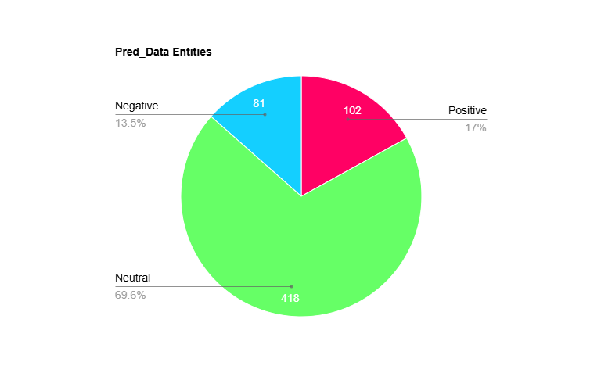
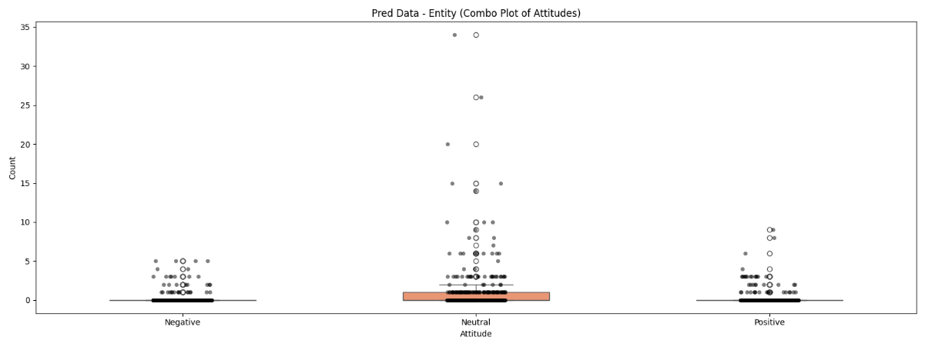
These Graphs show us that for Entity Pairs, POLAR covers a large majority of Neutral pairings, with some Positives/Negatives, averaging ≈0 Positive/Negative and 0-1 Neutral assigns per Sample, with the highest being 35 Neutral assigns for 1 sample.
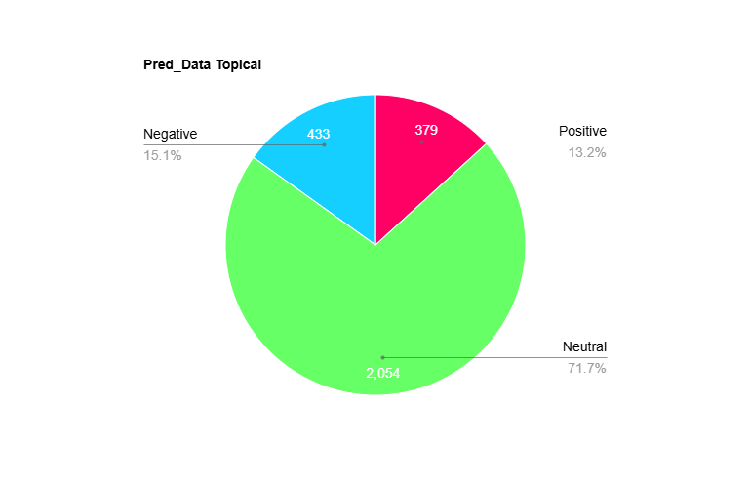
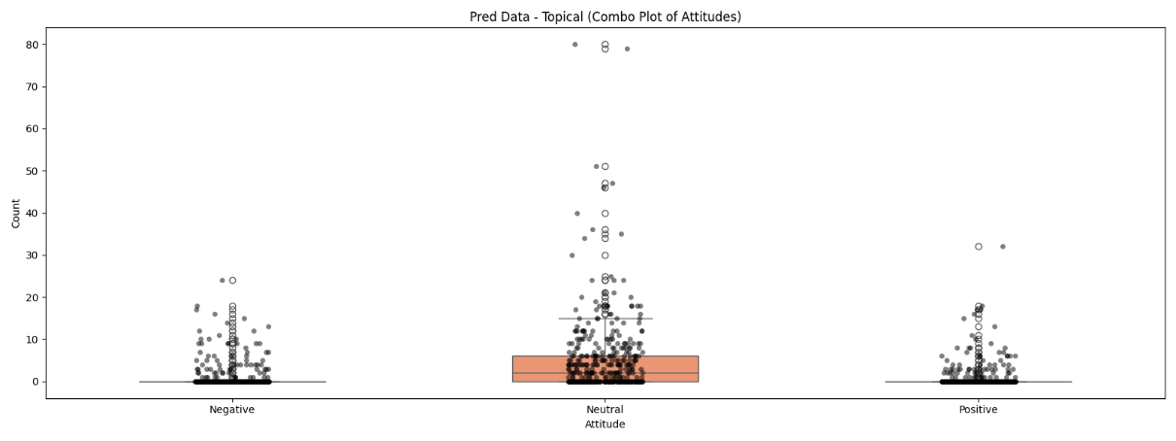
These Graphs show us that for Topical Pairs, POLAR covers a large majority of Neutral pairings, with some Positives/Negatives, averaging ≈0 Positive/Negative and 0-7 Neutral assigns per Sample, with the highest being 80 Neutral assigns for 1 sample.

6.2.2.1.2 Brexit Dataset:
An additional analysis was conducted on a dedicated dataset of a polarizing topic, Brexit of around 770 Article Parts, to see whether the models captured the polarizing and mostly negative responses to that topic.
However due to an oversight as well as later resource and time constraints, these Articles were all written in the U.S., this does not change the evaluation however it is important to note, as it shows clear preference to U.S. Figures.

“True_Data” (GPT):
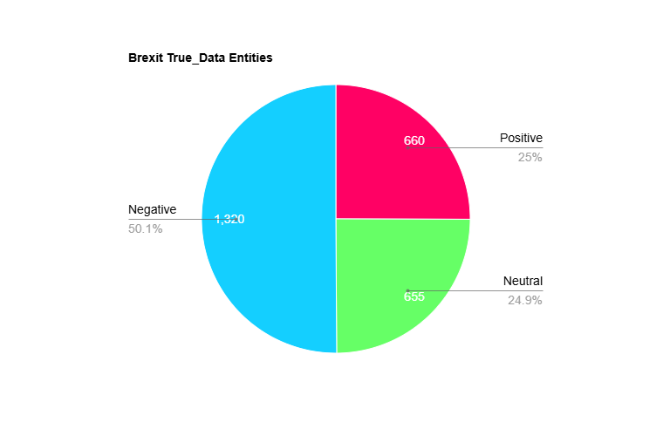
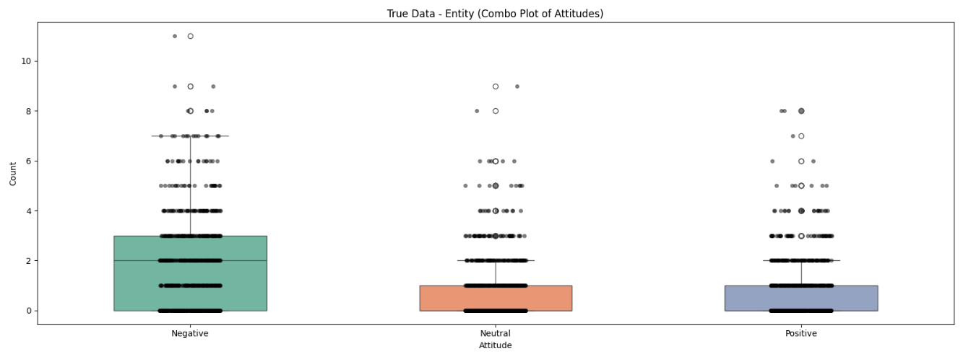
These Graphs show us that for the Brexit dataset, Entity Pairs, GPT covers a majority of Negative pairings, with some Positives/Neutral, averaging 0-1 Positive/Neutral and 0-3 Negative assigns per Sample, with the highest being 11 Negative assigns for 1 sample.
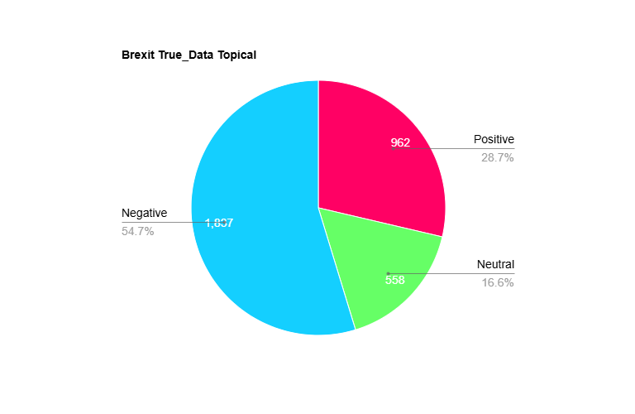
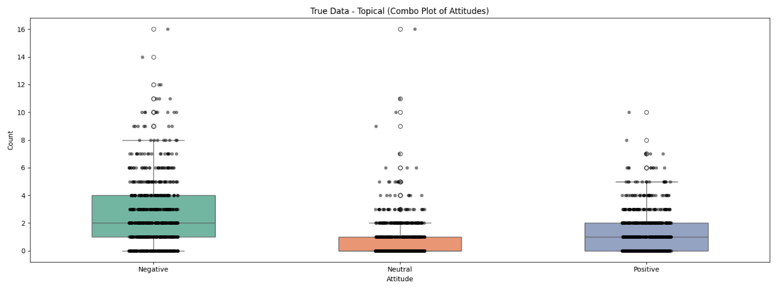
These Graphs show us that for Topical Pairs, GPT covers a larger majority of Negative pairings, with some Positives/Neutral, averaging 0-1 Neutral, 0-2 Positive and 1-4 Negative assigns per Sample, with the highest being 16 Negative assigns for 1 sample.

“Pred_data” (POLAR):
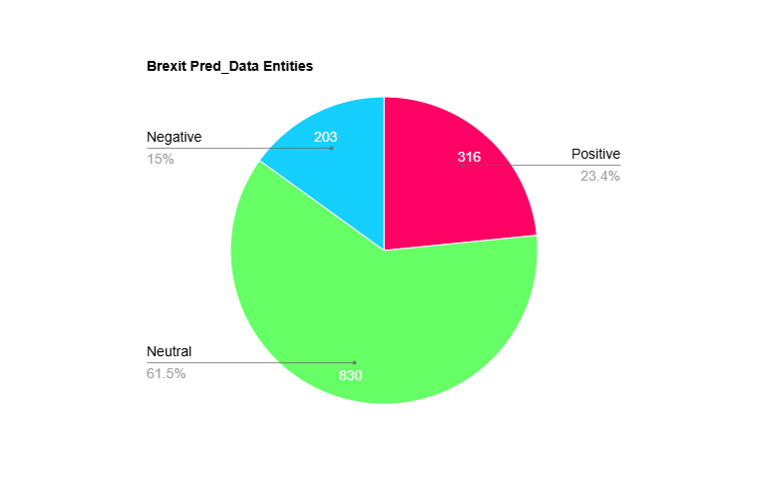
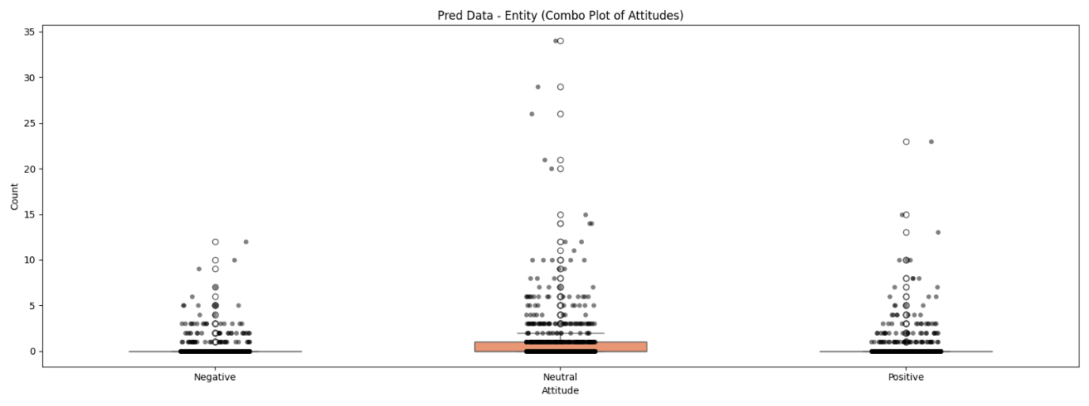
These Graphs show us that for Entity Pairs, POLAR covers a majority of Neutral pairings, with some Positives/Negative, averaging 0-1 Neutral and ≈0 Negative/Positive assigns per Sample, with the highest being 34 Negative assigns for 1 sample.
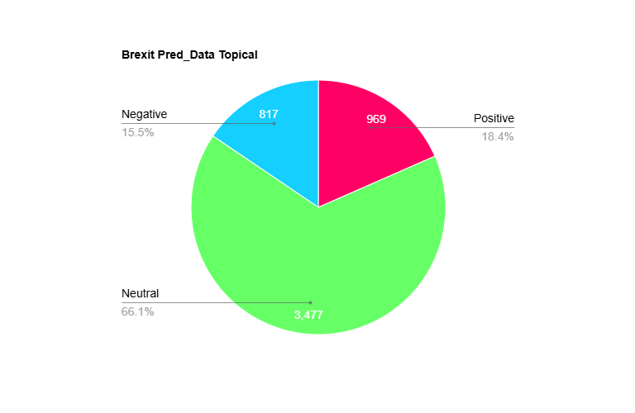
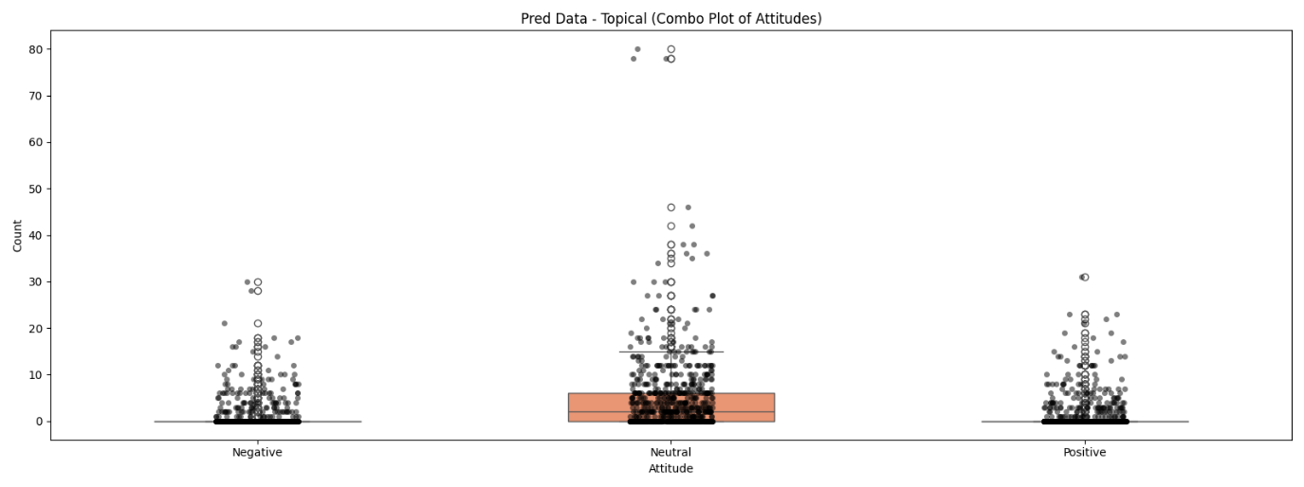
These Graphs show us that for Topical Pairs, POLAR covers a majority of Neutral pairings, with some Positives/Negative, averaging 0-7 Neutral and ≈0 Negative/Positive assigns per Sample, with the highest being 80 Negative assigns for 1 sample.

6.2.2.2 Overall Attitude Summary Conclusion
The results in this section highlight a clear divergence in attitude assignment between GPT and POLAR, across both datasets a consistent pattern was shown:
- GPT distributes Positive/Neutral/Negative attitudes with high granularity and diversity, adapting its usage to the tone and context of each sample.
- POLAR, instead, exhibits a dominant bias toward Neutrality, frequently assigning Neutral to pairs, whereas GPT infers more polarized relationships
This is shown due to the structural limitations of POLAR, being error-prone to dependency parsing errors as well as sentiment scoring through pre-existing lexicons, which fail at more nuanced or complex sentences.
6.2.2.2.1 Training dataset
In the General training dataset comprising of multiple non-organized likely polarizing topics.
- GPT assigned Positive/Neutral/Negative ratings in an organized fashion that reflects general diversity between articles, such as praise, criticism, disagreement etc.
- POLAR however assigned Neutral to the overwhelming majority of both Entity and Topical pairs, with the Average Positive/Negative rating per Article averaging at ≈0 for both, whereas the Neutral ratings averaging 0-1 to 0-7 instead.

6.2.2.2.2 Brexit dataset
The Brexit dataset served as a biased test case, since Brexit related discourse is inherently polarizing and often emotionally charged, leading people to feel strongly about either side of polarity.
- GPT’s responses reflect this polarity, assigning a strong majority of the pairs as Negative, for both Entities and Topics, followed by a smaller majority of them being Positive for Topics and even with Neutral assignments for Entities.
- POLAR, on the other hand, continued its overwhelming Neutral dominant pattern, with no clear sign of preference to Negative attitudes unlike GPT’s responses. This is likely due to dependency errors or a lack of coverage by the sentiment lexicon (mpqa)
This shows that POLAR tends to underestimate Negativity in politically charged datasets, which impacts its general applicability to stance detection for Entities, mapping controversies etc.
Either this or POLAR failed to find any emotionally intensive Pairs or polarizing relationships within this dataset, however this is proven false from Section 6.2.4

6.2.3 Attitude Analysis Conclusion
These results demonstrate that while POLAR’s Sentiment Extraction provides a structured and interpretable approach, it can drastically underrepresent polarity in real world articles.
LLMs like GPT and Mistral can significantly improve on this aspect of Sentiment Extraction, offering a richer and more descriptive Attitude analysis as well as context-awareness when evaluating Attitudes.

6.2.4 Topics and Pair Frequency Comparisons
To analyze a broader range of comparisons between POLAR and GPT, the Topics extracted through the Pipeline were compared, which is an independent step from the Sentiment Attitudes.
We also analyzed the Pair Frequency of the Brexit Dataset for both POLAR and GPT to see through a broader scope whether the models identified similar pairs and their calculated attitudes.
6.2.4.1 Topics
In this section we compared the Topics file generated by the Topic_Identifier step of the POLAR Pipeline, see Chapter 2 - Figure 1, this was done by treating the Topics in the Topical Pairs as Noun_Phrases and reformatting them to generate the topics.json.gz.
We compared the LLM integrated topics file with the normal POLAR topics file.
These Comparisons were done on the Brexit Dataset.
Recall | 0.7294
True Positives | 2235
False Negatives | 829
POLAR Topics | 2671
GPT Topics | 2628
Unmatched POLAR | 436
Unmatched GPT | 393
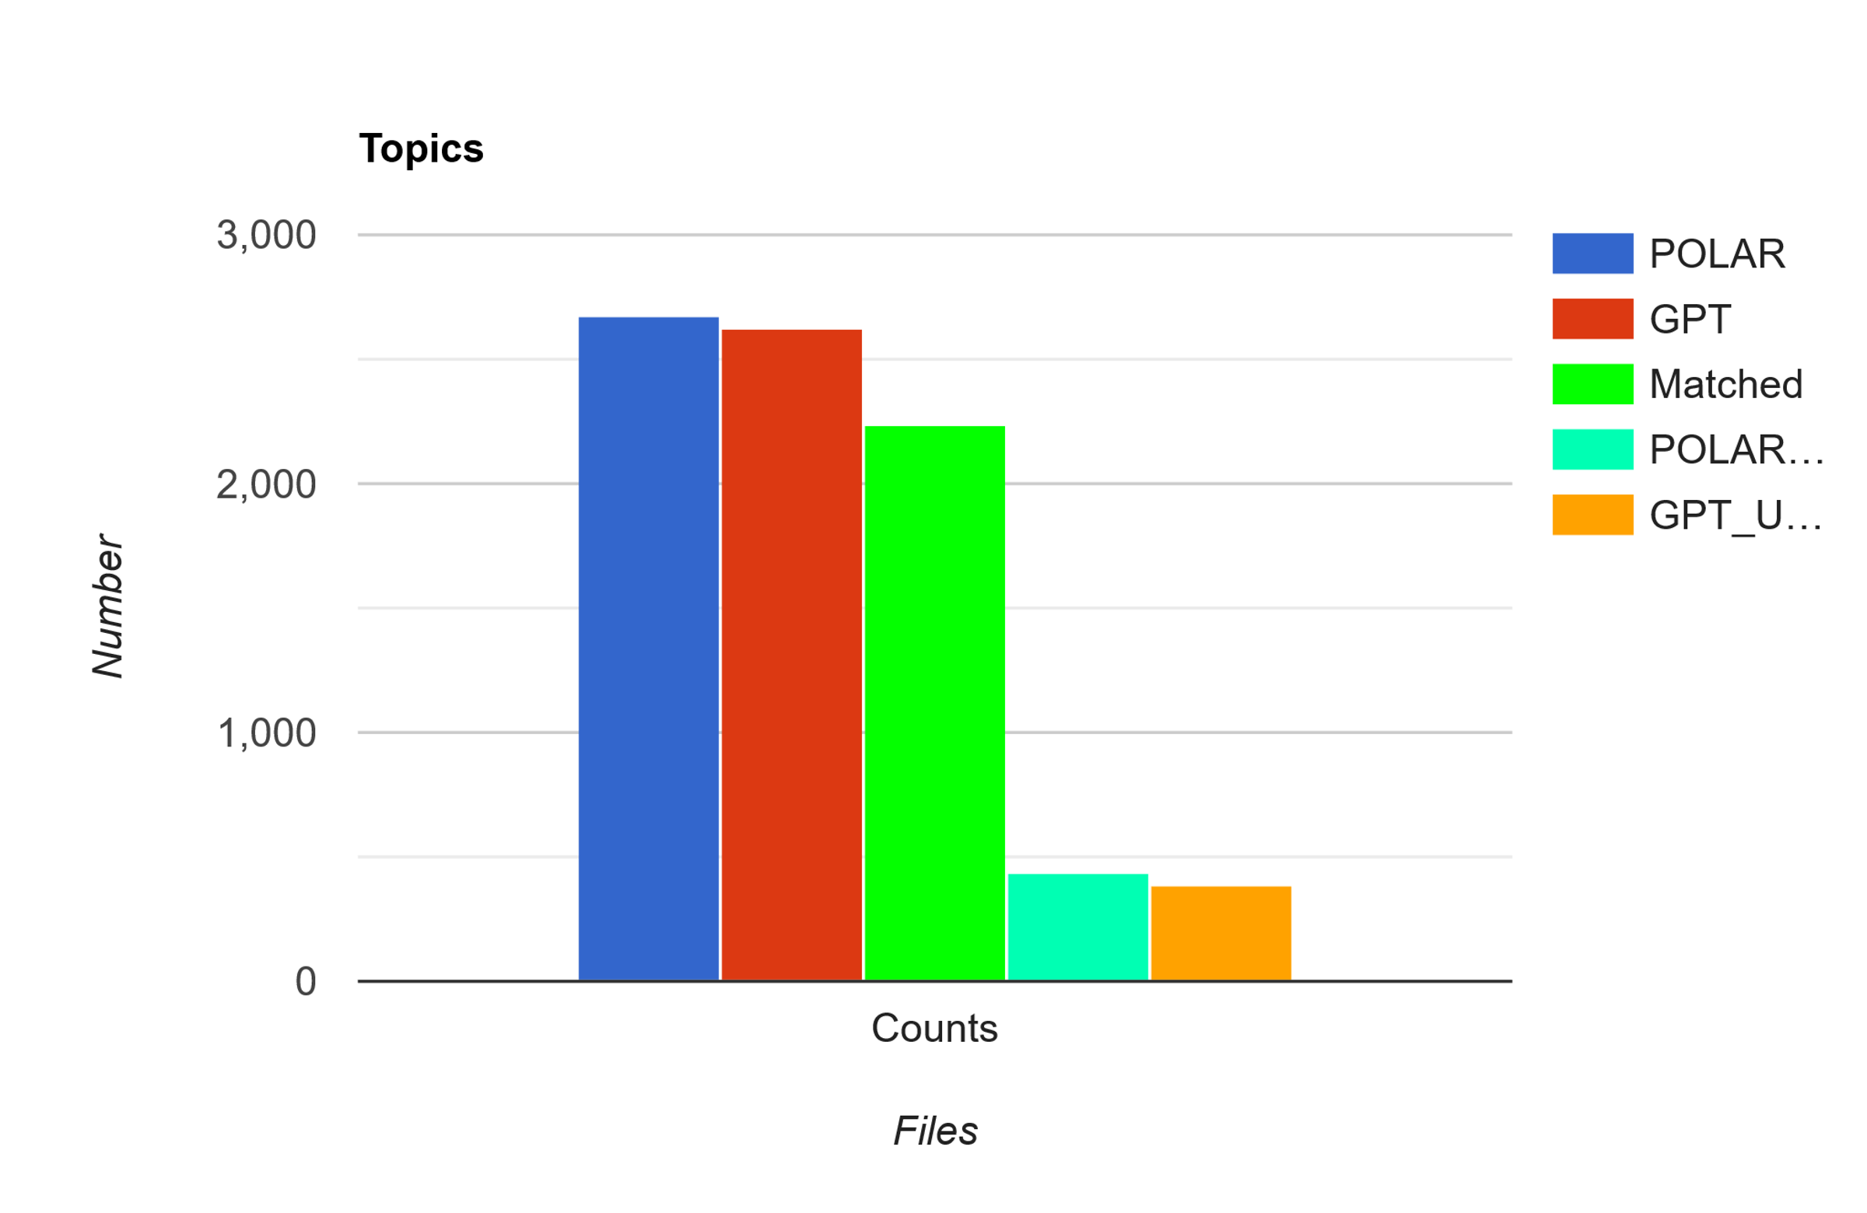
From this graph we can see that, even though the per-article analysis proved that these Datasets are wildly different, their calculated Topics were very similar, where 83.68% of the POLAR Attitudes were matched with GPT Attitudes and 85.05% of GPT Attitudes were matched with POLAR Attitudes.
These results are aligned with POLAR’s Topic Calculations done in the POLAR Journey, with very similar results to the ones gathered from that research. [ ALEX ]
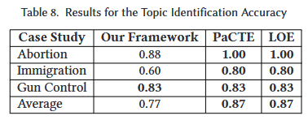

The Topics were compared to each other using Semantic Similarity with Sentence Transformers with a Threshold of 0.6.
Examples of matches with the lowest Threshold:
"a potential Brexit" <-> "The so-called 'Brexit' decision" , score: 0.6003
"a political crisis" <-> "economic and political uncertainty" , score: 0.609

6.2.4.2 Pair Frequency
Utilizing the results gathered from comparing each individual Sample, we gathered every unique mention of a Pair in every Sample for both Entity/Topical fields and counted every time each Pair is mentioned in both the Predicted Data and the Ground Truth Data.
We grouped up every mention of each pair as well as every time the pair was mentioned in both the Ground Truth set and the Predicted set, as well as every time it was declared as Positive, Neutral or Negative.
It is important to note that this step was not done using Semantic Similarity to compare the pairs due to Time Constraints, since to accurately and fairly compare every pair with every pair using Semantic Similarity would take multiple days of execution, however would likely yield better results.

6.2.4.2.1 Overlapping Entity Pairs
Overlapping Entity Pairs (113) == Top 10
Where True Attitudes refer to GPT and Predicted Attitudes refer to POLAR:
Pairs | True_Attitudes | Pred_Attitudes
('european union', 'united kingdom') | TRUE: 72 (Neg: 47, Neu: 18, Pos: 7) | PRED: 109 (Neg: 14, Neu: 80, Pos: 15)
('brexit', 'european union') | TRUE: 7 (Neg: 7, Neu: 0, Pos: 0) | PRED: 44 (Neg: 10, Neu: 24, Pos: 10)
('brexit', 'united kingdom') | TRUE: 5 (Neg: 1, Neu: 2, Pos: 2) | PRED: 43 (Neg: 9, Neu: 28, Pos: 6)
('united kingdom', 'united states') | TRUE: 29 (Neg: 5, Neu: 6, Pos: 18) | PRED: 6 (Neg: 0, Neu: 5, Pos: 1)
('barack obama', 'european union') | TRUE: 11 (Neg: 1, Neu: 4, Pos: 6) | PRED: 13 (Neg: 4, Neu: 6, Pos: 3)
('barack obama', 'united kingdom') | TRUE: 16 (Neg: 5, Neu: 4, Pos: 7) | PRED: 8 (Neg: 1, Neu: 4, Pos: 3)
('donald trump', 'hillary clinton') | TRUE: 21 (Neg: 19, Neu: 0, Pos: 2) | PRED: 1 (Neg: 0, Neu: 1, Pos: 0)
('brexit', 'donald trump') | TRUE: 13 (Neg: 5, Neu: 2, Pos: 6) | PRED: 7 (Neg: 0, Neu: 6, Pos: 1)
('nato', 'russia') | TRUE: 15 (Neg: 11, Neu: 2, Pos: 2) | PRED: 3 (Neg: 0, Neu: 2, Pos: 1)
('barack obama', 'brexit') | TRUE: 6 (Neg: 3, Neu: 2, Pos: 1) | PRED: 10 (Neg: 3, Neu: 4, Pos: 3)

Given the topic of Brexit and the general timeframe of the articles of it happening 2016/6-7/22-10, ( European Union <-> United Kingdom ) is the most represented pair and that lines up with the topic perfectly, with 72 mentions from GPT and 109 from Polar, with the same reasoning for the 2nd and 3rd row, with a small oversight being that Brexit should have been considered a topic rather than an Entity.
The Entities that are matched are accurate to the Topic of Brexit, however the Attitudes associated with them are as mentioned in Section 6.2.2.2. POLAR’s Attitudes are primarily Neutral, even with the predominantly Negative nature of the Pairs, such as:
(European Union <-> United Kingdom), should be the most polarizing pair, given real world scenarios of what happened, and GPT encapsulates that by having 65.27% of these pairs be Negative, followed by 25% Neutral and only 9.7% Positive. Meanwhile POLAR has 73.39% of these pairs be classified as Neutral, with 13.76% Positive and only 12.84% Negative.
Regardless of whether these pairs were found in the same Sample or not, they were found in the same Dataset, so the pairs being Neutral focused is due to POLAR rather than the dataset, since GPT attributed a majority of them as Negative.

6.2.4.2.2 Overlapping Topical Pairs
Overlapping Topical Pairs (45) == Top 10
Where True Attitudes refer to GPT and Predicted Attitudes refer to POLAR:
Pairs | True_Attitudes | Pred_Attitudes
('brexit', 'european union') | TRUE: 70 (Neg: 58, Neu: 10, Pos: 2) | PRED: 20 (Neg: 6, Neu: 14, Pos: 0)
('european union', 'united kingdom') | TRUE: 12 (Neg: 7, Neu: 5, Pos: 0) | PRED: 47 (Neg: 6, Neu: 34, Pos: 7)
('brexit', 'united kingdom') | TRUE: 34 (Neg: 22, Neu: 9, Pos: 3) | PRED: 21 (Neg: 2, Neu: 16, Pos: 3)
('barack obama', 'brexit') | TRUE: 24 (Neg: 14, Neu: 8, Pos: 2) | PRED: 1 (Neg: 0, Neu: 1, Pos: 0)
('brexit', 'united states') | TRUE: 15 (Neg: 8, Neu: 4, Pos: 3) | PRED: 9 (Neg: 1, Neu: 4, Pos: 4)
('european union', 'united states') | TRUE: 4 (Neg: 1, Neu: 0, Pos: 3) | PRED: 5 (Neg: 1, Neu: 4, Pos: 0)
('boris johnson', 'brexit') | TRUE: 8 (Neg: 1, Neu: 0, Pos: 7) | PRED: 1 (Neg: 0, Neu: 1, Pos: 0)
('brexit', 'david cameron') | TRUE: 8 (Neg: 7, Neu: 1, Pos: 0) | PRED: 1 (Neg: 0, Neu: 1, Pos: 0)
('barack obama', 'european union') | TRUE: 5 (Neg: 1, Neu: 2, Pos: 2) | PRED: 3 (Neg: 1, Neu: 1, Pos: 1)
('united kingdom', 'united states') | TRUE: 2 (Neg: 1, Neu: 1, Pos: 0) | PRED: 5 (Neg: 1, Neu: 3, Pos: 1)

The Topical pairs are once again accurate to the events of Brexit, the Outliers are the pairs consisting of 2 entities instead of an entity and a topic, example:
('european union', 'united kingdom')
('united kingdom', 'united states')
These same pairs are found above in the Entity Pairs

6.3 POLAR Pipeline End Result Comparison
In this section we are moving past the Sentiment Attitude Extraction aspect of POLAR and looking at the Artifacts output at different Steps of the Pipeline and comparing the Standard POLAR method with our Integrated LLM Method.
6.3.1 Fellowships:
POLAR:
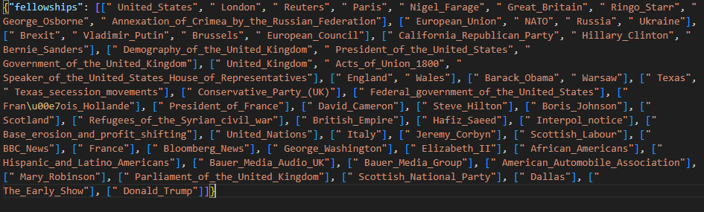
GPT:
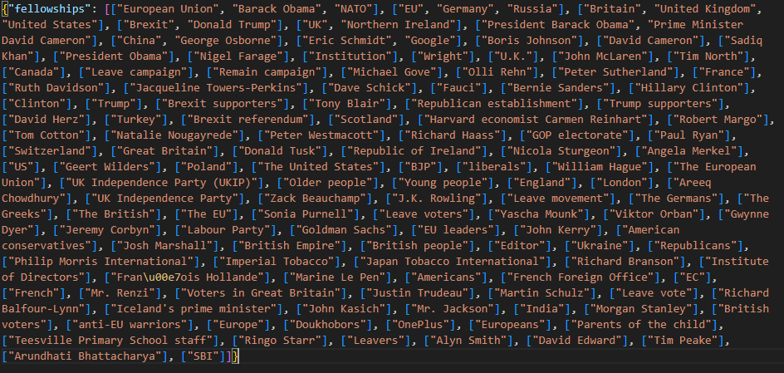
From these Fellowships we can infer multiple things:
GPT:
- 110+ Clusters of Fellowships, ranging from 1-3 Entities each with a majority of single Entities, many overlaps (European Union – EU, etc.)
- Contains Various named Entities not limited to strictly known entities
- High Noise, a lot of Single Entity Fellowships
POLAR:
- ~40 Clusters of Fellowships, ranging from 1-9 Entities each, more compact with less overlaps
- Represents Entities Strictly off Dbpedia links that correspond to Entities
- Very low Noise, very curated
Very few similarities between the 2 models, with the closest match in fellowships being:
"POLAR ": ["Demography_of_the_United_Kingdom",
"Government_of_the_United_Kingdom"
"President_of_the_United_States”],
"GPT ": [ "Britain",
"United Kingdom",
"United States” ]
Comparing the fellowship clusters of POLAR and GPT reveals two distinct modeling philosophies.
POLAR’s DBpedia-aligned clusters are compact and curated, offering high precision but missing some aspects of political and sociological discourse.
GPT, on the other hand, surfaces a richer, more sociologically nuanced set of actors, including campaign groups, media personalities, and ideologically charged with the trade-off of a messier and noisier output.

6.3.2 SAG (Signed Attitude Graph):
In this section we compared the SAG graphs output by POLAR’s pipeline which shows the Sentiment between Entities in an undirected graph.
What the Connections represent:
The Nodes represent Entities and the Edges represent Sentiment calculated between Entities whose pairs were found through the Entity_Extractor and Sentiment_Attitude, or in the case of the LLMs, the Entity_attitude field from the responses.
The Colors represent whether the weight attached to these pairs is Positive or Negative. The POLAR function in the pipeline that constructs the SAG skips over strictly Neutral pairs, to focus more on Polarization.
POLAR:
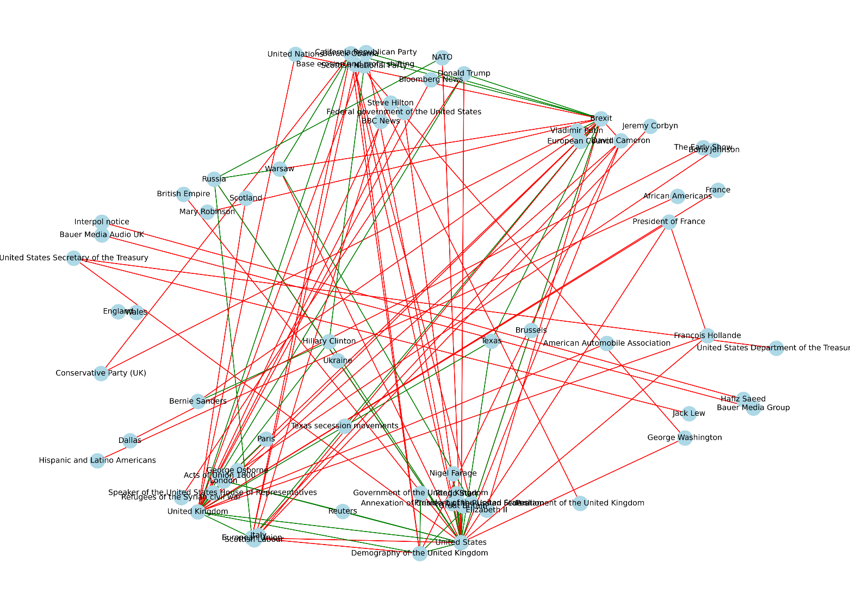

GPT:
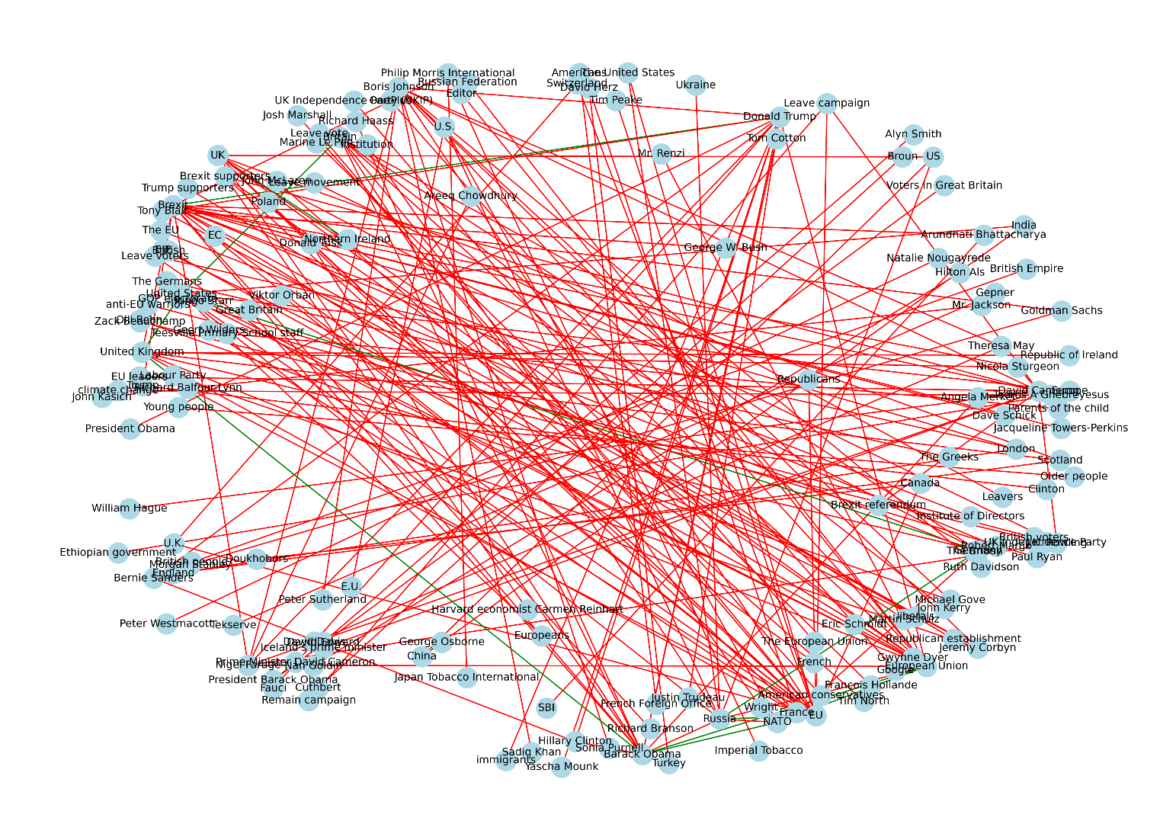
From these Graphs we can see:
POLAR
- SAG is more compact and structured, containing less noise
- Entities are Formal and linked to dbpedia URLs each (removed from the Graph for clarity)
- Mix of Positive and Negative edges, leaning heavily towards Negative
GPT
- Messy Graph with a high number of Nodes and Edges, very densely connected
- Heavily skewed towards Negative Sentiment Edges with only a handful of Positives
- Entities are informal mentions through text, not linked to pre-existing Entities

These results are very dissimilar, likely because GPT overproduces Entity Pairs, as seen in section 6.2.2.1.2, POLAR produces 1320 Entity Pairs to GPT’s 2552. Added in the fact that GPT’s Entity Pairs are not traditionally normalized like Polar’s use of Dictionary linking to dbpedia links, and this creates this difference we see, with GPT appearing messier and denser, with noisy Entities that appear few times.

6.3.3 Attitude Dipoles:
This is the final Artifact output from the POLAR Pipeline, the attitudes.pckl file, which is the culmination of all the previous steps in the Pipeline, it shows all of the key entities’ connection with the other key entities by linking them with their opinions on the most impactful topics found.
What each Color Represents:
Blue: Neutral to slight Agreement on the Topic
Gray: Mixed to Neutral on the Topic
Green: Positive Agreement on the Topic
Orange: Negative Agreement on the Topic
Red: Polarization on the Topic
POLAR:
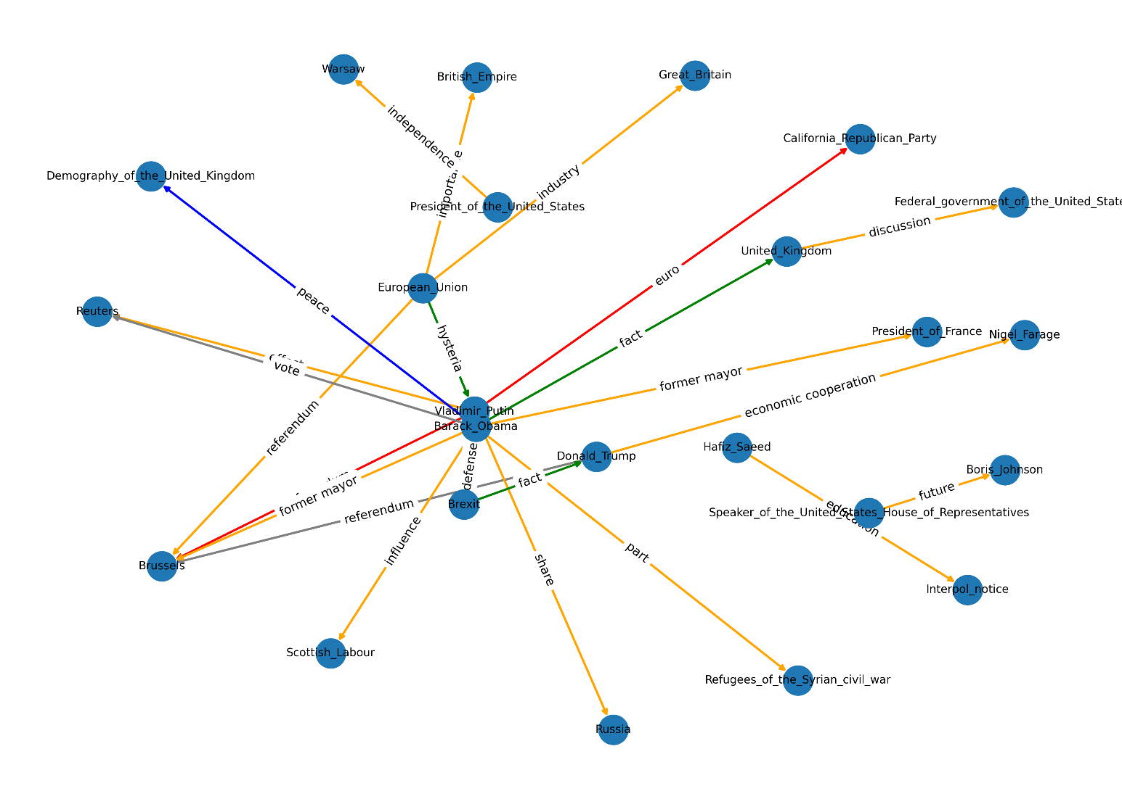
GPT:
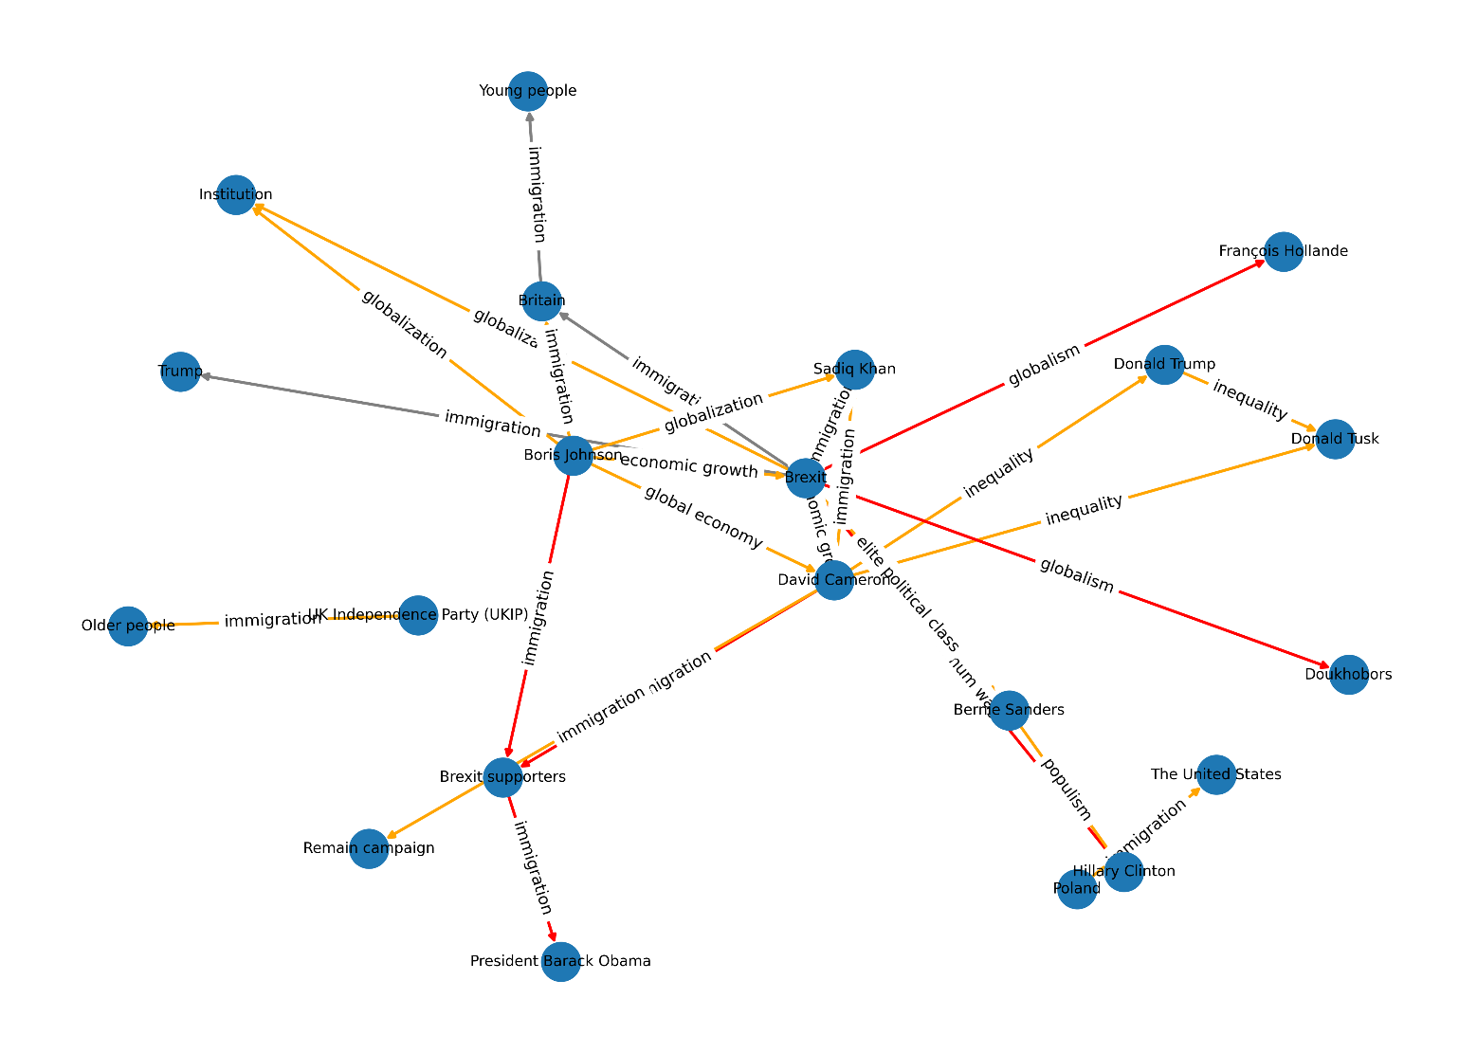
Analysis:
Initially, at a first glance the models’ outputs share some Similarities, such as having a large majority of the Edges being Negative Agreement, where both Entities Disagree on the Topic of their Pair, such as:
- GPT (David Cameron <-> Donald Trump, Topic: inequality)
- POLAR (Barack_Obama <-> Russia, Topic: share).
The number of Polarizing Pairs are few for POLAR and a bit more prevalent in GPT’s graph, with pairs such as:
- GPT (Boris Johnson <-> Brexit supporters, Topic: immigration, where Boris Johnson: Positive Attitude, Brexit supporters: Negative Attitude)
- POLAR (Vladimir_Putin <-> California_Republican_Party, Topic: euro, where Vladimir_Putin: Negative Attitude, California_Republican_Party: Positive Attitude)
There are slight Positive Agreements and a few Neutral Pairs as well.
The Topics that connect the pairs in the models vary substantially for GPT and POLAR, where POLAR’s Topics are plentiful and nuanced, but do not seem to be Topics of high Polarity or Discourse, consisting mainly of generic Noun Phrases, such as:
- Part
- Share
- Fact
- Discussion
- Former mayor
- Future
- euro
On the other hand, GPT’s Topics are very few comparatively, with only 17 unique Topics found in the Dipoles out of 43, with immigration appearing in 16 entries (roughly 37%). As such the Topic coverage of GPT is less nuanced and consists of some repeating topics between Entities, however the Topics being compared are divisive and are likely to cause Discourse, such as:
- immigration
- globalism
- globalization
- inequality
- global economy

In order to determine the quality of the Topics gathered by GPT and POLAR, the Topics were all sent to multiple LLMs for them to classify as Sociopolitical, Slightly Sociopolitical and Not Sociopolitical, with a brief explanation that Sociopolitical topics are issues related to government, society, public policy, inequality, rights, identity or power structures and may be emotionally charged in public discourse.
The topics were sent randomly with no reference to which response they correlate to, in order to remove any inherent bias in the outputs, with these results gathered from purely considering the Sociopolitical classified topics:
Sociopolitical Topics detected using LLMs
Model | GPT Percentage of Matches | POLAR Percentage of Matches
GPT-4.0 | 100% | 45.1%
Deepseek-V3 | 76.7% | 40.7%
Claude-3.7 Sonnet | 74.4% | 29.7%
Gemini-2.0 Flash | 76.7% | 44.0%
Le Chat - Mistral | 72.1% | 31.9%
Average Overall: | 80.0% | 38.3%

6.3.4 Conclusion:
It is hard to definitively declare which model is superior in the end, a more thorough analysis would need to be conducted with a much larger dataset of Articles to be able to more accurately compare the models.
From the Data of 727 Article Parts however, on the topic of Brexit, the analysis between GPT and POLAR reveals a clear trade-off between topic depth and topic breadth:
GPT overwhelmingly identifies socio-politically meaningful topics, as validated by multiple LLMs. Focusing on issues with real-world ideological divides.
In contrast, POLAR extracts a much larger and diverse topic set of 65 unique topics of 91 total Attitudes to GPT’s 17 of 43 total Attitudes, as well as reflecting a broader topical coverage when compared to GPT. The trade-off is that many of POLAR’s topics are shallow or generic, with no means of discourse or polarity, with only a small portion of sociopolitical topics covered (roughly 38.3% according to the LLMs requested)

6.4 Fine-Tuned Mistral Evaluation
This evaluation aims to measure how well the fine-tuned Mistral-7B model replicates the outputs of GPT3.5. The GPT responses were set as the Ground Truth, with the Mistral responses acting as the prediction, the comparisons were focused on entity/topic pair identification, attitude classification on the true pairs and justification quality.
It is important to note that the Dataset that was compared was a dataset excluded from the fine-tuning dataset of the model.
6.4.1 Evaluation
Evaluation - Mistral completed in 4467.64 seconds.(~74.46 minutes)
“Entity”
Pair Matching
Precision | 0.8725
Recall | 0.9418
F1 | 0.9059
True Positives | 664
False Positives | 97
False Negatives | 41

Attitude Prediction
Accuracy | 0.9771
True Positives | 683
False Negatives | 16

Justification Overlap
Overlap | 0.8581
Matched Justifications | 798
Total Justifications | 930

From this data, we can see that from the evaluated dataset, Mistral Successfully manages to predict 664 pairs from the 705 pairs in the Ground Truth dataset == roughly 94.18% of the pairs in Ground Truth were accurately predicted.
Of those 664 pairs, 699 attitudes were compared between the Ground Truth and the Predicted Dataset, with Mistral correctly predicting 683 of them == roughly 97.71% pairs were correctly attributed.
Of those 664 pairs, the justification was successfully matched using ROUGE-L similarity roughly 85.81% of the time.
“Topical”:
Pair Matching
Precision | 0.8658
Recall | 0.9365
F1 | 0.8998
True Positives | 826
False Positives | 128
False Negatives | 56

Attitude Prediction
Accuracy | 0.9750
True Positives | 820
False Negatives | 21

Justification Overlap
Overlap | 0.8785
Matched Justifications | 477
Total Justifications | 543

From this data, we can see that from the evaluated dataset, Mistral Successfully manages to predict 826 pairs from the 882 pairs in the Ground Truth dataset == roughly 93.65% of the pairs in Ground Truth were accurately predicted.
Of those 826 pairs, 841 attitudes were compared between the Ground Truth and the Predicted Dataset, with Mistral correctly predicting 820 of them == roughly 97.50% pairs were correctly attributed.
Of those 826 pairs, the justification was successfully matched using ROUGE-L similarity roughly 87.85% of the time.

6.4.2 Conclusion
From this dataset we can confidently state that Mistral replicates GPT remarkably well, accurately guessing GPT’s Entity / Topical Pairs around 93-94% of the time, with a precision of around 86-87%, meaning that at any point that Mistral locates a pair, there is an 86-87% likelihood that it is included in the GPT results. These are incredible results, especially since Mistral is a marginally smaller open-weight model than GPT 3.5.
Mistral is also incredibly accurate at predicting the Attitudes of the calculated pairs, accurately guessing around 97% of the pairs in the same way that GPT would.
These results indicate that Mistral, once fine-tuned, is not only a viable replacement for GPT-based processing in the POLAR pipeline, but also one that can produce slightly richer outputs. In the test set, an additional 97 Entity Pairs and 128 Topical Pairs were identified by Mistral that do not match any pairs in the GPT outputs. This can be interpreted as an enhancement (greater granularity and sensitivity to subtle Sentiment Attitudes) or as potential noise (false pairs with lower precision). The appropriate interpretation of these added pairs depends on the strictness or flexibility of the use case.
Beyond raw performance metrics, there are operational trade-offs that distinguish the two models:
Attribute | GPT-3.5 (API) | Mistral-7B (Fine-Tuned)
Hosting | Cloud (OpenAI) | Local
Internet Dependency | Required | None
Prompt Length | Long (1200+ char) | Minimal
Latency per Request | ~15–35 seconds | ~1–2 minutes
Multithread-ability | Minimal | None
Cost per Use | Usage-based fees | Local
Fine-tune Time | N/A | ~3 hours
System Requirements | N/A | Cuda compatible GPU

