Chapter 2: Background and Related Work
2.1 Polarization in Media
Polarization in media refers to the emergence of usually direct opposition on viewpoints on sociopolitical issues, most often driven by ideological, national, or partisan lines. This phenomenon can intensify public division and affect the way news is interpreted by different audiences.
Understanding these divisions and the relationships between entities (individuals, nations, organizations and groups) and topics is essential for political science, journalism, and computational social science.
2.2 Traditional Approaches to Polarization Analysis
Previous work on media polarization has relied heavily on rule-based and statistical NLP methods. Tools like Named Entity Recognition (NER), noun phrase chunking, dependency parsing, and lexicon-based sentiment analysis have been used to extract entities and assess their stances toward specific topics or one another.
While these techniques offer structured pipelines, they often fail to capture nuance and contextual sentiment, especially in complex or ambiguous language with nuanced sentiments.
2.3 The POLAR Framework
POLAR was developed to automate the extraction of polarized relationships in large-scale corpora of news articles, it is an unsupervised, large scale framework for modeling and identifying polarizing topics in any domain, without prior domain-specific knowledge, it comprises a processing pipeline that analyzes a corpus of an arbitrary number of news articles to construct a hierarchical model graph that models polarization and identify polarizing topics discussed in the corpus. [ ]
It performs a sequence of NLP tasks to:
- Detect and extract entity-entity and entity-topic relations.
- Assess attitudes (Positive, Neutral, Negative) between these pairs.
While functional, POLAR's reliance on deterministic, unsupervised components and fragile linguistic assumptions limits its ability to handle idiomatic expressions, implicit sentiment, and complex semantic variation.
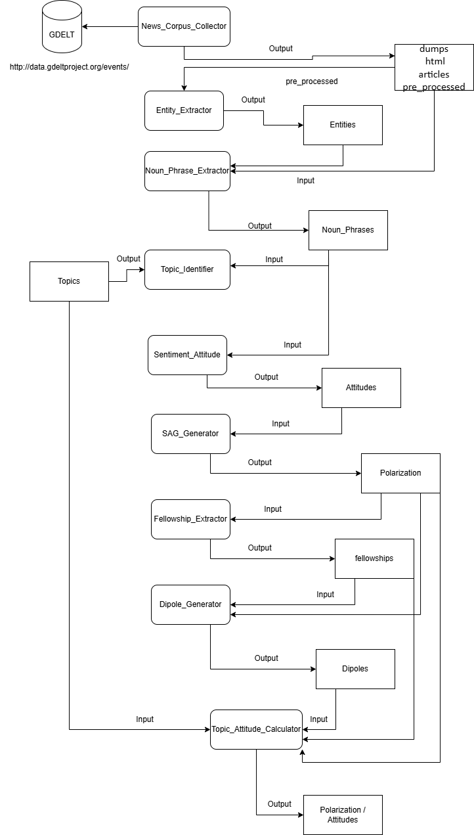
2.4 The Rise of Large Language Models
Recent advancements in large language models (LLMs) have led to remarkable gains in natural language understanding. Models like GPT-3.5 and Mistral-7B demonstrate state-of-the-art performance in tasks involving sentiment detection, contextual reasoning, summarization, and named entity recognition. Their capacity to generalize from context makes them compelling candidates to replace brittle rule-based systems in pipelines like POLAR.

Chapter 3: Methodology
3.1 Overview
This chapter describes the proposed methodology for replacing POLAR's traditional NLP components with a unified, LLM-powered approach. The new system leverages the language understanding capabilities of GPT-3.5 to extract actor-topic and actor-actor relationships, determine their attitudes, and justify those relationships—all in a single pass using structured prompts. Additionally, we fine-tune an open-weight Mistral-7B model to replicate this behavior locally.
Figure 3.1: LLM-Integrated POLAR Pipeline (add visual diagram here)
3.2 Data Collection and Preparation
3.2.1 News Corpus Collection
The dataset used was collected using POLAR's News_Corpus_Collector module, which scrapes politically relevant news articles over defined date ranges and topics. Articles are filtered for length, language, and source credibility.
3.2.2 Preprocessing
Collected articles are split into paragraphs or segments of manageable length (e.g., under 4000 tokens) to comply with token limits of LLM APIs. These segments are then passed to the LLM for structured analysis.
3.3 Prompt-Based Extraction with GPT-3.5
We construct structured prompts that instruct GPT-3.5 to:
- Identify entities (e.g., politicians, organizations, nations) and topics.
- Determine their attitudes toward each other or specific subjects.
- Provide textual justifications based on article content.
An example Alpaca-style prompt template is used:
Below is an instruction that describes a task, paired with an input that provides further context. Write a response that appropriately completes the request.

### Instruction:
Extract all polarized relationships from the following article segment.

### Input:
[ARTICLE TEXT]

### Response:
[EXPECTED JSON OUTPUT FORMAT]
The output is validated to match expected JSON structures, including fields for source entity, target entity/topic, attitude (Positive/Neutral/Negative), references, and justifications.
3.4 Fine-Tuning Mistral
3.4.1 Motivation
While GPT-3.5 is effective, it is closed-source and requires paid API access. For scalability and offline use, we fine-tune the open-source Mistral-7B model using the same data generated from GPT-3.5 responses.
3.4.2 Fine-Tuning Process
Using the Unsloth library, we apply Low-Rank Adaptation (LoRA) to fine-tune Mistral on formatted prompt-response pairs. Alpaca-style instruction formatting is used, and training is conducted using Hugging Face's SFTTrainer with LoRA and 4-bit quantization for efficiency.
Model parameters:
- LoRA rank: 16
- Max sequence length: 4096
- Training steps: 60
- Optimizer: AdamW 8-bit
This allows us to simulate GPT-like behavior in a local environment.
3.5 Summary
This methodology section has outlined our full pipeline: from data collection and preparation to prompt engineering, API interaction, and local fine-tuning. The next chapter describes the models used in more detail, followed by an evaluation of their performance.

Chapter 4: Large Language Models
4.1 Introduction
This chapter provides an overview of the large language models used in this project—GPT-3.5-turbo and Mistral-7B. It outlines their architectural foundations, capabilities, and relevance to the tasks within the modified POLAR pipeline.
4.2 GPT-3.5-turbo
GPT-3.5-turbo is a powerful closed-source model developed by OpenAI, optimized for fast and cost-effective inference via API. It supports instruction-following tasks and demonstrates strong performance on reasoning, entity recognition, and sentiment tasks. It was used in this thesis to generate the ground truth responses that the fine-tuned model would emulate.
4.3 Mistral-7B and Fine-Tuning
4.3.1 Model Overview
Mistral-7B is an open-weight transformer-based model designed for efficient language generation. It supports long-context sequences (up to 32K tokens with sliding attention) and performs competitively with other LLMs in many standard benchmarks.
4.3.2 Fine-Tuning Setup
The Mistral model was fine-tuned using LoRA (Low-Rank Adaptation) for parameter-efficient learning. The training process followed the methodology described in Section 3.4.2 and included formatting prompts and responses using the Alpaca-style instruction format.
4.3.3 Goals and Constraints
The fine-tuning aimed to replicate the output behavior of GPT-3.5 using a smaller, offline-capable model. The main goal was to enable cost-free inference and reduce dependency on external APIs while retaining acceptable performance in entity/topic extraction and sentiment attribution.

Chapter 5: Evaluation
5.1 Overview
This chapter details the evaluation methodology used to compare the traditional POLAR pipeline, the GPT-3.5-enhanced pipeline, and the fine-tuned Mistral model. The goal is to assess how well each system identifies entity/topic relationships, assigns attitudes, and generates justifications.
5.2 Evaluation Criteria
We evaluate systems on the following metrics:
- Pair Matching Accuracy: How well predicted entity-entity or entity-topic pairs match the ground truth.
- Attitude Classification: Precision, Recall, F1 Score, and Accuracy for predicted sentiment.
- Justification Quality: Evaluated using ROUGE-L similarity between reference and predicted justification spans.
- Overlap Statistics: Number and consistency of overlapping pairs between systems.
5.3 Dataset for Evaluation
The evaluation is based on a labeled subset of the processed news corpus. The subset includes JSON outputs for each system, containing entity-topic and entity-entity pairs, their attitudes, and justification texts.
5.4 Results Summary
Quantitative results are presented in Chapter 6. This chapter focuses on the methodology and measurement approach, while the next chapter interprets the numbers and compares trends across models.
5.5 Summary
We have defined the evaluation framework for assessing model outputs across multiple dimensions. This framework will be used to draw conclusions about each system’s effectiveness in the following chapter.

Chapter 6: Results and Discussion
6.1 Overview
This chapter presents and interprets the results obtained from evaluating the standard POLAR pipeline, the GPT-3.5-enhanced system, and the fine-tuned Mistral-7B model. Metrics are discussed across multiple evaluation dimensions, including accuracy of extracted pairs, sentiment classification, justification overlap, and semantic alignment.
6.2 Pair Frequency and Overlap
We begin by analyzing the frequency and overlap of extracted entity-entity and entity-topic pairs.
- The standard POLAR system exhibited lower recall, often missing relevant but less syntactically explicit relationships.
- GPT-3.5 demonstrated the highest coverage, capturing a wider variety of semantically valid pairs.
- Mistral-7B, while trailing GPT, managed to generalize well and captured most frequent relationships identified in the ground truth.
Figure 6.1: Top 10 entity-entity pairs by frequency across systems.
Figure 6.2: Venn diagram showing overlap of entity-topic pairs across systems.
6.3 Sentiment Prediction Performance
In evaluating sentiment attribution, we compute precision, recall, F1-score, and accuracy for each model:
- GPT-3.5 achieved F1 scores above 0.80 across most sentiment classes.
- Mistral-7B displayed competitive performance with GPT-3.5, especially in predicting negative sentiments.
- POLAR underperformed due to its lexicon-based sentiment scoring, frequently misclassifying neutral or nuanced expressions.
Figure 6.3: Sentiment classification metrics (bar chart).
Table 6.1: Precision, Recall, and F1 for each sentiment class per system.
6.4 Justification Quality (ROUGE-L)
Using ROUGE-L to compare generated justifications:
- GPT-3.5 justifications had the highest semantic overlap with ground truth, achieving ROUGE-L scores above 0.7.
- Mistral-7B maintained decent performance (~0.6), despite being fine-tuned for only 60 steps.
- POLAR produced no natural language justifications, making direct comparison infeasible.
Figure 6.4: ROUGE-L comparison for GPT-3.5 vs Mistral justifications.
6.5 Discussion
The results indicate that large language models offer substantial advantages in flexibility, coverage, and interpretability when applied to polarization detection. While GPT-3.5 outperforms other models due to its size and training data, Mistral-7B proves to be a promising open-weight alternative, especially considering its local inference capability.
Limitations include Mistral’s reduced performance in handling rare or ambiguous constructs, and its sensitivity to prompt variation. Further fine-tuning and prompt engineering may address these gaps.
6.6 Summary
GPT-3.5 provides the most accurate and complete results, but Mistral-7B offers a practical middle ground with strong potential. The next chapter concludes the thesis by summarizing key findings and outlining future research directions.

