Content
Introduction
…
Background & Related Work
2.1 Polar
2.1.1 Overview
2.1.2 Brief Explanation of Key Steps for our Integration
2.1.2.1 News_Corpus_Collector
2.1.2.2 Entity_Extractor and Noun_Phrase_Extractor
2.1.2.3 Sentiment Attitude
2.1.2.4 Topic_Identifier
Methodology
3.1 Modified Polar Pipeline
3.2 Steps in Depth Analysis
3.2.1 Article Gathering
3.2.2 Article Splitting
3.2.3 LLM Communicator
3.2.3.1 Request Format
3.2.3.2 Code Structure
3.2.4 LLM Authenticator
3.2.5 Attitude_Normalizer
3.2.6 LLM_To_Attitudes / LLM_To_Noun_Phrases
Large Language Models and Mistral
4.1 LLMs Attempted
4.1.1 GPT-3.5-turbo
4.1.2 Deepseek
4.1.3 Llama
4.1.4 Mistral
4.2 Mistral Fine-Tuning
4.2.1 Why Mistral
4.2.2 LoRa (Low-Rank Adaptation)
4.2.3 Fine-Tuning Dataset
4.2.4 Fine-Tuning Process
Evaluation
5.1 Overview and Objectives
5.2 Evaluation Pipeline
5.3 Metrics Used
5.3.1 Pair Matching Metrics
5.3.2 Attitude Prediction Metrics
5.3.3 Justification Overlap
Results And Analysis
6.1 Overview
6.1.1 What is being evaluated
6.1.2 What systems are compared
6.1.3 Metrics and qualitative measures used
6.2 POLAR Compared to LLMs
6.2.1 Attitudes Comparison
6.2.1.1 Attitudes Evaluation
6.2.1.2 Attitude Comparison Conclusion
6.2.1.3 Discussion
6.2.2 Further analysis
6.2.2.1 Overall Attitude Summary
6.2.2.1.1 Training Dataset
6.2.2.1.2 Brexit Dataset:
6.2.2.2 Overall Attitude Summary Conclusion
6.2.2.2.1 Training dataset
6.2.2.2.2 Brexit Dataset
6.2.3 Attitude Analysis Conclusion
6.2.4 Topics and Pair Frequency Comparisons
6.2.4.1 Topics
6.2.4.2 Pair Frequency
6.2.4.2.1 Overlapping Entity Pairs
6.2.4.2.2 Overlapping Topical Pairs
6.3 POLAR Pipeline End Result Comparison
6.3.1 Fellowships
6.3.2 SAG (Signed Attitude Graph)
6.3.3 Attitude Dipoles
6.3.4 Conclusion
6.4 Fine-Tuned Mistral Evaluation
6.4.1 Evaluation
6.4.2 Conclusion
Conclusion and Future Work
7.1 Summary of Findings
7.2 Model Trade-offs
7.3 Limitations
7.4 Future Work

Chapter 1

Introduction

…

1.3 Objectives

The primary goal of this thesis is to evaluate whether large language models can serve as an effective replacement for POLAR’s traditional NLP components in detecting polarized relationships within Articles.
Specific objectives:
- Integrate GPT-3.5 into the POLAR pipeline for entity/topic extraction and attitude detection.
- Fine-tune the open-weight Mistral-7B model using outputs from GPT to replicate its performance locally.
- Evaluate and compare POLAR, GPT-3.5, and fine-tuned Mistral on key metrics: pair identification, sentiment accuracy, justification overlap, and topic relevance.
- Analyze the trade-offs in terms of model accuracy, speed, interpretability, and operational constraints.

Chapter 2

Background & Related Work

2.1 Polar
2.1.1 Overview
2.1.2 Brief Explanation of Key Steps for our Integration
2.1.2.1 News_Corpus_Collector
2.1.2.2 Entity_Extractor and Noun_Phrase_Extractor
2.1.2.3 Sentiment Attitude
2.1.2.4 Topic_Identifier

2.1 Polar
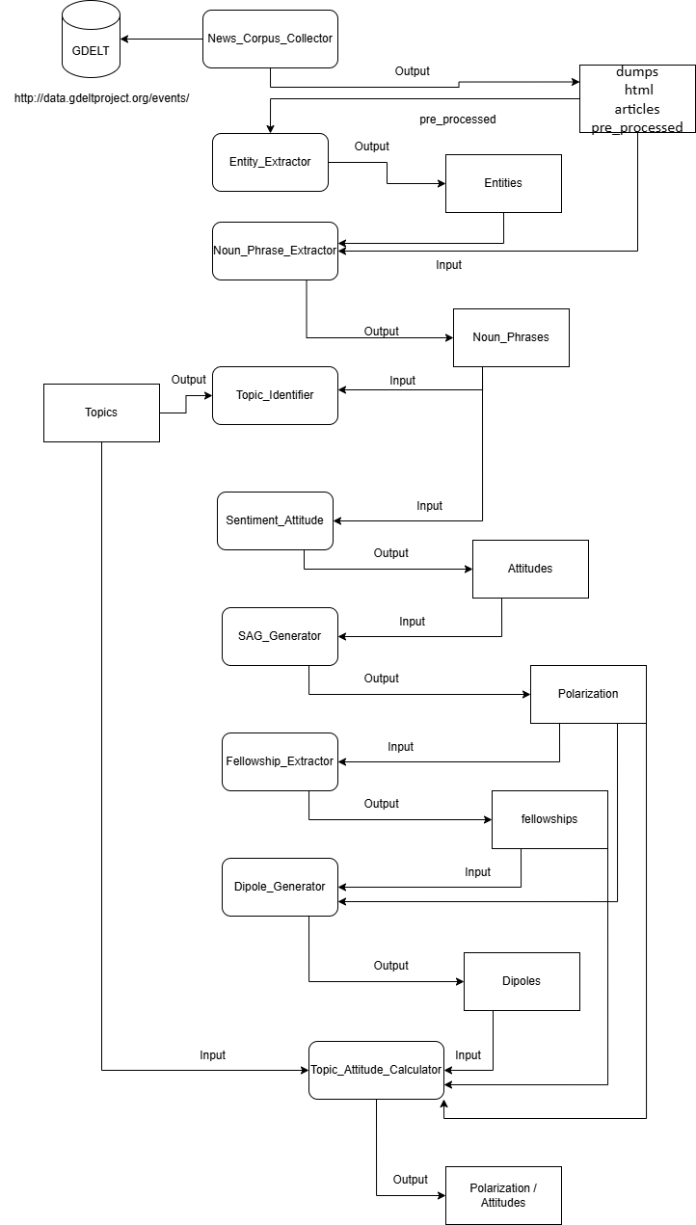
Figure 1 POLAR Pipeline

2.1.1 Overview

POLAR is an unsupervised, large scale framework for modeling and identifying polarizing topics in any domain, without prior domain-specific knowledge, it comprises a processing pipeline that analyzes a corpus of an arbitrary number of news articles to construct a hierarchical model graph that models polarization and identify polarizing topics discussed in the corpus. [ ]

2.1.2 Brief Explanation of Key Steps for our Integration

These Steps are either needed to integrate LLMs into the Polar Pipeline (News_Corpus_Collector, Topic_Identifier) or are the steps planned to be omitted from the pipeline (Entity_Extractor, Noun_Phrase_Extractor, Sentiment_Attitude).

2.1.2.1 News_Corpus_Collector

Articles were collected using topic-specific keywords and date filters, allowing control over corpus size, geographic scope, and relevance. This Class allows for the use of keywords for gathering Articles like max number of articles per request, other variables like actor 1 and 2 country codes, being able to filter the articles by place of origin and most importantly the Start and End Date from which the Articles were published, as well as keywords for the article to contain, these were the noteworthy variables for the scope of this thesis, these fields have to be placed manually, preferably a topic high in Polarization as well as the appropriate Dates for polarizing articles to have been posted.
Examples:
Topic: Brexit -> keywords: 'brexit'
Date: 2016/6 - 7/22 – 10
The Articles are saved as Raw String Json files with this format:
"{\"uid\": \" Filename ",
\"text\": “ Article content “ “}”

2.1.2.2 Entity_Extractor and Noun_Phrase_Extractor

These steps are used in order to extract Named Entities from the set of Articles from the Corpus, it utilizes Named Entity Recognition (NER) [ ] using SpaCy [ ] in order to identify the Entities as well as link them to a Dbpedia link [ ] that matches the entity, it then gathers the noun phrases similarly using SpaCy and cleans them using tokenization and removing stopwords.
These steps are crucial to the Polar Pipeline, however they are error prone and unsupervised, the most common error types being Dictionary Errors and Dependency Parsing Errors.
Dictionary Errors:
this occurs when an NLP component like SpaCy’s NER relies on a fixed lexicon or a static way of assigning components and fails to interpret a word or phrase.
Dependency Parsing Errors:
this refers to a mistake in the syntactical analysis of a sentence, where the parser incorrectly identifies the relationship between words, resulting in incomplete noun phrases and mistaken attitudes.
Example:
entity1: “Howard” -> reference: "http://dbpedia.org/resource/John_Howard"
entity2: "Schneider" -> reference: “http://dbpedia.org/resource/Schneider_Electric”
Sentence: “Participants hold a British Union flag and an EU flag during a pro-EU referendum event at Parliament Square in London Thomson Reuters By David Lawder and Howard Schneider Advertisement WASHINGTON (Reuters)"
Problem: Assigns Howard -> Schneider when Howard Schneider is the full name of the person
Dependency Parsing Error: Incorrectly splits the Entity “Howard Schneider” into 2 subparts “Howard” and “Schneider” and assigns different dbpedia links to them (“John_Howard” and “Schneider_Electric”).
Dictionary Error: Does not correctly link the Entity “Howard Schneider” to a pre-existing dbpedia link, as it does not exist.

2.1.2.3 Sentiment Attitude

This step estimates the sentiment between pairs of entities or noun phrases based on the syntactic paths that connect them in the sentence and then assigns a polarity score to them, being Positive, Neutral or Negative.
It utilizes techniques such as Dependency Parsing via SpaCy, and Lexicon-based sentiment using MPQA [ ]
This step is highly error prone to Dependency Parsing errors, as the entire process hinges on correct dependency parsers.
This is shown by how POLAR predominantly labels most pairs as Neutral when the pairs are uncertain or ambiguous or face high syntactic complexity, we will go through more in depth in the Results & Analysis section.
Example of Dependency Parsing Error:
entity1: "U.S. monetary policy" -> reference: “http://dbpedia.org/resource/Monetary_policy_of_the_United_States”
entity2: "British" -> reference: “http://dbpedia.org/resource/United_Kingdom”
Sentence: " A vote by Britons to leave the European Union on Thursday may not drag the United States into recession, but its effects on U.S. monetary policy, trade and corporate profits are causing concern in Washington D.C. and boardrooms alike."
attitude: “Positive”
Problem: Attitude is labeled Positive however the Sentence describes how it is causing concern about it’s effects possibly going into a recession, this should be a Negative Pair

2.1.2.4 Topic_Identifier

This class performs automatic topic clustering by analyzing the noun phrases extracted from the articles. Its main job is grouping semantically similar noun phrases together into clusters, based on the sentence embeddings and calculated cosine similarity using Sentence Transformers[ ].
Outputs the calculated Topics as a compressed Json file, necessary for linking the Attitudes to the calculated pairs in the Topic_Attitude_Calculator.

In the following chapters, we present our modifications to the POLAR pipeline, replacing the traditional NLP modules described above with a unified, LLM-driven extraction approach

Chapter 3

Methodology

3.1 Modified Polar Pipeline
3.2 Steps in Depth Analysis
3.2.1 Article Gathering
3.2.2 Article Splitting
3.2.3 LLM Communicator
3.2.3.1 Request Format
3.2.3.2 Code Structure
3.2.4 LLM Authenticator
3.2.5 Attitude_Normalizer
3.2.6 LLM_To_Attitudes / LLM_To_Noun_Phrases

3.1 Modified Polar Pipeline
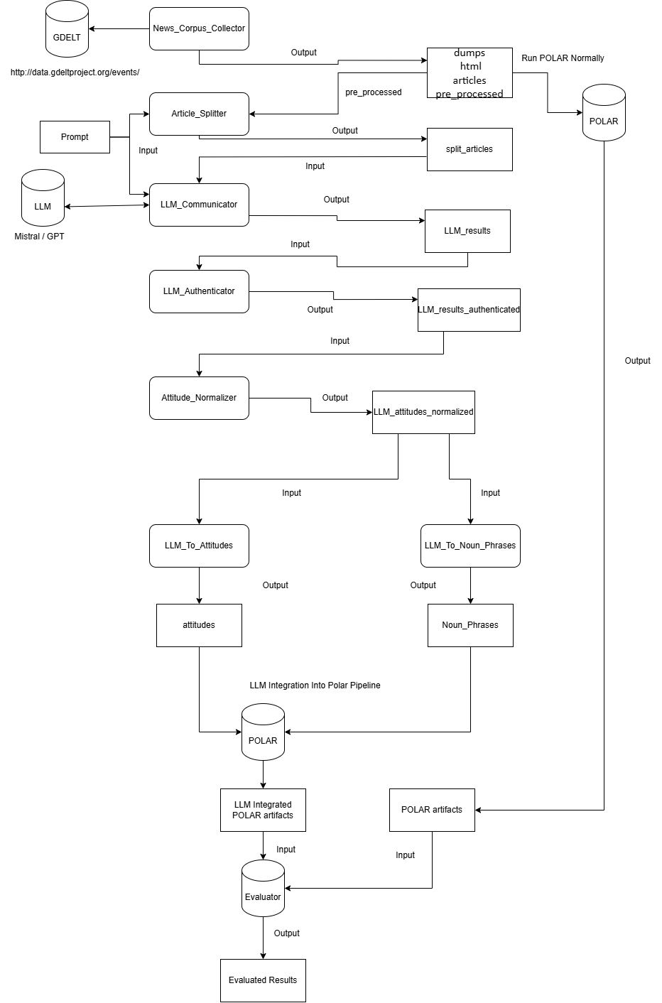
Figure 2 LLM Integrated POLAR Pipeline

3.1.1 Overview and Explanation

The Process begins with Gathering Articles that fit a likely Polarizing topic using Polar’s News Corpus Collector, which based on a set of keywords gathers the articles that match the keywords from the GDELT Database [ ] and pre-processes them into Json files with their name matching their URL.
The Articles are then processed by a simple algorithm that attempts to cut the Articles so that they all fit into the LLM’s Window Size without hitting it’s limit, thus they are split if necessary into Article Parts, so that the LLM Prompt + the Article Part do not exceed the window size.
The newly Split Articles are then processed into a Request for the LLM with the content being the Prompt which explains in detail to the LLM all of the instructions followed by the Article Part for the analysis. The request is processed and responds with a Json formatted file with all of the necessary data.
The files are then analyzed for any malformed files or non Json formatted requests and cleans them if possible.
After that the attitudes are normalized so that multiple mentions of an entity/topic is clustered accordingly even if their names aren’t a direct match.
The files are then reformatted into Noun_Phrases and into Attitudes, 2 outputs created by Polar and that are necessary for the implementation into the Polar Pipeline.

3.2 Steps in Depth Analysis

3.2.1 Article Gathering

This step is identical to Polar’s News_Corpus_Collector, see Chapter 2, Section 2.1.2.1.

3.2.2 Article Splitting

This code processes a set of articles and splits them into Parts small enough to fit into a model’s maximum token limit, taking into account a fixed prompt that will be added onto it. It uses 2 types of models for tokenizing that depend on the model of the LLM, OpenAI models like GPT use tiktoken encoding while HuggingFace models like Mistral use AutoTokenizer.
These tokens are used to accurately count the maximum window size measured in Tokens using the built-in functions of tiktoken (tiktoken.encode()) and AutoTokenizer (tokenizer.tokenize())[ ].
Once the maximum window size is reached, so once the available tokens + the prompt tokens reach the window size limit, the code uses LangChain to split the articles based on character count, so that it tries to preserve the sentences and words as much as possible in each part, prioritizing paragraph breaks and sentence breaks [ ]. As such the Part is split, assigning Part {i} into it’s filename and keeping the “uid” field and having the split article part in the “text” field.

3.2.3 LLM Communicator

This code takes as input the LLM to request, the Prompt for the LLM as well as the split articles. The prompt consists of detailed instructions and a set of rules for the LLM to follow for our particular case, which is gathering Polarization between Entities, as well as Polarization between Entities and Topics in articles.

3.2.3.1 Request Format

It also consists of a OneShot example for the LLM to be able to easily format its output and boost consistency in its replies, the OneShot example containing as follows:
{ 'topical_attitudes': [ {
'source' : { 'entity' : 'Donald Trump' , 'references' : ['Donald Trump']},
'target' : { 'topic' : 'mask mandate' , 'references' : ['usage of masks']},
'justifications' : [ 'constantly pushing against the usage of masks. '],
'attitude' : 'Negative' }],
'entity_attitudes': [ {
'entity1' : { 'entity' : 'Dr. Anthony Fauci' , 'references' : [ 'Fauci' ]},
'entity2' : { 'entity' : 'Donald Trump' , 'references' : [ 'Donald Trump' ]},
'justifications' : [ 'Donald Trump was in disagreement with Fauci' ],
'attitude' : 'Negative' } ]}

Where the entities and topics as well as the justifications are found in the Sentence / Article provided, it is left onto the LLM to find these pairs and assign onto them the attitude it thinks is accurate.

3.2.3.2 Code Structure

The Code iterates through all of the Article Parts and Sequentially or in Parallel depending on the input, constructs the payload of each Article Part, the payload being the Prompt followed by the text field from the Article, essentially telling the LLM the structure it wants to process the Article, it then sends the request to the LLM with a temperature of 0.2 (Temperature is set low in order to have less variance and some consistency in the outputs, minimizes randomness of responses), and awaits its response which it saves to the Output Directory in the same directory structure as Polar.
Important to note that each request made to the LLM is a Stateless Request, as each Article Part gets its own dedicated request, a small optimization could have been to detect whenever an Article was split by the Article_Splitter and have a Stateful Session for that Article only, this was avoided in order to make the code more easily parallelizable by making each request independent.

3.2.4 LLM_Authenticator

This code Iterates over the responses from the LLM and confirms whether or not the replies are proper Json format, and if not attempts to fix them, otherwise omitting them.
Firstly it checks whether the responses start with “```json” and end with “```”, this is a common pattern for chat based UIs (like ChatGPT, Github, Discord etc.), as it triggers syntax highlighting and preserves formatting, however for our case since we use an API we need to strip it.
It also checks whether the reply is actually a Json formatted reply, omitting additional comments made by the LLM if any, and omitting the file entirely if it isn’t formatted correctly.

3.2.5 Attitude_Normalizer

This code gathers all the attitudes calculated from the LLM_Authenticator and processes their reference field, which references the appearance of the entity/topic in the article, and attempts to normalize them so that each mention of them in all the articles match.
It does so by checking every mention and utilizing Semantic Similarity and some manual aliasing to attempt to have less noise in the later steps of the pipeline.

3.2.6 LLM_To_Attitudes / LLM_To_Noun_Phrases

These codes are simple and do a similar task, they iterate over the authenticated responses from the LLM and convert the data to the appropriate Polar data format needed (Attitudes / Noun_Phrases) from the response of the LLM, the Attitudes field is required to continue with the Framework and the Noun_Phrases are required for the topics.json.gz generation, which is an earlier step in the Polar pipeline.

With all components in place, the LLM-integrated pipeline was evaluated against POLAR and fine-tuned Mistral, as described in Chapter 5.

Chapter 4

Large Language Models and Mistral

4.1 LLMs Attempted
4.1.1 GPT-3.5-turbo
4.1.2 Deepseek
4.1.3 Llama
4.1.4 Mistral
4.2 Mistral Fine-Tuning
4.2.1 LoRa (Low-Rank Adaptation)
4.2.2 Fine-Tuning Dataset
4.2.3 Fine-Tuning Process

4.1 LLMs Attempted

While attempting to run the LLM Integrated pipeline, we tried these options by modifying the payload, variables and window size as well as any API needed. The LLMs tested were all used during the LLM Communicator part of the our Methodology Pipeline, see Chapter 3.2.3.

4.1.1 GPT-3.5-turbo

The main LLM used and the one in which of the data was gathered was by using GPT-3.5-turbo [ ] through the API provided by a reverse proxy through Docker [ ].
For our calculations, GPT was used as the benchmark for the other LLMs, as it followed the prompt well and gave concise responses that accurately predicted entity pairs and topical pairs if it detected any in the articles. The speed of the replies of GPT were also the highest in terms of the LLMs, mostly due to the fact it was called via an API, which also allowed for some Parallel calling, the Numbers being as follows:
Dataset of 563 Article Parts:
-GPT_Communication Elapsed time: 10280.43 seconds == 171.34 minutes == 2.856 hours
Polar:
-entity_extractor Elapsed time: 640.87 seconds
-noun_phrase_extractor Elapsed time: 4545.63 seconds
-topic_identifier Elapsed time: 1226.28 seconds
-sentiment_attitude_pipeline Elapsed time: 239.86 seconds
-load_sentiment_attitudes Elapsed time: 2.89 seconds
-> 6653.53 seconds == 110.89 seconds == 1.848 hours

Polar was faster for the dataset when compared to a sequential model of requesting the API of GPT, with each GPT request taking about 18 seconds with around 5 seconds of standard deviation, since the request is directly tied to the length of the article and the Entity/Topical Pairs detected, from our experience, the code is partially parallelizable and it overall decreases the overall time needed, however runs the risk of blocking the API with too many calls depending on the requests per second.

4.1.2 Deepseek

The other LLM attempted which yielded promising results was the currently newly implemented Deepseek [ ]. For the use of Deepseek we opted to install it locally from the HuggingFace database via Ollama [ ] and have managed to setup up to Deepseek-8b, due to VRAM constraints.
Using the same technique used in GPT with the same format, Deepseek returned very similar results that were properly structured as specified by the prompt, while also being fully localized, however the time per Article was tanked as a result:
-Average time required Per Article Part: 900 - 1050 seconds == 15 - 17 minutes
An attempt was made to Parallelize the code to test whether it would help, however since it was being run locally on the device, the overall time did not improve:
-Average time required Per Article with 4 Threads, where each Thread operates on each own Article: 2700 – 3500 seconds == 45 – 58 minutes
Due to the time required per article, we did not further pursue using Deepseek, even if the short number of Articles parsed were satisfactory.

4.1.3 Llama

A small attempt was made to utilize Llama, we tried to install it locally through the meta instructions [ ] but were unsuccessful, we then attempted to use Llama through Groq [ ] by using their API service.
The results from Llama were unsatisfactory, with the LLM often not following the prompt instructions well as well as not outputting in Json format most of the time, the Groq API also would also limits it’s service to about 300 Articles, limiting its usage.

4.1.4 Mistral

We also tried to Use Mistral, which at first was unsatisfactory, however after fine-tuning it with GPT’s outputs, it became satisfactory, almost replicating GPT’s outputs, Evaluation results shown in later Chapters.

4.2 Mistral Fine-Tuning

To enable local, lower-latency and independent inference with similar behavior to the GPT-based entity attitude extraction, we chose to use the Mistral-7B Language Model [ ].
Mistral was selected for its model quality, ease of access and compatibility and ease of access with quantization and parameter efficient fine-tuning methods, such as LoRa (Low-Rank Adaptation) [ ] . It also offers strong performance among open-weight models.
The actual fine-tuning process was conducted using Unsloth [ ], which is a library that utilizes fast LoRa training on HuggingFace models like Mistral.

4.2.1 LoRa (Low-Rank Adaptation)

LoRA is a parameter-efficient fine-tuning method that reduces training cost by freezing most of the model's weights and only training small low-rank matrices injected into select layers, as such LoRa was applied to key attention projection layers in the Mistral model.
This setup significantly reduced memory usage and training time, making fine-tuning feasible within the constraints of a single GPU.

4.2.2 Fine-Tuning Dataset

The training dataset consisted of a custom JSONL dataset containing the valid and authenticated responses gathered from the GPT 3.5 model, the responses were from varying Polarizing Topics (Brexit, Elon Musk (Twitter), France Olympics 2024, Vaccines (2020)).
Each example followed an instruction-based prompt format modeled after the Alpaca instruction-tuning template[ ]. Each entry followed this structure:
{“instruction”: “Extract attitudes between entities and topics from the article in json format and categorize them [Positive, Neutral, Negative] and justify them quoting the article”,

“input”: Article Part text ,
“output”: The GPT response to the Article Part in input }
Where “Instruction” is an instruction given to the LLM before receiving any input from the user, it sets its expected input and what to reply with.
The “input” field is the input given by the user, in this case the user needs to only request with an article, no prompt needed.
The “output” field is the Model’s output to the request.

In order to enrich the Fine-Tuning, an additional external polarization focused dataset was added to the Jsonl file [ ] , containing a different Instruction than the GPT instructions, in order to enrich the Model’s output for shorter prompts.
The new dataset followed a format like so:
{"instruction": "Extract attitudes in json format",
“input”: General Sentences/paragraphs to be deciphered,
“output”: Model’s expected output in Json format}
Following this format, 2018 Instructions were gathered from our requests with GPT with the Topics mentioned, along with 1744 General instructions by the added dataset.

4.2.3 Fine-Tuning Process

We performed lightweight fine-tuning using the Unsloth library, which simplifies the process of LoRa and 4-bit quantization.
We began by loading a quantized version of Mistral-7B (unsloth/mistral-7b-bnb-4bit) and applied LoRa by injecting trainable adapters into key transformer modules.
Our Dataset was formatted using the Alpaca-style instruction format, being: “instruction”, followed by “input” and expected “output”, which worked for both our dataset, as well as the added dataset of General Instructions.
Then we called the Hugging Face SFTTrainer [ ] to run the training process, leaving a small subset of the training data as test cases to test whether the model successfully replicated the results.
After the training had concluded, the model was stored locally by saving the LoRa Weights, and being able to load them effectively whenever the fine-tuned model needed to be used.

Chapter 5

Evaluation

5.1 Overview and Objectives
5.2 Evaluation Pipeline
5.3 Metrics Used

5.1 Overview and Objectives

This chapter outlines the methodology used to evaluate the different systems designed to extract and represent polarization, including the fine-tuned Mistral model, the original LLM Integrated POLAR Pipeline, and the standard POLAR system.
The goal of this evaluation is to determine how well each system can identify relevant Entity-Topic / Entity-Entity relationship pairs and predict their associated attitudes and justifications for said Attributes and pairs.
Given the inherently subjective and interpretative nature of polarization, traditional classification metrics are complemented by semantic and qualitative analyses as well as further analyses and measures in Chapter 6.

5.2 Evaluation Pipeline
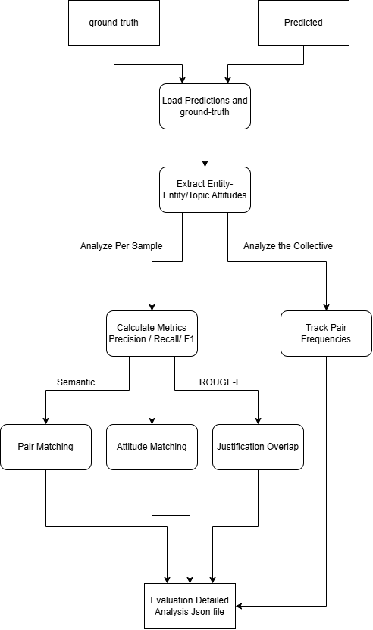
Figure 3 Evaluation Pipeline

To systematically compare systems, we designed a modular evaluation pipeline. Figure 3 illustrates the sequence of steps applied to each pair of ground-truth and predicted Json files:

- Load Data: Import and parse the files of both the ground-truth and predicted set into Json structure and order them such that each entry of the predicted and ground-truth set refer to the same Article.
- Pair Matching: Identify Entity-Topic and Entity-Entity pairs in both sets, and calculate matches using Semantic Similarity with Sentence Transformers [ ] , comparing each pair from the predicted set with each ground-truth pair, until a match is found or it checks every pair, repeating for each predicted pair. A matched pair being considered when both Source Entities match and both Target Entities/Topics match, using a threshold of 0.7.
Example matches using Sentence Transformers:
Matching Topic Pair: (Britain, United Kingdom)
Matching Topic Pair: (Ukraine, Kyiv)
Matching Entity Pair: (Tony Blair, British prime minister)
Matching Entity Pair: (Trump, Donald Trump)
Matching Entity Pair: (Britain, France)
Matching Topic Pair: (Germany, Russia))
- Attitude Comparison: For all matched pairs, compare the predicted attitude (Positive, Negative, Neutral) against the ground truth, considering the matches as True Positive and the wrong predictions as False Negatives.
- Justification Evaluation: For all matched pairs, ROUGE-L [ ] is called to compare textual overlap between predicted and true justifications, considering matched Sentences those whose overlap reaches a threshold of 0.5.
ROUGE-L is a metric that measures how similar two sequences of text are based on their Longest Common Subsequence (LCS), considering that if two pieces of text share a long ordered subsequence of words, they are semantically, or structurally similar, with a higher ROUGE-L score indicating greater textual alignment. Especially in our case, since the LLMs and POLAR quote the Article directly in the justification field, if they have similar subsequences, they are likely referring to the same sentence from the Article.
- Pair Frequency Analysis: Count the number of unique Entity-Topic and Entity-Entity pairs and count each of their appearances in both the ground-truth and the Predicted Set. It does so by Normalizing the fields:
Lowercasing the fields
Removing Punctuation like commas and periods
Singularizing the fields, turning plural nouns into singular
Lemmatizing the fields, converting words to their basic forms
Manually aliasing certain words (trump->donald trump, eu->european union)
This is done so in order to more accurately cluster mentions of certain entities throughout multiple Articles and group up certain similar topics.
This showcases the appearance rate of each pair, as well as the frequency of which it is assigned each attitude by both models.

5.3 Metrics Used

Pair Matching Metrics
To assess how well the Predicted dataset identifies the ground-truth Entity-Topic or Entity-Entity pairs, we compute:
- True Positives (TP): Pairs present in both predicted and true sets and correctly matched.
- False Positives (FP): Pairs present in predictions but not in the ground truth.
- False Negatives (FN): Pairs present in ground truth but missed by predictions.
Using these metrics we can calculate:
- Precision: Precision = TP / (TP + FP). Measures the accuracy of the predicted pairs, whenever the prediction detects a pair, how often it is found in the ground-truth.
- Recall: Recall = TP / (TP + FN). Measures the model's coverage of all relevant pairs, shows the percentage of missed pairs undetected from the ground-truth.
- F1 Score: F1 = 2 * (P * R) / (P + R). Harmonic mean of Precision and Recall.

Attitude Prediction Metrics
For all matched pairs, we evaluate the similarity of their Attitude Sentiment:
- True Positives (TP): Sentiment Attitude of Predicted pair matches ground-truth pair
- False Negatives (FN): Sentiment Attitude of Predicted pair does not match ground-truth pair
Using these metrics we can calculate:
- Accuracy: TP / TP + FN. How accurate the Predicted model is at matching the ground-truth model.

Justification Overlap
For all matched pairs, we use ROUGE-L to calculate the textual alignment between the two models and see whether it reaches the threshold (0.5) to be considered a match, using these metrics:
- Matched Justifications (MJ): The ROUGE-L score calculated reaches the threshold, the justifications match.
- Total Justifications (TJ): All the Justifications present in the Matched Pairs.
As such we can calculate:
- Justification Overlap: MJ / TJ. The percentage of the Total Justifications that were successfully matched between both pairs.

Chapter 6

Results And Analysis

6.1 Overview
6.1.1 What is being evaluated
6.1.2 Metrics and qualitative measures used
6.2 POLAR Compared to LLMs
6.2.1 Attitudes Comparison
6.2.1.1 Attitudes Evaluation
6.2.1.2 Attitude Comparison Conclusion
6.2.1.3 Discussion
6.2.2 Further analysis
6.2.2.1 Overall Attitude Summary
6.2.2.2 Overall Attitude Summary Conclusion
6.2.3 Attitude Analysis Conclusion
6.2.4 Topics and Pair Frequency Comparisons
6.2.4.1 Topics
6.2.4.2 Pair Frequency
6.3 POLAR Pipeline End Result Comparison
6.3.1 Fellowships
6.3.2 SAG (Signed Attitude Graph)
6.3.3 Attitude Dipoles
6.3.4 Conclusion
6.4 Fine-Tuned Mistral Evaluation
6.4.1 Evaluation
6.4.2 Conclusion

6.1 Overview

6.1.1 What is being evaluated

This chapter evaluates the artifacts produced by integrating Large Language Models (LLMs) into the POLAR pipeline. Specifically, it assesses how well GPT-3.5 and a fine-tuned Mistral-7B model replicate or improve upon POLAR’s traditional NLP pipeline. The artifacts evaluated include Entity and Topical attitudes, Signed Attitude Graphs (SAGs), Fellowship groupings, Topic coverage, and Attitude Dipoles, on the following systems:
- POLAR: The baseline pipeline using conventional NLP tools.
- GPT-3.5: A large language model used as a drop-in replacement for several POLAR components.
- Fine-tuned Mistral-7B: An open-weight language model trained to replicate GPT-3.5’s outputs and evaluated for fidelity, efficiency, and practical deployment advantages.

6.1.2 Metrics and Qualitative Measures Used

Evaluation metrics were computed over the subset of articles for which both the GPT-generated ground truth and the Mistral predictions produced valid Json structured outputs. This excluded any malformed responses from both GPT and Mistral for their respective datasets.
Pair matching and attitude evaluation were performed on a per-article basis, with each sample evaluated independently. As such, the same entity or topic pair may appear multiple times across the dataset and is evaluated separately in each occurrence.
Metrics:

In the context of Pair Matching:
“True Positive” : X number of pairs from the Predicted Dataset were matched with pairs from the Ground Truth Dataset
“False Positive” : X number of pairs were found Only in the Predicted Dataset and were not included in the Ground Truth Dataset
“False Negative” : X number of pairs were found Only in the Ground Truth Dataset and were not included in the Predicted Dataset
In the context of Attitude Matching:
“True Positive” X number of Attitudes were correctly predicted to the Ground Truth Attitude
“False Negative” : X number of Attitudes were incorrectly predicted to the Ground Truth Attitude
In the context of Justification Overlap:
Overlap: How similar the model’s justification for the Pair/Attitude were, using ROUGE-L [ ] for the calculation of the similarity with a threshold of 0.7 to be considered matched.

6.2 POLAR Compared to LLMs Evaluation

This section will focus on the evaluation of the GPT Integrated Pipeline when compared to the Standard POLAR pipeline.

6.2.1 Attitudes Comparison

6.2.1.1 Attitudes Evaluation

In this section of the evaluation, we aimed to assess the extent to which the POLAR system
could replicate the Attitudes field generated by a large language model (LLM), specifically
GPT-3.5. The Attitudes field comprises entity or topic relationships and the corresponding
sentiment classification (Positive, Neutral, or Negative). The goal was to analyze the degree of
similarity between the attitudes identified by POLAR and those generated by GPT-3.5 for the
same input samples.
To conduct this comparison, we designated GPT-3.5’s output as the reference (or ground truth)
and applied POLAR to the same dataset, which consisted of approximately 404 article segments.
The Attitudes fields produced by POLAR were then treated as predictions and compared against
the GPT-3.5 outputs to evaluate alignment and divergence.
Evaluation - Polar completed in 395.37 seconds. (~6.59 minutes)

“Entity”
Pair Matching
Precision | 0.0787
Recall | 0.0295
F1 | 0.0429
True Positives | 20
False Positives | 234
False Negatives | 658

Attitude Prediction
Accuracy | 0.35
True Positives | 7
False Negatives | 13

Justification Overlap
Overlap | 0.1379
Matched Justifications | 4
Total Justifications | 29

From this data, we can see that from the evaluated dataset, POLAR Successfully manages to predict 20 pairs from the 678 pairs in the Ground Truth dataset == roughly 2.95% of the pairs in Ground Truth were accurately predicted.
Of those 20 pairs, 20 attitudes were compared between the Ground Truth and the Predicted Dataset, with POLAR correctly predicting 7 of them == roughly 35% pairs were correctly attributed.
Of those 20 pairs, the justification was successfully matched using ROUGE-L similarity roughly 13.79% of the time.

“Topical”
Pair Matching
Precision | 0.0300
Recall | 0.0528
F1 | 0.0383
True Positives | 44
False Positives | 1422
False Negatives | 789

Attitude Prediction
Accuracy | 0.1591
True Positives | 7
False Negatives | 37

Justification Overlap
Overlap | 0.0
Matched Justifications | 0
Total Justifications | 0

From this data, we can see that from the evaluated dataset, POLAR Successfully manages to predict 44 pairs from the 833 pairs in the Ground Truth dataset == roughly 5.28% of the pairs in Ground Truth were accurately predicted.
Of those 44 pairs, 44 attitudes were compared between the Ground Truth and the Predicted Dataset, with POLAR correctly predicting 7 of them == roughly 15.91% pairs were correctly attributed.
The Justification Overlap was overlooked for the Topical case here since POLAR does not provide a Sentence for its Noun_Phrase_Attitudes, which are what the Topical Pairs here are.

6.2.1.2 Attitude Comparison Conclusion

From these results, POLAR and GPT, in terms of a per-article basis, have widely different results each, with POLAR failing to emulate GPT’s output.
in terms of Entity Pairs, POLAR matched 20 of its 254 results to GPT, this shows that POLAR is more conservative with what it considers an Entity Pair, when compared to the 678 GPT results. From the Precision we can see that when a POLAR Entity Pair is calculated, it will match GPT 7.87% of the time.
However, the Topical Pairs calculated by POLAR are nearly double GPT’s, with 1466 vs 833 respectively, however only managing to match 44 of them (5.28%), given the precision, we see that when a POLAR Topical Pair is calculated, it will match GPT 3.00% of the time.
In terms of Attitude Prediction and Justification Overlap for the matched pairs, POLAR is also dissimilar to GPT, only having 15-35% similar Pair Attitudes with only roughly 13-14% Justification Overlap.

6.2.1.3 Discussion

These results do Not tell us that POLAR is a worse model than GPT, or vice versa. All this means is that fundamentally, for a per-article basis, these models are completely different in what they consider Pairs and calculating Attitudes.
The issue regarding comparing the calculated Attitudes for a line of text, is that there is no inherent “Absolute”, or “Correct” amount of Pairs to expect these models to output, the same can be said about the attitude between the Entities/Topics to be calculated merely through text.

6.2.2 Further analysis

From an initial comparison, the models differ drastically when comparing their results per article, however we wanted to see their results Overall as well as compare their results in different parts of the POLAR pipeline instead of just their Sentiment Attitude Assignment.

6.2.2.1 Overall Attitude Summary

These graphs show the Overall number of Positive/Neutral/Negative attitudes that GPT assigned to the pairs, as well as the Seaborn Graph [ ] showcasing the amount of those attitudes assigned for each sample, where each Dot corresponds to one Sample.

Training Dataset:

“True_Data”(GPT):
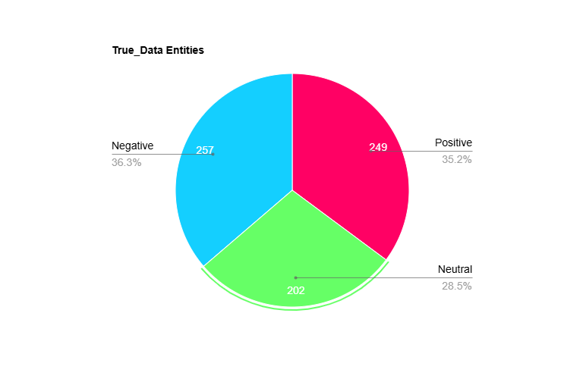
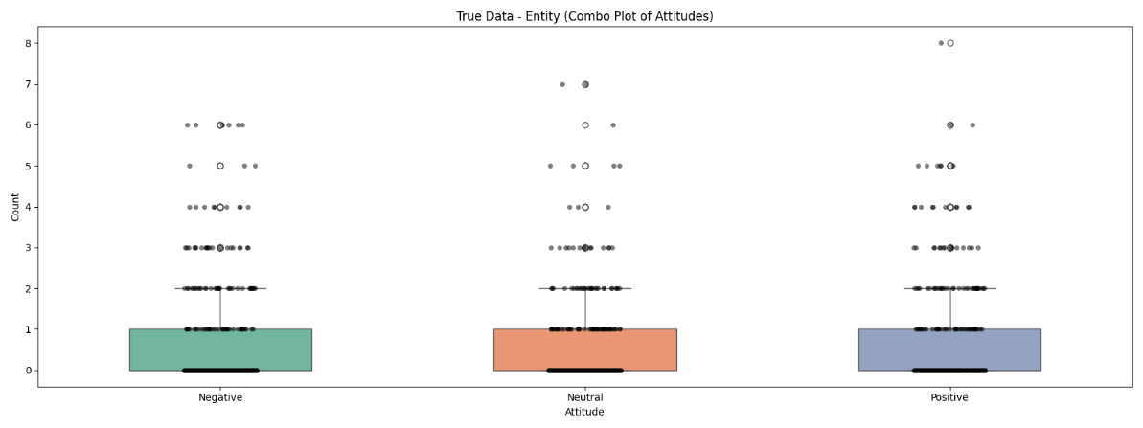
These Graphs show us that for this dataset comprising of Articles from multiple topics, GPT covers both Positive/Neutral/Negative consistently in terms of Entity Pairs, averaging 0-1 of each per Sample with the highest number of assigns being 8 Positive for a single Sample.
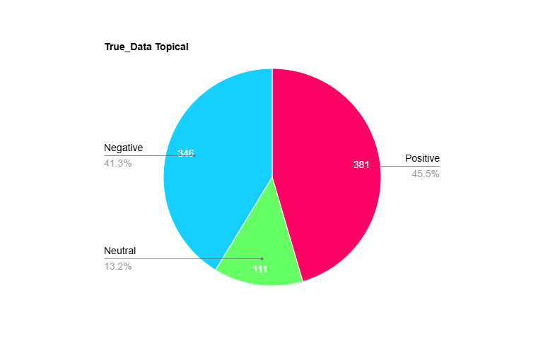
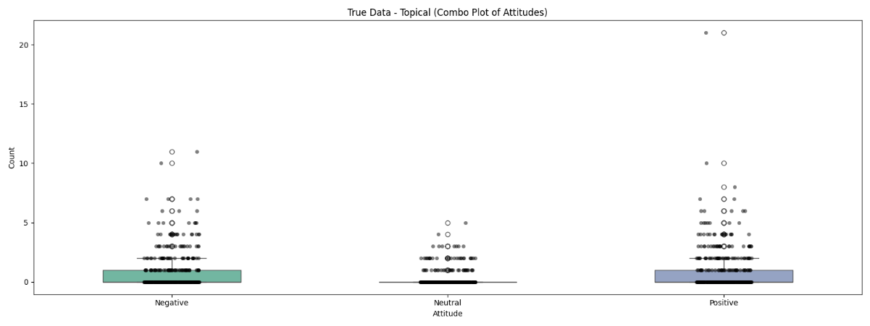
These Graphs show us that for Topical Pairs, GPT covers both Positive /Negative consistently with a few Neutral assigns, averaging 0-1 of each per Sample except Neutral with the highest number of assigns being 20 Positive for a single Sample.

“Pred_Data” (POLAR):
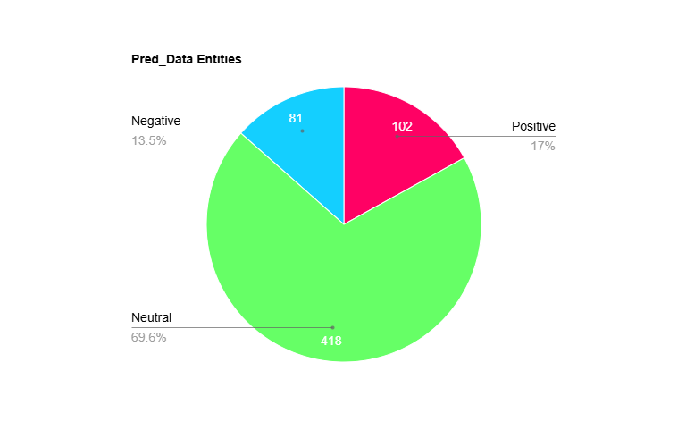
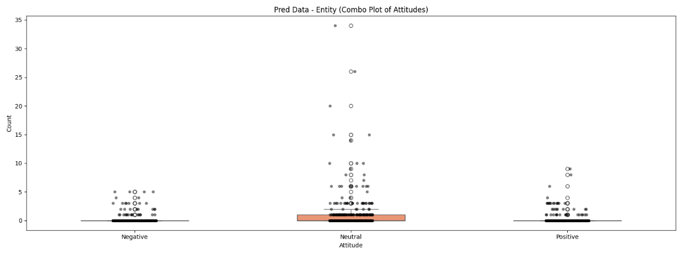
These Graphs show us that for Entity Pairs, POLAR covers a large majority of Neutral pairings, with some Positives/Negatives, averaging ≈0 Positive/Negative and 0-1 Neutral assigns per Sample, with the highest being 35 Neutral assigns for 1 sample.
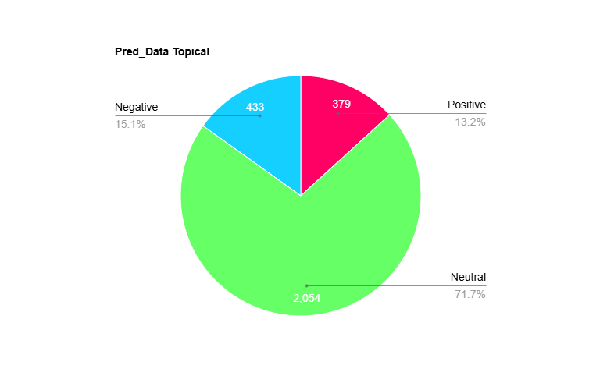
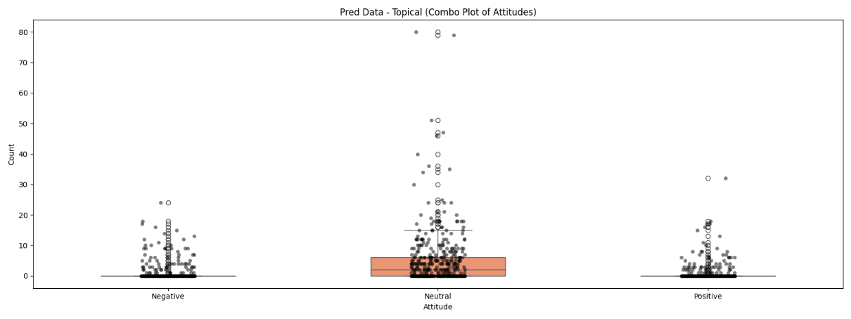
These Graphs show us that for Topical Pairs, POLAR covers a large majority of Neutral pairings, with some Positives/Negatives, averaging ≈0 Positive/Negative and 0-7 Neutral assigns per Sample, with the highest being 80 Neutral assigns for 1 sample.

Brexit Dataset:
An additional analysis was conducted on a dedicated dataset of a polarizing topic, Brexit of around 770 Article Parts, to see whether the models captured the polarizing and mostly negative responses to that topic.
However due to an oversight as well as later resource and time constraints, these Articles were all written in the U.S., this does not change the evaluation however it is important to note, as it shows clear preference to U.S. Figures.

“True_Data” (GPT):
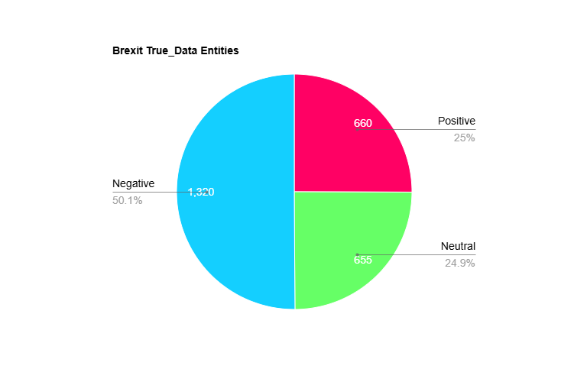
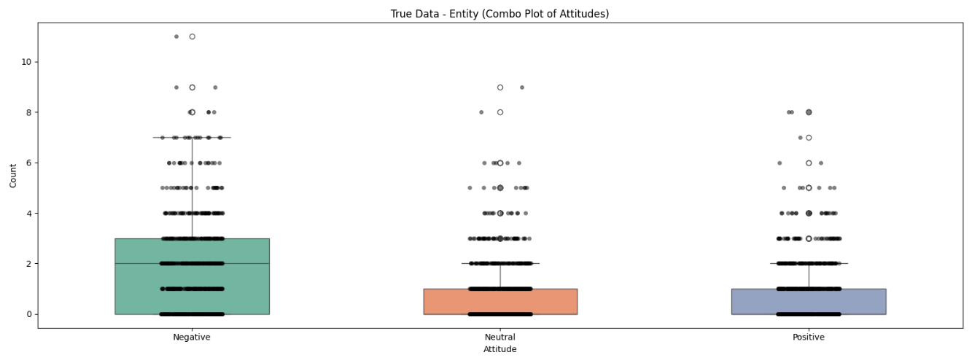
These Graphs show us that for the Brexit dataset, Entity Pairs, GPT covers a majority of Negative pairings, with some Positives/Neutral, averaging 0-1 Positive/Neutral and 0-3 Negative assigns per Sample, with the highest being 11 Negative assigns for 1 sample.
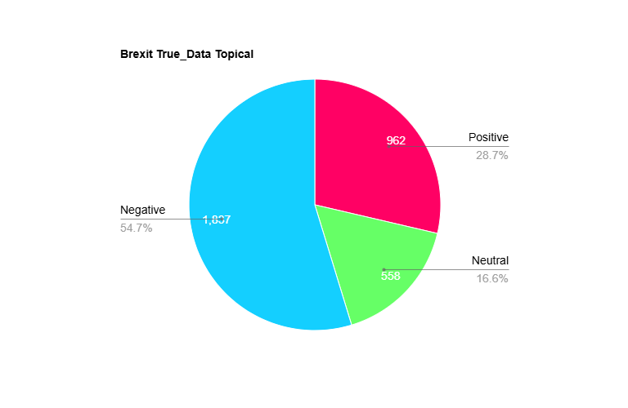
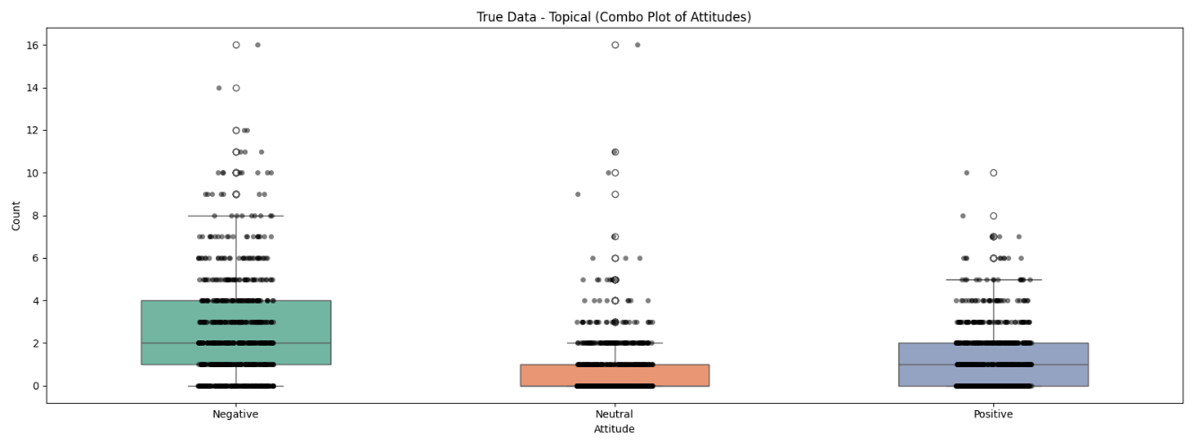
These Graphs show us that for Topical Pairs, GPT covers a larger majority of Negative pairings, with some Positives/Neutral, averaging 0-1 Neutral, 0-2 Positive and 1-4 Negative assigns per Sample, with the highest being 16 Negative assigns for 1 sample.

“Pred_data” (POLAR):
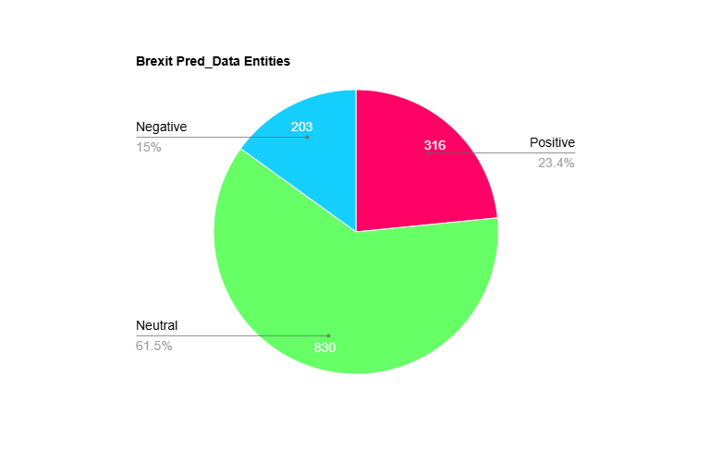
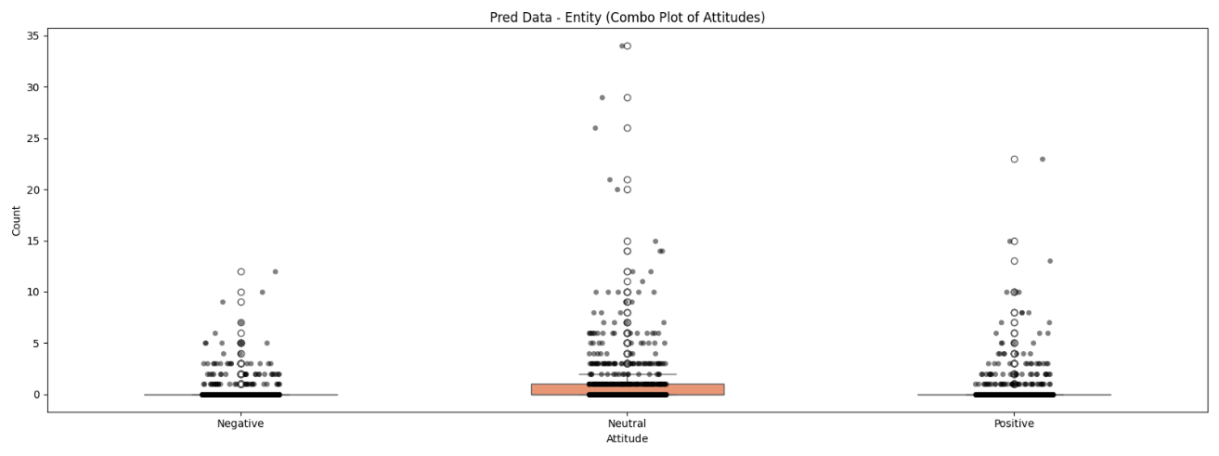
These Graphs show us that for Entity Pairs, POLAR covers a majority of Neutral pairings, with some Positives/Negative, averaging 0-1 Neutral and ≈0 Negative/Positive assigns per Sample, with the highest being 34 Negative assigns for 1 sample.
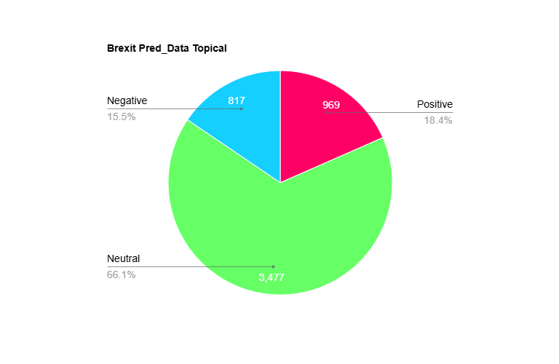
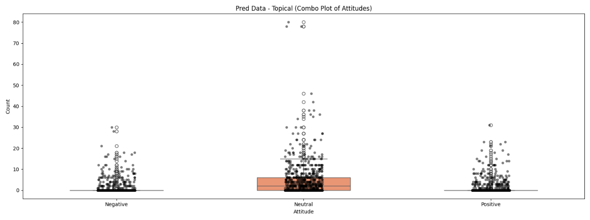
These Graphs show us that for Topical Pairs, POLAR covers a majority of Neutral pairings, with some Positives/Negative, averaging 0-7 Neutral and ≈0 Negative/Positive assigns per Sample, with the highest being 80 Negative assigns for 1 sample.

6.2.2.2 Overall Attitude Summary Conclusion

The results in this section highlight a clear divergence in attitude assignment between GPT and POLAR, across both datasets a consistent pattern was shown:
- GPT distributes Positive/Neutral/Negative attitudes with high granularity and diversity, adapting its usage to the tone and context of each sample.
- POLAR, instead, exhibits a dominant bias toward Neutrality, frequently assigning Neutral to pairs, whereas GPT infers more polarized relationships
This is shown due to the structural limitations of POLAR, being error-prone to dependency parsing errors as well as sentiment scoring through pre-existing lexicons, which fail at more nuanced or complex sentences.

Training Dataset:
In the General training dataset comprising of multiple non-organized likely polarizing topics.
- GPT assigned Positive/Neutral/Negative ratings in an organized fashion that reflects general diversity between articles, such as praise, criticism, disagreement etc.
- POLAR however assigned Neutral to the overwhelming majority of both Entity and Topical pairs, with the Average Positive/Negative rating per Article averaging at ≈0 for both, whereas the Neutral ratings averaging 0-1 to 0-7 instead.

Brexit Dataset:
The Brexit dataset served as a biased test case, since Brexit related discourse is inherently polarizing and often emotionally charged, leading people to feel strongly about either side of polarity.
- GPT’s responses reflect this polarity, assigning a strong majority of the pairs as Negative, for both Entities and Topics, followed by a smaller majority of them being Positive for Topics and even with Neutral assignments for Entities.
- POLAR, on the other hand, continued its overwhelming Neutral dominant pattern, with no clear sign of preference to Negative attitudes unlike GPT’s responses. This is likely due to dependency errors or a lack of coverage by the sentiment lexicon (mpqa)
This shows that POLAR tends to underestimate Negativity in politically charged datasets, which impacts its general applicability to stance detection for Entities, mapping controversies etc.
Either this or POLAR failed to find any emotionally intensive Pairs or polarizing relationships within this dataset, however this is proven false from Section 6.2.4

6.2.3 Attitude Analysis Conclusion

These results demonstrate that while POLAR’s Sentiment Extraction provides a structured and interpretable approach, it can drastically underrepresent polarity in real world articles.
LLMs like GPT and Mistral can significantly improve on this aspect of Sentiment Extraction, offering a richer and more descriptive Attitude analysis as well as context-awareness when evaluating Attitudes.

6.2.4 Topics and Pair Frequency Comparisons

To analyze a broader range of comparisons between POLAR and GPT, the Topics extracted through the Pipeline were compared, which is an independent step from the Sentiment Attitudes.
We also analyzed the Pair Frequency of the Brexit Dataset for both POLAR and GPT to see through a broader scope whether the models identified similar pairs and their calculated attitudes.

6.2.4.1 Topics

In this section we compared the Topics file generated by the Topic_Identifier step of the POLAR Pipeline, see Chapter 2, Section 2.1.2.4, this was done by treating the Topics in the Topical Pairs as Noun_Phrases and reformatting them to generate the topics.json.gz.
We compared the LLM integrated topics file with the normal POLAR topics file.
These Comparisons were done on the Brexit Dataset.
Recall | 0.7294
True Positives | 2235
False Negatives | 829
POLAR Topics | 2671
GPT Topics | 2628
Unmatched POLAR | 436
Unmatched GPT | 393
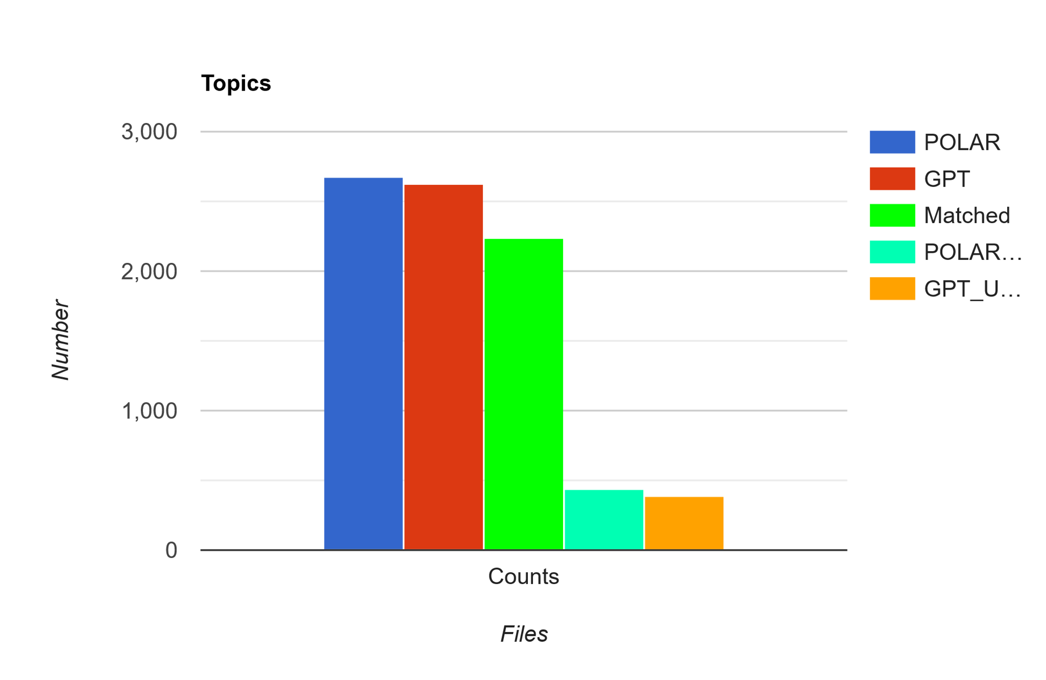
From this graph we can see that, even though the per-article analysis proved that these Datasets are wildly different, their calculated Topics were very similar, where 83.68% of the POLAR Attitudes were matched with GPT Attitudes and 85.05% of GPT Attitudes were matched with POLAR Attitudes.
These results are aligned with POLAR’s Topic Calculations done in the POLAR Journey, with very similar results to the ones gathered from that research. [ ]
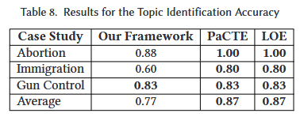

The Topics were compared to each other using Semantic Similarity with Sentence Transformers with a Threshold of 0.6.
Examples of matches with the lowest Threshold:
"a potential Brexit" <-> "The so-called 'Brexit' decision" , score: 0.6003
"a political crisis" <-> "economic and political uncertainty" , score: 0.609

6.2.4.2 Pair Frequency

Utilizing the results gathered from comparing each individual Sample, we gathered every unique mention of a Pair in every Sample for both Entity/Topical fields and counted every time each Pair is mentioned in both the Predicted Data and the Ground Truth Data.
We grouped up every mention of each pair as well as every time the pair was mentioned in both the Ground Truth set and the Predicted set, as well as every time it was declared as Positive, Neutral or Negative.
It is important to note that this step was not done using Semantic Similarity to compare the pairs due to Time Constraints, since to accurately and fairly compare every pair with every pair using Semantic Similarity would take multiple days of execution, however would likely yield better results.

Overlapping Entity Pairs:
Overlapping Entity Pairs (113) == Top 10
Where True Attitudes refer to GPT and Predicted Attitudes refer to POLAR:
Pairs | True_Attitudes | Pred_Attitudes
('european union', 'united kingdom') | TRUE: 72 (Neg: 47, Neu: 18, Pos: 7) | PRED: 109 (Neg: 14, Neu: 80, Pos: 15)
('brexit', 'european union') | TRUE: 7 (Neg: 7, Neu: 0, Pos: 0) | PRED: 44 (Neg: 10, Neu: 24, Pos: 10)
('brexit', 'united kingdom') | TRUE: 5 (Neg: 1, Neu: 2, Pos: 2) | PRED: 43 (Neg: 9, Neu: 28, Pos: 6)
('united kingdom', 'united states') | TRUE: 29 (Neg: 5, Neu: 6, Pos: 18) | PRED: 6 (Neg: 0, Neu: 5, Pos: 1)
('barack obama', 'european union') | TRUE: 11 (Neg: 1, Neu: 4, Pos: 6) | PRED: 13 (Neg: 4, Neu: 6, Pos: 3)
('barack obama', 'united kingdom') | TRUE: 16 (Neg: 5, Neu: 4, Pos: 7) | PRED: 8 (Neg: 1, Neu: 4, Pos: 3)
('donald trump', 'hillary clinton') | TRUE: 21 (Neg: 19, Neu: 0, Pos: 2) | PRED: 1 (Neg: 0, Neu: 1, Pos: 0)
('brexit', 'donald trump') | TRUE: 13 (Neg: 5, Neu: 2, Pos: 6) | PRED: 7 (Neg: 0, Neu: 6, Pos: 1)
('nato', 'russia') | TRUE: 15 (Neg: 11, Neu: 2, Pos: 2) | PRED: 3 (Neg: 0, Neu: 2, Pos: 1)
('barack obama', 'brexit') | TRUE: 6 (Neg: 3, Neu: 2, Pos: 1) | PRED: 10 (Neg: 3, Neu: 4, Pos: 3)

Given the topic of Brexit and the general timeframe of the articles of it happening 2016/6-7/22-10, ( European Union <-> United Kingdom ) is the most represented pair and that lines up with the topic perfectly, with 72 mentions from GPT and 109 from Polar, with the same reasoning for the 2nd and 3rd row, with a small oversight being that Brexit should have been considered a topic rather than an Entity.
The Entities that are matched are accurate to the Topic of Brexit, however the Attitudes associated with them are as mentioned in Section 6.2.2.2. POLAR’s Attitudes are primarily Neutral, even with the predominantly Negative nature of the Pairs, such as:
(European Union <-> United Kingdom), should be the most polarizing pair, given real world scenarios of what happened, and GPT encapsulates that by having 65.27% of these pairs be Negative, followed by 25% Neutral and only 9.7% Positive. Meanwhile POLAR has 73.39% of these pairs be classified as Neutral, with 13.76% Positive and only 12.84% Negative.
Regardless of whether these pairs were found in the same Sample or not, they were found in the same Dataset, so the pairs being Neutral focused is due to POLAR rather than the dataset, since GPT attributed a majority of them as Negative.

Overlapping Topical Pairs:
Overlapping Topical Pairs (45) == Top 10
Where True Attitudes refer to GPT and Predicted Attitudes refer to POLAR:
Pairs | True_Attitudes | Pred_Attitudes
('brexit', 'european union') | TRUE: 70 (Neg: 58, Neu: 10, Pos: 2) | PRED: 20 (Neg: 6, Neu: 14, Pos: 0)
('european union', 'united kingdom') | TRUE: 12 (Neg: 7, Neu: 5, Pos: 0) | PRED: 47 (Neg: 6, Neu: 34, Pos: 7)
('brexit', 'united kingdom') | TRUE: 34 (Neg: 22, Neu: 9, Pos: 3) | PRED: 21 (Neg: 2, Neu: 16, Pos: 3)
('barack obama', 'brexit') | TRUE: 24 (Neg: 14, Neu: 8, Pos: 2) | PRED: 1 (Neg: 0, Neu: 1, Pos: 0)
('brexit', 'united states') | TRUE: 15 (Neg: 8, Neu: 4, Pos: 3) | PRED: 9 (Neg: 1, Neu: 4, Pos: 4)
('european union', 'united states') | TRUE: 4 (Neg: 1, Neu: 0, Pos: 3) | PRED: 5 (Neg: 1, Neu: 4, Pos: 0)
('boris johnson', 'brexit') | TRUE: 8 (Neg: 1, Neu: 0, Pos: 7) | PRED: 1 (Neg: 0, Neu: 1, Pos: 0)
('brexit', 'david cameron') | TRUE: 8 (Neg: 7, Neu: 1, Pos: 0) | PRED: 1 (Neg: 0, Neu: 1, Pos: 0)
('barack obama', 'european union') | TRUE: 5 (Neg: 1, Neu: 2, Pos: 2) | PRED: 3 (Neg: 1, Neu: 1, Pos: 1)
('united kingdom', 'united states') | TRUE: 2 (Neg: 1, Neu: 1, Pos: 0) | PRED: 5 (Neg: 1, Neu: 3, Pos: 1)

The Topical pairs are once again accurate to the events of Brexit, the Outliers are the pairs consisting of 2 entities instead of an entity and a topic, example:
('european union', 'united kingdom')
('united kingdom', 'united states')
These same pairs are found above in the Entity Pairs

6.3 POLAR Pipeline End Result Comparison

In this section we are moving past the Sentiment Attitude Extraction aspect of POLAR and looking at the Artifacts output at different Steps of the Pipeline and comparing the Standard POLAR method with our Integrated LLM Method.

6.3.1 Fellowships:

POLAR:
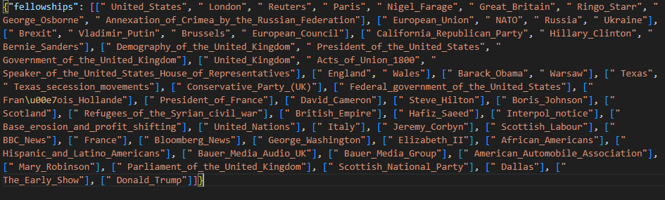
GPT:
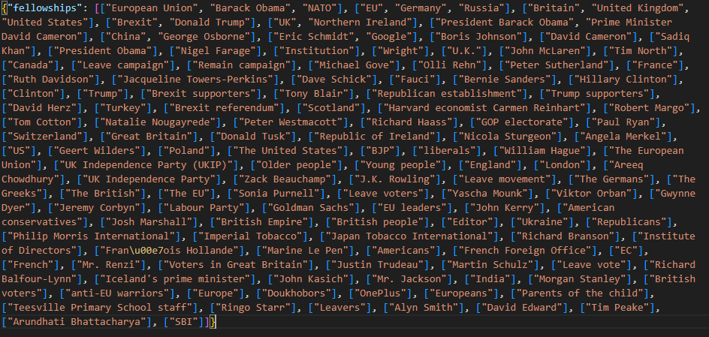
From these Fellowships we can infer multiple things:
GPT:
- 110+ Clusters of Fellowships, ranging from 1-3 Entities each with a majority of single Entities, many overlaps (European Union – EU, etc.)
- Contains Various named Entities not limited to strictly known entities
- High Noise, a lot of Single Entity Fellowships
POLAR:
- ~40 Clusters of Fellowships, ranging from 1-9 Entities each, more compact with less overlaps
- Represents Entities Strictly off Dbpedia links that correspond to Entities
- Very low Noise, very curated
Very few similarities between the 2 models, with the closest match in fellowships being:
"POLAR ": ["Demography_of_the_United_Kingdom",
"Government_of_the_United_Kingdom"
"President_of_the_United_States”],
"GPT ": [ "Britain",
"United Kingdom",
"United States” ]
Comparing the fellowship clusters of POLAR and GPT reveals two distinct modeling philosophies.
POLAR’s DBpedia-aligned clusters are compact and curated, offering high precision but missing some aspects of political and sociological discourse.
GPT, on the other hand, surfaces a richer, more sociologically nuanced set of actors, including campaign groups, media personalities, and ideologically charged with the trade-off of a messier and noisier output.

6.3.2 SAG (Signed Attitude Graph):

In this section we compared the SAG graphs output by POLAR’s pipeline which shows the Sentiment between Entities in an undirected graph.
What the Connections represent:
The Nodes represent Entities and the Edges represent Sentiment calculated between Entities whose pairs were found through the Entity_Extractor and Sentiment_Attitude, or in the case of the LLMs, the Entity_attitude field from the responses.
The Colors represent whether the weight attached to these pairs is Positive or Negative. The POLAR function in the pipeline that constructs the SAG skips over strictly Neutral pairs, to focus more on Polarization.
POLAR:
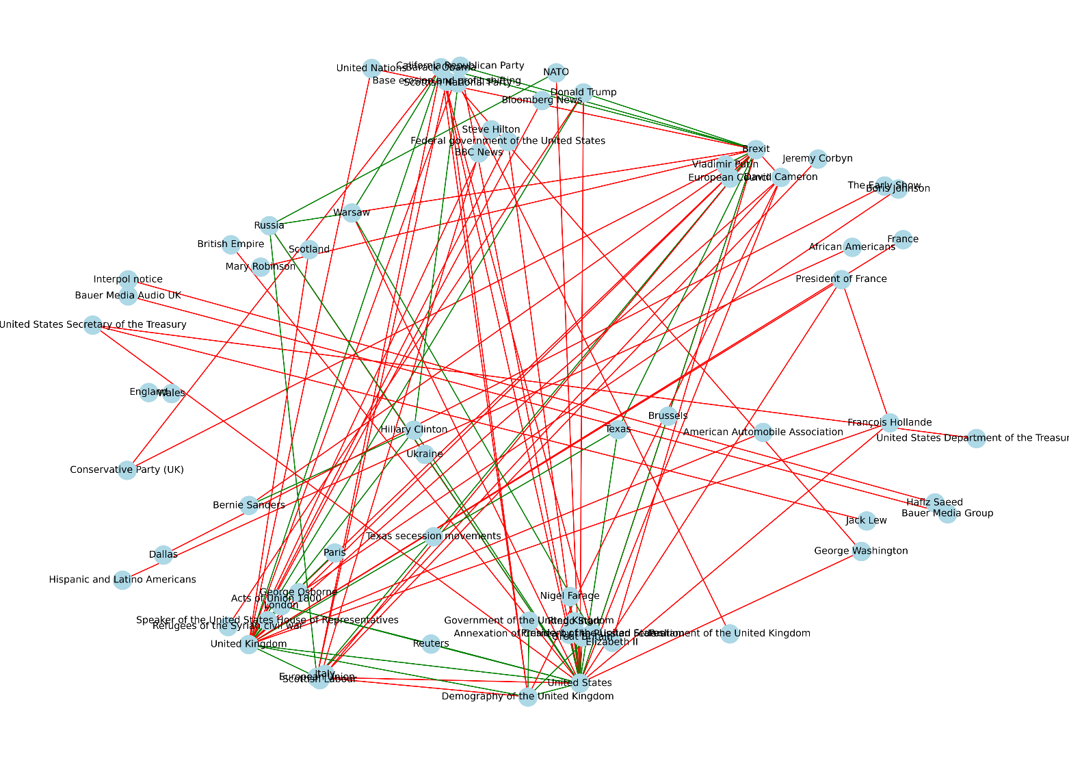

GPT:
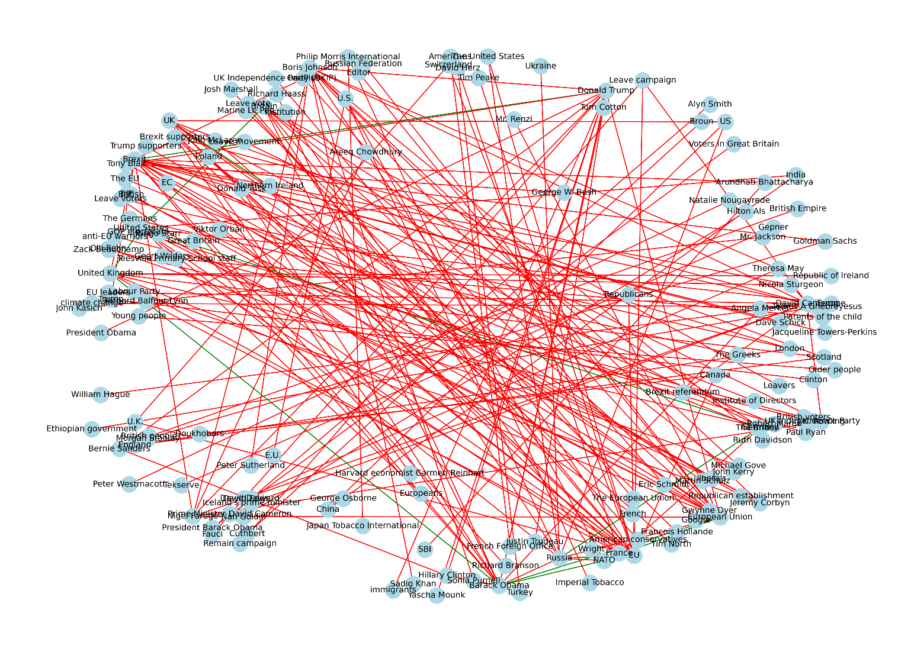
From these Graphs we can see:
POLAR
- SAG is more compact and structured, containing less noise
- Entities are Formal and linked to dbpedia URLs each (removed from the Graph for clarity)
- Mix of Positive and Negative edges, leaning heavily towards Negative
GPT
- Messy Graph with a high number of Nodes and Edges, very densely connected
- Heavily skewed towards Negative Sentiment Edges with only a handful of Positives
- Entities are informal mentions through text, not linked to pre-existing Entities

These results are very dissimilar, likely because GPT overproduces Entity Pairs, as seen in section 6.2.2.1.2, POLAR produces 1320 Entity Pairs to GPT’s 2552. Added in the fact that GPT’s Entity Pairs are not traditionally normalized like Polar’s use of Dictionary linking to dbpedia links, and this creates this difference we see, with GPT appearing messier and denser, with noisy Entities that appear few times.

6.3.3 Attitude Dipoles:

This is the final Artifact output from the POLAR Pipeline, the attitudes.pckl file, which is the culmination of all the previous steps in the Pipeline, it shows all of the key entities’ connection with the other key entities by linking them with their opinions on the most impactful topics found.
What each Color Represents:
Blue: Neutral to slight Agreement on the Topic
Gray: Mixed to Neutral on the Topic
Green: Positive Agreement on the Topic
Orange: Negative Agreement on the Topic
Red: Polarization on the Topic
POLAR:
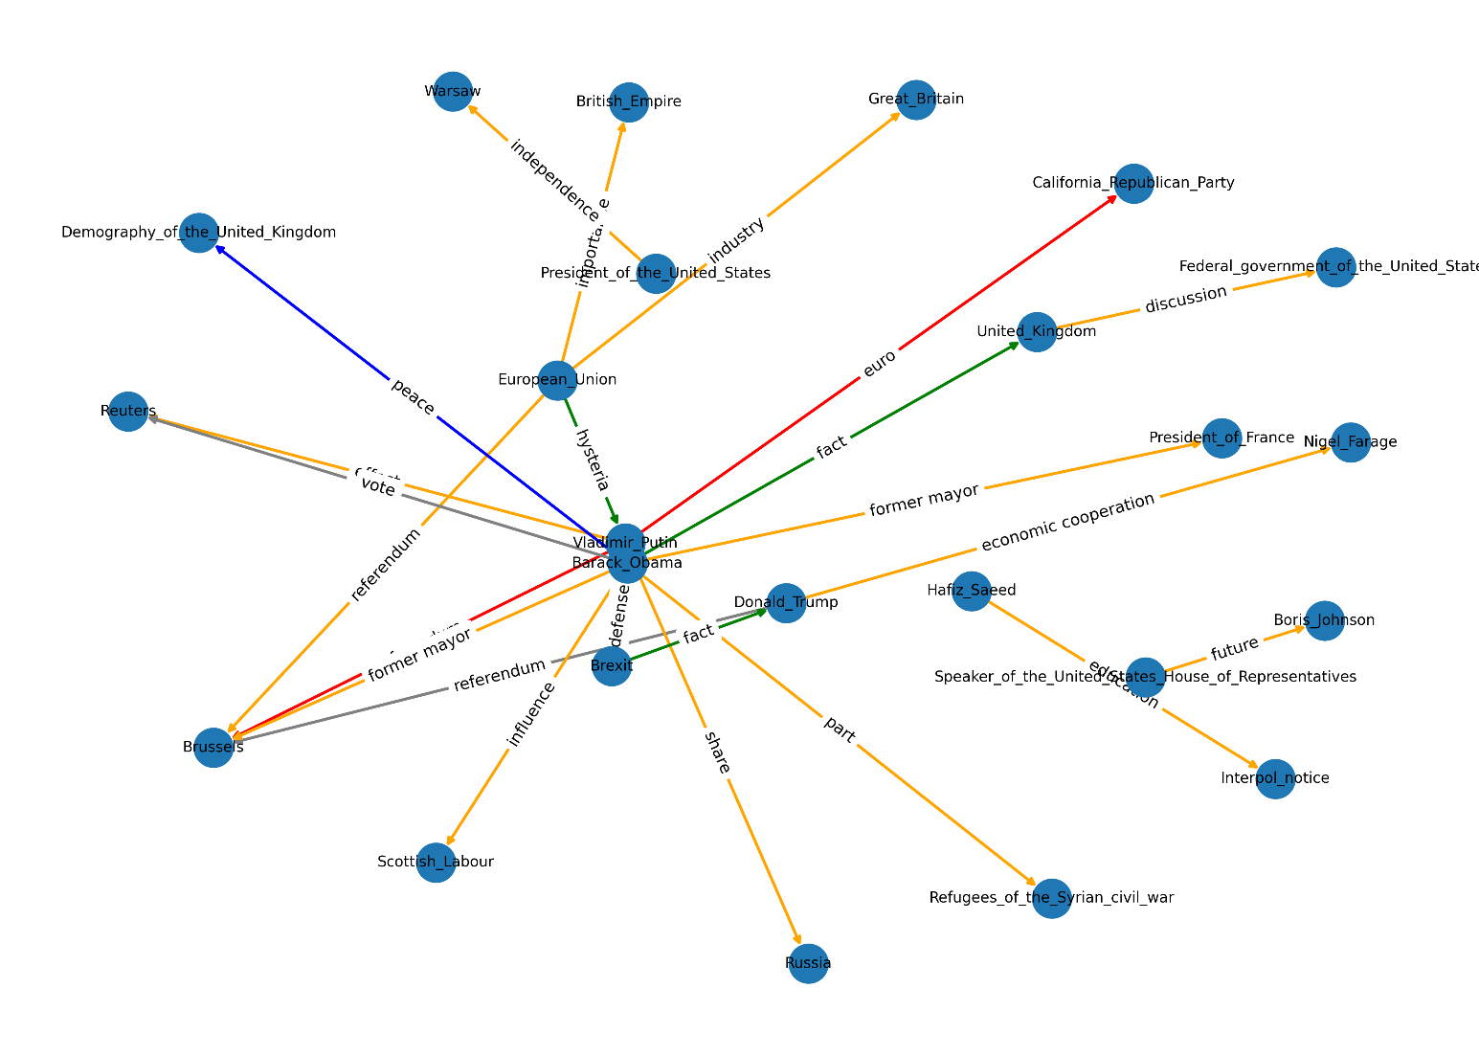
GPT:
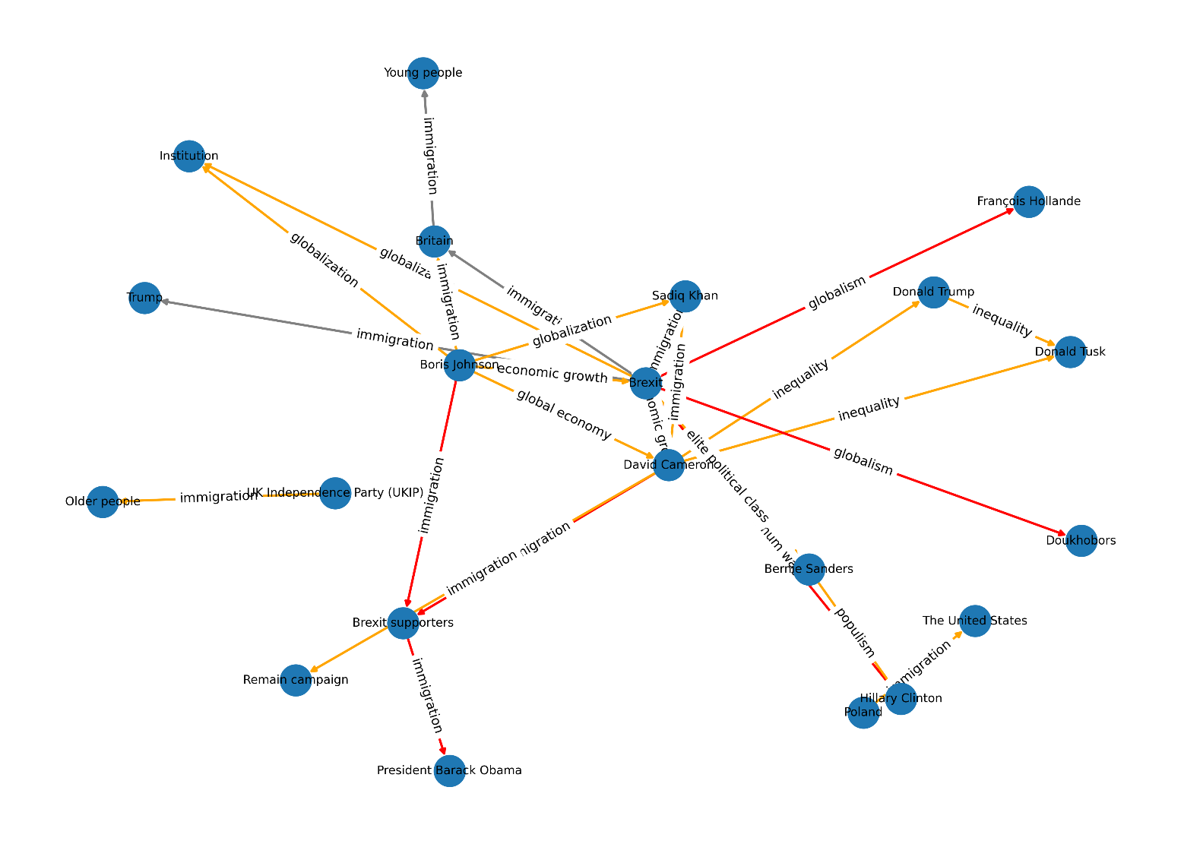
Analysis:
Initially, at a first glance the models’ outputs share some Similarities, such as having a large majority of the Edges being Negative Agreement, where both Entities Disagree on the Topic of their Pair, such as:
- GPT (David Cameron <-> Donald Trump, Topic: inequality)
- POLAR (Barack_Obama <-> Russia, Topic: share).
The number of Polarizing Pairs are few for POLAR and a bit more prevalent in GPT’s graph, with pairs such as:
- GPT (Boris Johnson <-> Brexit supporters, Topic: immigration, where Boris Johnson: Positive Attitude, Brexit supporters: Negative Attitude)
- POLAR (Vladimir_Putin <-> California_Republican_Party, Topic: euro, where Vladimir_Putin: Negative Attitude, California_Republican_Party: Positive Attitude)
There are slight Positive Agreements and a few Neutral Pairs as well.
The Topics that connect the pairs in the models vary substantially for GPT and POLAR, where POLAR’s Topics are plentiful and nuanced, but do not seem to be Topics of high Polarity or Discourse, consisting mainly of generic Noun Phrases, such as:
- Part
- Share
- Fact
- Discussion
- Former mayor
- Future
- euro
On the other hand, GPT’s Topics are very few comparatively, with only 17 unique Topics found in the Dipoles out of 43, with immigration appearing in 16 entries (roughly 37%). As such the Topic coverage of GPT is less nuanced and consists of some repeating topics between Entities, however the Topics being compared are divisive and are likely to cause Discourse, such as:
- immigration
- globalism
- globalization
- inequality
- global economy

In order to determine the quality of the Topics gathered by GPT and POLAR, the Topics were all sent to multiple LLMs for them to classify as Sociopolitical, Slightly Sociopolitical and Not Sociopolitical, with a brief explanation that Sociopolitical topics are issues related to government, society, public policy, inequality, rights, identity or power structures and may be emotionally charged in public discourse.
The topics were sent randomly with no reference to which response they correlate to, in order to remove any inherent bias in the outputs, with these results gathered from purely considering the Sociopolitical classified topics:
Sociopolitical Topics detected using LLMs
Model | GPT Percentage of Matches | POLAR Percentage of Matches
GPT-4.0 | 100% | 45.1%
Deepseek-V3 | 76.7% | 40.7%
Claude-3.7 Sonnet | 74.4% | 29.7%
Gemini-2.0 Flash | 76.7% | 44.0%
Le Chat - Mistral | 72.1% | 31.9%
Average Overall: | 80.0% | 38.3%

6.3.4 Conclusion:

It is hard to definitively declare which model is superior in the end, a more thorough analysis would need to be conducted with a much larger dataset of Articles to be able to more accurately compare the models.
From the Data of 727 Article Parts however, on the topic of Brexit, the analysis between GPT and POLAR reveals a clear trade-off between topic depth and topic breadth:
GPT overwhelmingly identifies socio-politically meaningful topics, as validated by multiple LLMs. Focusing on issues with real-world ideological divides.
In contrast, POLAR extracts a much larger and diverse topic set of 65 unique topics of 91 total Attitudes to GPT’s 17 of 43 total Attitudes, as well as reflecting a broader topical coverage when compared to GPT. The trade-off is that many of POLAR’s topics are shallow or generic, with no means of discourse or polarity, with only a small portion of sociopolitical topics covered (roughly 38.3% according to the LLMs requested)

6.4 Fine-Tuned Mistral Evaluation

This evaluation aims to measure how well the fine-tuned Mistral-7B model replicates the outputs of GPT3.5. The GPT responses were set as the Ground Truth, with the Mistral responses acting as the prediction, the comparisons were focused on entity/topic pair identification, attitude classification on the true pairs and justification quality.
It is important to note that the Dataset that was compared was a dataset excluded from the fine-tuning dataset of the model.
6.4.1 Evaluation
Evaluation - Mistral completed in 4467.64 seconds.(~74.46 minutes)
“Entity”
Pair Matching
Precision | 0.8725
Recall | 0.9418
F1 | 0.9059
True Positives | 664
False Positives | 97
False Negatives | 41

Attitude Prediction
Accuracy | 0.9771
True Positives | 683
False Negatives | 16

Justification Overlap
Overlap | 0.8581
Matched Justifications | 798
Total Justifications | 930

From this data, we can see that from the evaluated dataset, Mistral Successfully manages to predict 664 pairs from the 705 pairs in the Ground Truth dataset == roughly 94.18% of the pairs in Ground Truth were accurately predicted.
Of those 664 pairs, 699 attitudes were compared between the Ground Truth and the Predicted Dataset, with Mistral correctly predicting 683 of them == roughly 97.71% pairs were correctly attributed.
Of those 664 pairs, the justification was successfully matched using ROUGE-L similarity roughly 85.81% of the time.
“Topical”:
Pair Matching
Precision | 0.8658
Recall | 0.9365
F1 | 0.8998
True Positives | 826
False Positives | 128
False Negatives | 56

Attitude Prediction
Accuracy | 0.9750
True Positives | 820
False Negatives | 21

Justification Overlap
Overlap | 0.8785
Matched Justifications | 477
Total Justifications | 543

From this data, we can see that from the evaluated dataset, Mistral Successfully manages to predict 826 pairs from the 882 pairs in the Ground Truth dataset == roughly 93.65% of the pairs in Ground Truth were accurately predicted.
Of those 826 pairs, 841 attitudes were compared between the Ground Truth and the Predicted Dataset, with Mistral correctly predicting 820 of them == roughly 97.50% pairs were correctly attributed.
Of those 826 pairs, the justification was successfully matched using ROUGE-L similarity roughly 87.85% of the time.

6.4.2 Conclusion

From this dataset we can confidently state that Mistral replicates GPT remarkably well, accurately guessing GPT’s Entity / Topical Pairs around 93-94% of the time, with a precision of around 86-87%, meaning that at any point that Mistral locates a pair, there is an 86-87% likelihood that it is included in the GPT results. These are incredible results, especially since Mistral is a marginally smaller open-weight model than GPT 3.5.
Mistral is also incredibly accurate at predicting the Attitudes of the calculated pairs, accurately guessing around 97% of the pairs in the same way that GPT would.
These results indicate that Mistral, once fine-tuned, is not only a viable replacement for GPT-based processing in the POLAR pipeline, but also one that can produce slightly richer outputs. In the test set, an additional 97 Entity Pairs and 128 Topical Pairs were identified by Mistral that do not match any pairs in the GPT outputs. This can be interpreted as an enhancement (greater granularity and sensitivity to subtle Sentiment Attitudes) or as potential noise (false pairs with lower precision). The appropriate interpretation of these added pairs depends on the strictness or flexibility of the use case.
Beyond raw performance metrics, there are operational trade-offs that distinguish the two models:
Attribute | GPT-3.5 (API) | Mistral-7B (Fine-Tuned)
Hosting | Cloud (OpenAI) | Local
Internet Dependency | Required | None
Prompt Length | Long (1200+ char) | Minimal
Latency per Request | ~15–35 seconds | ~1–2 minutes
Multithread-ability | Minimal | None
Cost per Use | Usage-based fees | Local
Fine-tune Time | N/A | ~3 hours
System Requirements | N/A | Cuda compatible GPU

Chapter 7

Conclusion and Future Work

7.1 Summary of Findings
7.2 Model Trade-offs
7.3 Limitations
7.4 Future Work

7.1 Summary of Findings

This dissertation explored the integration of large language models (LLMs) into the POLAR pipeline, aiming to replace traditional NLP techniques for the task of extracting and evaluating polarized attitudes between entities over controversial topics. The study compared outputs from two key systems: the original POLAR algorithm and GPT-3.5 Turbo. Additionally, a fine-tuned Mistral-7B model was trained and evaluated to assess its ability to replicate GPT’s outputs.
Through both quantitative metrics and qualitative analysis, it was shown that GPT identifies fewer overall dipole attitudes, but does so with a strong focus on sociopolitical topics that are typically associated with public polarization. In contrast, POLAR detects a greater number of dipoles and topics, but many are shallow or of limited sociopolitical relevance.
The fine-tuned Mistral model demonstrated impressive results, with over 93% agreement with GPT on detected entity and topical pairs, and approximately 97% agreement on attitude classification. Precision hovered around 86–87%, suggesting that when Mistral detects a pair, it is very likely to also be present in GPT’s outputs. Mistral also produced additional pairs, which could be interpreted as either enriching or introducing noise, depending on the use case.
These findings strongly support the viability of LLMs in replacing traditional NLP components for polarization analysis and suggest that local fine-tuned models like Mistral can offer high performance while maintaining deployment flexibility.

7.2 Model Trade-offs

While GPT provides high-quality, coherent results with an emphasis on sociopolitical salience, it comes with limitations: reliance on internet access, API availability, cost, and lack of customization. Mistral, in contrast, can be fine-tuned, deployed locally, and used offline. However, Mistral requires greater inference time (approximately 1-2 minutes per article versus GPT's 15–35 seconds), and requires significant upfront effort to fine-tune (approximately 3 hours in this project).
The choice between these systems depends largely on user needs. For scalable, on-demand inference with strong semantic understanding, GPT remains ideal. For private, cost-effective, or customizable solutions, Mistral proves to be a compelling alternative.

7.3 Limitations

This study had several constraints. The evaluation was conducted on a limited set of articles, which restricts the generalizability of the findings. The notion of what constitutes a "correct" or "meaningful" attitude or topic remains somewhat subjective, especially in politically complex or ambiguous articles. Additionally, this work only considered binary dipoles, where Entities felt Positive/Neutral/Negative, whereas real-world discourse may involve more complex, multi-party relationships. The scope was also restricted to English-language datasets.

7.4 Future Work

- Dynamic topic scoring: Integrating a non-binary scale for attributing to Sentiments, as well as more expressive Attitude Dipole SAGs.
- Dataset expansion: Applying the models across larger datasets, containing lengthier Articles, as well as a bigger number of Articles to parse.
- Robustness testing: Evaluating model outputs across different domains (healthcare, climate change, foreign policy etc.)
- Additional Mistral Evaluation: The Fine-Tuned Mistral Evaluation was only conducted comparing itself to GPT3.5, with remarkable results, however additional experiments could be conducted to see its full integration in the POLAR Pipeline.

